**Lab 2**

**Name: Mihir Malikali Mithani.**

**Enrollment No: 92301733025.**

**Experiment:** Hands-on experimentation on the current-voltage characteristics of NMOS transistor and PMOS transistor and find power dissipation

**Device Structure and Physical Operation**

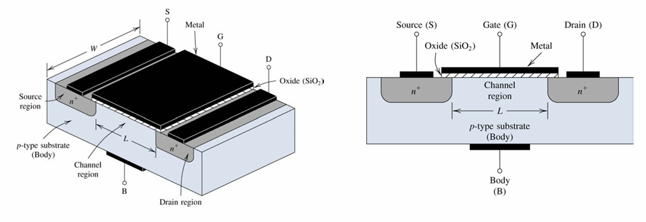

**Linear Operation**

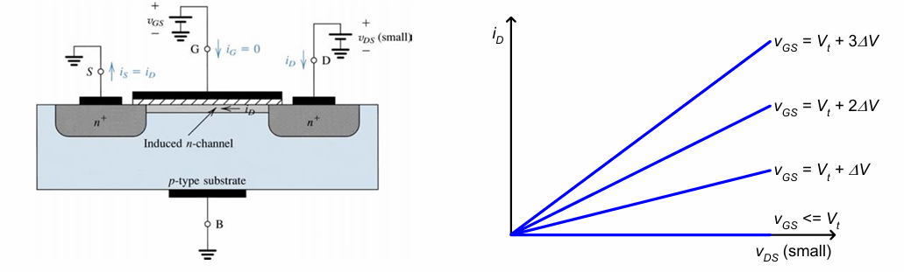

**Triode to Saturation Region**

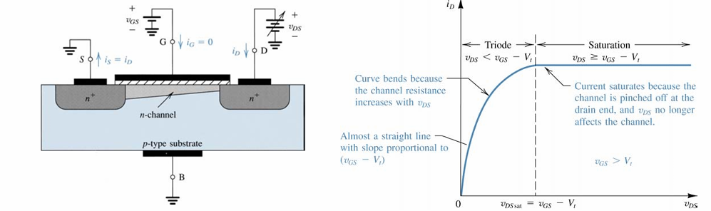

**Cutoff Mode:**

Occurs when $V_{GS}≤V_{TH(N)}$

$$I_{D}=0$$

A MOSFET is in cutoff when no channel has been induced. Thus, for an enhancement NMOS device:



Likewise, for an enhancement PMOS device:



**Triode Mode:**

Occurs when $V_{GS}>V_{TH(N)}$ and $V_{DS}<V_{GS}−V_{TH(N)}$





$$I_{D}=\frac{W}{L}μ_{n}C_{OX}\left(V_{GS}−V_{TH\left(N\right)}−\frac{V_{DS}}{2}\right)V_{DS}$$

**Saturation Mode:**

Occurs when $V_{GS}>V_{TH(N)}$ and $V_{DS}≥V_{GS}−V_{TH(N)}$

$$I_{D}=\frac{W}{L}μ_{n}C_{OX}\frac{1}{2}{\left(V_{GS}−V_{TH\left(N\right)}\right)}^{2}\left(1+λ_{n}V_{DS}\right)$$





**Circuit**

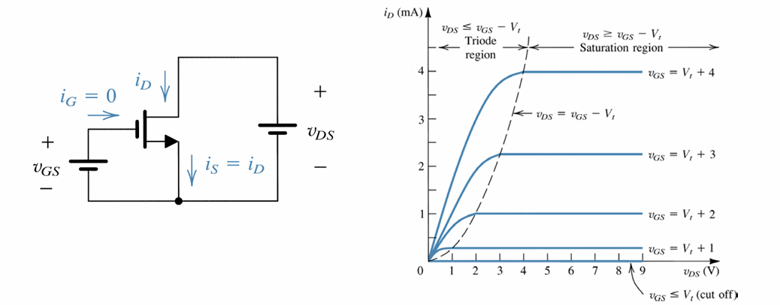

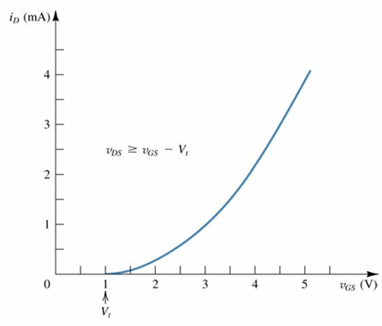

**The Process Transconductance Parameter k′ is a constant that depends on the process technology used to fabricate an integrated circuit. Therefore, all the transistors on a given substrate will typically have the same value of this parameter.**

**The Channel Aspect Ratio WL is simply the ratio of channel width W to channel length L. This is the MOSFET device parameter that can be altered and modified by the circuit designer to satisfy the requirements of the given circuit or transistor.**

**We can likewise combine these parameter to form a single MOSFET device parameter K :**

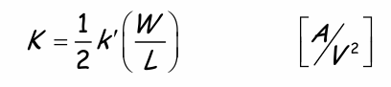

**Observation Table:**

**NMOS**

**Model Parameters:**

**=**

|  |  |
| --- | --- |
|  |  |
|  |  |
|  |  |
|  |  |
|  |  |
|  |  |
|  |  |

|  |  |
| --- | --- |
|  |  |
|  |  |
|  |  |
|  |  |
|  |  |
|  |  |
|  |  |

|  |  |
| --- | --- |
|  |  |
|  |  |
|  |  |
|  |  |
|  |  |
|  |  |
|  |  |

**PMOS**

**Model Parameters:**

**=**

|  |  |
| --- | --- |
|  |  |
|  |  |
|  |  |
|  |  |
|  |  |
|  |  |
|  |  |

|  |  |
| --- | --- |
|  |  |
|  |  |
|  |  |
|  |  |
|  |  |
|  |  |
|  |  |

|  |  |
| --- | --- |
|  |  |
|  |  |
|  |  |
|  |  |
|  |  |
|  |  |
|  |  |

**Output Waveform**

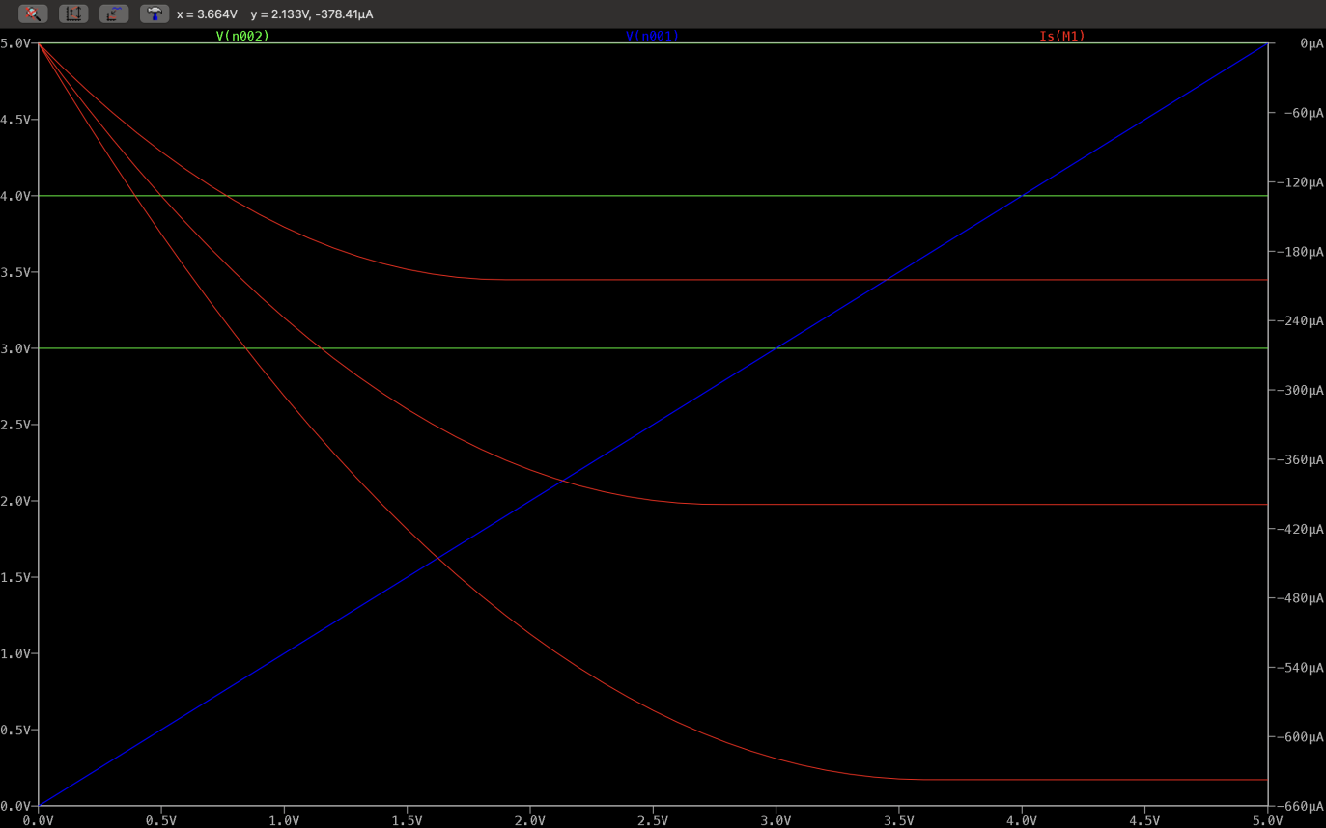

**Conclusion**