NAME ; ADITYA KUMAR
REG NO : 2647203

QUESTTION 1

Code :

#include <stdio.h>
#include <string.h>
#include <math.h>
#include <ctype.h>
#include <stdlib.h>

int bin_ser(int ele, int *arr, int n){
int st = 0, en = n - 1;
while (st <= en){
int mid = (st +(en-st)/2);
if (arr[mid] == ele){
return mid;
}
else if (arr[mid] < ele){
st = mid + 1;
}
else if (arr[mid] > ele){
en = mid - 1;
}
else{
printf("ERROR");
break;
}
}
return -1;
}

int main(){
int arr[100];
int a,n;

printf("Enter size of array :");
scanf("%d",&n);

printf("enter the elements (in sorted order) :\n");
for (int i = 0; i<n; i++){
scanf("%d", &arr[i]);
}

printf("Enter element to search ;");
scanf("%d",&a);

int result = bin_ser(a, arr, n);

if (result != -1){
printf("Element found at index %d\n", result);
}
else{
printf("-1 \n");
}

return 0;
}

Output:
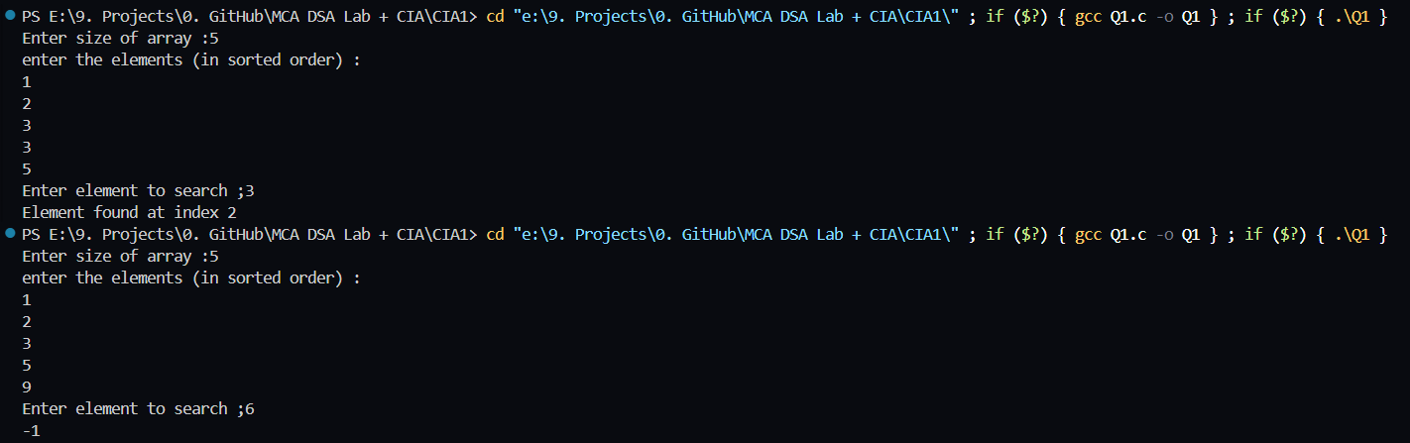
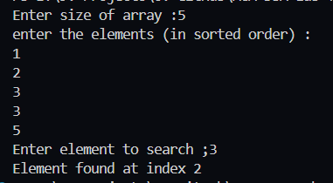
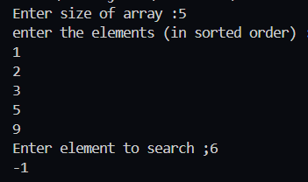
Question 2

#include <stdio.h>
#include <stdlib.h>

typedef struct Node {
int data;
struct Node* next;
} Node;

Node* head = NULL;
Node* tail = NULL;

void insertAtEnd(int value) {
Node* newNode = (Node*)malloc(sizeof(Node));
newNode->data = value;
newNode->next = NULL;
if (head == NULL) {
head = newNode;
tail = newNode;
} else {
tail->next = newNode;
tail = newNode;
}
}

void deleteFirstNode() {
if (head == NULL) {
printf("List is empty\n");
return;
}
Node* temp = head;
int value = temp->data;
head = temp->next;
if (head == NULL) {
tail = NULL;
}
free(temp);
printf("Deleted value: %d\n", value);
}

void displayList() {
Node* curr = head;
while (curr != NULL) {
printf("%d -> ", curr->data);
curr = curr->next;
}
printf("NULL\n");
}

void reverseList() {
Node* prev = NULL;
Node* current = head;
Node* next = NULL;
tail = head;
while (current != NULL) {
next = current->next;
current->next = prev;
prev = current;
current = next;
}
head = prev;
}

int main() {
int choice, value;
while (1) {
printf("1. Insert at end\n");
printf("2. Delete first node\n");
printf("3. Display list\n");
printf("4. Reverse list\n");
printf("5. Exit\n");
printf("Enter choice: ");
scanf("%d", &choice);
switch (choice) {
case 1:
printf("Enter value to insert: ");
scanf("%d", &value);
insertAtEnd(value);
break;
case 2:
deleteFirstNode();
break;
case 3:
displayList();
break;
case 4:
reverseList();
break;
case 5:
exit(0);
default:
printf("Invalid choice\n");
}
}
return 0;
}

Code:

Output:
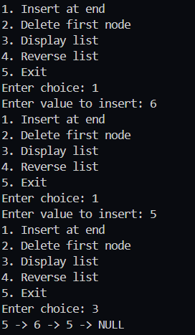
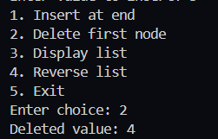
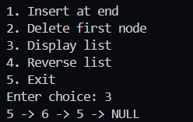
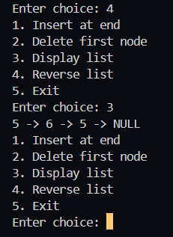

Question 3

Code:

#include <stdio.h>
#include <string.h>
#include <math.h>
#include <ctype.h>
#include <stdlib.h>

typedef struct Stack{
char arr[100];
int size;
int top;
} Stack;

int main(){
int n;
char arr[100];

printf("Enter the size of the stack :");
scanf("%d",&n);

printf("Enter the brackets : \n");
for(int i= 0 ; i < n; i++){
scanf(" %c", &arr[i]);
}

Stack *st = (Stack *)malloc(sizeof(Stack));
st->top = -1;
st->size = n;

int isBalanced = 1;
for (int i=0 ; i< n; i++){
if (arr[i] == '(' || arr[i] == '[' || arr[i] == '{'){
st->arr[++st->top] = arr[i];
}
else if (arr[i] == ')' || arr[i] == ']' || arr[i] == '}'){
if (st->top == -1 ||
(arr[i] == ')' && st->arr[st->top] != '(') ||
(arr[i] == ']' && st->arr[st->top] != '[') ||
(arr[i] == '}' && st->arr[st->top] != '{')){
isBalanced = 0;
break;
}
st->top--;
}
}

if (st->top != -1){
isBalanced = 0;
}

if (isBalanced){
printf("\n Brackets are Balanced");
}
else{
printf("\n Brackets are NOT Balanced");
}

free(st);
return 0;
}

Output :
