CHRIST (Deemed to be University)
Department of Computer Science
Master of Computer Applications

Course: MCA411-2 - PYTHON Programming
LAB Exercise I –
Demonstrate use of Python data structures, Tuple, Set, List, and Dictionary.
Date of assignment: 16-09-2026
Date of submission: 16-09-2026

Name : Aditya Kumar
Reg. No : 2647203
Class : 2 MCA – B

Domain : Clean Energy Systems & Grid Decarbonization

Lab 1
Lab Exercise I:

Demonstrate use of Python data structures, Tuple, Set, List, and Dictionary.

- Create a tuple, a list, a set, and a dictionary containing records/items from your selected domain. Demonstrate how to add, update, delete, and access elements. Display the data appropriately.

- Tuple:

Code:
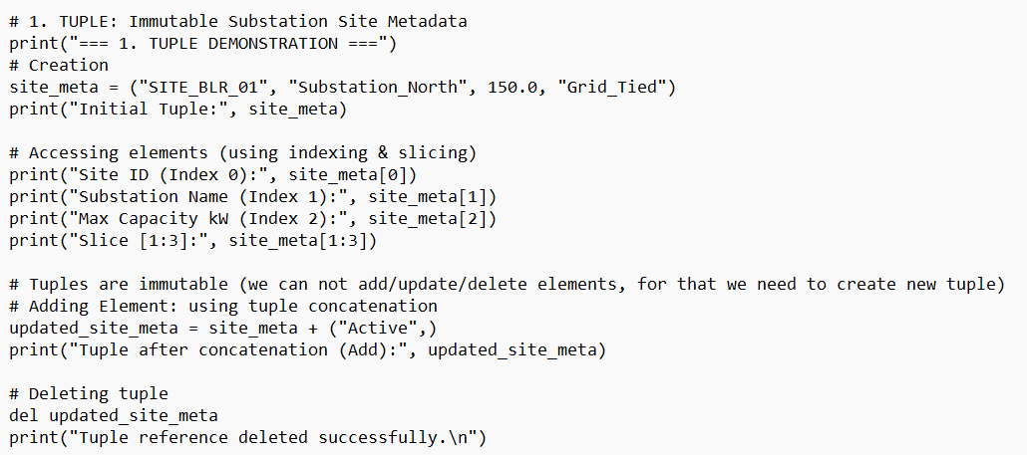

Output:
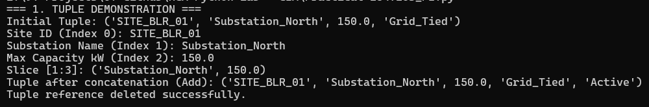

- List:

Code:
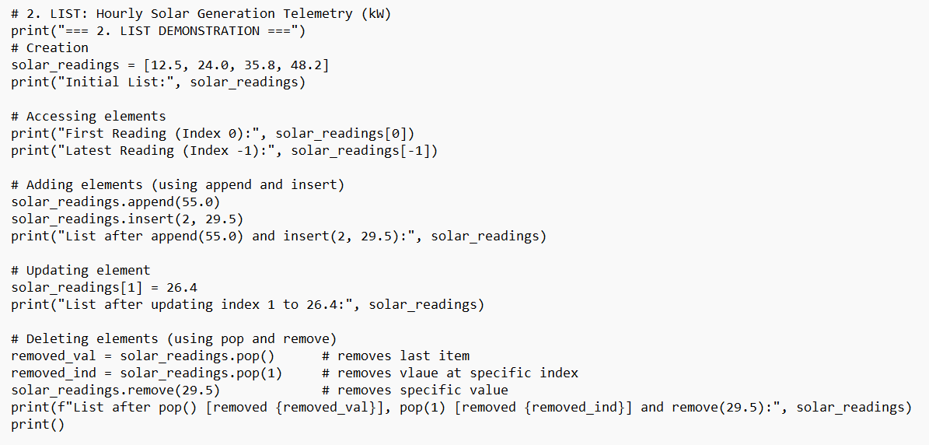

Output:
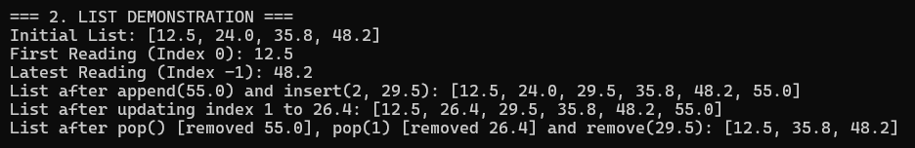

- Set:

Code:
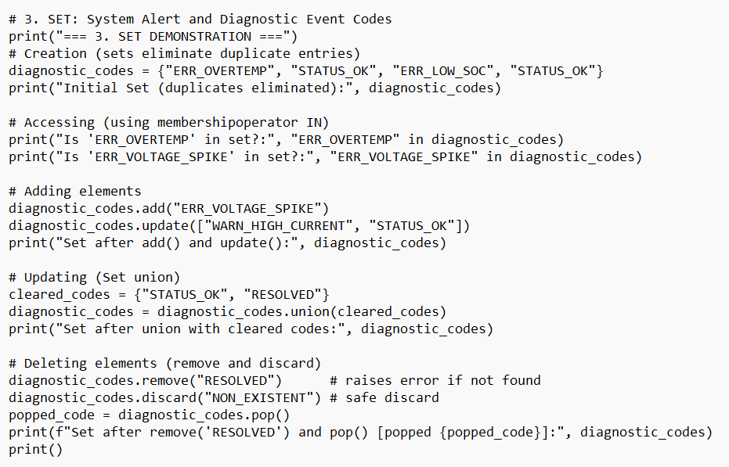

Output:
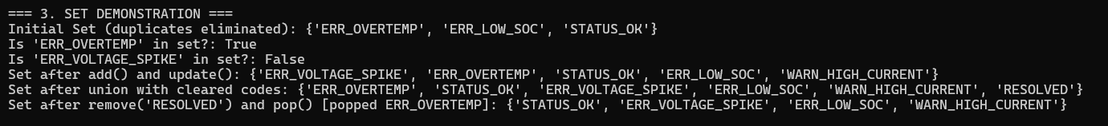

- Dictionary:

Code:
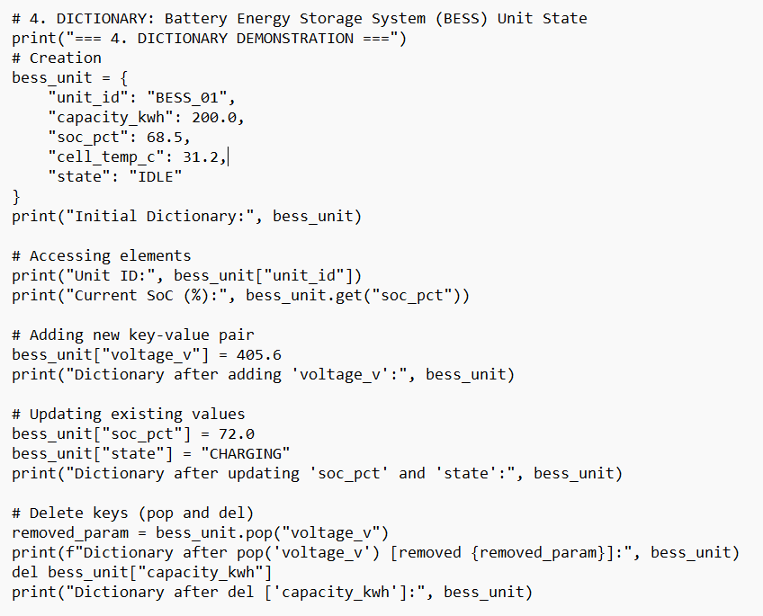

Output:
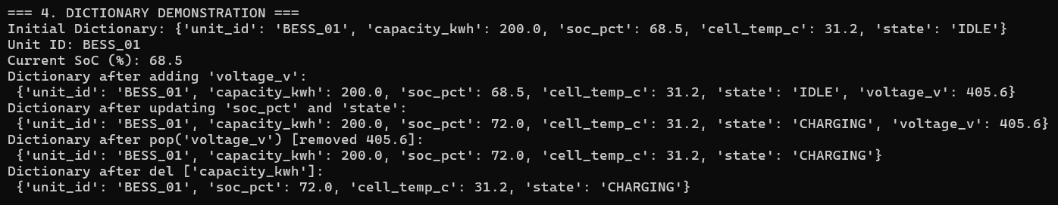

- Design and develop a menu-driven data management system for a complete data-processing solution using combinations of lists, tuples, sets, and Dictionaries.
The program should demonstrate Nested data structures, set operations, dictionary operations, List comprehension, set comprehension, Dictionary comprehension, sorting, searching, Aggregation, and data validation

Code:

'''
*** PART B: Menu-Driven Solar Microgrid & BESS Data Management System ***
'''

# A main dictionary storing site details.
'''
Each site contains:
- A tuple for fixed details (Location, Capacity kW)
- A list for recent power readings
- A set for unique alert codes
- Simple numeric values for battery percentage and temperature
'''
sites = {
"SITE_1": {
"info": ("Substation North", 150.0), # Tuple
"readings": [40.0, 55.0, 65.0], # List
"soc": 75.0, # Float (State of Charge %)
"temp": 32.0, # Float (Temperature °C)
"alerts": {"OK", "HIGH_TEMP"} # Set
},
"SITE_2": {
"info": ("Substation South", 90.0),
"readings": [20.0, 30.0, 25.0],
"soc": 25.0,
"temp": 40.0,
"alerts": {"LOW_BATTERY", "HIGH_TEMP"}
},
"SITE_3": {
"info": ("Substation East", 200.0),
"readings": [80.0, 95.0, 110.0],
"soc": 85.0,
"temp": 28.0,
"alerts": {"OK"}
}
}

def view_sites():
print("\n--- Site Records ---")
for s_id, d in sites.items():
print(f"[{s_id}] {d['info'][0]} | Cap: {d['info'][1]} kW | SoC: {d['soc']}% | Temp: {d['temp']}°C")
print(f" Readings: {d['readings']} | Alerts: {d['alerts']}")

# Comprehensions (list and dicinory)
low_soc = [s_id for s_id, d in sites.items() if d["soc"] < 30.0]
all_alerts = {a for d in sites.values() for a in d["alerts"]}
avg_gen = {s_id: round(sum(d["readings"]) / len(d["readings"]), 2) for s_id, d in sites.items()}

print("\nLow SoC (<30%):", low_soc)
print("All Alerts:", all_alerts)
print("Average Power (kW):", avg_gen)

def add_site():
print("\n--- Add New Site ---")
s_id = input("Enter Site ID: ").strip().upper()
if s_id == "" or s_id in sites:
print("Invalid or duplicate Site ID.")
return

loc = input("Enter Location: ").strip()
if loc == "":
print("Location cannot be empty.")
return

cap_str = input("Enter Capacity in kW (10 to 500): ").strip()
if not (10 <= float(cap_str) <= 500):
print("Invalid capacity value.")
return

soc_str = input("Enter Battery SoC % (0 to 100): ").strip()
if not (0 <= float(soc_str) <= 100):
print("Invalid SoC percentage.")
return

sites.update({
s_id: {
"info": (loc, float(cap_str)),
"readings": [0.0],
"soc": float(soc_str),
"temp": 25.0,
"alerts": {"OK"}
}
})
print(f"{s_id} registered.")

def search_site():
print("\n--- Search / Delete Site ---")
s_id = input("Enter Site ID: ").strip().upper()

if s_id in sites:
d = sites[s_id]
print(f"Found: {s_id} | {d['info'][0]} | Cap: {d['info'][1]} kW | SoC: {d['soc']}%")
ch = input("Delete this record? (y/n): ").strip().lower()
if ch == "y":
sites.pop(s_id)
print(f"{s_id} removed.")
else:
print("Site not found.")

def compare_alerts():
print("\n--- Set Operations on Alerts ---")
id1 = input("Enter First Site ID: ").strip().upper()
id2 = input("Enter Second Site ID: ").strip().upper()

if id1 in sites and id2 in sites:
a1 = sites[id1]["alerts"]
a2 = sites[id2]["alerts"]
print(f"{id1} Alerts: {a1}")
print(f"{id2} Alerts: {a2}")
print("Union:", a1 | a2)
print("Intersection:", a1 & a2)
print(f"Only in {id1}:", a1 - a2)
else:
print("Invalid Site ID(s).")

def sort_sites():
print("\n--- Sort Sites ---")
print("1. By Capacity")
print("2. By SoC")
ch = input("Choice: ").strip()

if ch == "1":
res = sorted(sites.items(), key=lambda x: x[1]["info"][1], reverse=True)
for s_id, d in res:
print(f"{s_id}: {d['info'][1]} kW ({d['info'][0]})")
elif ch == "2":
res = sorted(sites.items(), key=lambda x: x[1]["soc"], reverse=True)
for s_id, d in res:
print(f"{s_id}: {d['soc']}%")
else:
print("Invalid choice.")

def show_aggregations():
if not sites:
print("No records available.")
return

print("\n--- Telemetry Aggregations ---")
all_readings = [r for d in sites.values() for r in d["readings"]]
total_cap = sum(d["info"][1] for d in sites.values())
total_pow = sum(all_readings)

print("Total Capacity (kW):", total_cap)
print("Total Power Logged (kW):", total_pow)
print("Max Power (kW):", max(all_readings))
print("Min Power (kW):", min(all_readings))
print(f"Average Power (kW): {total_pow / len(all_readings):.2f}")

# Main Menu
while True:
print("\n--- MENU ---")
print("1. View All Sites")
print("2. Add Site")
print("3. Search / Delete Site")
print("4. Compare Alerts (Set Ops)")
print("5. Sort Sites")
print("6. Show Aggregations")
print("7. Exit")

choice = input("Enter option (1-7): ").strip()
if choice == "1":
view_sites()
elif choice == "2":
add_site()
elif choice == "3":
search_site()
elif choice == "4":
compare_alerts()
elif choice == "5":
sort_sites()
elif choice == "6":
show_aggregations()
elif choice == "7":
print("Exiting...")
break
else:
print("Invalid option.")

Output:

Main Menu:
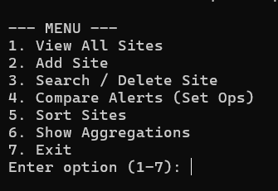

All Sites (using Comprehensions):
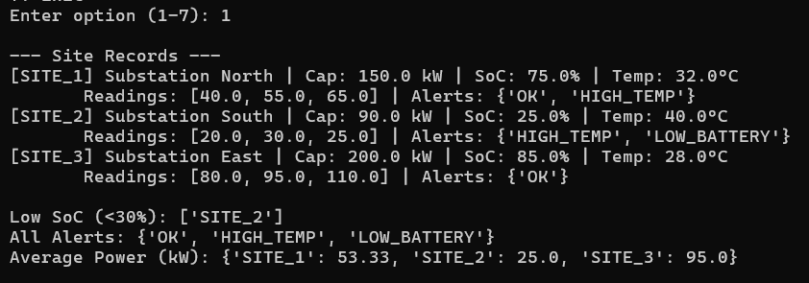

Add Site:
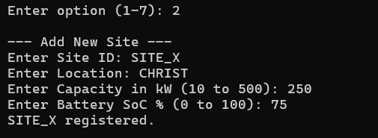

Search:
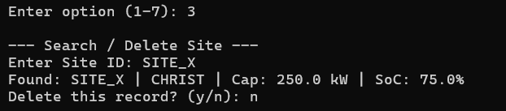

Search & Delete:
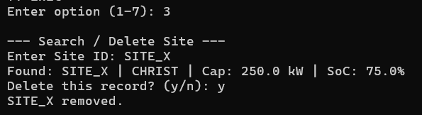

Compare Alert:
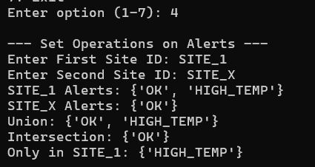

Sort:
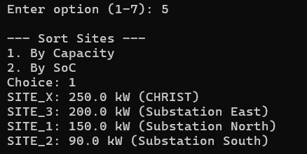

Aggregation:
