CHRIST (Deemed to be University)
Department of Computer Science
Master of Computer Applications

Course: MCA411-2 - PYTHON Programming
LAB Exercise II –
Demonstrate Custom modules with functions.
Date of assignment: 21-09-2026
Date of submission: 21-09-2026

Name : Aditya Kumar
Reg. No : 2647203
Class : 2 MCA – B

Domain : Clean Energy Systems & Grid Decarbonization

Lab 2
Lab Exercise II:

Demonstrate Custom modules with functions.

- Design a reusable domain-independent utility modules and demonstrate its integration into your application.

Code:

'''
# Reusable Domain-Independent Utility Modules
'''

# Prints a Title Banner in between '='
def print_title(msg):
print("\n" + "=" * 45)
print(msg)
print("=" * 45)

# Prints a simple line divider
def print_divider():
print("-" * 45)

# Checks if a string is non-empty
def check_empty(text):
return text.strip() != ""

# Formates the Float with 2 Decimal places
def format_decimal(val):
return f"{float(val):.2f}"

# Check if the string enter is a no or not
def check_num(val_str):
return val_str.strip().replace(".", "", 1).isdigit()

# Takes confirmation before Prociding
def confirm_action(prompt_text):
ans = input(f"{prompt_text} (y/n): ").strip().lower()
return ans == "y"

# Checks if the Value is in the reange or not
def check_range(val, min_val, max_val):
return min_val <= val <= max_val

Output:

print_title:
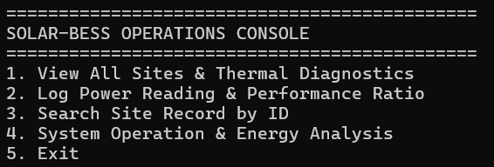

print_divider:
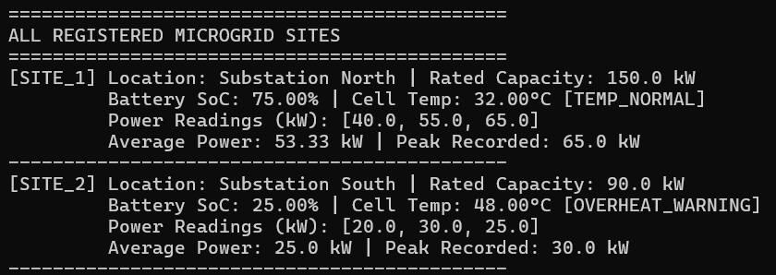

format_decimal:
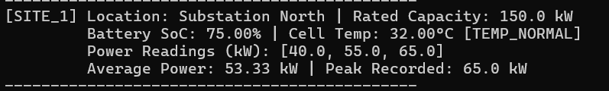

confirm_action:
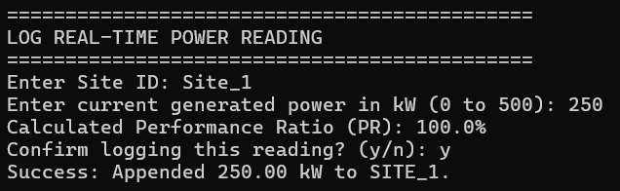

check_range:
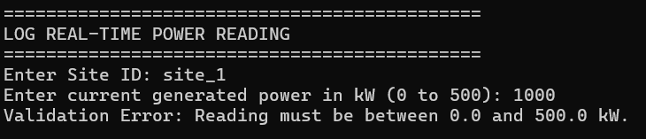

check_num:
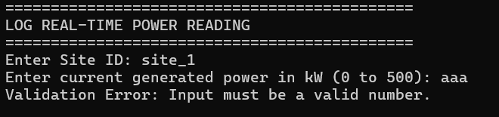

- Create a custom Python module containing at least five reusable functions relevant to your selected domain.

Code:

'''
# Reusable Domain-Based Modules
'''

# Add power reading to the History List
def add_reading(readings_list, new_kw):
readings_list.append(round(new_kw, 2))

# Calculate Average Readings for the Site
def cal_average(readings_list):
if len(readings_list) == 0:
return 0.0
return round(sum(readings_list) / len(readings_list), 2)

# Find Highest (peak) Reading
def get_peak(readings_list):
if len(readings_list) == 0:
return 0.0
return max(readings_list)

# Search site using ID
def search_site(sites_dict, site_id):
return sites_dict.get(site_id.strip().upper())

# Calculate net power surplus or deficit
def calculate_balance(solar_kw, load_kw):
net = solar_kw - load_kw
if net > 0:
status = "SURPLUS"
elif net < 0:
status = "DEFICIT"
else:
status = "BALANCED"
return round(net, 2), status

# Check if battery temperature is within safe limits
def check_thermal_status(temp_c, max_limit=45.0):
if temp_c > max_limit:
return False, "OVERHEAT_WARNING"
return True, "TEMP_NORMAL"

# Calculate solar performance ratio (PR)
def cal_pr(actual_kw, rated_capacity_kw):
# Computes system efficiency ratio: (Actual Power / Rated Capacity) * 100.
if rated_capacity_kw <= 0:
return 0.0
pr = (actual_kw / rated_capacity_kw) * 100
if pr > 100.0:
pr = 100.0
return round(pr, 2)

Output:

add_reading:
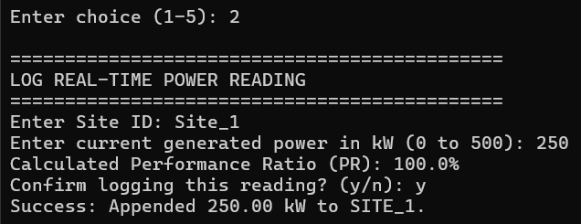

cal_average:
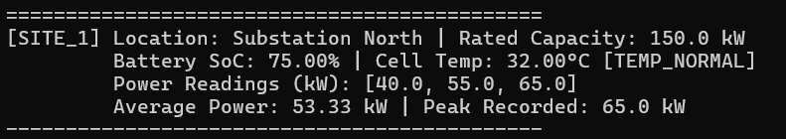

get_peak:
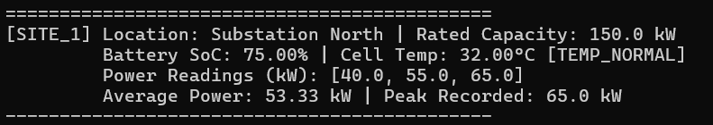

search_site:
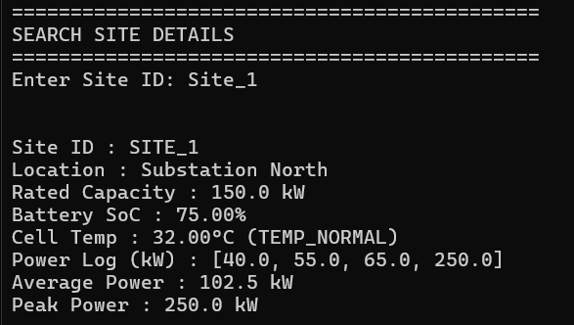

calculate_balance:
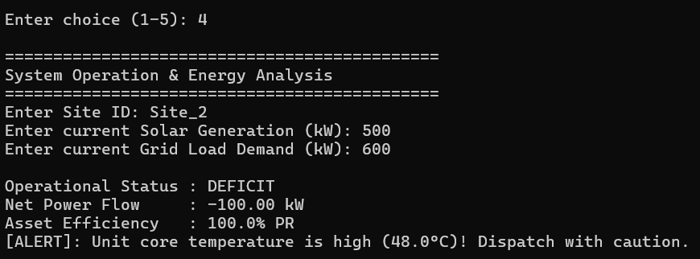

check_thermal_status:

cal_pr:

Main Python File Code:

import Module_2647203_P2 as mod

# Operational Dataset
sites = {
"SITE_1": {
"location": "Substation North",
"capacity_kw": 150.0,
"soc": 75.0,
"temp": 32.0,
"readings": [40.0, 55.0, 65.0]
},
"SITE_2": {
"location": "Substation South",
"capacity_kw": 90.0,
"soc": 25.0,
"temp": 48.0,
"readings": [20.0, 30.0, 25.0]
},
"SITE_3": {
"info": ("Substation East", 200.0),
"location": "Substation East",
"capacity_kw": 200.0,
"soc": 85.0,
"temp": 28.0,
"readings": [80.0, 95.0, 110.0]
}
}

# Print All the Added Sites
def view_all_sites():
mod.print_title("ALL REGISTERED MICROGRID SITES")
for s_id, d in sites.items():
avg_kw = mod.cal_average(d["readings"])
peak_kw = mod.get_peak(d["readings"])
is_safe, thermal_status = mod.check_thermal_status(d["temp"])

print(f"[{s_id}] Location: {d['location']} | Rated Capacity: {d['capacity_kw']} kW")
print(f"\t Battery SoC: {mod.format_decimal(d['soc'])}% | Cell Temp: {mod.format_decimal(d['temp'])}°C [{thermal_status}]")
print(f"\t Power Readings (kW): {d['readings']}")
print(f"\t Average Power: {avg_kw} kW | Peak Recorded: {peak_kw} kW")
mod.print_divider()

# Add new reading for a Site
def add_power_reading():
mod.print_title("LOG REAL-TIME POWER READING")
s_id = input("Enter Site ID: ").strip().upper()
site = mod.search_site(sites, s_id)

if not site:
print("Error: Site ID does not exist.")
return

val_str = input("Enter current generated power in kW (0 to 500): ").strip()

# Using module validation utilities
if not mod.check_num(val_str):
print("Validation Error: Input must be a valid number.")
return

val = float(val_str)
if not mod.check_range(val, 0.0, 500.0):
print("Validation Error: Reading must be between 0.0 and 500.0 kW.")
return

# Check performance ratio before saving
pr = mod.cal_pr(val, site["capacity_kw"])
print(f"Calculated Performance Ratio (PR): {pr}%")

if mod.confirm_action("Confirm logging this reading?"):
mod.add_reading(site["readings"], val)
print(f"Success: Appended {mod.format_decimal(val)} kW to {s_id}.")
else:
print("Action cancelled.")

# Searching a Site
def search_site_record():
mod.print_title("SEARCH SITE DETAILS")
s_id = input("Enter Site ID: ").strip().upper()
site = mod.search_site(sites, s_id)

if site:
avg_kw = mod.cal_average(site["readings"])
peak_kw = mod.get_peak(site["readings"])
is_safe, thermal_status = mod.check_thermal_status(site["temp"])

print("\n")
print(f"Site ID : {s_id}")
print(f"Location : {site['location']}")
print(f"Rated Capacity : {site['capacity_kw']} kW")
print(f"Battery SoC : {mod.format_decimal(site['soc'])}%")
print(f"Cell Temp : {mod.format_decimal(site['temp'])}°C ({thermal_status})")
print(f"Power Log (kW) : {site['readings']}")
print(f"Average Power : {avg_kw} kW")
print(f"Peak Power : {peak_kw} kW")
else:
print("Error: Site record not found.")

def simulate_dispatch():
mod.print_title("System Operation & Energy Analysis")
s_id = input("Enter Site ID: ").strip().upper()
site = mod.search_site(sites, s_id)

if not site:
print("Error: Site record not found.")
return

sol_str = input("Enter current Solar Generation (kW): ").strip()
load_str = input("Enter current Grid Load Demand (kW): ").strip()

if not (mod.check_num(sol_str) and mod.check_num(load_str)):
print("Validation Error: Both solar and load inputs must be numbers.")
return

sol = float(sol_str)
load = float(load_str)

# Calculate net balance using module function
net, status = mod.calculate_balance(sol, load)
pr = mod.cal_pr(sol, site["capacity_kw"])

print(f"\nOperational Status : {status}")
print(f"Net Power Flow : {mod.format_decimal(net)} kW")
print(f"Asset Efficiency : {pr}% PR")

# Warn if battery cell temperature is high
is_safe, thermal_status = mod.check_thermal_status(site["temp"])
if not is_safe:
print(f"[ALERT]: Unit core temperature is high ({site['temp']}°C)! Dispatch with caution.")

while True:
mod.print_title("SOLAR-BESS OPERATIONS CONSOLE")
print("1. View All Sites & Thermal Diagnostics")
print("2. Log Power Reading & Performance Ratio")
print("3. Search Site Record by ID")
print("4. System Operation & Energy Analysis")
print("5. Exit")

choice = input("\nEnter choice (1-5): ").strip()

if choice == "1":
view_all_sites()
elif choice == "2":
add_power_reading()
elif choice == "3":
search_site_record()
elif choice == "4":
simulate_dispatch()
elif choice == "5":
print("Terminating console application.")
break
else:
print("Invalid selection. Please choose 1 to 5.")

Output:

Main Menu:
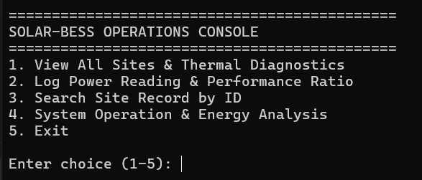

List all site:
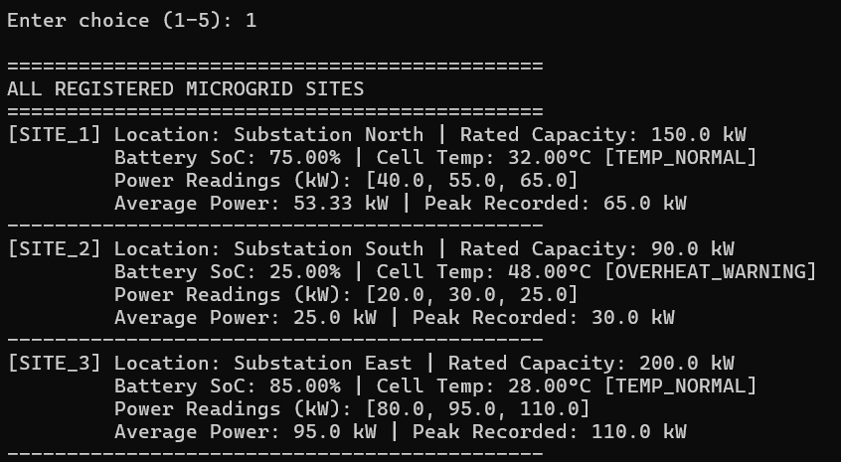

Log Reading and Performance Ratio:
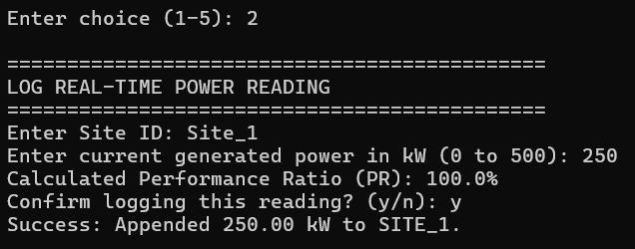

Search:
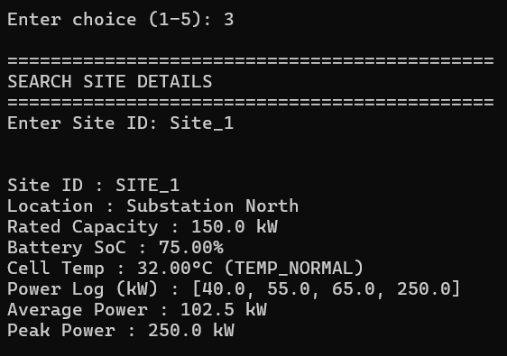

System Operation & Energy Analysis:

