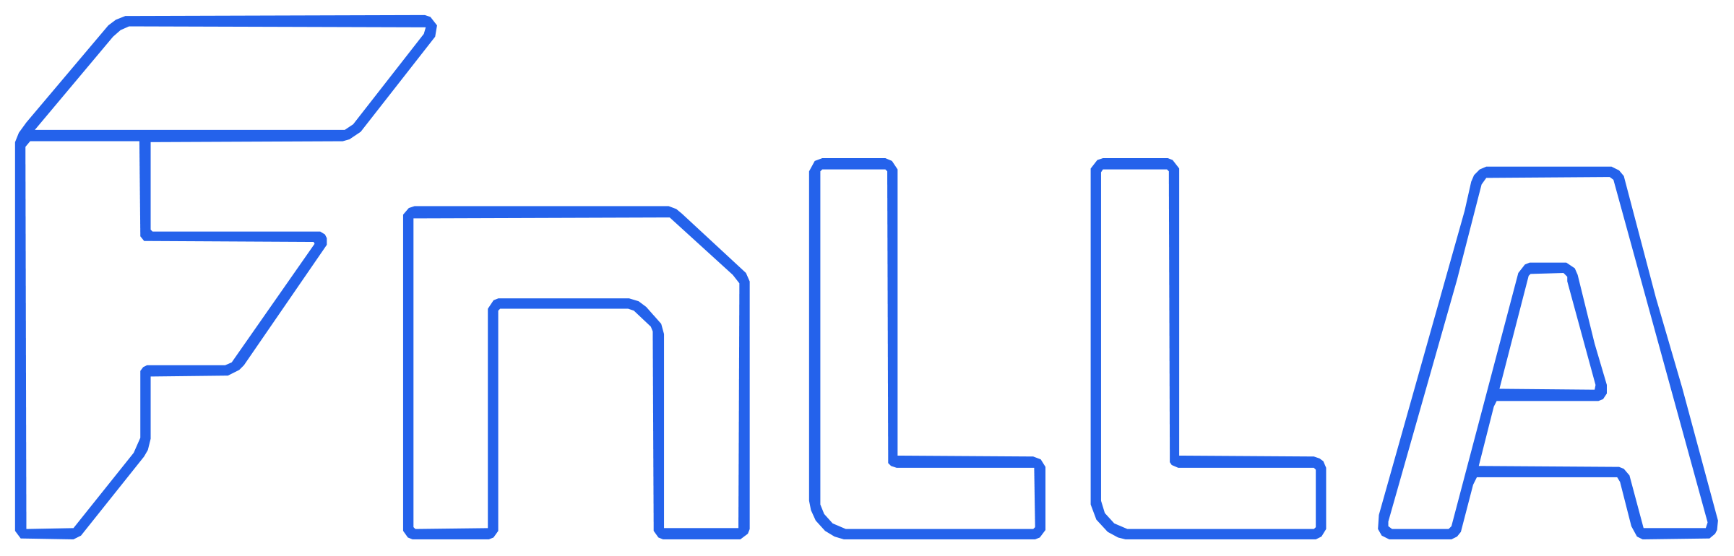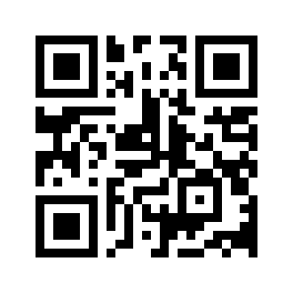  Marcin Kordyaczny  Lead Developer / Product Manager  hello@techayo.co.uk  fnlla.com / techayo.co.uk  Created & maintained by TechAyo |  |   Marcin Kordyaczny  Lead Developer / Product Manager  hello@techayo.co.uk  fnlla.com / techayo.co.uk  Created & maintained by TechAyo
  Marcin Kordyaczny  Lead Developer / Product Manager  hello@techayo.co.uk  fnlla.com / techayo.co.uk  Created & maintained by TechAyo |  |   Marcin Kordyaczny  Lead Developer / Product Manager  hello@techayo.co.uk  fnlla.com / techayo.co.uk  Created & maintained by TechAyo
  Marcin Kordyaczny  Lead Developer / Product Manager  hello@techayo.co.uk  fnlla.com / techayo.co.uk  Created & maintained by TechAyo |  |   Marcin Kordyaczny  Lead Developer / Product Manager  hello@techayo.co.uk  fnlla.com / techayo.co.uk  Created & maintained by TechAyo
  Marcin Kordyaczny  Lead Developer / Product Manager  hello@techayo.co.uk  fnlla.com / techayo.co.uk  Created & maintained by TechAyo |  |   Marcin Kordyaczny  Lead Developer / Product Manager  hello@techayo.co.uk  fnlla.com / techayo.co.uk  Created & maintained by TechAyo

