**Magnetic stripe emulation**

*Satyendra Emani – 2nd year Computer Engineering Technology*

**Motivation:**

One thing I always wished that was present on more phones was the presence of an MST (Magnetic Secure Transmission) module. However, due to the technology being patented by Samsung, such a module is not legally available for sale. With the desire to have this technology, I decided to create my own standalone MST device using concepts I learned from Microcontroller Systems.

**Project Description:**

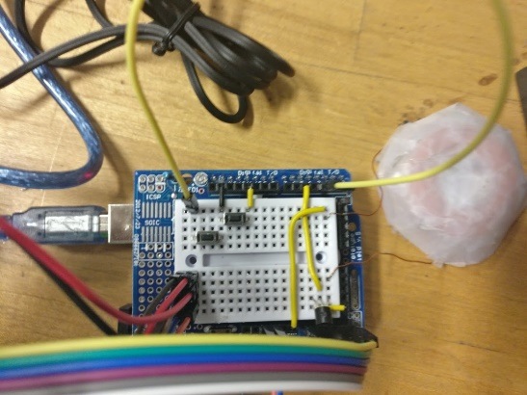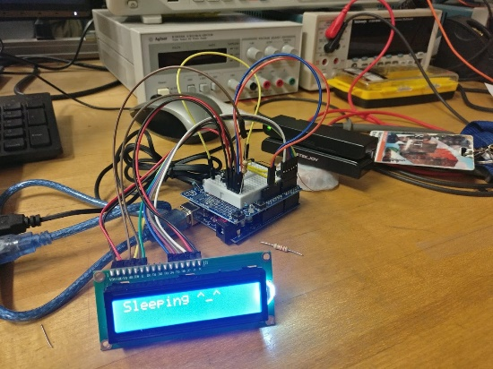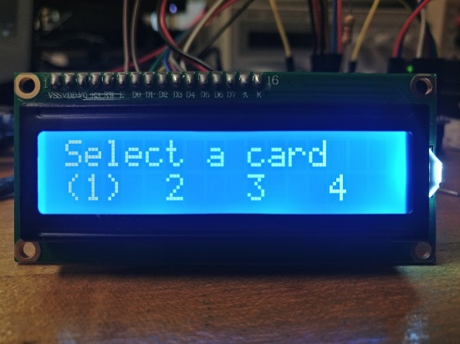The device uses a coil of magnet wire to transmit the electromagnetic signals to the card reader, with a 2N3904 transistor to pulse the coil on and off. The user can program in up to 4 cards through the Serial interface and can select which card to transmit using the LCD and push-buttons. Cards are stored on the microcontroller’s EEPROM, eliminating the need for any external storage. While the device is idling, the microcontroller goes into a low power mode.

**Testing:**

I tested the device using my own card reader and card readers around campus. The coil has a range of about 1.5-2 inches from the read head of the card reader. Access card readers (such as those for doors and elevators) are a little harder to transmit to reliably due to the location of the read head.

**Challenges:**

The hardest part about this project was storing and retrieving the cards from EEPROM. To do this I first needed to create a memory map and figure out how much memory to allocate to each card to prevent corruption. In the end, I allocated 256 bytes for each card, since the maximum size for each card is 232 characters according to the ISO-7813.

**Meaning:**

After building this project, I believe that there is a practical use to this technology. With the rise in demand for contactless and mobile payment technology, storeowners need to install new point-of-sale (POS) systems to process these types of transactions. However, MST devices already work with any POS terminal. If this were to be implemented with a virtual credit card system to transmit a unique, one-time use card number for each transaction, devices like credit card skimmers could not be used against such a system.

**Potential Improvements:**

More cards could possibly be stored on the EEPROM if they were encoded first, since the reduced character set for each track means that the characters, when encoded into binary for each track, takes up less length than if it was still in the alphanumeric format. Power consumption could be reduced by turning off the LCD backlight during sleep, or by utilizing another microcontroller, such as the ATtiny85. The read distance and reliability could also be improved by using an H-bridge to drive the coil. Other designs I found also used PCB inductors (An inductor made from PCB traces), which will also increase portability.