The Challenge

- 1. Find out the number of days between two datetime parameters.
- 2. Find out the number of weekdays between two datetime parameters.
- 3. Find out the number of complete weeks between two datetime parameters.
- 4. Accept a third parameter to convert the result of (1, 2 or 3) into one of seconds, minutes, hours, years.
- 5. Allow the specification of a timezone for comparison of input parameters from different timezones.
Project Index
Challenge details | Page 1
Configuration and technologies used | Page 1
File and directory structure and sample helper class usage | Page 2
Steps to run the project | Page 3
Test Cases | Page 5-8
Browsers used to test | Page 9

This competition has been developed in Laravel Framework, below are the configuration and steps to execute the project.
Configuration and Technologies used
Apache | 2.4.29 (Win32) OpenSSL/1.0.2l PHP/7.1.11
Laravel | 5.5.33
PHP | 7.1.11
MySQL | 5.5
Bootstrap | 3.3.5
JQuery | 3.3.1

Developed in Windows 8.1 Operating System.

Directory and File Structure
Below is the laravel and projects file structure:
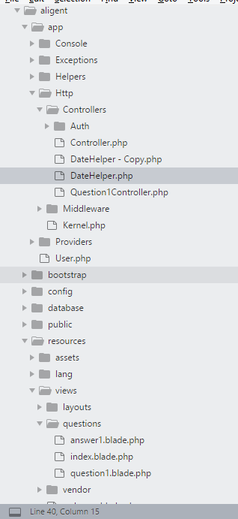 | The projects main controllers are:  Location: aligent/app/Http/Controllers  1. DateHelper.php  Helper class with date functions  2. Question1Controller.php  Main controller to the landing and questions page. This controller calls the helper class for the functionality.  The projects main views are :  Location: aligent/resources/views/questions  1. index.blade.php - laravel's default landing page  2. question1.blade.php - project's landing page  3. answer1.blade.php - project's form page to accept parameters and return results.
Below are the steps to call the DateHelper class and use it's functions:
Given date range - start:$start_dateM and end date:$end_dateM.
1. Create object of the datehelper - with functions
DateHelper: app/Http/Controllers/DateHelper.php
$dFunc = new DateHelper();

2. Date helper function to calculate the days in a given range

$dFunc->getDaysFromDateRange($start_dateM,$end_dateM);

3. Date helper function to calculate the weekdays (excluding weekends) in a given range

$dFunc->getWeekDaysFromDateRange($start_dateM,$end_dateM);

4. Date helper function to calculate the complete weeks

$dFunc->getCompleteWeeksFromDateRange($start_dateM,$end_dateM,$detailed);

Steps to execute the project
Step 1: Assumed the webserver is running and it supports above the stated configuration and other required configurations to run a Laravel project.
Step 2: Create a folder "aligent" and Unzip the compressed project folder.
Say for example c:\xammp\htdocs\aligent
Step 3: If everything is fine then you should be able to access the project as show in the screen shot below by accessing the url:
http://localhost/aligent/public/questions
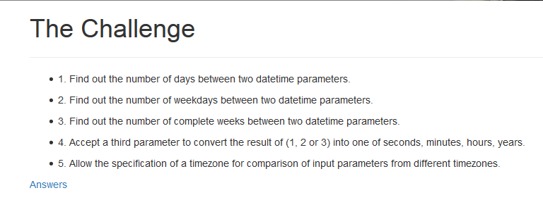
Step 4: Click the Answers link to input the parameters for the questions and see result - as shown in the screen shot below.
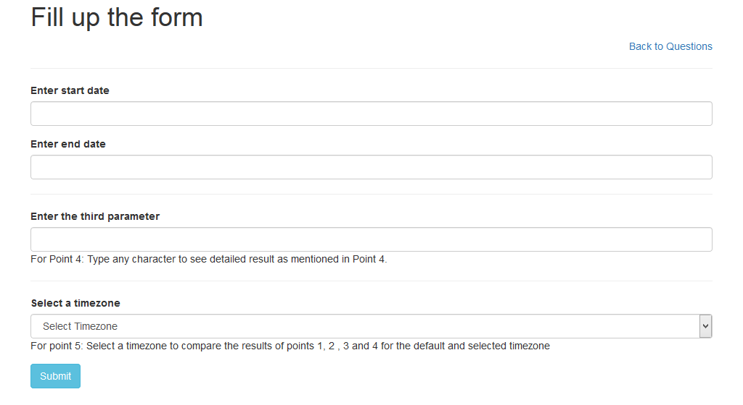

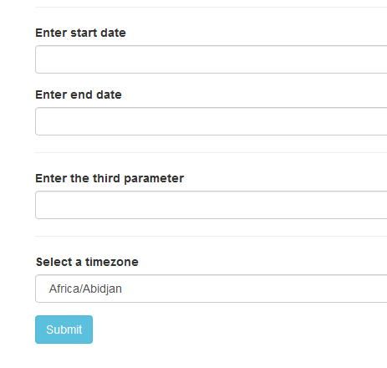 | Enter Start and End Date.  Start and End Date both are mandatory.
End Date should be greater than Start Date.
If Start and end date is selected and submitted then answer to the points 1,2 and 3 will be displayed.
The Third parameter determines whether to show a detailed result with year, months, days, hours, minutes and seconds.
You can type anything.
 | If Time zone is selected then answer to the points 1,2 and 3 will be displayed for the selected time zone as well.
If Time zone is selected there will be two results
1. Result with the default time zone
2. Result for the selected time zone.

Below is the screen shot of the input and out screen.

Input Screen | Output or result Screen
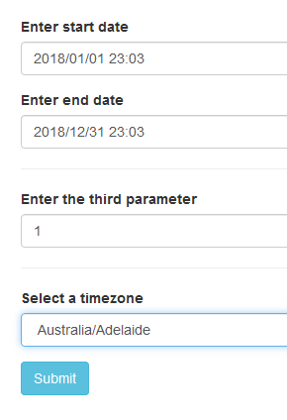 | 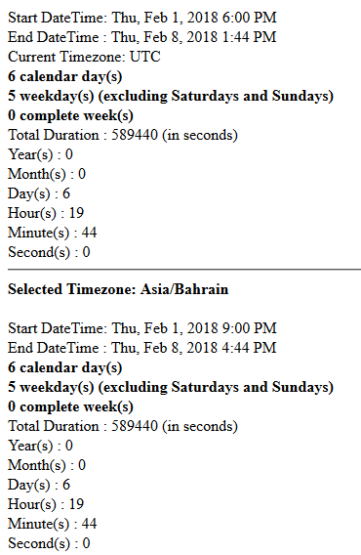

Test Cases
1. Days - test case
Start DateTime: Thu, Feb 1, 2018 6:00 PM
End DateTime : Sun, Feb 4, 2018 1:44 PM
Selected Timezone: Australia/Adelaide
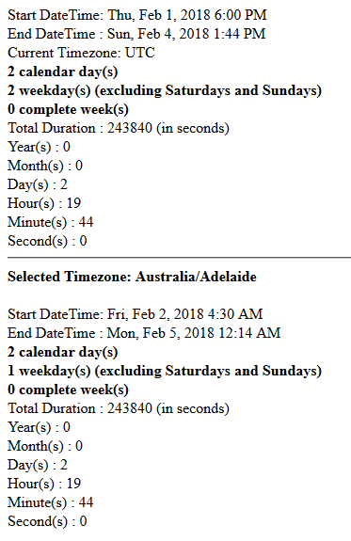
2. Week - test case
Start Date Time: Thu, Feb 1, 2018 6:00 PM
End Date Time : Thu, Feb 8, 2018 1:44 PM
Selected Timezone: Asia/Bahrain

3. Months - test case
Start DateTime: Thu, Feb 1, 2018 6:00 PM
End DateTime : Fri, Jul 20, 2018 1:44 PM
Selected Timezone: Australia/Adelaide
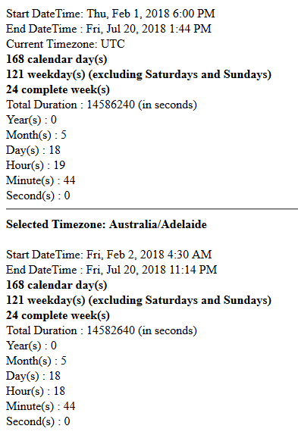

4. MidNight - test case
Start DateTime: Fri, Apr 6, 2018 11:00 PM
End DateTime : Sat, Apr 7, 2018 12:00 AM
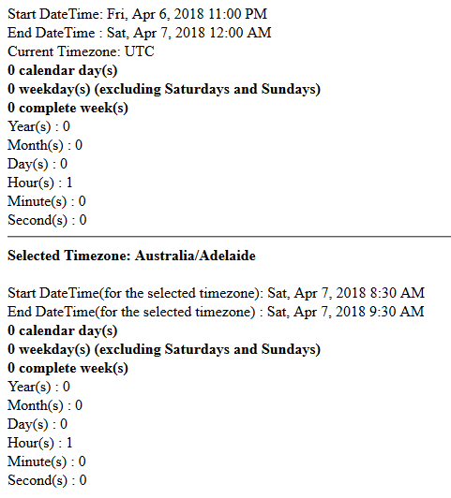
Issue: for UTC the weekday count was getting "1 day" while it was just 1 hour difference.
Issue Status: Fixed.
5. DST - Test case
Start DateTime: Mon, Jan 1, 2018 4:35 PM
End DateTime : Thu, Mar 22, 2018 4:34 PM
Selected Timezone: America/New_York
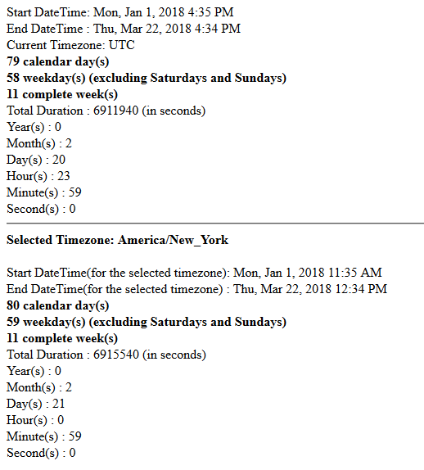
Selected Timezone: Australia/Adelaide
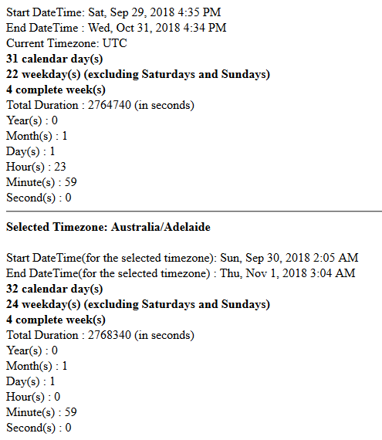

6. Yearly - test case
Start DateTime: Wed, Feb 1, 2017 1:00 PM
End DateTime : Sat, Oct 10, 2020 12:00 AM
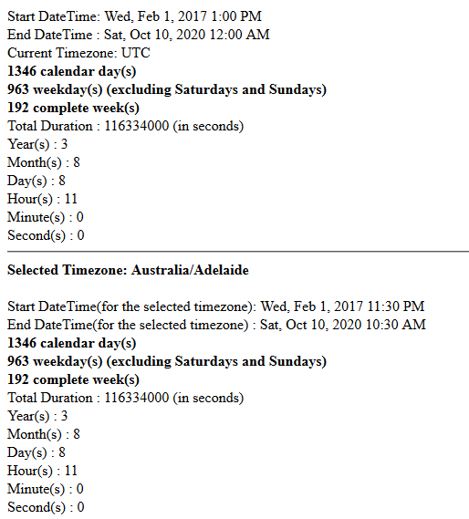

Browsers Tested
1. Chrome
2. Firefox

