Vtiger-Alfresco-Integration

Description:
Vtiger Alfresco Module can be used to do upload documents to alfresco .

Requisites:
1. VTiger 6.0
2. VTiger 6.1
3. VTiger 6.2

-------------

Installation on Vtiger 6.0.0

1. Login to VTiger CRM with admin credentials.
2. Go to CRM Settings
3. Under Studio click `Module Manager`
4. Click `Install from File` option
5. Select zip file Vtiger-Alfresco_Plugin.zip provided in the plugin folder.
6. Click Import and install module.
7. After installation open modules/Alfresco/Alfresco/config.php and set hostname parameter of
alfresco.

Installation on Vtiger 6.1.0
1. Login to VTiger CRM with admin credentials.
2. Go to CRM Settings
3. Under Studio click `Module Manager`
4. Click `Install from zip` option
5. Select zip file Vtiger-Alfresco_Plugin.zip provided in the plugin folder.
6. Click Import and install module.
7. After installation open modules/Alfresco/Alfresco/config.php and set hostname parameter of
alfresco.

Installation on Vtiger 6.2.0
1. Login to VTiger CRM with admin credentials.
2. Go to CRM Settings
3. Under Studio click `Module Manager`
4. Click `Install from zip` option
5. Select zip file Vtiger-Alfresco_Plugin.zip provided in the plugin folder.
6. Click Import and install module.
7. After installation open modules/Alfresco/Alfresco/config.php and set hostname parameter of
alfresco.

Usage:

Authorization:
First Go to Documents Section , click on Alfresco widget (from left side) then click on 'Authorise From Alfresco' as shown.

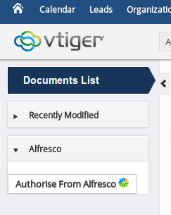

After that you will be presented login page

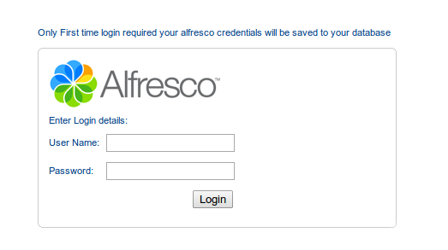

Login will be required only first time after that your credentials will be saved to your database.
After login you will be asked to create folder on alfresco home and all your uploaded documents from vtiger will be saved in this folder . Remember , you must have administrative right to create folder in alfresco home.

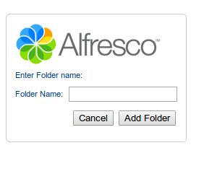

For Uploading:
First Go to Documents Section , click on Alfresco (from left side) then click on 'Upload To Alfresco' option

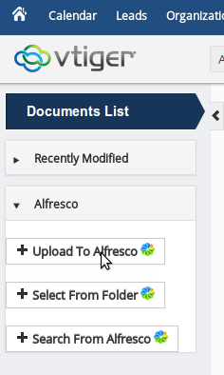

After click you will be taken to upload document page as shown.

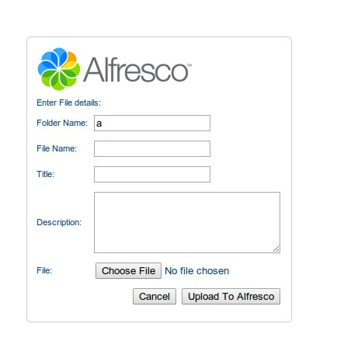

Now, you can upload document to alfresco . Uploaded document will be saved in created folder. After Uploading documents it will also be added to document section of vtiger , you can download the uploaded document from this section.You can access it from both, list and detail view of documents.

For View:
Click on 'select from folder ' (from left side) option and You can view all documents in alfresco folder (created from vtiger).

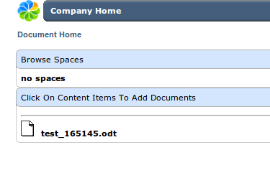

You can also add documents from here to vtiger just clicking on document link then you will be shown .

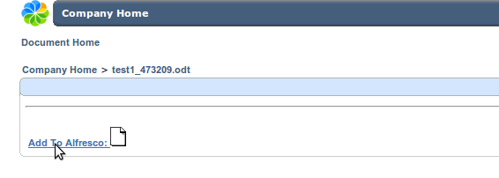

By clicking on 'Add To Alfresco' your document will be added to document section of vtiger.

For Search:
Click on 'search from alfresco ' (from left side) option,then you will be taken to page shown.

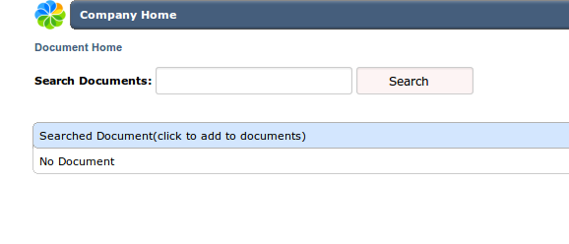

You can search documents on alfresco by name,just enter keyword for document name and click on search, then you will be presented list of documents matched by keyword document name.

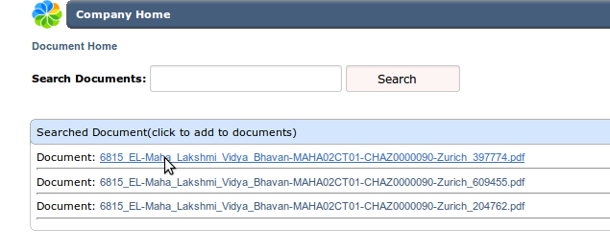

By clicking on document link you can add it to vtiger documents section and you can download this document from there.

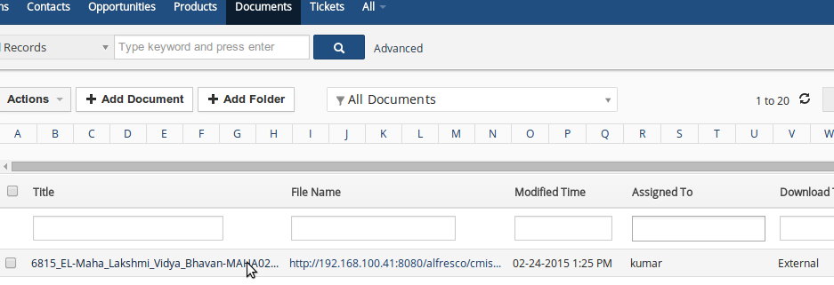

move folder from one space to other From Vtiger:

Click on 'select from folder ' (from left side) option and there you can see an option for moving folder .

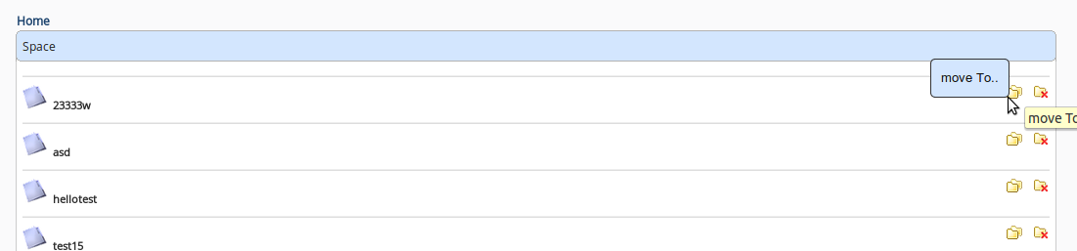

Just clicking on link will take you to shown page, from here you can move folder by clicking on 'paste here' link by choosing appropriate folder. Your folder will be moved.

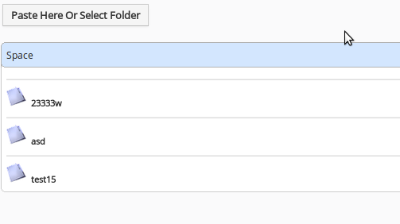

move document from one space to other From Vtiger:
Click on 'select from folder ' (from left side) option and there you can see an option for moving document .

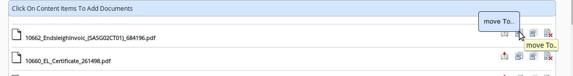
Next step works same as move folder.

copy document from one space to other From Vtiger:
Click on 'select from folder ' (from left side) option and there you can see an option for copy document .

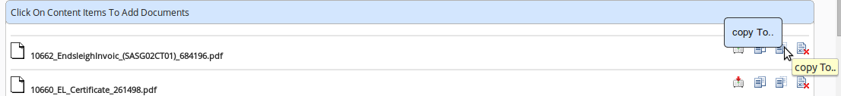
Next step works same as move folder.

download document :
Click on 'select from folder ' (from left side) option and there you can see an option for downloading document .

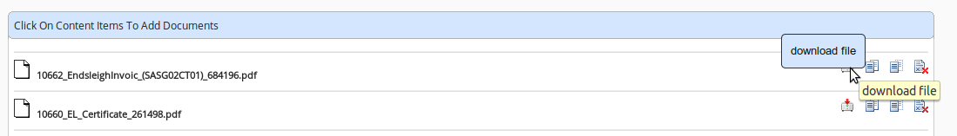

delete folder from space From Vtiger:
there is an option for deleting spaces as shown, just clicking on link will delete your respective space.

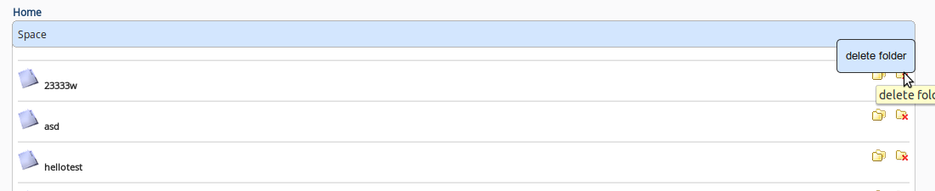

delete document from space From Vtiger:
there is an option for deleting document as shown, just clicking on link will delete your respective document.

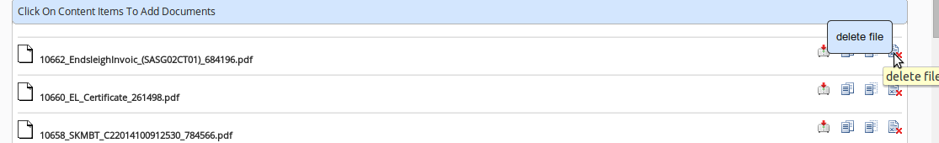

Upload document and add folder from current space From Vtiger:
Click on 'select from folder ' (from left side) option and there you can see option for uploading document and adding folder to current space .

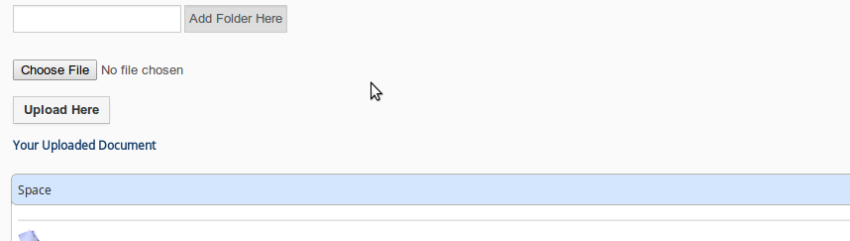

Script For copy documents to alfresco From Vtiger:
Run 'Your_Vtiger_HostName/index.php?module=Alfresco&view=uploadscript' from browser then you will be redirected to page shown.But you must have authorized from alfresco before running this script.

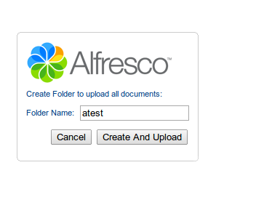

Click after entering folder name then it will create a folder on alfresco with specified name and all of your vtiger existing document will be copied from vtiger to alfresco in this folder ,it will take some time to upload (around 8 to 10 minutes for 1000 documents depending on your internet speed).

Created & Updated by:
Dheeraj Kumar
Date: 31/03/2015

