This Application is purely developed on 3-layered architecture in VS2019 using the following technologies Asp.Net MVC, jQuery, BootStrap, C#.Net, Entity Framework and Ms Sql Server.

## **Understanding the Architecture**

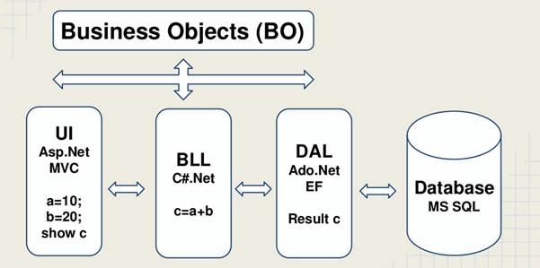

Data Access Layer

In the above architecture, our application’s back end is Microsoft SQL Server and to access the data from the database we are using ADO.NET Entity Framework and we call it as Data Access Layer (DAL).

### Business Logic Layer

Before I store data into the database or after reading data from the database, I need to perform some business logic on the data. For example, I want to store the salary of an employee and it is $25 per hour and say he is worked for 50hrs. So, his salary would be calculated as 25X50=1250$ which is called as business logic and this logical code will go to business logic layer and it will be developed using C#.NET programming language. So, here it is Business Logic Layer (BLL).

### UI

Now, how do I interact with the application? Yes, the interface from which I interact with the application is called as user interface of presentation logic layer where we see all the form controls like textboxes, buttons, grids, etc., and we are going to use ASP.NET MVC 5 to implement our Presentation Logic Layer (PLL).

### Business Object Layer

And finally, how do I pass the data from one layer to another layer? We need a container to store the data so that we can pass that container to other layers and that container is called as business object and they reside in Business Object Layer (BOL).