PTAI Assignment 3

Students : Praneeth Jakkaraju, Tudor Chiribes, Laura Gonzalez

Student Id’s : 19239985, 19240205, 19240029

List of Tasks attempted :

* 9565186b.json
* 28bf18c6.json
* ea786f4a.json

Github Link to Solution :

<https://github.com/techdem/ARC/tree/master/src>

Task Description :

**Task 9565186b.json :**

**Pattern:**

The pattern in this task is to identify the cells which are colored same in n*n grid and get all maximum cells colored with a particular color. Consider these cells in the input grid and color all the other cells with grey which makes our output.

**Solution – Solve Method**

Input is passed as python list of lists to the solve method. First step in solve method is to convert the input to numpy array. The coding part is made generic to work for any kind of input color code. To get all the color codes in input, numpy unique function is used which returns color code and count of cells which have that particular color. Then I map it to a dictionary using zip function, and get a dictionary of color code and count of cells which have that color. Then I get the max count which implies that the cells which have this color shouldn’t be altered and assign it to a variable. Then I loop through the input array and compare each element of array with the unaltered code to make these cells unaltered and alter all the other cells with value 5(grey). At the end the function returns the input array with altered cells.

This solution works for all the inputs and outputs given in input file.

**Python Libraries:**

As part of this solution, I have used numpy package. Which is also mentioned in requirements.txt as this package has to be installed before running the solution. Numpy is used to get the unique values from array, here we get unique colors in the grid with count of cells.

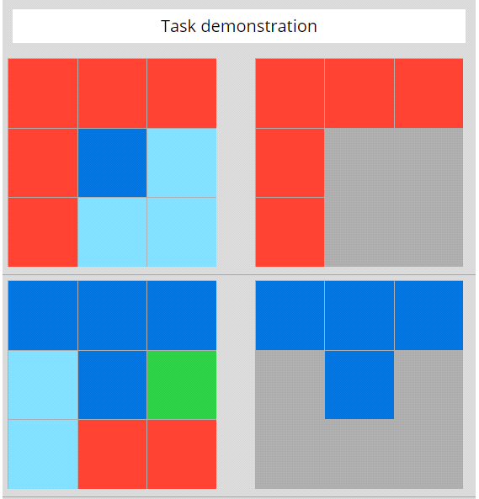

Task Description :

**Task ea786f4a.json:**

**Pattern:**

The pattern in this task is to identify the color in the center of the input grid and fill both of the diagonals with the same color and leave all of other cells as it is.

**Solution – Solve Method**

Input is passed as python list of lists to the solve method. First step in solve method is to convert the input to numpy array. From this array we get the color of the center cell in the diagonal. And then we fill the diagonals with the selected color using numpy diagonal method.

This solution works for all the inputs and outputs given in input file.

**Python Libraries:**

As part of this solution, numpy is used to fill the diagonals of the matrix with the selected color code.

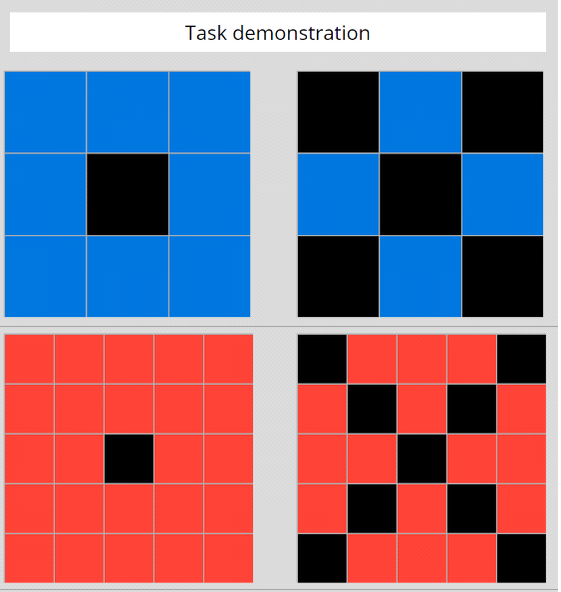

Task Description :

**Task 28bf18c6.json:**

**Pattern:**

The input is a grid of 8x8 from which a smaller grid of 3x3 contains non-negative values. The output is generated by combining two copies of the 3x3 array into a 3x6 one.

**Solution**

The solve method will receive a list of lists which can be represented as a 2D array with rows and columns. From this resulting 8x8 grid we can find the 3x3 grid with non-negative values by iterating over each possible 3x3 grid and calculating the one with the highest value. This is achieved by using a nested for loop with n squared complexity. At each individual element we are adding the values of the other eight ones that form the grid. If for a grid the total value is higher than the stored largest value, each row is duplicated and the result is stored. At the end, a 3x6 list of lists with the duplicated grid is returned.

