Documentation

**User Login**

1. User Login

* Login using password and userID

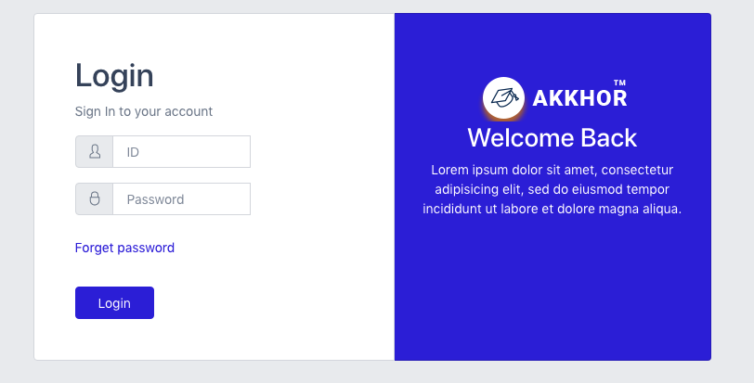

1. Forget Password

* Recover password by sending recover code to your email

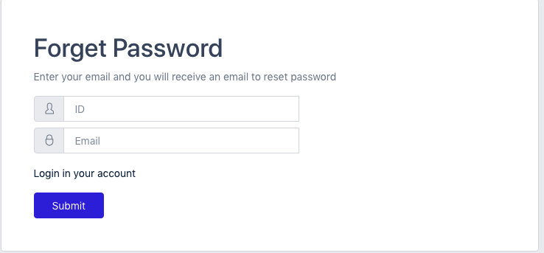

Reset Password

* Reset password using the recover password code from the email

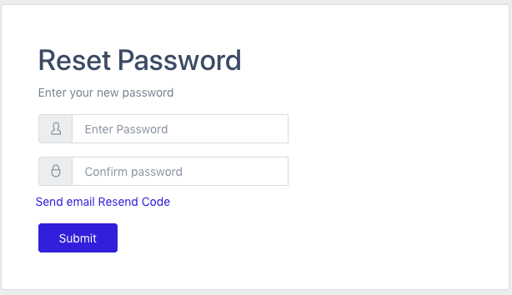

**System Functionalities:**

**Students**

1. New Registration.

* Using auto generated userID or generate your own

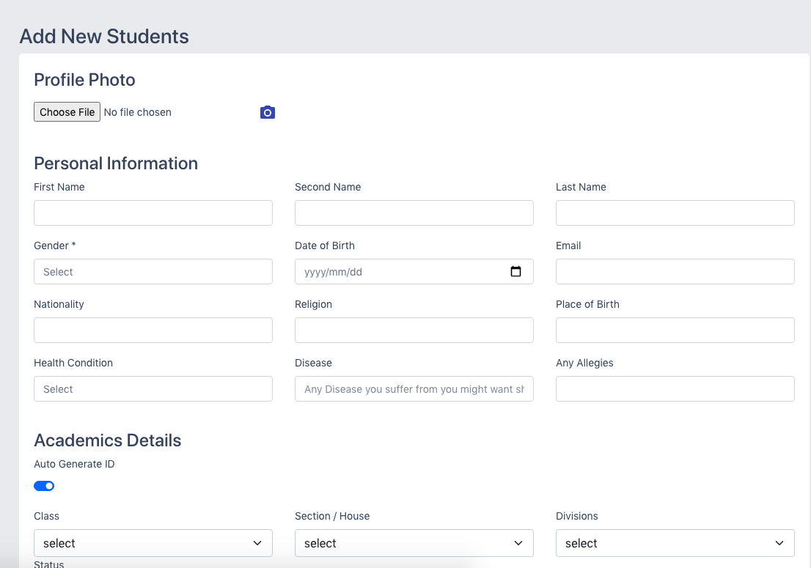

1. View Student Details

* View Student’s Details

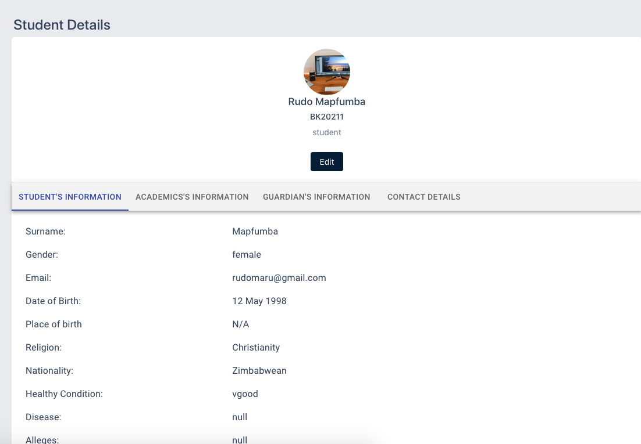

1. Edit Student

* Edit student’s details

1. Student List

* View all students in the database

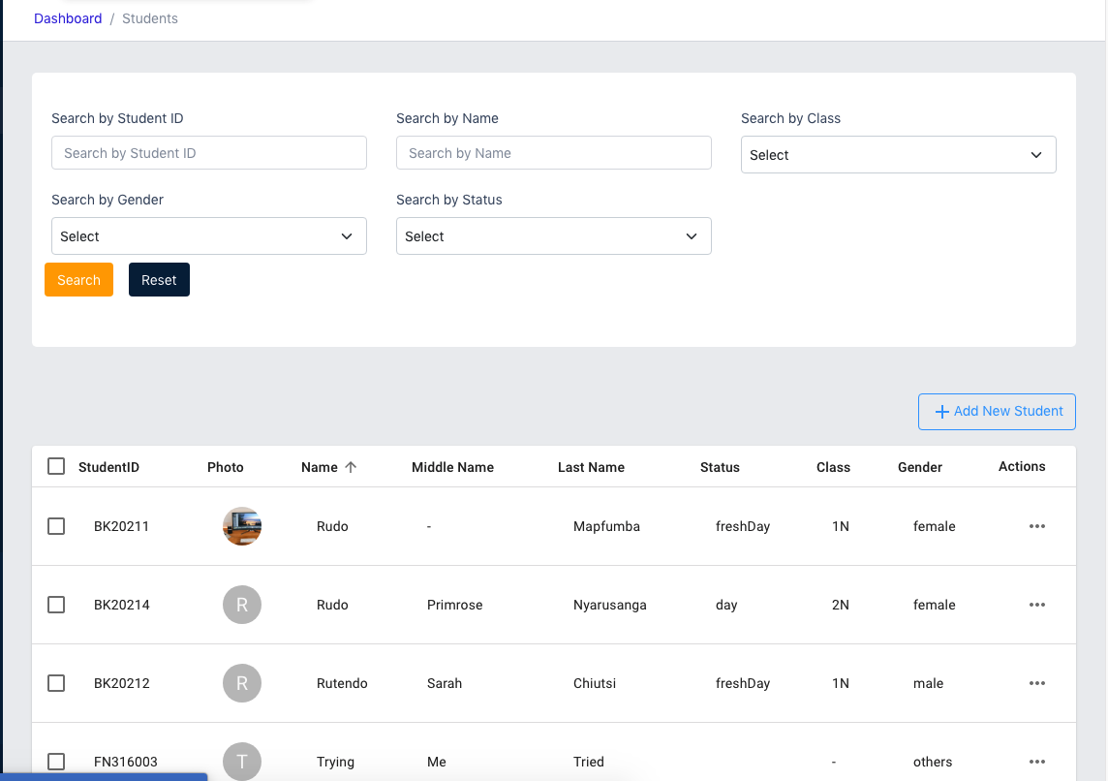

1. Manage Scholarship

* Add scholarship
* Delete scholarship
* Edit scholarship

1. Record Attendance

* Record Today’s Attendance
* View Past Attendance

1. Manage Section

* Add Section
* Delete Section
* Edit Section

1. Manage Campus

* Create Campus
* Edit Campus
* Delete Campus

1. Promotions

* Promoting students
* Move one student to another class
* Move whole class to another class
* Move students from one dormitory to another
* Move students from one campus to another

1. Prefects

* Add prefects
* Remove prefects
* edit prefects

1. View Past Students

* View past students

1. View Withdrawn Students

* View withdrawn students

1. Delete Student

* Delete single students
* Delete all students

1. Withdraw Student

* withdraw an existing students

1. Re-enroll withdrawn Student

* Unwithdrawn a student

**Academics**

1. Manage Divisions

* Add division
* Edit division
* Delete division

1. Manage Classes

* Create class
* Edit class
* Delete classes

1. Manage Subjects

* Create Subject
* Edit Subject
* Delete courses

1. Manage Calendar
2. Notes
3. SBA
4. Year Groups
5. Terminal Reports
6. Manage Letters / Correspondences

* Create Correspondence Letter
* View Correspondence letter
* Delete correspondence

**HR**

1. Manage Department
2. Add Staff
3. View Staff list
4. Edit Staff Details
5. Staff Payroll
6. PAYE Deductions
7. Staff Bank Details
8. PAYE Calculator
9. Delete/ Archive Staff

**Library**

1. Books Categories
2. Books

**Finance**

1. View Set Fees
2. Set/ Delete Fees
3. Prepare Bill
4. Bill Payment
5. Non-billable items payment
6. View Payments
7. Debtors Inventory module

**Admin Dashboard**

* Students

1. All Students – (list of all students in the database)
2. Registration – add new students
3. Campuses – Create, Edit or Delete Campus;
4. Dormitories – Create, Edit or Delete Campus;
5. Sections – Create, Edit or Delete Campus;
6. Upgrading – moving students from one class, dormitory or campus to another
7. Prefects – add, remove or edit prefects
8. Scholarships – add, remove or edit prefects

* Staff

1. All Staff (list of all staff, can view, edit or delete a single staff)
2. Add Staff (add new Staff)

* Academics

1. Classes. Create, Edit or Delete classes
2. Courses. Create, Edit or Delete courses
3. Divisions. Create, Edit or Delete divisions
4. School Calendar. Create, Edit or Delete events to the calendar
5. Notes. Create, Edit or Delete notes

* Attendance

1. Students attendance- List of past attendance data of all classes
2. Register Student’s attendance - Register attendance by class
3. Staff attendance. Register all staff attendance register
4. Register Staff’s attendance. Register all staff attendance

* Finance

1. Fees – Set school fees
2. Payrow – set staff payrow
3. Students Fees – transactions of fees payments
4. Payrow Payment – transactions of salary payments
5. Transactions – all transactions
6. Banking – bank details

* Canteens

1. All members – All canteen payments
2. All Members – all members
3. Add New Members – add new member to canteen
4. Make Payments – make payment
5. Payment Plans – canteen payment plan /

* Message

1. Inbox (incoming messages)
2. Message Staff
3. Message Guidance
4. Bulk Message

* Notifications – school notice boarded. view all Add or delete
* Settings- logout, change password

**Teachers Dashboard**

* Dashboard

1. View profile
2. Edit profile
3. Payrow

* Academics

1. Class. View class details and register students in the class attendance
2. Courses – view courses and add notes to course
3. School calendar – view school calendar events

* Attendance – view attendance records
* Canteen - canteen payments transactions, join
* Notifications - view school notice board
* Settings - change password and logout

**Student Dashboard**

* Dashboard

1. My profile. – view my profile info
2. Edit Profile – edit profile

* Academics

1. Class
2. Courses
3. Calendar – view school calendar events

* Attendance – view attendance history
* Finance

1. Fees – view fees payment transactions
2. Canteen – canteen payments transactions, join

* Messages

1. Inbox – inbox messages
2. Message admin. – send message to school admin
3. Message teacher – send message to staff member

* Notifications – view school notice board
* Settings – change password and logout

**Quick Start**

# . Client side - npm run start

#. Server side – npm run dev (dev mode) npm run start (production mode)

Libraries used in Client Side –

* React
* Redux
* Bootstap
* React- router-dom
* Material-Ui
* Axios
* React-hook-form
* React-toastify

Liabraries in Server Side

* Mongoose
* Node.js/ Express
* bcrypt
* dotenv
* multet
* nodemon

Live Video:

1. login - <https://vimeo.com/517487114>
2. dashboard intro - <https://vimeo.com/517579858>
3. add edit student - <https://vimeo.com/517586473>
4. student other functions - <https://vimeo.com/517589639>
5. create staff - <https://vimeo.com/517592635>
6. <https://vimeo.com/517597353>
7. Student dashboard - <https://vimeo.com/517810475>
8. Fees - <https://vimeo.com/517622533>
9. Attendance - <https://vimeo.com/517622067/a62f0edca3>

Notes and events - https://vimeo.com/517621291/3f3807fb24