**Assignment 1**: Draw your Home Network Topology and explain how you are accessing the RPS Lab environment.

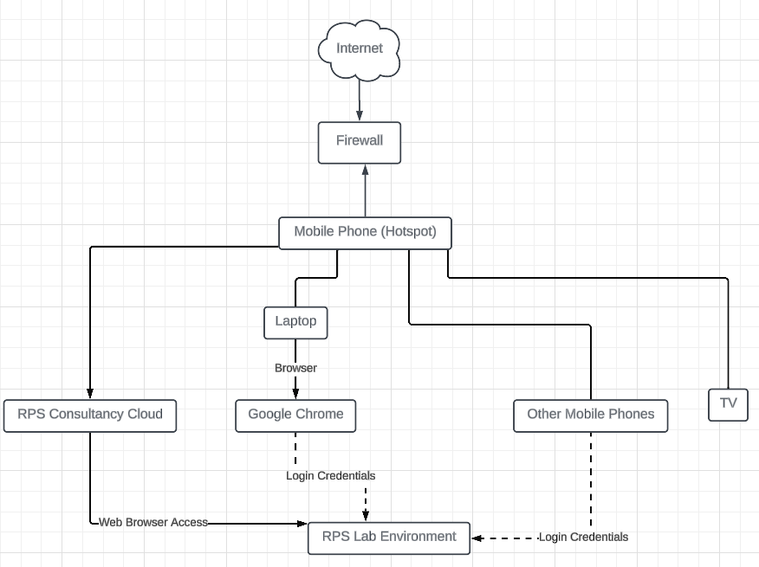

**Assignment 2**: Identify a real-world application for both parallel computing and networked systems. Explain how these technologies are used and why they are important in that context.

**Parallel Computing: Online Search Engines**

In the realm of online search engines like Google, chrome and Firefox, parallel computing is pivotal for delivering fast and accurate search results to users worldwide. Search engines utilize parallel processing techniques to index and search vast amounts of web pages, documents, and multimedia content efficiently.

Search engines use parallel computing to quickly read and organize information from billions of web pages. It's like having many people working together to sort through a massive library of books, finding the ones with the information you need.

When you type a query into a search engine, parallel computing helps it find relevant results across millions of web pages in just a fraction of a second. It's like searching through a giant database with many helpers, each looking for different pieces of information to give you the best results.

Once search results are found, parallel computing algorithms rank them based on relevance and popularity. It's like having a team of experts quickly decide which books are most important for you to read based on your question.

**Networked Systems: Online Retail**

Networked systems are integral to the operation of online retail platforms such as Amazon, flipkart, meesho. These platforms connect buyers and sellers worldwide, facilitating transactions, product discovery, and fulfillment processes.

In the context of online retail, networked systems encompass various components including web servers, databases, content delivery networks (CDNs), payment gateways, and logistics networks. These systems work together to ensure seamless shopping experiences for customers while efficiently managing inventory, orders, and shipments.

Networked systems enable real-time communication and data exchange between different components of the retail ecosystem, allowing for dynamic pricing, personalized recommendations, and inventory optimization. Additionally, robust network infrastructure ensures scalability and reliability, even during peak traffic periods such as holiday seasons or promotional events.