System Call to Concatenate String

➢ A system call (or sys call) is a mechanism used by programs to
request services from the operating system's kernel. These
services can include operations such as reading or writing to
files, creating or managing processes, interacting with devices,
and more.

➢ When a program executes a system call, it transitions from user
mode (where user applications run) to kernel mode (where the
operating system's kernel operates). This transition involves
switching the processor's execution mode, typically via a special
instruction (e.g., int 0x80 on x86 architecture). Once in
kernel mode, the kernel performs the requested operation on
behalf of the program. After completing the operation, control
returns to the user program.

➢ System calls provide an interface between user-level processes
and the operating system's kernel, allowing programs to access
privileged functionalities and interact with hardware resources
in a controlled and secure manner. They form the foundation of
how applications communicate and utilize the resources
provided by the operating system.

Flow diagram for System Call build:

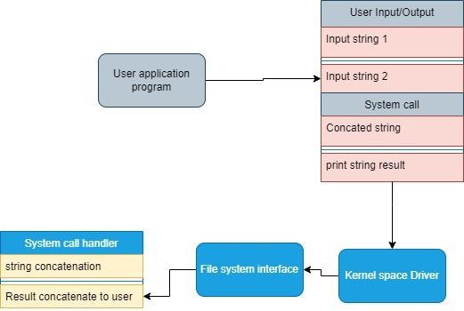

Here's a document outlining the steps involved in adding a customsystem call to the Linux kernel and testing it with a simple user-space program:

Step 1: Downloading and Extracting Linux Kernel Source
wget -P ~/Downloads/ http://cdn.kernel.org/pub/linux/kernel/v6.x/linux-
6.9.2.tar.xz
cd ~/Downloads
tar -xvf linux-6.9.2.tar.xz
cd linux-6.9.2

Step 2: Creating Directory for Custom System Call
mkdir System_call_string
cd System_call_string

Step 3: Creating Custom System Call Implementation
gedit system_string.c

#include <linux/unistd.h>
#include <linux/init.h>
// Define the system call with asmlinkage
asmlinkage long sys_concat_strings(const char __user *str1, const char __user *str2, char __user *result) {
char kernel_str1[500]; // Buffer to hold the first string from user space
char kernel_str2[500]; // Buffer to hold the second string from user space
char kernel_result[1000]; // Buffer to hold the concatenated result

// Check if any of the pointers are NULL
if (str1 == NULL || str2 == NULL || result == NULL) {
return -EINVAL; // Return an invalid argument error
}

// Copy the first string from user space to kernel space
if (copy_from_user(kernel_str1, str1,500 )) {
return -EFAULT; // Return a fault error if copy fails
}

// Copy the second string from user space to kernel space
if (copy_from_user(kernel_str2, str2, 500)) {
return -EFAULT;
}

// Concatenate the two strings and store in kernel_result
snprintf(kernel_result, 1000, "%s%s", kernel_str1, kernel_str2);

// Copy the concatenated result back to user space
if (copy_to_user(result, kernel_result, strlen(kernel_result) + 1)) {
return -EFAULT;
}

return 0;
}

Step 4: Modifying syscall Table
gedit arch/x86/entry/syscalls/syscall_64.tbl

Add :
222 common helloworld sys_helloworld

Step 5: Updating syscall Header File
gedit include/linux/syscalls.h

Add:
asmlinkage long sys_concat_strings(const char __user *str1, const char __user *str2, char __user *result)

Step 6: Creating Makefile for Custom System Call
gedit Makefile
Add :
obj-y += system_string/

Step 7: Compiling and Installing the Kernel
sudo make -j$(nproc)
sudo make modules_install install -j$(nproc)
sudo reboot

Step 8: Verifying the New System Call
vim user1.c
#include <stdio.h>
#include <unistd.h>
#include <sys/syscall.h>

#define SYSCALL_NUM 222 // Define the syscall number

int main() {
char str1[] = "Hello, ";
char str2[] = "world!";
char result[1000];

// Invoke the custom system call with the defined syscall number
int ret = syscall(SYSCALL_NUM, str1, str2, result);

// Check if the syscall was successful
if (ret == 0) {
// Print the concatenated string if successful
printf("Concatenated String: %s\n", result);
} else {
// Print the error return value if syscall failed
printf("Syscall failed with return value: %d\n", ret);
}

return 0;
}

}
Step 9: Compiling and Running the Test Program
make user1
./user1
dmesg | tail
Expected Output in dmesg: Hello World!

Block Diagram:

User-Space Program
--------------------
| |
| Input String 1 |
| | |
| Input String 2 |
| | |
| v |
| System Call |
| | |
| v |
| Concatenated |
| Result |
| | |
| v |
| Print |
| Result String |
| |
--------------------
|
v
Kernel-Space System Call
-------------------------
| |
| System Call Handler |
| | |
| String Concatenation |
| | |
| Return Concatenated |
| String to User |
-------------------------

These steps together outline the process of adding a custom system call to the
Linux kernel and testing it with a user-space program. Each step contributes to
different aspects of this process, including implementation, integration, and
verification

