Don’t forget

- After serialization data can’t modify if you need request data modification before in serializers and data are dictinory formate.
- In create user ,
- from django.contrib.auth.models import User
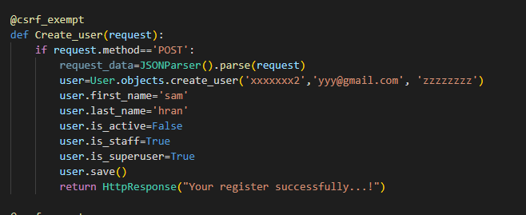

In user predefine user only accepts username , email ,password and others fields update methord filed this data are filed defalt table ‘auth_user’

