Tech Em Studios Digital Arts Summer Camp

Digital Design Activity:

Scavenger Hunt!

### **Objective**

It is your mission to hunt down these items in and around the Tech Em Studio. Use your iPads to take a picture of each item. In order to win, you must find all of the items and have the pictures on your iPad before time is called. If more than one person finds all the items, the instructors will judge the winner based on the quality of the photos and the collages.

### **Materials**

* iPads

### **Scavenger Hunt Items**

* 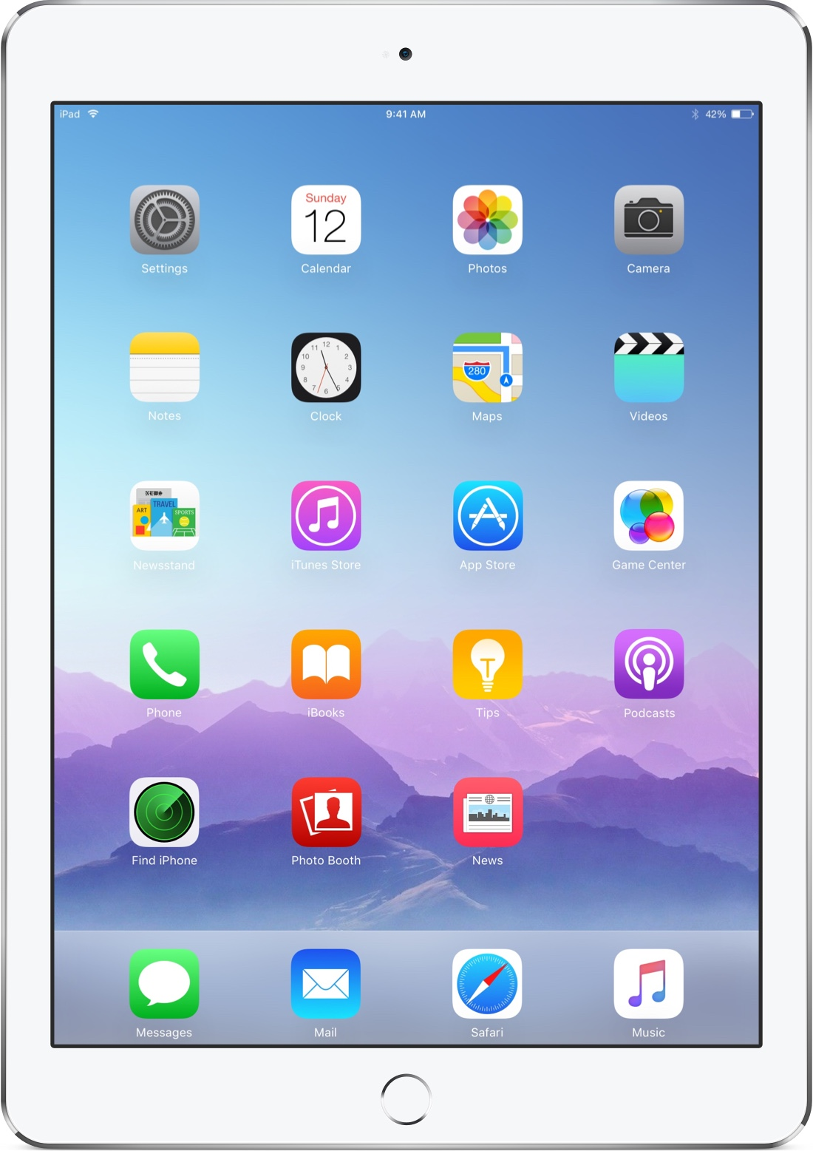A person (could be a whole person or someone’s hand/shoe etc.)
* Something in Nature (bird, plant, rock, bug, etc.)
* Food item
* Hardware (keyboard, mouse, monitor, iPad, tv, etc.)
* Colorful car
* Umbrella
* Tech Em Sign
* 3D print
* Water bottle
* Book

### **Rules**

* You must have an instructor with you if you go outside of the studio.
* Each person must work on their own.
* You must make two collages that combine pictures under the same category. For example, a collage of hardware or a collage of nature items.

### **Guidelines for Taking a Good Picture**

* Use Gridlines (a "tic-tac-toe" grid)
  + Position the camera so your subject appears where two of the lines meet or somewhere close to it.
* Pay attention to horizontal and vertical lines
  + keep horizons level and verticals straight