GraphQL:
GraphQL is a query language and runtime for APIs (Application Programming Interfaces) that was developed by Facebook. It provides a more efficient, powerful, and flexible alternative to traditional REST APIs. GraphQL enables clients to request only the data they need and nothing more, allowing for more efficient and tailored data fetching.

Key features and concepts of GraphQL include:
- Declarative Data Fetching:
Clients can specify exactly what data they need, and the server responds with only that data. This helps to minimize over-fetching.

- Single Endpoint:
Unlike REST, which often requires multiple endpoints for different resources, GraphQL typically exposes a single endpoint for all interactions. This simplifies the API surface and makes it easier for clients to request the data they need.

- Strongly Typed Schema
GraphQL APIs are defined by a schema, which specifies the types of data that can be queried and the relationships between them. The schema serves as a contract between the client and the server, providing a clear understanding of the available data and operations.

- Batched Queries and Mutations:
Clients can send multiple queries or mutations in a single request to the server, reducing the number of network requests and improving efficiency.

Apollo client:
Apollo Client is a powerful JavaScript library that provides a set of tools for consuming GraphQL APIs in client-side applications. It is often used with React, but it can be integrated with other frontend frameworks or used in vanilla JavaScript applications. Apollo Client simplifies data management, state management, and the interaction with GraphQL APIs.

Key features and concepts of Apollo Client include:
- Declarative Data Fetching:
Apollo Client enables developers to use a declarative approach to data fetching. Queries are written in GraphQL syntax, and components can specify the data they need. Apollo Client takes care of fetching the data, managing the local cache, and updating the UI.
- Local State Management::
Apollo Client can manage both remote data from a GraphQL server and local state within the client application. This allows developers to consolidate the management of global application state, whether it comes from the server or is maintained locally.

- Caching and Normalization:
Apollo Client includes a powerful caching system that stores fetched data in a normalized form. This enables efficient updates and minimizes redundant network requests. The cache can be configured to meet specific application requirements.
- Queries and Mutations:
Apollo Client supports both queries (for fetching data) and mutations (for modifying data on the server). These operations are written in GraphQL syntax and can be easily integrated into React components or other client-side frameworks.

Settup of Graphql
version:
graphql:16.6.0 && @apollo-client:3.7.14 && apollo-upload-client:17.0.0

index.js
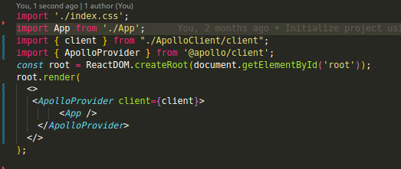
d
apolloClient.js
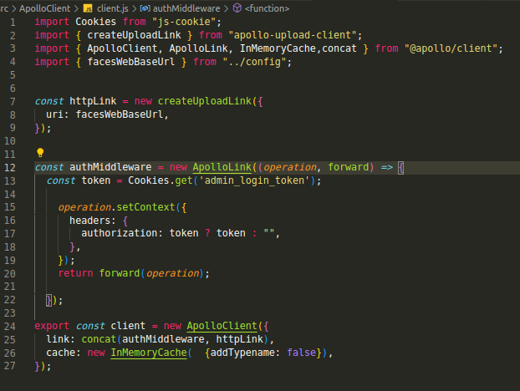
.
query.js
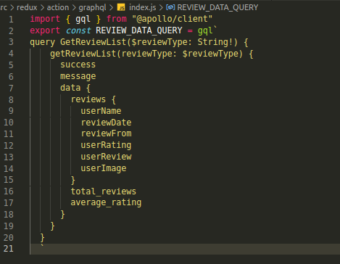
.

index.js
for query api call
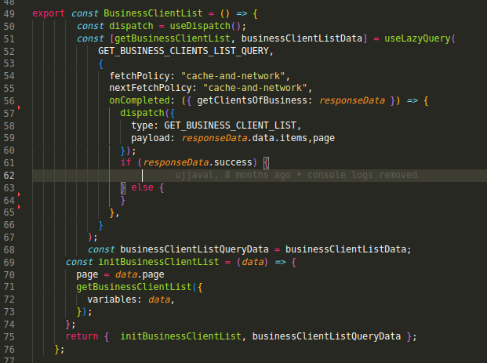

for mutation api call
