Redux:
Redux is an open-source JavaScript library for managing the state of an application.
We can use In react js for managing state.
- State:
The state of an application is represented by a single JavaScript object. This state object describes the entire state of the application.

- Actions:
Actions are plain JavaScript objects that represent events or user intentions. They contain a type property that describes the type of action being performed. Additional data related to the action can be included in the object.

- Reducers:
Reducers are pure functions that specify how the state changes in response to an action. They take the current state and an action as arguments and return a new state. Reducers must be pure functions, meaning they produce the same output for a given input and do not have side effects.

- Store:
The store is the central hub that holds the state of the application. It is created by passing a reducer function to the createStore function provided by Redux. The store has methods to dispatch actions, retrieve the current state, and subscribe to changes.

- Dispatch:
Actions are dispatched to the store using the dispatch method. This triggers the state change in the application. Reducers are then called to process the action and update the state accordingly.

Set up of redux:
redux version:4.2.1
react-redux version:8.0.5

index.js
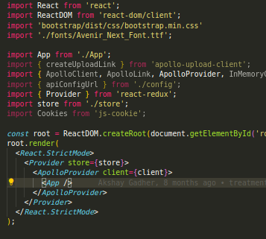

store.js
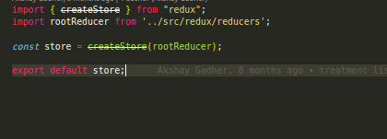
rootReducer.js
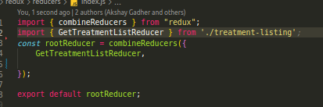

reducer
