## horizontal line



AI-FASHION ASSIST - MYNTRA

24.07.2024

**─**

Vinodh Nagarajaiah

# Description

Create a generative search system capable of searching a plethora of product descriptions to find and recommend appropriate choices against a user query. You may use this Myntra dataset on Kaggle to build such a system.

On modern e-commerce platforms like Myntra, users are often presented with an overwhelming number of product descriptions, making it difficult to efficiently locate relevant items. Typically, users have specific queries or requirements, such as seeking products with particular features, styles, or brands. The main challenge lies in creating a search system that can comprehend natural language queries, sift through extensive product descriptions, and deliver precise and relevant product recommendations.

# Goals

1. **Develop a Sophisticated Search System**: Create a search engine that understands and accurately interprets natural language queries, delivering relevant and precise product recommendations.
2. **Ensure User Experience**: Design a system that queries data while providing a fast, intuitive, and personalized search experience.

**Key Challenges:**

1. **Natural Language Understanding:** The system must accurately comprehend and interpret user queries expressed in natural language.
2. **Data Integration:** The system needs to integrate various data sources and manage comprehensive product descriptions.
3. **Relevance and Accuracy:** The system must produce search results that are both relevant to the user’s query and precise.
4. **Scalability:** The system should handle an increasing number of products and queries without a drop in performance.
5. **User Experience:** Ensuring that the search interface is intuitive and user-friendly, facilitating an easy and efficient search process.
6. **Real-Time Processing:** The system should provide fast and real-time search results, enhancing user satisfaction and engagement.
7. **Personalization:** The system must incorporate user preferences and behavior to provide personalized search results and recommendations.
8. **Multilingual Support:** The system should support multiple languages to cater to a diverse user base.
9. **Security and Privacy:** Ensuring that user data is protected and privacy is maintained throughout the search process.
10. **Adaptability:** The system must adapt to changing trends, new products, and user behavior over time to maintain its effectiveness.

# Technical Specifications

1. **Libraries and Tools**:
   * **Data Processing**: numpy, pandas
   * **Visualization**: matplotlib, seaborn
   * **NLP and AI**: openai, sentence_transformers, langchain
   * **Data Management**: chromadb, FAISS, Chroma
   * **Web Interface**: gradio
   * **HTML and Parsing**: BeautifulSoup, html
   * **Miscellaneous**: tqdm, colorama, tabulate
2. **Architecture**:
   * **Frontend**: User interface built using gradio for real-time interaction and visualization.
   * **Backend**: NLP processing and data management handled using langchain, openai, and chromadb.
   * **Database**: Product data integrated and managed using FAISS or Chroma.

**Diagrams**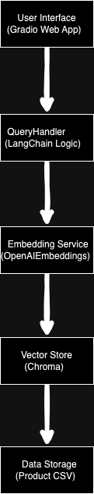

**Component Diagram:**

**Entity-Relationship Diagram :**

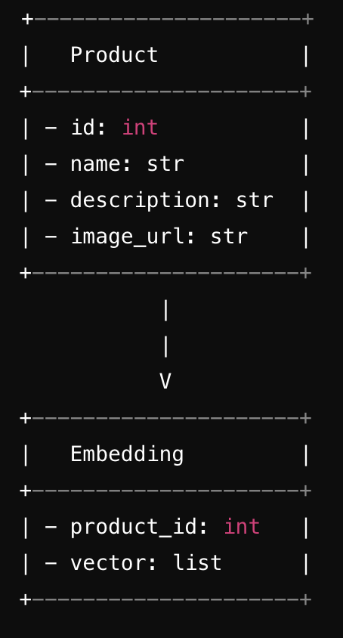

**State Diagram:**

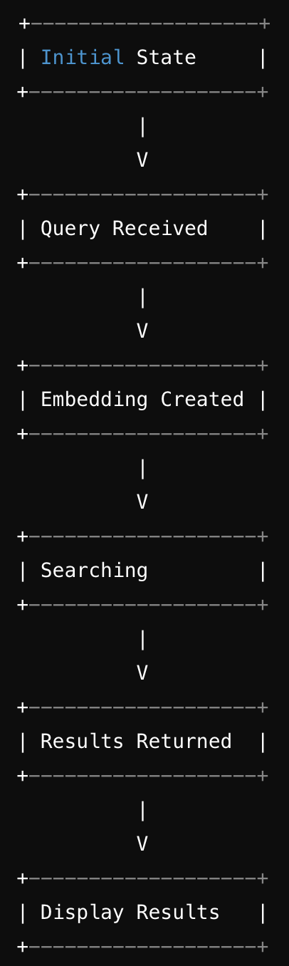

**Framework Chosen**

LANGCHAIN

**Challenges Faced and Learnings**

1. **Data Handling:**
   1. **Challenges:**
      1. ***Data Cleaning:*** Ensuring that data from different sources was clean and in a consistent format for analysis and use within the app.
      2. ***Integration:*** Merging various data types (text, images, and structured data) into a single cohesive dataset.
   2. **Learnings:**
      1. ***Effective Data Preprocessing:*** Learned advanced data cleaning techniques using pandas to handle missing values, data inconsistencies, and format discrepancies.
      2. ***Modular Data Pipelines:*** Implementing a modular approach to data handling helped in maintaining clean and manageable code.
2. **Ranking:**
   1. **Challenges:**
      1. ***Relevance and Accuracy:*** Ensuring that the product search results were relevant and accurately ranked based on user queries.
      2. ***Performance:*** Balancing between complex ranking algorithms and performance to maintain a responsive UI.
   2. **Learnings:**
      1. ***Algorithm Optimization:*** Gained insights into optimizing ranking algorithms for both accuracy and performance.
      2. ***User Feedback Loop:*** Leveraged user feedback to continually refine and improve the ranking logic.
3. **Embedded Storage:**
   1. **Challenges:**
      1. ***Efficient Storage:*** Deciding on the best storage solutions for quick access to product information and search results.
   2. **Learnings:**
      1. ***Choosing the Right Tools:*** Explored different embedded storage
      2. ***Data Retrieval Optimization:*** Implemented efficient data retrieval methods to minimize latency.
4. **UI Design:**
   1. **Challenges:**
      1. ***User Experience:*** Designing an intuitive and user-friendly interface.
      2. ***Responsiveness:*** Ensuring the app worked well across executions.
   2. **Learnings:**
      1. ***Gradio Proficiency:*** Gained extensive experience with Gradio to create dynamic and interactive UI components.

By addressing these challenges, significant improvements were made in data handling, ranking accuracy, storage efficiency, and user interface design. These learnings contributed to building a robust and user-friendly web application.

**Screenshots:**

**LangChain: *Suggest pink saree with border and embroidery*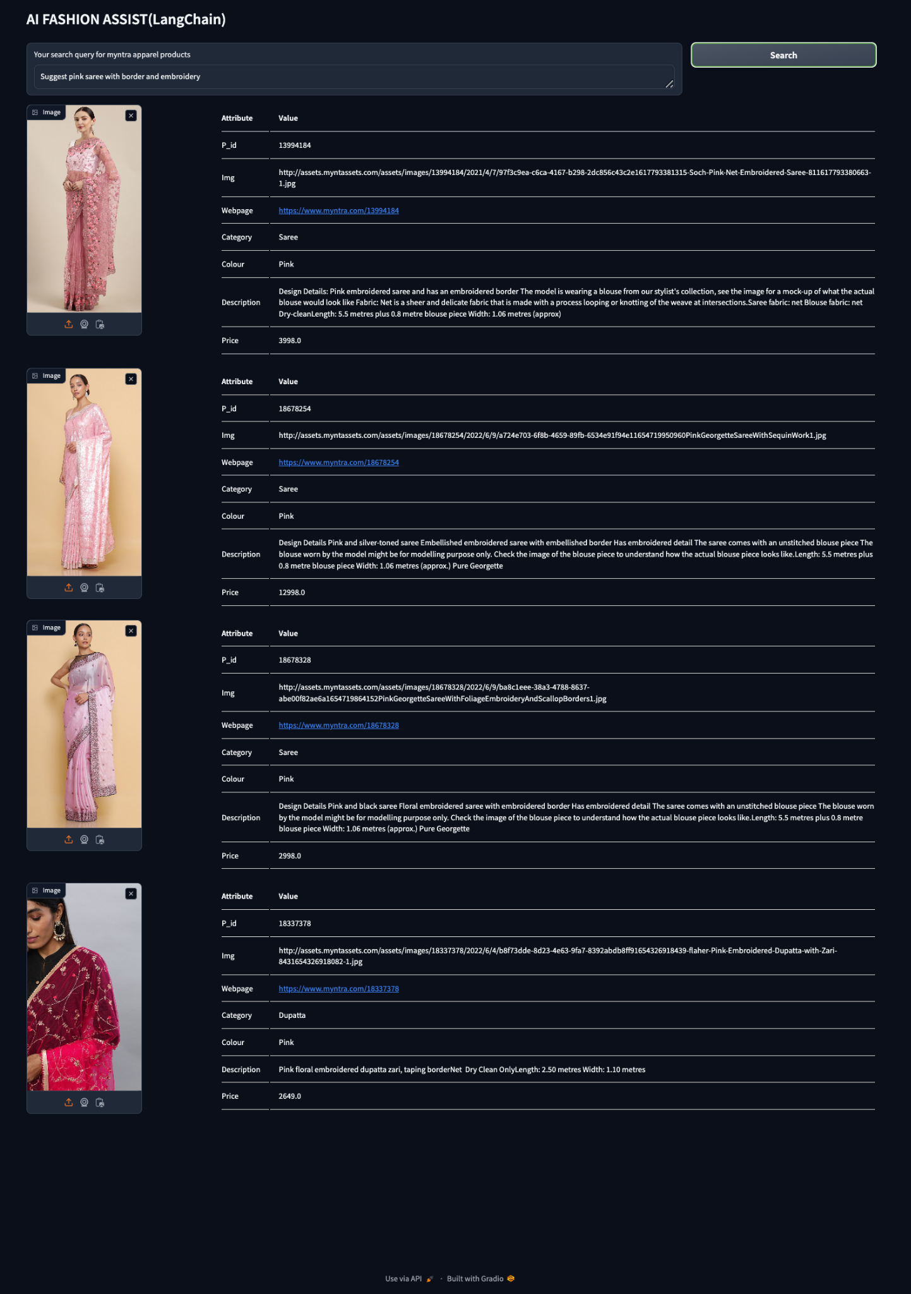**

**LlamaIndex: *Kashmiri shawls***

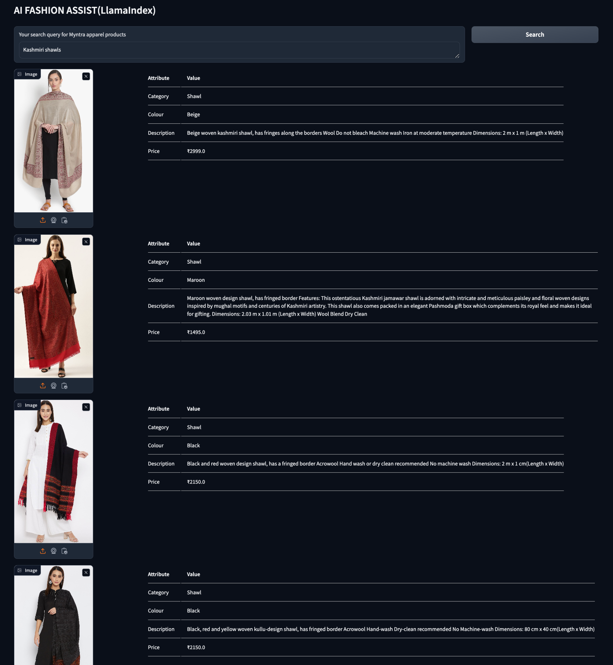

**Why have I chosen LangChain and its comparison with LlamaIndex**

## **LangChain v/s LlamaIndex**

### **LangChain**

LangChain is a framework designed to simplify the development of applications using large language models (LLMs). It provides tools to integrate LLMs into various applications, enabling developers to build sophisticated AI-powered solutions. LangChain focuses on:

1. Chain of Thought: Constructing complex pipelines where outputs from one model can be fed as inputs to another.
2. Memory Management: Storing and recalling information throughout an interaction.
3. Integration: Easily integrating with external tools, databases, and APIs.
4. Prompt Engineering: Simplifying the process of designing effective prompts for LLMs.

### **LlamaIndex**

LlamaIndex (formerly known as GPT Index) is a data framework designed to assist in the indexing and querying of LLMs. It helps to structure data in a way that is accessible and usable by large language models, focusing on:

1. ***Indexing:*** Creating indices over large datasets to facilitate efficient querying.
2. ***Query Processing:*** Optimizing queries to return relevant results quickly.
3. ***Data Integration:*** Merging data from various sources and managing it efficiently.
4. ***Scalability:*** Handling large volumes of data and queries without compromising performance.

### **Why LangChain is Better for My Use Case**

1. ***Natural Language Understanding:*** LangChain excels at constructing complex pipelines for natural language understanding, allowing for more sophisticated interpretation of user queries.
2. ***Integration:*** LangChain’s ability to easily connect with various APIs and tools is crucial for integrating diverse data sources and enhancing data management.
3. ***Memory Management:*** This feature is essential for maintaining context in user interactions, improving the overall user experience.
4. ***Prompt Engineering:*** Simplifies the creation of effective prompts, enhancing the relevance and accuracy of search results.
5. ***User Experience:*** LangChain’s capabilities in memory management and complex query handling contribute to a more intuitive and user-friendly search interface.
6. ***Real-Time Processing:*** The framework is designed to handle real-time interactions efficiently, ensuring quick responses to user queries.
7. ***Personalization:*** LangChain can leverage user data to provide personalized search results and recommendations, enhancing user satisfaction.
8. ***Multilingual Support:*** The framework supports multiple languages, catering to a diverse user base.
9. ***Adaptability:*** LangChain’s flexibility allows it to adapt to changing trends, new products, and evolving user behavior over time.
10. ***Continuous Learning:*** LangChain can incorporate feedback mechanisms to continuously learn and improve from user interactions. This ongoing improvement cycle helps in fine-tuning the search algorithms, ensuring that the system stays effective and relevant over time.

### **Additional Considerations for Using LangChain**

* ***Enhanced User Experience:*** LangChain’s memory management and prompt engineering capabilities ensure that users receive contextually relevant responses throughout their interaction. This leads to a smoother and more intuitive search experience, which is critical for user satisfaction and retention on an e-commerce platform.
* ***Advanced Query Handling:*** LangChain allows for the construction of complex pipelines, enabling advanced query handling and processing. This means the system can understand and respond to intricate and nuanced user queries, providing more precise product recommendations.
* ***Flexibility and Customization:*** LangChain offers a high degree of flexibility, allowing developers to customize the search system to meet specific business requirements. This adaptability ensures that the search functionality can evolve alongside the platform, accommodating new features and changes in user behavior.
* ***Integration with External Tools:*** LangChain’s ease of integration with various APIs and tools enhances its capability to manage extensive product data. This is crucial for maintaining accurate and up-to-date product descriptions, which directly impacts the relevance and accuracy of search results.
* ***Support for Continuous Learning:*** LangChain can incorporate feedback mechanisms to continuously learn and improve from user interactions. This ongoing improvement cycle helps in fine-tuning the search algorithms, ensuring that the system stays effective and relevant over time.

### **Why LlamaIndex Might Not Be a Good Fit**

1. ***Focus on Data Indexing and Query Processing:*** While LlamaIndex excels in efficient data indexing and query processing, it may not provide the comprehensive natural language understanding and memory management features required for handling complex and nuanced user queries.
2. ***Limited Memory Management:*** Unlike LangChain, LlamaIndex does not offer advanced memory management capabilities, which are crucial for maintaining context in user interactions and enhancing the user experience.
3. ***Less Emphasis on Prompt Engineering:*** LlamaIndex is less focused on simplifying prompt engineering, which could lead to less effective natural language processing and interpretation of user queries.
4. ***Integration Complexity:*** LlamaIndex might not offer the same level of ease in integrating with various external tools and APIs as LangChain, potentially complicating data integration and management.
5. ***User Experience:*** Without the advanced memory management and complex query handling features of LangChain, LlamaIndex might not provide as intuitive and user-friendly a search experience.
6. ***Personalization:*** LlamaIndex’s capabilities in leveraging user data for personalized search results may not be as robust as those offered by LangChain.
7. ***Adaptability and Learning:*** LlamaIndex may lack the flexibility and continuous learning capabilities needed to adapt to changing trends, new products, and evolving user behavior over time.

### **Summarizing the Benefits of LangChain for My Use Case**

1. ***Comprehensive Natural Language Understanding:*** Effectively interprets user queries for precise product recommendations.
2. ***Seamless Integration:*** Connects easily with various data sources and external tools.
3. ***Memory Management:*** Maintains context for better user interactions.
4. ***Prompt Engineering:*** Simplifies designing effective prompts for accurate results.
5. ***User Experience:*** Enhances the interface for an intuitive and efficient search process.
6. ***Real-Time Processing:*** Provides quick and responsive search results.
7. ***Personalization:*** Tailors search results to individual user preferences.
8. ***Multilingual Support:*** Accommodates a diverse user base.
9. ***Adaptability:*** Evolves with changing trends and user behavior.
10. ***Continuous Learning:*** Improves over time based on user feedback.

By leveraging LangChain, you can build a robust, scalable, and user-friendly search system that meets the complex needs of an e-commerce platform like Myntra. The framework’s advanced features and flexibility make it the superior choice for creating an effective search solution that enhances user satisfaction and drives business success.

**Conclusion**

* The application showcases the power of combining semantic search and natural language processing.
* Key innovations include data preprocessing, embedding-based retrieval, and intuitive UI.