Vera&JohnBot

Prepared by: Sabik Safkat

Created date: 2020/11/18

Revised by: Abul Bashar

Revised date: 2020/11/20

Revised date: 2020/11/24

Revised by: Kamrul Hossain

Revised date: 2020/11/26

**1.** **System definition 3**

1.1. Technology 3

1.2. Operating Environment 3

1.4. Project Scope 4

1.5. References 4

1.6. Audience 4

1.7. Keywords 4

**2.** **System features 5**

2.1. Web Application 5

*2.1.1.* *Add user 5*

*2.1.2.* *Generate client application download link 6*

*2.1.3.* *User data reporting 6*

*2.1.4.* *User BET timeline setting 6*

*2.1.5.* *User grouping 6*

*2.1.7.* *Auto off Setting 7*

2.2. Client application 7

*2.2.1.* *Downloading client application 7*

*2.2.2.* *Login & settings 7*

*2.2.3.* *Auto Betting process 8*

**3.** **System features 12**

**4.** **System UI 15**

4.1. Web application 15

*4.1.1.* *Login Screen 15*

*4.1.2.* *Create User 16*

*4.1.3.* *User List 17*

4.1.3.1. Deposit History 18

4.1.3.2. Cash Out History 19

4.1.3.3. Bet History 20

*4.1.4.* *User List 21*

4.1.4.1. Create Group List 21

4.1.4.2. Create Group 22

4.1.4.3. Individual List 23

4.1.4.4. Individual Setting 24

4.2. Client application 25

*4.2.1.* *Login Screen 25*

*4.2.2.* *Login Screen 26*

*4.2.3.* *Login Screen 27*

*4.2.4.* *Login Screen 28*

**5.** **Other Non-functional requirements 28**

5.1. Performance Requirements 28

5.2. Security Requirements 28

*5.2.1.* *Authorization 28*

*5.2.2.* *Authorized 28*

*5.2.3.* *Password 28*

*5.2.4.* *Timeout 29*

*5.2.5.* *Data Backup 29*

*5.3.1.* *Availability 29*

*5.3.2.* *Security 29*

*5.3.3.* *Usability 29*

1. System definition

The system will be a PC application with an associated web application for moderation, access control and monitoring. The web application will provide all necessary API’s for the client application. The client application can be installed into only one device and used by a single entity.

* 1. Technology

The client application will be designed in Python3. A special library named “Selenium Chromedriver” will be used for automation purpose.

The web application will be built in PHP and Javascript. A web framework called Laravel will be used.

* 1. Operating Environment

This is a desktop base application, there is no significant requirement to run the application except the followings:

1. Windows OS (v7, v10 etc.)
2. Chrome Browser (Latest version)
3. Apache webserver will be required for host the admin panel

* 1. Purpose

The client side application will be an automated software to operate bidding procedure in Vera&John online casino. The web application will be responsible for maintaining the clients. It will provide authentication API’s and manage complete reporting of all users.

* 1. Project Scope

The project will only operate on Vera&John casino website. The client system will try to maximize betting profits by using certain well-researched betting logics. The process involves deciding when to bet, how much to bet, where to bet. These decisions will be taken by the system based on observations that will span for reasonable number of games.

The associated web application will be the place where after sale monitoring and support will be provided from.

* 1. References

<https://verajohn.com/ja>

* 1. Audience

This document is created for both the client and development team to agree on bet automation logic, features and scopes of the project (both the client application and associated web application).

The application user manual will provide for both the client app and the admin panel.

* 1. Keywords

**User**: End users who will use the PC application for betting purposes.

The users of the system will be those who will subscribe the installable PC application downloaded from the pro-purchase link provided by the administration.

**Administration**: Users of the web application that controls and sells the client application.

**Client application**: The PC application that resides in a personal machine and used by the “Users”.

**Document Convention**:

|  |  |
| --- | --- |
| Y | Y for Yes, it means the prediction is correct |
| N | N for No, it means the prediction is wrong |
| D | D means Draw |
| P | P means Player |
| B | B means Bank |

1. System features

* 1. Web Application

* + 1. Add user

Filling up a form and providing the following will add new users.

* Full Name
* E-mail (unique) Use for log in ID
* Full address
* Contact info
* Password (a highly secured password will be generated from system)

The credentials used to register the user will be provided to them pro-purchase by the administration. These credentials must be used to log into the client system.

* + 1. Generate client application download link

The administrator will have fill in user credentials in a form to generate a link that will be provided to the user for downloading purposes.

* + 1. User data reporting

List of all the users of the system along with their activity (Balance, Cash out, History of Auto BET amount/Win/Loss) will be displayed for monitoring.

* + 1. User BET timeline setting

The administration will set up when and by what logic users can start betting using their client application. How long can the client application be used for betting in a day will also be decided from the web application.

* + 1. User grouping

Several users can be placed into a group so that same conditions of starting and ending of betting can be applied to all of them.

*Basing on user activity report, logic of starting and ending betting automation of individual user or group will be provided to the developers later.

* + 1. User controlling

Users can be enabled and disabled by the administration. Disabled users will not be able to log into their client application thus they cannot bet using the system.

* + 1. Auto off Setting

Administration can apply the auto off setting to a whole group or a single user. Initial BET amount & win or lose amount will consider for Auto off setting.

ie; if a user’s initial BET amount is $1, while auto off setting instructed 100 by administration. This user’s BET will auto off when the win or lose amount reaches $100.

* 1. Client application

* + 1. Downloading client application

The client application can be downloaded from a one-time link provided by the administration. The application then has to be installed in a computer run by windows OS.

* + 1. Login & settings

The user must log into the application using the credentials provided by the administration while the system was purchased. After logged in with user ID/PW, different ID/PW will not accept for log in.

Once logged in, he must insert his Vera&John id and password into the system for one time & the credentials will store to the application for login to auto bet.

Bet start amount can set, however the default amount will be $1.

Auto ON/OFF can set. While set to ON, auto bet will perform as per instruction set by administration.

Process monitor screen will display like command prompt (dummy information display).

* + 1. Auto Betting process

The client application is an automation software that operates on behalf of the users using his Vera&John account. Once the user logs into the client application and provided his Vera&John account credentials, the application will be prepared to bet for him.

The complete process and logic of betting that the system will use is as follows.

**Step 1**: The system will search and enter baccarat game lobby. Lobby details; “Evolution Gaming / LOBBY BACCARAT / Baccarat Lobby (Paris) $0.20-$50,000”

**Step 2**: There are multiple tables that are being played in the lobby. The system will start looking for a table that is almost at the end of its round thus will be started again soon. Stay time in every table will 5~30sec (randomly define) for searching.

**Step 3**: When a table that meets the criteria of step 2, the system will wait there for it to finish its round. When started again, it will observe the games being for a while.

There are two sides in a game. 1. Players 2. Bankers. For clarity and easier approach, the following notation will be used in this document.

**Y: Win.** That means the prediction made by the system turned out to be correct.

**N: Lose.** That means the prediction made by the system turned out to be wrong.

**D: Draw.** There was no winner of the game.

**P: Player.** One side of the game.

**B: Banker.** Other side of the game.

**Step 4**: See who wins the first game of the table. (P or B)

If the result is D, see next game result. This process will continue until the result P or B.

*The outcome of D will always be ignored by the system.

**Step 5**: Depending of the outcome of step 4, system will assume reverse for the next game result.

ex: step 4 winner is

P -> system assumption of next game winner: B or,

B -> system assumption of next game winner: P

**Step 6**: If result of step 5 is,

Y: Assume reverse again or,

N: Assume the same again

**Step 7**: Repeat step 5 to step 6, 4 more times.

**Step 8**: keep repeating step 5 to step 6, and keep count of Y and N until count_N = 4. If 2 consecutive Y is found, set count_N = 0 and continue until 34 games & back to Step 2.

When get N=4, system will start real BET.

Note: start amount for BET will be $1 by default. User can change it. The sequence of BET amount, which will be referred to as SET, will be as follows.

SET = [1x, 2x, 3x, 5x, 7x, 10x, 15x, 22x, 33x, 48x, 72x] where x = $1 by default.

**Step 9**: start BET on P or B following the same process described in step 5 to step 6. BET amount condition will be as follows.

1. The first BET amount will be the first element of SET
2. Consecutive BET amounts will be depending on the outcome of the previous game. If previous game output is

Y: Current game BET amount will be 2 * (previous game BET amount)

N: Current game BET amount will be next element in SET. The next element is decided upon how many elements has been used consecutively from SET.

1. If all elements of SET are used, start from the

first element again.

**Step 10**: continue step 9 until one of the following is met.

1. Table is finished
2. 2 consecutive Y is achieved

**Step 11**: Go back to step 2.

**Step 12**: Termination of BET process will execute upon the setting of Administration.

1. System features

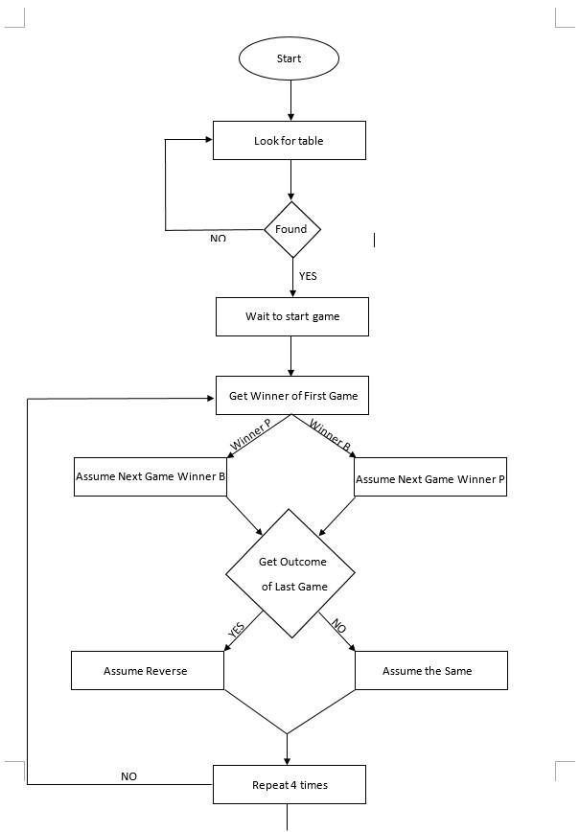

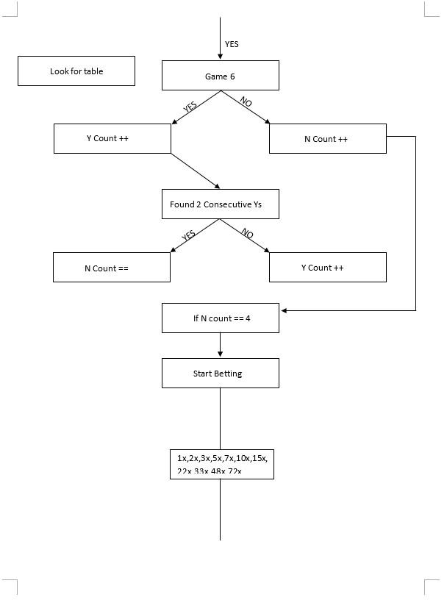

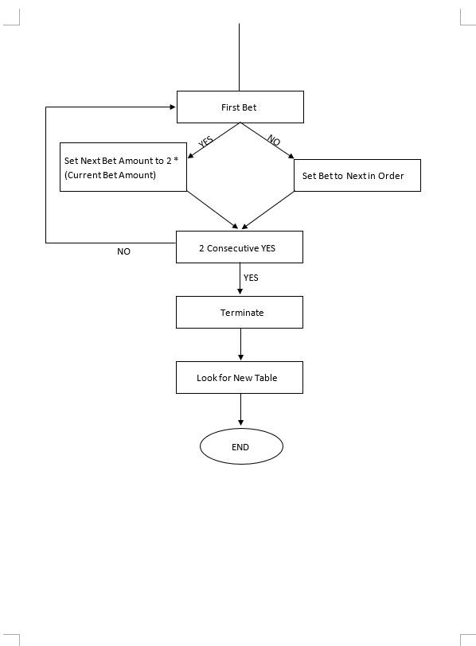

1. System UI

* 1. Web application

* + 1. Login Screen



* + 1. Create User



* + 1. User List



* + - 1. Deposit History



* + - 1. Cash Out History



* + - 1. Bet History



* + 1. User List
       1. Create Group List



* + - 1. Create Group



* + - 1. Individual List



* + - 1. Individual Setting



* 1. Client application
     1. Login Screen



* + 1. Login Screen



* + 1. Login Screen



* + 1. Login Screen

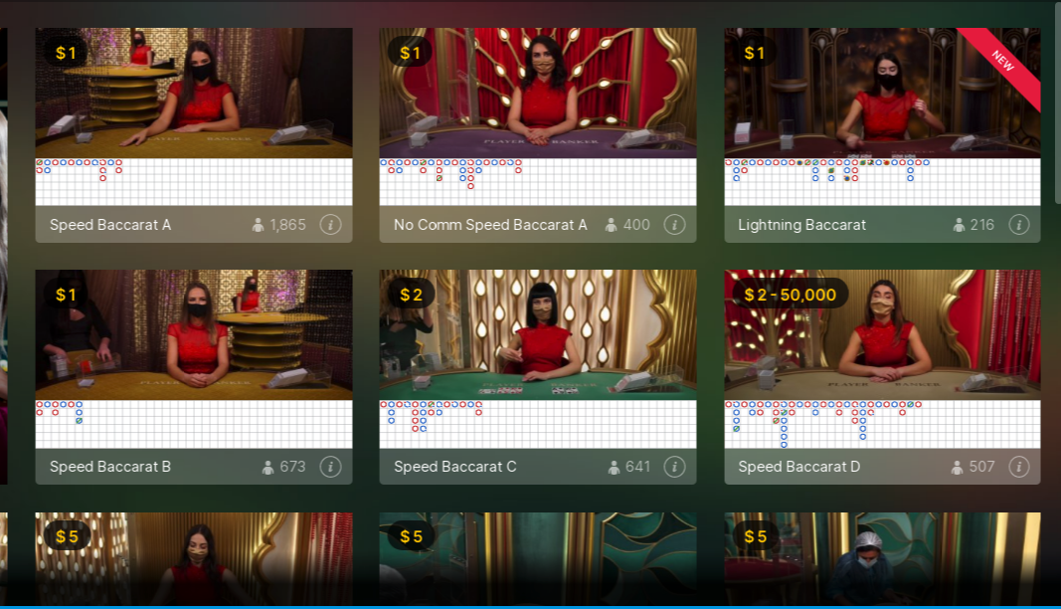

1. Other Non-functional requirements

* 1. Performance Requirements

To ensure smooth operation of the application, need to connect with a stable & high speed internet connection.

Vera&John website should active so that the application can access the site.

* 1. Security Requirements
     1. Authorization

Only the authentic user should be able to login.

* + 1. Authorized

User should be able to log into those modules only for which he is authorized.

* + 1. Password

Passwords will automatically generate at the time of user registration by administration & send the information through email direct to the user.

* + 1. Timeout

If the application is inactive, then it should timeout in a specified time.

* + 1. Data Backup

Data backup should be taken at a specified time and should be copied to a secured location.

* 1. Software Quality Attributes

* + 1. Availability

If the internet connection gets interrupted when transmitting data to the server,

* + 1. Security

The primary security problem is the user account, so proper login mechanisms should be used to prevent hacking and increase security.

Protection from unauthorized use of the application is therefore given.

* + 1. Usability

As the application is quick to manage and navigates without delays in the most predicted way. The machine program responds accordingly in that case and switches between its states quickly.