AEROMODELLNG WORKSHOP

TECHFEST 2004
2. Drag
Drag is the resistance an airplane experiences in moving forward through the air.
For an airplane to maintain steady flight, there must be sufficient lift to balance the weight of the airplane, and there must be sufficient thrust to overcome drag.
Figure shows an airfoil moving forward through the air and depicts the principle known as the resolution of forces. The vertical component (OL) is the lift and is used to support the weight of the airplane. The horizontal component (OD) is the drag. OR is the resultant reaction of these two components.
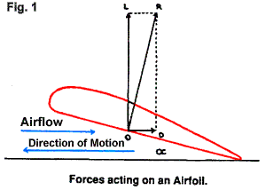
Since drag is a force directly opposed to the motion of the airfoil and, as the work of overcoming it is performed by the engine, it is desirable to have it as small as possible, to afford the engine to be more efficient.
Drag is of two principal types.
1. PARASITE DRAG is the term given to the drag of all those parts of the airplane which do not contribute to lift, that is, the fuselage, landing gear, struts, antennas, wing tip fuel tanks, etc. In addition, any loss of momentum of the airstreams caused by openings, such as those in the cowling and those between the wing and the ailerons and the flaps, add to parasite drag.
Parasite drag may be divided into two components.
- Form drag refers to the drag created by the form or shape of a body as it resists motion through the air.
- Skin friction refers to the tendency of air flowing over a body to cling to its surface.
- Although parasite drag can never be completely eliminated, it can be substantially reduced. One method is to eliminate altogether those parts of the airplane that cause it. For this reason, retractable landing gear has been developed. Wing struts have been eliminated in favour of fully cantilevered wings. Another method is to streamline those parts that cannot be eliminated. Skin friction can be reduced substantially by the removal of dust, dirt, mud or ice that has collected on the airplane.

Even the most carefully designed individual parts must, however, be joined together to create the total airplane. Resistance caused by the effect of one part on another (i.e. where the wing is attached to the fuselage, or the struts to the wings) is called interference drag and can be reduced by careful design in the fairing of one shape into another.
2. INDUCED DRAG is caused by those parts of an airplane which are active in producing lift (i.e. the wing). It is the result of the wing's work in sustaining the airplane in flight and is, therefore, a part of the lift and can never be eliminated. It increases as the angle of attack increases and decreases as the- angle of attack decreases.
Induced drag can be reduced only during the initial designing of an airplane. A wing with a high aspect ratio, that is, with a very long span and a narrow chord, produces less induced drag than does a wing with a short span and a wide chord. Gliders and sail planes are therefore commonly designed with high aspect ratio wings.
The phenomenon, known as wing tip vortices, is testimony to the existence of induced drag.
As the decreased pressure over the top of the wing is less than the atmospheric pressure around it, the air flowing over the top surface tends to flow inward. The air flowing over the lower surface, due to the relatively higher pressure around it, tends to flow outward and curl upward over the wing tips.
When the two airflows unite at the trailing edge of the wing, they are flowing contra-wise. Eddies and vortices are formed which tend to unite into one large eddy at each wing tip. These are called wing-tip vortices. This disturbed air exerts a resistant force against the forward motion of the wing. This resistant force is known as induced drag.
In order to support the weight of an airplane, a large amount of air must be displaced downward. This displaced air must have somewhere to go, and tends to flow spanwise outwards, as explained above. It is seeking to escape around the wing tips and flow into the low pressure area created over the upper surface of the wing. It will be become very clear that the heavier the airplane and the higher the span loading on the wing, the more air it will displace downward, therefore the greater will be the circulation of air, and the greater the magnitude of the wing tip vortex created and the greater the induced drag.
Induced drag does not increase as the speed increases. On the contrary, it is greatest when the airplane is flying slowly, a few knots above the stalling speed when maximum lift is being realized at minimum speed.
The induced drag characteristics of a wing are not the same very near the ground as they are at altitude. During landing and take-off, the ground interferes with the formation of a large wing-tip vortex. Induced drag is, therefore, reduced when an airplane is flown very near the ground. This phenomenon is known as ground effect.
Although induced drag cannot be eliminated, it can be reduced by certain design features. As has been stated earlier, less induced drag is generated by a long, narrow wing than by a short, broad one. It has also been found that winglets are effective in reducing induced

drag. Attached to the wing tip, the winglet, a small, vertical surface of airfoil section, is effective in producing side forces that diffuse the wind-tip vortex flow.

Aileron Drag
In banking to make an airplane turn, one aileron is depressed and the other is raised. The downgoing aileron, being depressed into the compressed airflow on the underside of the wing, causes drag. The upcoming aileron, moving up into a more streamlined position, causes less drag. The drag on the downgoing aileron is known as aileron drag and if not corrected for in the design of the aileron, tends to cause a yaw in the opposite direction to which the bank is applied.
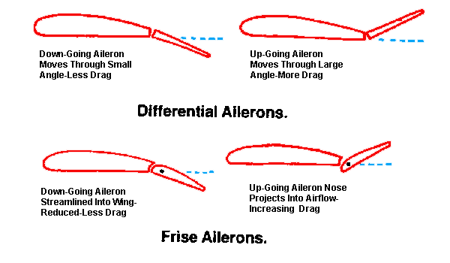s

