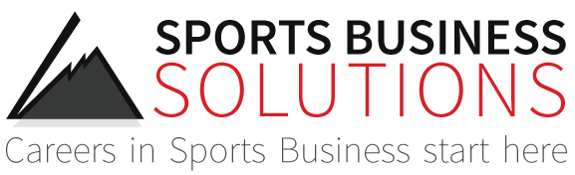

FOR IMMEDIATE RELEASE: December 7, 2015
Contact: Bob Hamer, bob@sportsbusiness.solutions (602) 788-7071

SPORTS BUSINESS SOLUTIONS HOSTS LARGEST SALES COMBINE YET
WITH THE DETROIT PISTONS
AUBURN HILLS, MI - After purchasing the Sports Sales Combine hiring event 14 months ago, Bob Hamer & the team at Sports Business Solutions have now completed their fourth event. This past weekend, December 4-5 in Michigan, they hosted their largest event to date as 50 participants and 23 sales coaches representing 15 different professional teams travelled from all of the country to participate.
“We just keep raising the bar” said Hamer. “We started with just 23 participants in Phoenix for our first event last October and in just over a year we’ve doubled it. We’ve seen great growth in a short period of time and expect that to continue.”
Over the last five years, the combine has been one of the industry’s most popular hiring events for those interested in a career in sports ticket sales, placing more than 190 people in full time employment. Prior to the event this past weekend, after SBS assumed ownership of the event last Fall, the combine has placed 31 job candidates in full time sports sales jobs.
This past weekend in Michigan, in addition to the Pistons, participating team recruiters represented: Miami Dolphins, New Jersey Devils, New York Mets, Cleveland Cavs, Cleveland Browns, Chicago Cubs, Columbus Blue Jackets, Pittsburgh Pirates, Washington Nationals, Atlanta Hawks, Eastern Michigan University – Aspire Group, Legends Global Sales – Notre Dame, Detroit Red Wings & Denver Nuggets.
In total there were 50 combine job candidates, up 35% from the last event and up 117% from the first event in Phoenix. There were 150 total interviews conducted by 15 different teams and Sports Business Solutions expects this event to place at least 15 of the participants in a full time job or internship in sports by the end of the school year in May.
When asked about the event, participating coach, Elliott Crichfield, Inside Sales Manager with the Denver Nuggets said “An absolutely amazing event with some of the best coaches in our industry” He went on to add, “We can't wait for the next combine!”
The next sales combine will be hosted in San Jose, California on February 26-27 with the San Jose Sharks.
If you’re interested in attending the event as a participant or a team recruiter, or interested in having your team host a sales combine in the future, please reach out to Bob directly at bob@sportsbusiness.solutions. To learn more about the sales combine, visit: http://www.sportsbusiness.solutions/sports-sales-combine/

- www.sportsbusiness.solutions -

