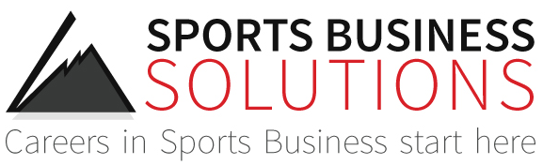 

Sports Business Solutions & the Detroit Pistons present:

The Sports Sales Combine – Auburn Hills, MI

December 4-5, 2015

***Thursday, December 3rd*** – Arrive in Detroit, MI

7:00p-9:00p Coaches Networking Social – Coaches Only

***Friday, December 4th- The Palace (6 Championship Dr. Auburn Hills, MI 48326)***

8:00a-8:30 Registration/Breakfast - Provided

8:30-8:45 Welcome – Bob Hamer

8:45-9:30 Introductions – Candidates & Coaches

9:30-10:15 Ticket Sales 101, building relationships, product knowledge – **(Detroit Pistons)**

10:15-10:30 *Break*

10:30-11:15 Open ended questions and needs analysis – **(Chicago Cubs)**

11:15-12:00 Candidate breakout and practice

12:00-12:15 *Quiz – Product knowledge and ticket sales 101*

12:15-1:30 *Lunch (Open, Candidates & Coaches on their own)*

1:30-2:00 Pistons guest speaker (Brad Lott, SVP Consumer Sales)

2:00-2:30 The Phone Script – How to make a sales call – **(NJ Devils)**

2:30-3:15 Role Play and Practice

3:15-3:30 *Break*

3:30-4:30 Tour & Concourse Intercept Script – **(Atlanta Hawks & Detroit Pistons)**

4:30-4:45 Practice the concourse intercept

4:45-5:15 *Break*

5:15-7:30 Concourse Intercept (Through end of 1st quarter)

7:30-9:30p Networking in Suite with Food and Drink

***Saturday, December 5th -*** ***The Palace (6 Championship Dr. Auburn Hills, MI 48326)***

8:00a-8:30 *Breakfast - Provided*

8:30-9:00 Day 1 review

9:00-9:15 Phone script & product knowledge review

9:15-9:45 Role play

9:45-10:00 *Break*

10:00-12:00 Sales Calls

12:00-1:30 Coaches *working* *lunch (Candidates on their own)*

1:30-1:45 Closing remarks & awards

2:00-4:00p Job Interviews