Image Classification : Use of Support Vector Machine and Random Forest algorithms parameters

Mr. Nagnath B. Aherwadi
Department of Computer Science and Engineering,
Lovely Professional University,
Punjab, India
aherwadinagesh@gmail.com
Ms. Pruthvi A. Tilekar
Department of Computer Science and Engineering,
Lovely Professional University,
Punjab, India
pruthvikesar1819@gmail.com

Abstract: In this paper we are presenting the proper use of parameters instead of using the default parameters in SVM and Random Forest algorithm. We will get the maximum accuracy by just changing some of the parameters from the algorithms. In the beginning we try to define SVM and Random forest with brief overview of theory. After that we are using the age and gender classification dataset from kaggle and showing the practical implementation results.

Keywords: SVM, Random Forest, Data Visualization.

Introduction

Support Vector Machine (SVM)

Support Vector Machine (SVM) were first heard in 1992, and it is delivered by Boser, Guyon, and Vapnik in COLT-92. Support vector machines (SVMs) are associated supervised learning methods used for regression and classification. They are familymembers of generalized linear classifiers.we can say that regression and classification prediction tool is Support Vector Machine (SVM) which is used to maximize predictive accuracy using machine learning which avoid over-fit to the data automatically. Support Vector machines may be described as structures which use speculation area of a linear features in a excessive dimensional characteristic area, educated with a studying set of rules from optimization technique that implements a studying bias derived from statistical studying that technique. Support vector machine was initially famous with the NIPS community and now is an active part of the machine learning research across the world. SVM turns into well-known when, the usage of pixel maps as input; it offers accuracy comparable to state-of-the-art of neural networks with elaborated features in a handwriting recognition work. It is likewise getting used for plenty applications, which includes hand writing evaluation, face evaluation and so forth, specially for pattern classification and regression based experiments.

Random Forest (RF):
Random decision forest is initially proposed in 1995 by HO. Ho established that forests of trees splitting with indirect hyper planes can advantage accuracy as they develop without tormented by overtraining, so long as the forests are randomly limited to be touchy to handiest decided on characteristic data. Random forests or random decision forests are an ensemble studying technique for classification, regression and different duties that perform by building a large number of decision trees at training time and outputting the class this is the mode of the classes (classification) or mean/average prediction (regression) of the character array. Random decision forests algorithm is accurate for decision trees dependency of over fitting to their training dataset.

Dataset

The dataset contains cropped pictures of celebrity and other csv files.
- All celebrity images are cropped with properly alignments in imgalignceleba.zip file.
- Training and validation with testing set partitioning is done in listevalpartition.csv file.
- 5 landmarks of images (i.e. left mouth, right mouth, left eye, right eye, nose) containing the listlandmarksalign_celeba.csv file
- For each images attribute labels are given in this listattrceleba.csv file where attributes are representing positive as “1” and negative as “-1”
Link of dataset: https://www.kaggle.com/jessicali9530/celeba-dataset

Literature Survey

1. G. Eason, B. Noble, and I.N. Sneddon, “Gender Classification from Face Images Using LBG Vector Quantization with Data Mining algorithms”.
This paper has proposed a system which can carry out gender classification in maximum efficient , reliable and robust way. The method is aggregate of data mining methodologies and picture processing algorithm. The system applies the usual steps of picture processing which includes acquisition, pre-processing, characteristic extraction the use of LBG vector quantization method, the extracted functions are surpassed to the data mining algorithms like Naïve Bayes , SVM Poly Kernel, SVM RDF Kernel and KNN for classification. Classification outcomes are received for above classification strategies and evaluation is achieved on those outcomes.[1]

2. Sun Rui, “Medical CT Images Classification Model Based on BBO-HS Algorithm Optimized SVM”.
A scientific CT photo class version with hybrid BBO (Biogeography Based Optimization) and HS (Harmony Search) set of rules is proposed to enhance scientific CT photo class accuracy and remedy SVM parameter optimization hassle withinside the classifier. Firstly, HS set of rules has robust seek competencies for international answers, however negative nearby seek abilities. It may be higher to look international and nearby answers with the aid of using integrating migration operations of BBO set of rules into HS set of rules.[3]

3. Huda Mady and Shadi M. S. Hille’s,“FACE RECOGNITION AND DETECTION USING RANDOM FOREST AND COMBINATION OF LBP AND HOG FEATURES”.
A mixture of Histograms of Oriented Gradients (HOG) and Local Binary Pattern (LBP) descriptors was carried out for faces functions extraction purpose. These descriptors have verified to be decrease computational time. The modern and correct approach was implemented for face classification based on Random Forest classifier (RF). To compare the performance of the Random Forest classifier, as compared it with Support Vector Machine classifiers (SVM) is executed with special existing feature extraction methodology. Four experiments have been applied on Mediu personnel database and incredible outcomes have suggested the performance of proposed algorithm average recognition accuracy is more than 96% The Computer Vision and Image Processing MAT LAB 2016b Toolboxes was used for coding the preferred system, dataset based on videos.[4]

4. Ned Horning’s , “RANDOM FORESTS : AN ALGORITHM FOR IMAGE CLASSIFICATION AND GENERATION OF CONTINUOUS FIELDS DATA SETS”.
In this paper authour presented his work that how random forest algorithm works and its benefits. And also told in paper that random forest algorithm has many benefits over the other image classification algorithms. Random forests is a robust algorithm that may be used for remotely sensed data classification and regression. Performance of random forests is on par with different machine learning algorithms however it is plenty less difficult to apply and extra forgiving in regards to over fitting and outliers than different algorithms. Some common applications of random forests classification consist of land cover and land cover alternate mapping and cloud and shadow detection.[5]
5. Andrés García-Floriano , Ángel Ferreira-Santiago , Oscar Camacho-Nieto and Cornelio Yáñez-Márquez’s,“A machine learning approach to medical image classification: Detecting age-related macular degeneration in fundus images”
People over 60 year old mostly affected by Age-Related Macular Degeneration (AMD) which is chronic, dangourous and progressive diesease. It is related to appearance of drusen: which deposits extracellular material in macular region. In this they are combining Image processing, mathematical morphology and robust machine learning algorithm which is powerful SVM(Support Vector Machine) is to begin a new approach. Contrast enhanced method is used to subject the enclosed macular region. This method is well to differntiate a healthy and afflicated cases using classsification.[6]

6. Özlem Akar and Oğuz Güngör’s ,“Classification of Multispectral Images Using Random Forest Algorithm”.
This paper examine targets at investigating the overall performance of RF set of rules the use of multispectral satellite tv for pc pix having distinctive spatial resolutions and scene attribute. To compare the performance of RF, the classification outcomes are in comparison with the outcomes acquired from Gentle AdaBoost (GAB), Support Vector Machine (SVM) and Maximum Likelihood Classification (MLC). Preliminary outcomes suggest that RF offers better classification accuracies than different methods. For Ikonos picture over city area, the outcomes show that RF algorithm offers 10% better classification accuracy than SVM, whereas GAB algorithm has the bottom classification accuracy (14 % decrese than random forset). For QuickBird picture (taken in 2008) of rural area, RF offers the high-quality end result as compared to the others. Also, for QuickBird picture containing noisy pattern, RF has 11% higher general accuracy than SVM.[7]

7. Gidudu Anthony, Hulley Greg and Marwala Tshilidzi’s, “Classification of Images Using Support Vector Machines”
In this paper, those techniques are evaluated in as a ways as their effect and implication for land cover mapping. The principal locating from this research is that whereas the 1AA method is greater predisposed to yielding unclassified and combined pixels, the resulting type accuracy isn't significantly distinct from 1A1 approach. It is the authors conclusions that ultimately the selection of method followed boils down to personal choice and the uniqueness of the dataset at hand. The 1AA method to multiclass classification has exhibited a better propensity for unclassified and combined pixels than the 1A1 method.[8]

8. Mehdi Habibzadeh Motlagh, Mahboobeh Jannesari, HamidReza Aboulkheyr, Pegah Khosravi, Olivier Elemento, Mehdi Totonchi and Iman Hajirasouliha’s, “Breast Cancer Histopathological Image Classification: A Deep Learning Approach”
Historically, a diagnosis has been initially carried out the usage of medical screening observed through histopathological analysis. Automated classification of cancers the use of histopathological pictures is a chciteallenging challenge of correct detection of tumor sub-types. This process can be facilitated through machine learning approaches, which can be extra dependable and economical as compared to conventional methods. To show this principle, we implemented fine-tuned pre-trained deep neural networks.The usae of 6;402 tissues micro arrayssamples of training are classifiesd the different cancer types. their framework correctly detected on average 99:8% of the 4 cancer kinds inclusive of breast, bladder, lung and lymphoma the use of the ResNet V1 50 pre-trained model.[9]

9. G. Vosselman’s , F.Nex , D.Duarte and N. Kerle “Satellite Image Classification Of Building Damages Using Airborne and Satellite Image Samples In A Deep Learning Approach”
In this paper the use of up/down-sampling picture samples throughout the training of a CNN, has validated to improve numerous remote sensing responsibilities for picture recognition, it is presently uncertain if this multi resolution information can also be captured from pictures with specific spatial resolutions like satellite and airborne imagery (from each manned and unmanned platforms). In this paper, a CNN framework the use of residual connections and dilated convolutions is used thinking about each manned and unmanned aerial picture samples to perform the satellite picture classification of constructing multilation. Combining characteristic maps generated from airborne and satellite picture samples, and refining those the use of best the satellite picture samples, improved almost 4% the general satellite picture classification of constructing multilation.[10]

10. Edoardo Pasolli, Melgani,Devis Tuia, Fabio Pacifici, and William J. Emery, “SVM Active Learning Approach for Image Classification Using Spatial Information”
In this paper, they discover the reality with the aid of using proposing a brand new lively gaining knowledge of method for assist vector machine classification. They advise combining spectral and spatial records directly in the iterative technique of sample selection. For that purpose, 3 standards are proposed to favor the choice of samples remote from the samples already composing the current training set. In the primary strategy, the Euclidean distances from the education samples are explicitly computed, while the second is primarily based totally on the Parzen window system. Finally, the last criterion entails the idea of spatial entropy. They are Experimenting on very extreme pics display the effect for active learning purpose of regularization in spatial area [11]

Mathematical Representation

Support Vector Machine (SVM)

- Linear SVM Mathematically:
- Let training set {(xi, yi)}i=1..n, xiRd, yi  {-1, 1} is separated by a hyperplane and margin ρ. After that for each training example (xi, yi):
WTxi + b ≤ - ρ/2 if yi = -1
=> yi(WTxi + b) ≥ ρ/2
WTxi + b ≥ ρ/2 if yi = 1
- For every support vector xs the above inequality is equality. After rescaling w and b by ρ/2 in the equality, we obtain that distance between each xs and the hyperplane is r
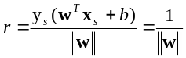
- Then the margin can be expressed through (rescaled) w and b as: 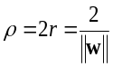
- Then we can formulate the quadratic optimization problem:
Find w and b such that
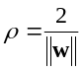 is maximized
And for all (xi, yi), i=1 to n : yi(wTxi + b) ≥ 1
- Which can be reformulated as:
Find w and b such that
Φ(w) = ||w||2 = wTw is minimized
and for all (xi, yi), i=1..n : yi (wTxi + b) ≥ 1
- The classifier is a separating hyperplane and most “important” training points are support vectors; they define the hyperplane.
- Quadratic optimization algorithms can identify which training point’s xi are support vectors with non-zero Lagrangian multipliers αi.
- In the both dual formulation of the problem and in solution training points display only inside inner products:
Find α₁…α_{N} such that
Q (α) =Σα_{i} - ½ΣΣα_{i}α_{j}y_{i}y_{j}x_{i}^{T}x_{j} is maximized and
(1) Σα_{i}y_{i} = 0
(2) 0 ≤ α_{i} ≤ C for all α_{i}

- The solution is:
f(x) = Σα_{i}y_{i}x_{i}^{T}x + b

- Non-linear SVMs Mathematically:
- Dual problem formulation:
Find α₁…α_{n} such that
Q(α) =Σα_{i} - ½ΣΣα_{i}α_{j}y_{i}y_{j}K(x_{i}, x_{j}) is maximized and
(1) Σα_{i}y_{i} = 0
(2) α_{i} ≥ 0 for all α_{i}

- The solution is:
f(x) = Σα_{i}y_{i}K (x_{i}, x_{j})+ b

- Optimization techniques for finding αi’s remain the same.

Random Forest (RF)

Formally, a random forest is a predictor consisting of a collection of randomized { rn(x,Ӫm, Dn), m≥1}, where Ӫ1, Ӫ2…are i.i.d. output for a variable which is randomized Ӫ. These random trees are combined to form the aggregated regression estimate
rn(X;Dn) = EӪ[rn(X , Ӫ , Dn)]
Where, EӪ denotes expectation with respect to the random parameter, conditionally on X and the data set Dn. In the following, to lighten notation a little, we will omit the dependency of the estimates in the sample, and write
For example rn(X) instead of rn(X;Dn).

The randomizing variable Ӫ is used to determine how the successive 3 cuts are performed while constructing the separate tree, such that selection of the coordinates for splitting and position of the splitting.

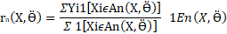

Where the event En(X, Ӫ) is defined by,

(Thus, by convention, the estimate is set to 0 on empty cells.) Taking finally expectation with respect to the parameter, the random forests regression estimate takes the form

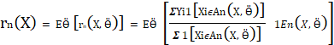

We see that, at the time of building the tree, each node, at each coordinate X (j) may be chosen with possibility. Even if we are not précising for the moment the way these possibilities are generated, we are stressed that second sample may be induced by them.

Result

- Random Forest (RF):

  - n_estimators Vs. Accuracy
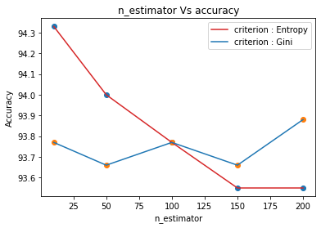

  - Accuracy Vs max_depth when n_estimator is 100
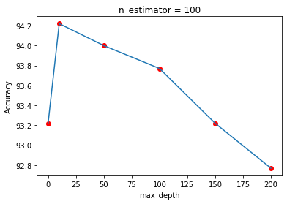
- Support Vector Machine (SVM):

  - SVM Kernels vs. Accuracy

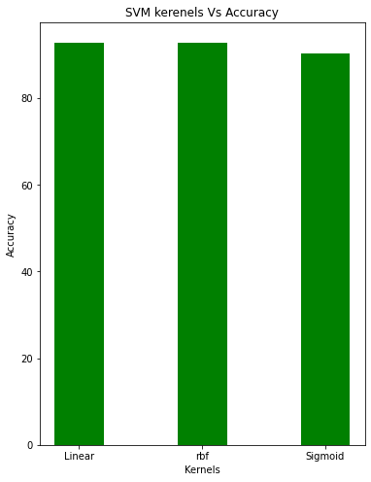

  - SVM Kernels vs. Accuracy for Scale and Auto

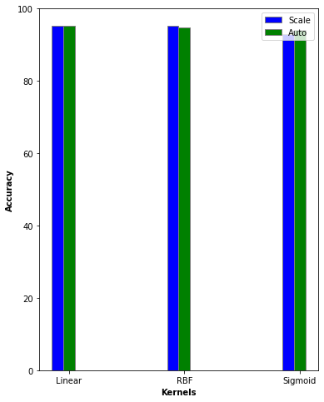

  - Accuracy for Scale and Auto with Sigmoid and Gamma
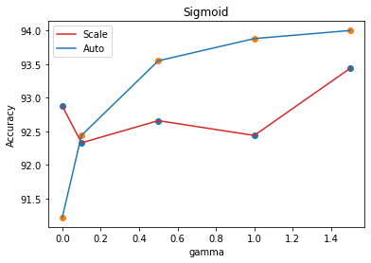
By observation of fig. 1.1 we are getting the same accuracy is nearly 93.8% for criterion Entropy and Gini at n_estimator = 100.
If we decrease the n_estimator value then getting more accuracy for criterion: Entropy as 94.2% and criterion: Gini as 93.8% than n_estimator =100
If we increase the n_estimator value then getting less accuracy for criterion: Entropy as 92.8% and more for criterion: Gini as 93.9% than n_estimator = 100
In fig.1.2 shown that if we increase max_depth value then accuracy is decreasing and if we decrease the max_depth value then accuracy is increasing.
The fig.2.1 and 2.2 observing we can say that accuracy for all the kernels of the SVM are nearly same but for sigmoid we are getting little bit less than other two kernels.
In fig.2.3 accuracy for scale and auto function with sigmoid and gamma function shown.

CONCLUSION

If we use the different parameters available in the algorithms instead of using their default parameters then we are getting the maximum accuracy for the support vector machine and random forest algorithm.

References

- G.Eason, B.Noble, and I.N.Sneddon, “Gender Classification from Face Images Using LBG Vector Quantization with Data Mining algorithms,” Fourth International Conference on Computing Communication Control and Automation(ICCUBEA), 2018.

- Phan Thanh Noi and Martin Kappas, “Comparison of Random Forest, k-Nearest Neighbor, and Support Vector Machine Classifiers for Land Cover Classification Using Sentinel-2 Imagery,” Sensors 2018, 18, 18.

- Sun Rui, “Medical CT Images Classification Model Based on BBO-HS Algorithm Optimized SVM,” 2020 IEEE, July 28-30, 2020•Shenyang, China.

- Huda Mady, Shadi M. S. Hilles, “Face recognition and detection using Random forest and combination of LBP and HOG features,” ©2018 IEEE International Conference on Smart Computing and Electronic Enterprise. (ICSCEE2018).

- Ned Horning, “Random Forests : An algorithm for image classification and generation of continuous fields data sets”, International Conference on Geoinformatics for Spatial Infrastructure Development in Earth and Allied Sciences 2010

- Andrés García-Floriano , Ángel Ferreira-Santiago , Oscar Camacho-Nieto and Cornelio Yáñez-Márquez’s,“A machine learning approach to medical image classification: Detecting age-related macular degeneration in fundus images”, A. García-Floriano et al. / Computers and Electrical Engineering 75 (2019) 218–229

- Özlem Akar and Oğuz Güngör’s ,“Classification of Multispectral Images Using Random Forest Algorithm”, January 2012Journal of Geodesy and Geoinformation 1(2):105-112, DOI:10.9733/jgg.241212.1

- Gidudu Anthony, Hulley Greg and Marwala Tshilidzi’s, “Classification of Images Using Support Vector Machines”, October 2007 / Source: arXiv

- Mehdi Habibzadeh Motlagh, Mahboobeh Jannesari, HamidReza Aboulkheyr, Pegah Khosravi, Olivier Elemento, Mehdi Totonchi and Iman Hajirasouliha’s, “Breast Cancer Histopathological Image Classification: A Deep Learning Approach”, doi: https://doi.org/10.1101/242818

- D.Duarte, F.Nex, N. Kerle and G. Vosselman’s, “Satellite Image Classification Of Building Damages Using Airborne and Satellite Image Samples In A Deep Learning Approach”,ISPRS Annals of the Photogrammetry, Remote Sensing and Spatial Information Sciences, Volume IV-2, 2018

- Edoardo Pasolli, Melgani,Devis Tuia, Fabio Pacifici, and William J. Emery, “SVM Active Learning Approach for Image Classification Using Spatial Information”, IEEE TRANSACTIONS ON GEOSCIENCE AND REMOTE SENSING, VOL. 52, NO. 4, APRIL 2014

- Yali LI, Shengjin WANG and Xiaoqing DING, “Person-Independent Head Pose Estimation Based On Random Forest Regression,” Proceedings of 2010 IEEE 17th International Conference on Image Processing, September 26-29, 2010, Hong Kong.

- Rehanullah Khan, Allan Hanbury, Julian Stoettinger Mady, Shadi M. S. Hilles, “Skin Detection: A Random Forest Approach,” Proceedings of 2010 IEEE 17th International Conference on Image Processing. September 26-29, 2010, Hong Kong.

- Emir Kremic and Abdulhamit Subasi, “Performance of Random Forest and SVMin Face Recognition,” The International Arab Journal of Information Technology VOL. 13, NO. 2, March 2016.

- M. Fachrurrozi, Saparudin, Saparudin, O. Arsalan, Samsuryadi, Ermatita, “Multiple Face Image Feature Extraction Using Geometric Moment Invariants Method,” 2019 International Conference on Informatics, Multimedia, Cyber and Information System (ICIMCIS).

- M. Fachrurrozi, Saparudin, Saparudin, O. Arsalan, Samsuryadi, Ermatita, “Testing a New Ensemble Model Based on SVM and Random Forest in Forest Fire Susceptibility Assessment and Its Mapping in Serbia’s Tara National Park”Forests 2019, 10, 408.

- Juan Huo, Tingting Shi, Jing Chang, “Comparison of Random Forest and SVM for Electrical Short-term Load Forecast with Different Data Sources”©2016IEEE M. Young, The Technical Writer’s Handbook. Mill Valley, CA: University Science, 1989.

- Mohammad Peikari1, Sherine Salama2, Sharon Nofech-Mozes2 & Anne L.Martel, “A Cluster-then-label Semisupervised Learning Approach for Pathology Image Classification”, Scientific Reports | (2018) 8:7193 | DOI:10.1038/S41598-018-24876-0.

- Anna Bosch, Andrew Zisserman and Xavier Mu˜noz, “Image Classification using Random Forests and Ferns”.

- Vaibhavi Solanki, Ms. Vibha Patel and Ms. Supriya Pati ,“Brain MRI Image Classification using Image Mining Algorithms”, Proceedings of the Second International Conference on Computing Methodologies and Communication (ICCMC 2018) IEEE Xplore ISBN:978-1-5386-3452-3

PLAGIARISM REPORT:

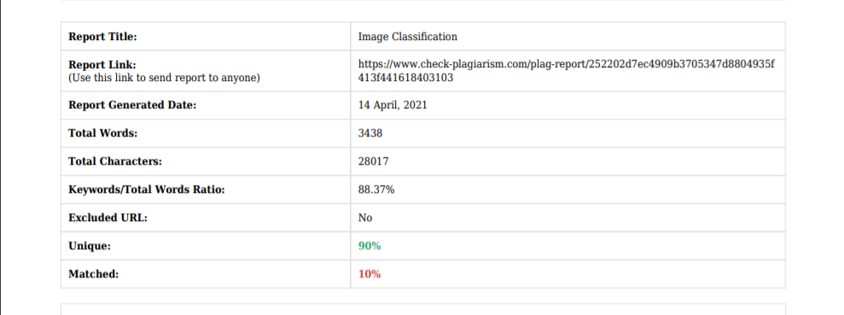

DECLARATION:

I hereby declare that I had not given this paper to any of other staff of my department; I am submitting this paper to only Prof. Mir Mohammad Yousuf sir for GEN531 subject.

Thank you!

(Nagnath B. Aherwadi)

