MID-SEMESTER PROGRESS REPORT
B. Tech. Project
Input Representation Dominates Model Choice in
Machine-Learning Modulation Format Identification
Submitted by
Nitesh Kumar Yadav (Roll No. 2023UEA7232)
Yash Mittal (Roll No. 2023UEA7225)
Sajan (Roll No. 2023UEA6603)
Under the supervision of
Dr. Manisha Khulbe
Department of Electronics and Communication Engineering
Netaji Subhas University of Technology, East Campus
Geeta Colony, New Delhi - 110031
September 2026

Certificate and Declaration
WRITE THIS YOURSELF ~45 words
One short paragraph. State that this report presents the work carried out by the three of you,
that it has not been submitted elsewhere, and that sources are acknowledged. Then a second
sentence from the supervisor certifying the work was done under their supervision.
Check whether your department has a prescribed wording — if it does, use theirs instead.
The Turnitin similarity report for this document is attached. Plagiarism: ______ %. AI-generated content: ______ %.
Signatures of all students
............................................................ ............................................................
Nitesh Kumar Yadav Yash Mittal
............................................................ ............................................................
Sajan Date
Signature of the supervisor
............................................................ ............................................................
Dr. Manisha Khulbe (Supervisor) Date

Table of Contents

1. Introduction
WRITE THIS YOURSELF ~50 words
Para 1 — Optical fibre carries the internet. Data is sent as light; to send more than one bit per
pulse the transmitter varies both amplitude and phase. Define "symbol" and "modulation format"
here; the committee may not be optical specialists.
WRITE THIS YOURSELF ~50 words
Para 2 — Elastic optical networks change format dynamically: 64-QAM on a short clean link,
QPSK on a long noisy one. State the consequence plainly: the receiver cannot demodulate
anything until it knows which format arrived.
WRITE THIS YOURSELF ~50 words
Para 3 — That is what modulation format identification (MFI) solves: infer the format from the
signal itself, with no control channel. Place it inside optical performance monitoring (OPM).

1.1 The five modulation formats considered
Format | Points | Bits/symbol | Shape on the I–Q plane
QPSK | 4 | 2 | 2×2 square
8-QAM | 8 | 3 | Star — 4 inner + 4 outer, rotated 45°
16-QAM | 16 | 4 | 4×4 square
32-QAM | 32 | 5 | Cross — 6×6 grid minus the 4 corners
64-QAM | 64 | 6 | 8×8 square
Table 1.1 — The five formats. Two are deliberately non-square, so a classifier cannot succeed by measuring grid density alone.
WRITE THIS YOURSELF ~45 words
One paragraph on the fundamental trade-off: more points carry more bits per symbol, but sit
closer together, so less noise is needed to push a received point into its neighbour's region.
Say that this tension drives every design decision in the project.
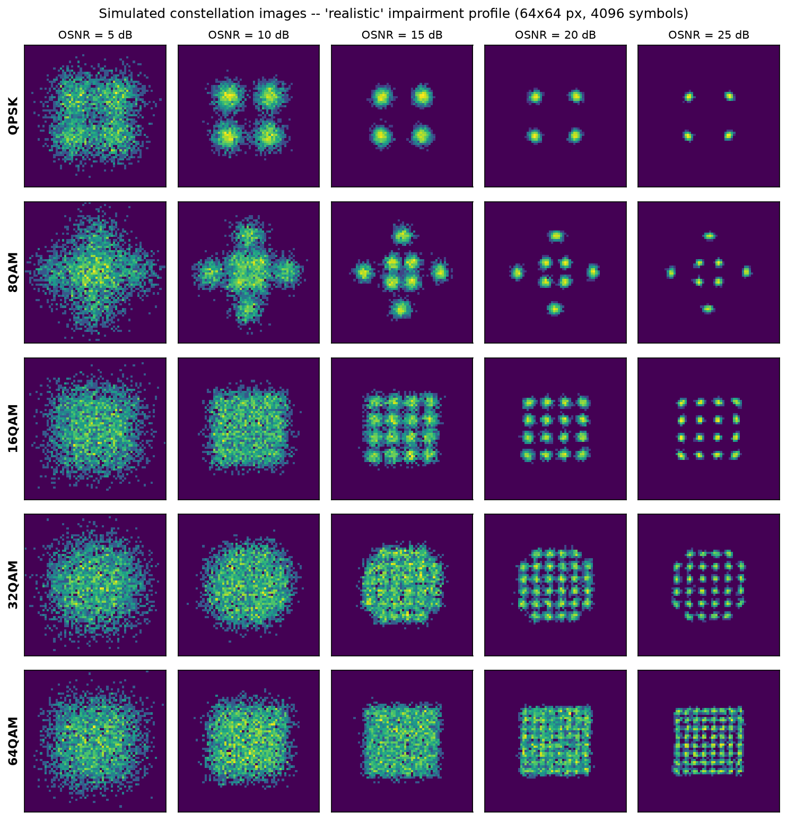
Fig. 1.1 — Constellation diagrams for the five formats across a range of OSNR. At low OSNR the classes become visually indistinguishable.
WRITE THIS YOURSELF ~60 words
Closing paragraph — our question and the contribution, in brief. The standard comparison in the
literature changes the model and the input at the same time, so it cannot say which caused the
gain. We add an MLP on the same 15 features to separate them. End with the headline result:
the representation is worth about three times what the algorithm is worth.

2. Literature Survey
This section is worth marks in its own right under the evaluation scheme. Organise it by theme, and end each subsection with what that line of work leaves open.

2.1 Feature-based MFI: the classical approach
WRITE THIS YOURSELF ~85 words
Higher-order cumulants as the standard pre-deep-learning tool. Swami and Sadler [2] established
the hierarchical cumulant approach; Dobre et al. [3] surveyed the field. Explain WHY cumulants:
Gaussian noise cancels at fourth order and above, so they fingerprint the constellation robustly.
Close on the limitation — they are statistics of an ASSUMED signal model.

2.2 Alternative hand-crafted representations
WRITE THIS YOURSELF ~95 words
Not everyone uses cumulants. Amplitude histograms (Khan et al. [5]; Wang and Liu [15]), Stokes
space with PCA (Xu et al. [12]; Jiang et al. [13]), and neural networks on histogram features
selected by genetic algorithms (Zhang et al. [14]). The point to land: the field has explored many
representations, but almost always changes the classifier at the same time.

2.3 Deep learning on constellation images
WRITE THIS YOURSELF ~95 words
Wang et al. [4] introduced the intelligent constellation diagram analyzer. Khan et al. [11] did
joint OSNR monitoring and MFI with deep neural networks. Huang et al. [8] used an SVM on
constellation images via GLCM features — a useful midpoint between the two camps. Leblebici
et al. [16] is a recent CNN case study. Gap: every one of these compares a deep model on images
against a shallow model on features.

2.4 The parallel in wireless communications
WRITE THIS YOURSELF ~85 words
O'Shea et al. [6] brought CNNs to raw I/Q in radio. Ge et al. [7] is the closest prior work to ours:
it analysed representation effects in WIRELESS automatic modulation classification. Tian et al. [9]
survey the whole deep-learning AMC field organised explicitly by data representation.
Be honest here — say plainly that the question has been asked in wireless. Examiners respect this.

2.5 The gap this project addresses
WRITE THIS YOURSELF ~55 words
Two or three sentences. Nobody, in the optical case, holds the input fixed while varying only the
algorithm AND holds the algorithm fixed while varying only the input. And nobody has asked
whether the representation affects a model's ability to detect its own failure — Yang and Sahay [10]
study uncertainty, but for a single representation.

3. Problem Statement and Methodology

3.1 Problem statement
WRITE THIS YOURSELF ~50 words
State it formally: given a capture of N symbols received by a coherent optical receiver, assign it
to one of five modulation formats. Then state the research question as an actual question:
does the gain reported for CNN-based MFI come from the model or from the input representation?

3.2 Experimental design
The design isolates the two variables that the literature changes together.
 | Shallow model | Deep model
15 hand-crafted features | SVM, k-NN | MLP ← the control that is usually missing
64×64 constellation image | — | CNN
Table 3.1 — Moving across a row changes only the algorithm. Moving down the MLP/CNN column changes only the representation.
WRITE THIS YOURSELF ~70 words
Explain why the MLP is the critical control: it is a trained deep network that sees only the 15
features. If MLP ≈ SVM, the representation is what matters. If MLP ≈ CNN, the model is what
matters. Say explicitly that either outcome would have been a real finding — that is what makes
this an experiment rather than a demonstration.

3.3 The optical link simulator
WRITE THIS YOURSELF ~55 words
Justify simulation in two or three sentences: no public dataset of labelled optical constellation
captures exists, a physical testbed is far beyond project budget, and simulation gives exactly
controlled OSNR sweeps — which the central claim requires.
The simulated signal chain, in order:
1. Draw 4096 random symbols from the chosen format
2. Residual chromatic dispersion (inter-symbol interference)
3. Laser phase noise and residual frequency offset
4. Carrier phase recovery over 64-symbol blocks
5. I/Q gain imbalance and phase skew
6. Automatic gain control — normalise to unit average power
7. Additive white Gaussian noise at the target OSNR

Impairment | Physical cause | Effect on the constellation
ASE noise | Spontaneous emission from the inline amplifier chain | Every point spreads into a cloud
Residual chromatic dispersion | Wavelengths travel at different speeds; pulses overlap | Points blur into each other
Laser phase noise | Laser phase drifts as a random walk, set by linewidth | Angular smearing into arcs
Frequency offset | Transmitter laser and local oscillator are separate devices | The constellation rotates
I/Q imbalance | Unequal receiver arm gain; hybrid not exactly 90° | Square grid skews to a parallelogram
Table 3.2 — The five impairments modelled. Most student projects simulate only the first row.
WRITE THIS YOURSELF ~70 words
Include the frequency-offset ordering problem as a short paragraph — it is a genuine finding and
good viva material. The offset must be applied BEFORE carrier phase recovery, because removing
it is one of CPE's jobs. Applied afterwards, 1 MHz of offset smeared every point into a 46° arc
and constellations looked destroyed even at 25 dB. Describe the fix and what it taught you.

3.4 Validation of the simulator
WRITE THIS YOURSELF ~45 words
Explain the check before the table: for a noiseless unit-power constellation the normalised
fourth-order cumulant is an exact finite sum over the constellation points — pure algebra, no
simulation. A faithful simulator must reproduce it.
Format | Exact theory | Simulated | Error
QPSK | 1.0000 | 0.9997 | 0.0003
8-QAM (star) | 1.5274 | 1.5251 | 0.0023
16-QAM | 0.6800 | 0.6830 | 0.0030
32-QAM (cross) | 0.1900 | 0.1868 | 0.0032
64-QAM | 0.6190 | 0.6198 | 0.0007
Table 3.3 — Normalised fourth-order cumulant |C40|/C21². All five formats agree with exact theory to within 0.004. The three square formats additionally match the constants published in the literature.

3.5 The three representations
Representation | Shape | Human pre-processing involved
Raw I/Q | 2 × 512 | None — the symbols as received
Constellation image | 64 × 64 | Binning into a 2-D histogram
Statistical features | 15 | Substantial — chosen cumulants and amplitude statistics
Table 3.4 — All three are derived from the same signal realisation, so the comparison between them is exactly fair.
WRITE THIS YOURSELF ~65 words
Explain why a 2-D histogram rather than a matplotlib scatter plot: roughly 250× faster to
generate, it preserves density where a scatter plot saturates to solid colour, and it has no axes
or anti-aliasing for the network to latch onto. Then the log(1+x) scaling, and why: cluster centres
get far more hits than the noise tails, which would otherwise round to zero and vanish.

3.6 The five classifiers
WRITE THIS YOURSELF ~75 words
A short paragraph per model family. For the CNN give the layer stack (three Conv3×3 → BatchNorm
→ ReLU → MaxPool blocks at 16/32/64 channels, dropout, two dense layers) and explain why it
flattens rather than using global average pooling — the geometric ARRANGEMENT of clusters is
the signal. Note that the 1-D model makes the opposite choice for the opposite reason.

3.7 Experimental protocol
WRITE THIS YOURSELF ~70 words
The split is 70/15/15, stratified on (format, OSNR) so all 105 cells are divided identically.
Explain why three sets and not two: validation decides when to stop, so it is no longer a neutral
judge; test is touched once. Mention the three seeds (42, 43, 44) and that every model sits inside
a Pipeline with StandardScaler so the scaler never sees test data — a common source of leakage.

4. Work Done Till Date, Results and Discussion
All figures are mean ± standard deviation over three seeds. Every number in this section is generated directly from the stored results and re-derived by an automated audit.

4.1 Main comparison
Model | Input | Accuracy | Parameters
CNN | 64×64 image | 98.73 ± 0.12 % | 285,941
SVM | 15 features | 93.41 ± 0.10 % | —
MLP | 15 features | 93.08 ± 0.10 % | 11,013
k-NN | 15 features | 91.58 ± 0.08 % | —
IQ-CNN | raw I/Q | 86.56 ± 4.64 % | 27,781
Table 4.1 — Test accuracy for all five classifiers on the realistic channel.
WRITE THIS YOURSELF ~75 words
The central result, in your own words. Three fundamentally different algorithms on identical
features span 1.83 points. Changing the representation to the density image gains 5.32 points —
about three times larger. Point out that the MLP, a deep network, came out BELOW the SVM,
a shallow one: adding depth to the feature pipeline bought nothing at all.
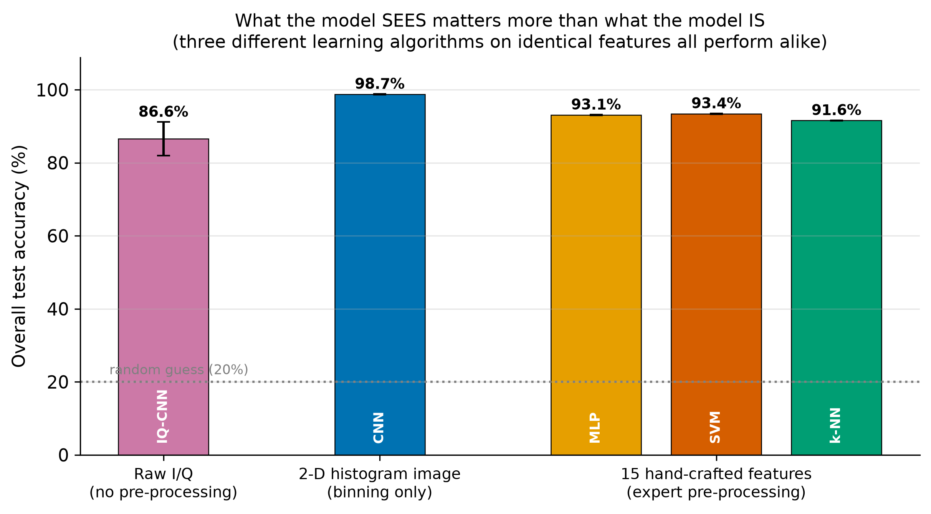
Fig. 4.1 — The algorithm effect and the representation effect, separated.

4.2 Accuracy against OSNR
Model | OSNR for ≥95 % accuracy | OSNR for ≥99 %
CNN | 7 dB | 10 dB
SVM | 14 dB | 18 dB
k-NN | 15 dB | 18 dB
Table 4.2 — The same result expressed as an OSNR margin, which converts directly into reach or amplifier count.
WRITE THIS YOURSELF ~55 words
Explain why the margin is the better number to quote to an optical engineer, and describe the
shape of the curves: below about 9 dB the feature-based classifiers fall away while the CNN holds.
At 5 dB the information is genuinely gone — no classifier can recover what the channel destroyed.

4.3 Generalisation to unseen OSNR
WRITE THIS YOURSELF ~45 words
The CNN scores 97.45 ± 0.16 % on OSNR levels withheld entirely from training, a drop of only
1.27 points. State the conclusion: it learned the physics of the constellation, not the specific
noise levels it was trained on.

4.4 Robustness under channel mismatch
Trained on | CNN → severe | SVM → severe
Clean (AWGN only) | 89.78 % | 21.84 %
Realistic | 91.17 % | 71.98 %
Severe (matched) | 97.84 % | 94.03 %
Table 4.3 — Train on one channel, test on another. Chance level is 20 %.
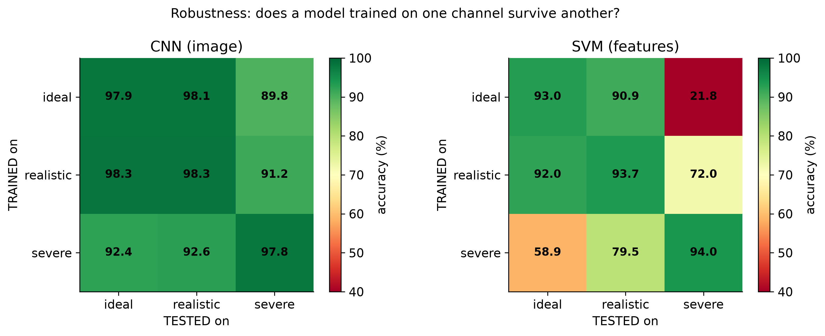
Fig. 4.3 — Accuracy under channel mismatch.
WRITE THIS YOURSELF ~80 words
This is the strongest result — give it room. The feature-based classifier collapses to essentially
random guessing on a channel it never saw, while the CNN degrades gracefully. Give the
mechanism, not just the number: cumulants are statistics of an assumed signal model, so when the
impairments change, the learned decision boundaries stop corresponding to anything real.
Note this is a deployment claim, and that it is only measurable because the data is simulated.

4.5 Does the model know when it is failing?
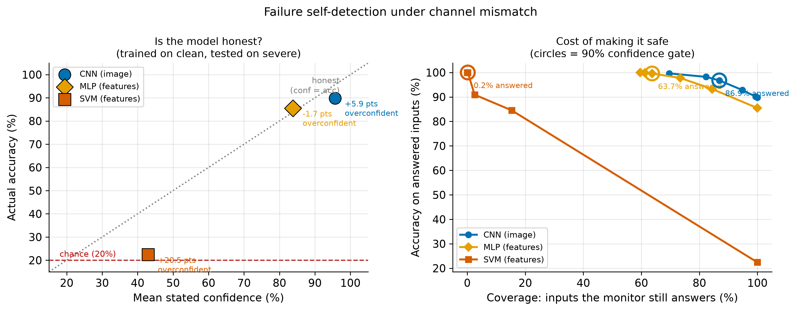
Fig. 4.4 — Coverage and accuracy as a function of the confidence gate, under channel mismatch.
WRITE THIS YOURSELF ~85 words
Explain why this matters operationally: accuracy is visible only to the experimenter, while a
deployed monitor knows only what it predicted and how confident it was. Under mismatch the SVM
claims roughly twice the accuracy it achieves. At a 90 % confidence gate the CNN still answers
86.9 % of inputs while the SVM answers 0.2 % — a ratio of about 447×. The feature-based monitor
can be made accurate only by silencing it. Say that this interaction has not, to our knowledge,
been reported before.

4.6 Capture length and architecture ablation
WRITE THIS YOURSELF ~50 words
State the honest limit on the ablation: it used a single seed, and the non-monotonic behaviour
across widths shows run-to-run noise of the same order as the differences. The supported claim is
"capacity is not the binding constraint", NOT "this width is optimal". Over-claiming from one seed
is exactly what a reviewer catches.

4.7 Impairment tolerance, and where the feature-based model wins
Impairment level | CNN | SVM
I/Q gain imbalance 2.5 dB | 95.48 % | 20.35 %
I/Q phase skew 14° | 96.35 % | 20.10 %
Residual CD 150 ps/nm | 54.89 % | 80.14 %
Table 4.5 — I/Q imbalance destroys the cumulant features, but chromatic dispersion inverts the result.
WRITE THIS YOURSELF ~70 words
Report the inversion prominently rather than burying it. At 150 ps/nm of residual chromatic
dispersion the SVM beats the CNN, 80.14 % against 54.89 %. Offer your explanation, and be clear
about how confident you are in it. Examiners mark honesty about a negative result well above a
clean story, and this is the question most likely to be asked.

4.8 Verification of correctness
Check | What it establishes
Recomputed accuracy | Saved weights reloaded and accuracy recomputed from scratch: 0.986984 reported, 0.986984 recomputed
No data leakage | Train, validation and test sets share zero samples
Simulator theory check | Cumulants match exact analytic values; square formats match published constants
Noise power | Measured SNR matches target to within 0.02 dB
Stratification | Every (format, OSNR) cell split within 2 % of the intended 15 %
Shuffled-label test | Training on randomised labels collapses accuracy to the 20 % chance level
Table 4.6 — Independent checks that re-derive results rather than trusting stored numbers.
WRITE THIS YOURSELF ~45 words
A short paragraph on why the shuffled-label test matters: if a model still scores well after you
destroy the labels, there is a leak somewhere. Mention that the checks initially failed on noise
power and investigation showed the CHECK was wrong, not the data.

5. Future Work
WRITE THIS YOURSELF ~45 words
Opening sentence or two framing what remains. Then take the items below in order — they are
arranged strongest first. Write each as two or three sentences, not as a bare list.
Experimental validation
Replace simulated captures with measurements from a real coherent testbed. Data-request emails to research groups holding such data are drafted. This is the honest answer to the project's single largest limitation.
Polarisation-multiplexed signals
Commercial long-haul systems send two independent signals on orthogonal polarisations; the present model uses one. Extending to dual polarisation doubles the observable structure and is closer to deployment.
Fibre nonlinearity
The channel modelled here is linear. Nonlinear noise is not Gaussian, so cumulant-based features would behave differently — and the robustness result predicts feature-based models would suffer more. That is a testable prediction, which makes it a strong candidate for the next phase.
Joint OSNR estimation
The same constellation image that identifies the format also carries OSNR information. This experiment was scoped and deliberately deferred; it is a natural extension.
More formats and other symbol rates
A deployed system may need more than five formats, and accuracy typically falls as classes are added. Everything here runs at 32 GBaud; transfer to other rates is untested.
Explaining the dispersion inversion
Our own negative result — the SVM outperforming the CNN under residual chromatic dispersion — is not yet explained. Understanding it may point to a hybrid representation.

6. References
All sixteen references were verified against publisher records on 23 September 2026.
[1] F. N. Khan, Q. Fan, C. Lu and A. P. T. Lau, "An optical communication's perspective on machine learning and its applications," J. Lightw. Technol., vol. 37, no. 2, pp. 493–516, 2019.
[2] A. Swami and B. M. Sadler, "Hierarchical digital modulation classification using cumulants," IEEE Trans. Commun., vol. 48, no. 3, pp. 416–429, 2000.
[3] O. A. Dobre, A. Abdi, Y. Bar-Ness and W. Su, "Survey of automatic modulation classification techniques: classical approaches and new trends," IET Commun., vol. 1, no. 2, pp. 137–156, 2007.
[4] D. Wang et al., "Intelligent constellation diagram analyzer using convolutional neural network-based deep learning," Opt. Express, vol. 25, no. 15, pp. 17150–17166, 2017.
[5] F. N. Khan, K. Zhong, W. H. Al-Arashi, C. Yu, C. Lu and A. P. T. Lau, "Modulation format identification in coherent receivers using deep machine learning," IEEE Photon. Technol. Lett., vol. 28, no. 17, pp. 1886–1889, 2016.
[6] T. J. O'Shea, J. Corgan and T. C. Clancy, "Convolutional radio modulation recognition networks," in Engineering Applications of Neural Networks (EANN 2016), CCIS vol. 629, Cham: Springer, 2016, pp. 213–226.
[7] Z. Ge, H. Jiang, Y. Guo and J. Zhou, "Accuracy analysis of feature-based automatic modulation classification via deep neural network," Sensors, vol. 21, no. 24, art. 8252, 2021.
[8] Z. Huang et al., "Modulation format identification based on signal constellation diagrams and support vector machine," Photonics, vol. 9, no. 12, art. 927, 2022.
[9] X. Tian et al., "A survey on deep learning enabled automatic modulation classification methods: data representations, model structures, and regularization techniques," Signal Processing, vol. 242, art. 110444, 2026.
[10] H. Yang and R. Sahay, "An uncertainty quantification framework for deep learning-based automatic modulation classification," arXiv preprint arXiv:2503.04142, 2025.
[11] F. N. Khan, K. Zhong, X. Zhou, W. H. Al-Arashi et al., "Joint OSNR monitoring and modulation format identification in digital coherent receivers using deep neural networks," Opt. Express, vol. 25, no. 15, p. 17767, 2017.
[12] H. Xu, L. Yang, X. Yu, Z. Zheng et al., "Blind and low-complexity modulation format identification scheme using principal component analysis of Stokes parameters for elastic optical networks," Opt. Express, vol. 28, no. 14, p. 20249, 2020.
[13] J. Jiang, Q. Zhang, X. Xin, R. Gao et al., "Blind modulation format identification based on principal component analysis and singular value decomposition," Electronics, vol. 11, no. 4, art. 612, 2022.
[14] S. Zhang, Y. Peng, Q. Sui, J. Li et al., "Modulation format identification in heterogeneous fiber-optic networks using artificial neural networks and genetic algorithms," Photonic Netw. Commun., vol. 32, no. 2, pp. 246–252, 2016.
[15] T. Wang and X. Liu, "A novel modulation format identification based on amplitude histogram space," Front. Optoelectron., vol. 12, no. 2, pp. 190–196, 2019.
[16] M. Leblebici, A. Çalhan and M. Cicioğlu, "Deep learning-based modulation recognition with constellation diagram: a case study," Phys. Commun., vol. 63, art. 102285, 2024.
Reference [15]: confirm the issue year before submission. Crossref records the online-first date as June 2018, but volume 12 belongs to the 2019 volume year. Cite the issue year, not the online date.

