SMART INDIA HACKATHON 2026 · PROBLEM STATEMENT SIH26007 · THEME: SMART AUTOMATION · CATEGORY: HARDWARE
MISTRA
Multimodal Intelligence & Safety Tracking for Regional Assets
A heterogeneous, confidence-aware sensing and edge-fusion architecture for HEMM dumper safety under fog, dust, and low-visibility conditions in open-cast iron ore mines.
Document Type | Technical Feasibility Report
Application Site | Bailadila Iron Ore Mines
Compute Platform | NVIDIA Jetson AGX Orin
Estimated Unit Cost | ₹5,17,500 (≈ ₹5.2 lakh, preliminary)
Team | Team Aveng6rs

Executive Summary
Dense fog at open-cast mines such as Bailadila can reduce visibility to only a few metres. Heavy Earth Moving Machinery (HEMM) dumper operators then face a hard trade-off: keep moving and risk collisions with vehicles, personnel, or the road edge, or slow and stop, which causes haulage delays and production loss. MISTRA proposes a vehicle-mounted, multi-sensor perception and decision-support system intended to help drivers keep moving safely by continuously estimating risk and issuing a clear GO / SLOW / STOP / HOLD / REROUTE advisory.
MISTRA is not proposed in a vacuum. Fog-based mining safety systems already exist and have been field-tested — most notably NMDC and CSIR-CIMFR's Vehicle Enhancement System (VES) trials at Bailadila Bacheli, which combine IR cameras, proximity radar, GNSS, V2X communication and AI-based perception. MISTRA is positioned as an extension and alternative architecture to this existing work: it adds complementary sensing modalities (SWIR, event-based vision), a confidence-aware fusion layer that adapts to which sensors are degraded by current environmental conditions, and edge AI inference on an NVIDIA Jetson AGX Orin to convert multi-sensor signals into a single, vehicle-specific driving advisory.
Problem → Solution → Technology → Impact
Problem: Fog & dust cut visibility on haul roads, forcing a choice between collision risk and costly stoppages.
→ Proposed Solution: A heterogeneous, confidence-aware multimodal perception system that fuses sensor data into one clear advisory.
→ Technology: LWIR + SWIR + event camera + 77-GHz radar + RTK-GNSS/IMU, fused on a Jetson AGX Orin at the edge.
→ Expected Impact: Better situational awareness and fewer avoidable stoppages, extendable to a connected HEMM fleet.

₹5.2 L | 77–122 W | 5 | 5
Est. unit retrofit cost (preliminary) | Est. system power draw | Sensing modalities fused at the edge | Advisories: GO/SLOW/STOP/HOLD/REROUTE

What is technically feasible today: every individual component in the MISTRA stack — thermal and SWIR imaging, mmWave radar, RTK-GNSS/IMU, and Jetson-class edge AI compute — is commercially available and has documented use in automotive or industrial perception. The engineering work that remains is integration: synchronizing these heterogeneous streams, weighting each sensor's contribution by how dependable it currently is, and turning the fused estimate into a dependable advisory in real time. What is not yet demonstrated is a working MISTRA hardware prototype in an actual mine; the current stage of work is component-level simulation and a concept visualization of the intended system, detailed in Section 7.

SECTION 02

Problem & Existing Solutions
Open-cast iron ore mines such as Bailadila operate large HEMM dumpers on haul roads that are shared with light vehicles, personnel, and fixed infrastructure. Seasonal fog, dust thrown up by moving fleets, and moisture on optical surfaces all reduce the effective range at which a driver — or a camera-only perception system — can reliably detect hazards. Conventional visual perception (ordinary cameras, unaided human vision) degrades sharply under these conditions, which is exactly when haulage is most safety-critical.
This is a recognised problem, and it has already received serious engineering attention. NMDC and CSIR-CIMFR have field-tested a Vehicle Enhancement System (VES) at Bailadila Bacheli, and a 2025 peer-reviewed study documents a smart driving-assistance system for open-pit mining under foggy conditions using IR cameras, proximity radar, GNSS, wireless communication, GPU-based image enhancement, CNN-based object detection, geofencing, digital mine maps and a driver dashboard (see References, Section 12). MISTRA does not claim to be the first system to address fog-related mining safety. A remaining, genuinely open challenge is a perception layer that stays reliable as environmental conditions change — one that knows, moment to moment, which of its sensors it should currently trust — and that converts that fused picture into one deterministic, vehicle-specific advisory rather than leaving interpretation to the driver.
Related Work Comparison
Capability | Existing 2025 DAS (Bailadila) | MISTRA Proposal
Infrared vision | ✓ IR camera | ✓ LWIR, 640×512
Radar | ✓ Proximity radar | ✓ 77-GHz mmWave
Positioning | ✓ GNSS | ✓ RTK-GNSS + industrial IMU
SWIR imaging | — not reported as a primary modality | Proposed
Event-based camera | — not reported | Proposed
Environmental sensing | Limited | Proposed
Confidence-aware fusion | Different architecture (CNN + geofencing) | Proposed — EKF, confidence-weighted
Edge AI compute | GPU-based processing | Jetson AGX Orin + TensorRT
Fleet-level decision layer | Not the primary focus reported in the cited study | Proposed
Field validation | ✓ Existing field study | Future phase (Section 10)
A "—" indicates the capability is not reported as a primary modality in the cited study, not that it is absent from every mining safety system anywhere.

SECTION 03

MISTRA System Architecture
MISTRA's contribution is not any single sensor — it is the architecture that combines them. The diagram below shows how environmental conditions, sensing hardware, edge compute and the decision layer connect, from raw sensing to the two outputs a driver and a control centre actually see.
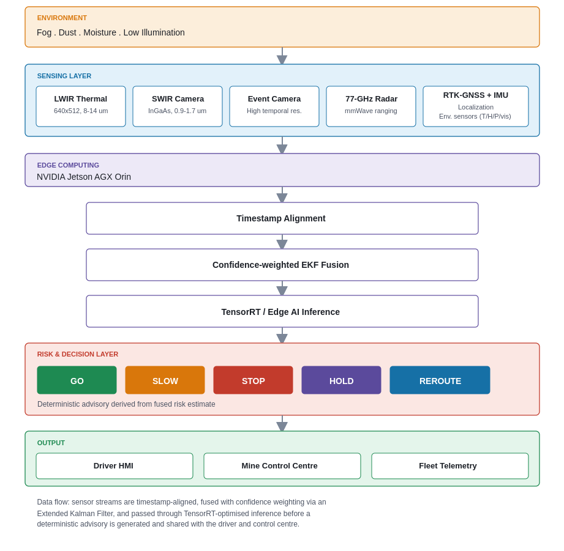
Legend: amber = environment / mining conditions · blue = sensing & data · purple = AI / fusion / edge compute · red = risk & decision (STOP) · green = output / safe state.

SECTION 04

How MISTRA Works
Stripped of hardware detail, MISTRA follows the same seven-step loop on every processing cycle:
01 Sense
LWIR, SWIR, event camera, radar, RTK-GNSS/IMU and environmental sensors continuously observe the vehicle's surroundings.
02 Synchronize
Measurements from different sensors are aligned in time, so a radar return, and a thermal frame captured at nearly the same instant are treated as describing the same moment.
03 Assess Confidence
Current environmental readings (visibility, humidity, particulate levels) determine how much each sensing modality can currently be trusted.
04 Fuse
Confidence-weighted measurements are combined using an Extended Kalman Filter (EKF)-based state-estimation approach to produce one unified picture of the vehicle's surroundings.
05 Detect & Track
TensorRT-optimised edge AI inference, together with radar tracking, supports obstacle detection and tracking on the fused data.
06 Decide
The fused, tracked risk estimate is converted into one deterministic driver advisory: GO, SLOW, STOP, HOLD or REROUTE.
07 Communicate
The advisory and relevant vehicle state are shown on the driver HMI and can be transmitted to the mine control centre and fleet telemetry layer.

SECTION 05

Hardware & Preliminary Bill of Materials
The table below is a preliminary, per-vehicle retrofit estimate built from currently available commercial component categories. It is not a vendor quotation.
Component | Specification / Category | Estimated Cost
Jetson AGX Orin | Edge AI compute | ₹50,000
LWIR Camera | 640×512, 8–14 µm | ₹75,000
SWIR Camera | InGaAs, 0.9–1.7 µm | ₹2,50,000*
Event Camera | High-temporal-resolution DVS | ₹65,000*
77-GHz Radar | mmWave ranging / tracking | ₹40,000
RTK-GNSS + IMU | Localization | ₹4,000*
Environmental Sensors | Temp / Humidity / Pressure / Visibility | ₹3,500*
Enclosure + Power | Rugged casing / cabling / DC regulation | ₹30,000
Estimated Total — Single Vehicle Retrofit |  | ₹5,17,500 ≈ ₹5.2 lakh
*Preliminary / provisional estimate; final pricing depends on selected commercial part numbers. Figures are engineering estimates, not confirmed vendor quotations.

Power Budget
Estimated continuous power draw across the sensing stack, edge compute, HMI, and thermal management:
Subsystem | Estimated Draw
Jetson AGX Orin | 15–60 W
LWIR camera | ~6 W
SWIR camera | ~8 W
Event camera | ~4 W
77-GHz radar | ~12 W
GNSS + IMU | ~4 W
Environmental sensors + wireless | ~8 W
Display + thermal management | ~20 W
Estimated Total System Power | ~77–122 W
Final power consumption depends on the specific components selected and the operating mode (e.g., Jetson AGX Orin power profile).

SECTION 07

Simulation & Demonstration Evidence
It is important to be precise about what MISTRA has demonstrated so far versus what is proposed for future work. Three distinct categories of evidence exist at this stage:
Concept / Simulation
Component-Level Simulation
Software-based simulation of individual processing components (e.g., sensor data flow, fusion logic) demonstrating the intended data flow and processing concept — not a full end-to-end hardware run.

Concept / Simulation
AI-Generated Concept Visualization
AI-Generated Concept Visualization — not a photograph of the physical prototype. A visual illustration of how the intended system and driver HMI are meant to look and operate, used to communicate the design intent.

Planned
Physical Prototype
Planned / in development. Vehicle-mounted hardware integration, bench testing and field validation are future-phase activities described in the roadmap (Section 10).

For reference, the underlying multimodal fog-safety concept for HEMM operation has already been demonstrated in the field by NMDC/CSIR-CIMFR's VES trials at Bailadila Bacheli (see Section 12); MISTRA's own architecture, described above, remains at the simulation and concept stage.

SECTION 08

Feasibility & Risk
Challenge | Risk | Mitigation
Sensor calibration | Different fields of view / optical centres across modalities | Spatial calibration procedure across all sensors
Time synchronization | Incorrect association between signals from different sensors | Timestamp alignment stage before fusion
Sensor degradation | Fog, dust, and moisture reduce individual modality reliability | Confidence weighting + redundant modalities
Compute load | Real-time processing demands on edge hardware | Jetson AGX Orin + TensorRT optimisation
Thermal management | Harsh mining environment stresses electronics | Rugged enclosure + thermal design
SWIR cost | High contribution to overall BOM | Evaluate lower-cost SWIR alternatives
Data availability | Limited multimodal mining datasets for training/testing | Simulation + staged real-world data collection
Field validation | Simulation results do not guarantee real-mine performance | Controlled testing before deployment

SECTION 09

Expected Impact
EXPECTED / POTENTIAL IMPACT — FIELD VALIDATION REQUIRED
Safety
Potentially improves situational awareness for drivers during periods of low visibility.
Operational Continuity
Provides decision support during conditions that might otherwise require cautious slowing or stopping.
Collision-Risk Reduction
Multimodal redundancy is intended to reduce dependence on any single degraded sensing modality.
Fleet Scalability
The architecture can potentially expand from one retrofitted dumper to connected HEMM fleets.
Indigenous Engineering
Combines commercially available sensing, edge AI and communication technologies into a mining-specific safety architecture.

SECTION 10

Implementation Roadmap
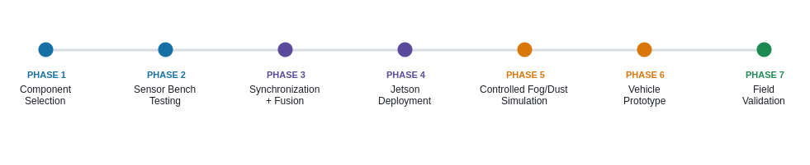

Future Scalability
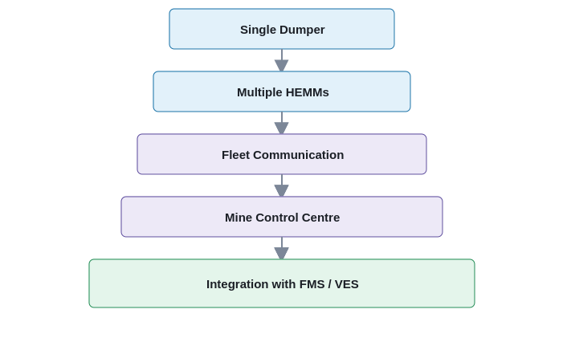
The single-vehicle retrofit described in this report is the entry point. Because the core contribution is an architecture rather than a fixed hardware set, the same fusion and decision approach is intended to extend to multiple HEMMs, fleet-level communication, and eventual integration with NMDC's existing Fleet Management System (FMS) and Vehicle Enhancement System (VES), rather than replacing them.

SECTION 12

References & Existing Work
- SIH26007 — Smart India Hackathon 2026 Problem Statement: "Safe and Efficient Operation of Mine Vehicles in Fog and Low-Visibility Conditions in Open Cast Iron Ore Mines."
- Smart driving-assistance system for open-pit mining under foggy conditions, Bailadila Iron Ore Mines — Discover Applied Sciences / Springer, 2025. https://link.springer.com/article/10.1007/s44291-025-00054-1
- NMDC Annual Report 2018–19 — VES trial evidence at Bailadila Bacheli.
- CSIR-CIMFR Annual Report 2021–22 and 2022–23 — field trials combining cameras, radar, GNSS, V2X and AI-based perception for foggy mine conditions.
- NMDC Sustainability Report 2022–23 — digital systems including VES and FMS for mine safety and monitoring.
- Mining vehicle research paper, Swades Kumar Chaulya, Volume 56, 2024.
- NIOSH Proximity Warning Systems Research, 2007.
- DGMS Circular 07/2025.
Sources listed are those referenced by the project team's own research; no additional citations have been introduced beyond what is used in this report.

