**CHAPTER 1**

**INTRODUCTION**

**1.1 Basic Information**

“ENVIRONMENT” is essential for everyone and present everywhere, that supply all-natural needs in an abundant manner but also, we have some responsibilities towards our environment. In several urban areas although the dustbins are provided so that it can be used by the people but its proper maintenance is also needed lacking of which inhygiene increases destroying our environment day by day also resulting severe adverse effects for mankind. People are more interested to use such technologies which can reduce their time and effort in efficient manner. Automation is the most demandable feature now a day. For this purpose, smart dustbins are the much suitable approach. It will be helpful to develop green and smart city. For this we have to develop a fully automatic dustbin which will be able to detect the current status of dustbin trash level and indicate using led (glow led) or message. In the recent decades, Urbanization has increased tremendously. At the same phase there is an increase in waste production. Waste management has been a crucial issue to be considered. In this project we develop a smart dustbin using arduino sensors and servo motor.

The IR sensor is used to open the dustbin. The output pin is connected to servo motor which will rotate the lever when sensor detects the object in front of it. So, it is fixed in front of dustbin.

Ultrasonic sensor is placed at the top of the dustbin which will measure the stature of the dustbin. Project will be programmed in such a way that when the dustbin is being filled, the remaining height from the threshold height will be displayed. Once the garbage reaches the threshold level ultrasonic sensor will glow the LED. The LED will continuously glow until the required authority squashed the bin. Once the dustbin is squashed, people can reuse the dustbin. At regular intervals dustbin will be squashed. Once these smart bins are implemented on a large scale, by replacing our traditional bins present today, waste can be managed efficiently as it avoids unnecessary lumping of wastes on roadside. Foul smell from these rotten wastes that remain untreated for a long time, due to negligence of authorities and carelessness of public may lead to long term problems. Breeding of insects and mosquitoes can create nuisance around promoting unclean environment. This may even cause dreadful diseases.

**1.2 Recent Scenario**

Though the world is in a stage of up gradation, there is yet another problem that has to be dealt with. Garbage! Pictures of garbage bins being overfull and the garbage being spilled out from the bins can be seen all around. This leads to various diseases as large number of insects and mosquitoes breed on it. A big challenge in the urban cities is solid waste management. Hence, smart dustbin is a system which can eradicate this problem or at least reduce it to the minimum level. Our present Prime Minister of India, Sri. Narendra Modiji has introduced the concept of implementing 100 smart cities in India. “Swachh Bharat Abhiyan” was initiated to ensure a clean environment.

**1.3 Internet of Things**

The Internet of Things, also called The Internet of Objects, refers to a wireless network between objects. Usually the network will be wireless and self-configuring, such as household appliances. Internet of Things refers to the concept that the Internet is no longer just a global network for people to communicate with one another using computers, but it is also a platform for devices to communicate electronically with the world around them. The Internet of Things (IOT) is the network of physical objects—devices, vehicles, buildings and other items which are embedded with electronics, software, sensors, and network connectivity, which enables these objects to collect and exchange data. The Internet of Things allows objects to be sensed and controlled remotely across existing network infrastructure, creating opportunities for more direct integration of the physical world into computer-based systems, and resulting in improved efficiency, accuracy and economic benefit.

**1.4 Arduino and Anti-Theft**

Arduino is an open-source electronics platform based on easy-to-use hardware and software. Arduino Boards are able to read inputs - light on a sensor, a finger on a button, or a Twitter message - and turn it into an output - activating a motor, turning on an LED, publishing something online. You can tell your board what to do by sending a set of instructions to the microcontroller on the board. To do so you use the Arduino programming language (based on Wiring), and the Arduino software IDE, based on processing.

**It also includes antitheft mechanism which will use to protect dustbin from theft. To implement antitheft mechanism it uses IR sensor, buzzer and battery to supply power. Whenever the dustbin moves or displace from its place the buzzer will get activated.**

**1.5 Motivation**

With increase of population, the scenario of cleanliness with respect to garbage management is degrading tremendously. In city there are many public places where garbage bins are placed but are overflowing. This creates unhygienic condition in the nearby surroundings. Also creates ugliness and some serious diseases.

To avoid such situation, we come up with a project called ‘Smart Dustbin’ which is provided with waste collection bins, overflow indicator system and anti-theft mechanism.

One main motivation behind this project is the ongoing campaign Swachh Bharat Abhiyan (Clean India Movement) launched on October 02,2014 at Rajghat, New Delhi by the Prime Minister of India Narendra Modi.

**1.6 Organization of Report**

Chapter one describes about the introduction about the objective and the basic knowledge of hardware components.

Chapter two is the literature review which includes brief description of all the hardware components used in the project. It also describes about Arduino and its IDE.

Chapter three contains the proposed approach. In this, proposed methodology and working of various used components are explained.

Chapter four explains the brief system architecture and UML diagram such as use case diagram and activity diagram.

Chapter five provides the implementation details, working source code and results.

Chapter six deals with the conclusive remark on the conclusion derived from the system with its limitation and future scope.

**CHAPTER 2**

**LITERATURE REVIEW**

**2.1 Arduino**

Arduino is an open source, computer hardware and software company, project, and user community that designs and manufactures microcontroller kits for building digital devices and interactive objects that can sense and control objects in the physical world. The project's products are distributed as open-source hardware and software, which are licensed under the GNU Lesser General Public License (LGPL) or the GNU General Public License (GPL), permitting the manufacture of Arduino boards and software distribution by anyone. Arduino boards are available commercially in preassembled form, or as do-it-yourself kits. Arduino board designs use a variety of microprocessors and controllers. The boards are equipped with sets of digital and analog input/output (I/O) pins that may be interfaced to various expansion boards (*shields*) and other circuits. The boards feature serial communications interfaces, including Universal Serial Bus (USB) on some models, which are also used for loading programs from personal computers. Arduino/Genuino Uno is a microcontroller board based on the ATmega328P (datasheet). It has 14 digital input/output pins (of which 6 can be used as PWM outputs), 6 analog Inputs, a 16 MHz quartz crystal, a USB connection, a power jack, an ICSP header and a reset button. It contains everything needed to support the microcontroller; simply connect it to a computer with a USB cable or power it with a AC-to-DC adapter or battery to get started. You can tinker with your UNO without worrying too much about doing something wrong, worst case scenario you can replace the chip for a few dollars and start over again. "Uno" means one in Italian and was chosen to mark the release of Arduino Software (IDE) 1.0. The Uno board and version 1.0 of Arduino Software (IDE) were the reference versions of Arduino, now evolved to newer releases. The Uno board is the first in a series of USB Arduino boards, and the reference model for the Arduino platform; for an extensive list of current, past or outdated boards see the Arduino index of boards.

**2.1.1 Pins**

**(i) Power USB**

Arduino board can be powered by using the USB cable from your computer. All you need to do is connect the USB cable to the USB connection.

**(ii) Power (Barrel Jack)**

Arduino boards can be powered directly from the AC mains power supply by connecting it to the Barrel Jack.

**(iii) Voltage Regulator**

The function of the voltage regulator is to control the voltage given to the Arduino board and stabilize the DC voltages used by the processor and other elements.

**(iv) Arduino Reset**

You can reset your Arduino board, i.e., start your program from the beginning. You can reset the UNO board in two ways. First, by using the reset button on the board. Second, you can connect an external reset button to the Arduino pin labelled RESET.

**(v) Pins (3.3, 5, GND, Vin)**

* 3.3V − Supply 3.3 output volt
* 5V - Supply 5 output volt
* Most of the components used with Arduino board works fine with 3.3 volt and 5 volt.
* GND (Ground): There are several GND pins on the Arduino, any of which

can be used to ground your circuit.

* Vin: This pin also can be used to power the Arduino board from an external power source, like AC mains power supply.

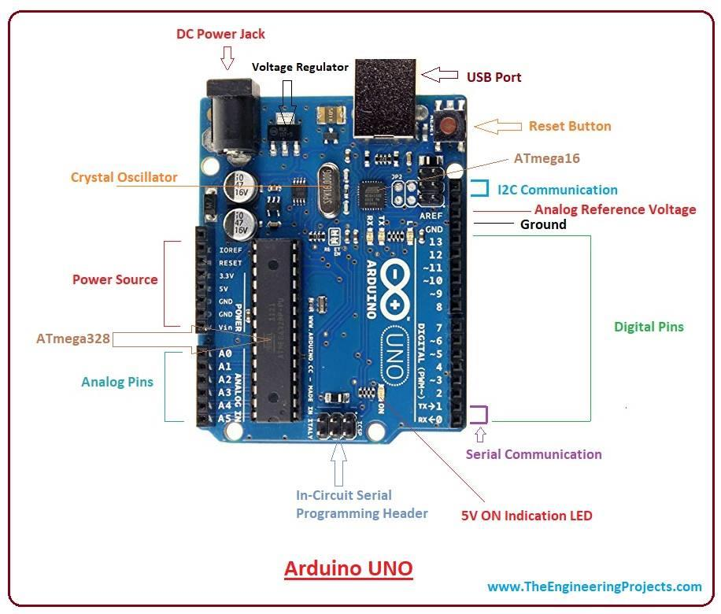

Fig 2.1 Pin diagram of Arduino

**(vi) Analog pins**

The Arduino UNO board has six analog input pins A0 through A5. These pins can read the signal from an analog sensor like the humidity sensor or temperature sensor and convert it into a digital value that can be read by the microprocessor.

**(vii) Main microcontroller**

Each Arduino board has its own microcontroller. You can assume it as the brain of your board. The main IC (integrated circuit) on the Arduino is slightly different from board to board. The microcontrollers are usually of the ATMEL Company. You must know what IC your board has before loading up a new program from the Arduino IDE. This information is available on the top of the IC. For more details about the IC construction and functions, you can refer to the data sheet.

**(viii) Power LED indicator**

This LED should light up when you plug your Arduino into

a power source to indicate that your board is powered up correctly. If this light does not

turn on, then there is something wrong with the connection.

**(ix) TX and RX LEDs**

On your board, you will find two labels: TX (transmit) and RX (receive). They appear in two places on the Arduino UNO board. First, at the digital pins 0 and 1, to indicate the pins responsible for serial communication. Second, the TX and RX led. The TX led flashes with different speed while sending the serial data. The speed of flashing depends on the baud rate used by the board. RX flashes during the receiving process.

**(x) Digital I/O**

The Arduino UNO board has 14 digital I/O pins. These pins can be configured to work as input digital pins to read logic values (0 or 1) or as digital output pins to drive different modules like LEDs, relays, etc. The pins labelled can be used to generate PWM.

**(xi) AREF**

AREF stands for Analog Reference. It is sometimes, used to set an external reference voltage (between 0 and 5 Volts) as the upper limit for the analog input pins. Microcontroller- ATmega2560

Operating Voltage: 5V

Input Voltage (recommended): 7-12V

Input Voltage (limit): 6-20V

**2.2 ULTRASONIC SENSOR**

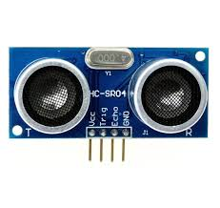The HC-SR04 ultrasonic sensor uses SONAR to determine the distance of an object just like the bats do. It offers excellent non-contact range detection with high accuracy and stable readings in an easy-to-use package from 2 cm to 400 cm or 1” to 13 feet. The operation is not affected by sunlight or black material, although acoustically,soft materials like cloth can be difficult to detect. It comes complete with ultrasonic transmitter and receiver module.

Fig 2.2 Ultrasonic sensor

|  |  |  |
| --- | --- | --- |
| **Pin Number** | **Pin Name** | **Description** |
| 1 | Vcc | The Vcc pin powers the sensor, typically with +5V |
| 2 | Trigger | Trigger pin is an Input pin. This pin has to be kept high for 10us to initialize measurement by sending US wave. |
| 3 | Echo | Echo pin is an Output pin. This pin goes high for a period of time which will be equal to the time taken for the US wave to return back to the sensor. |
| 4 | Ground | This pin is connected to the Ground of the system. |

Table 2.2 Pin description Ultrasonic Sensor

**2.3 Servo Motor:**

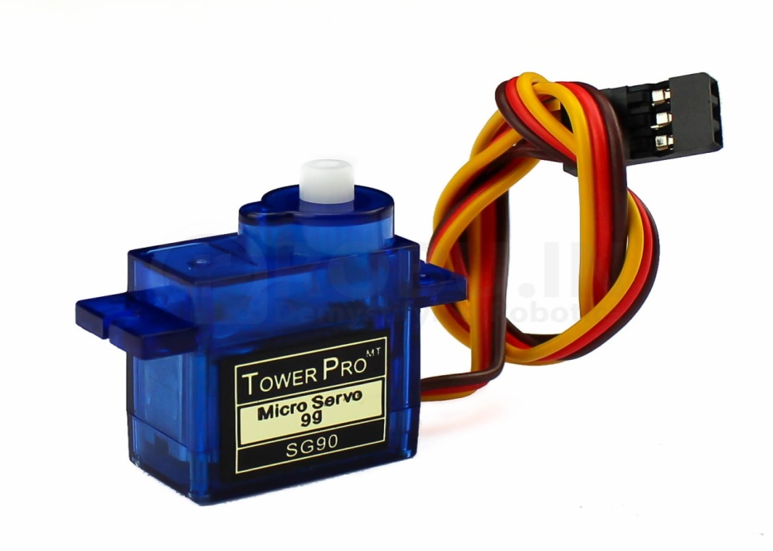A Servo Motor is a small device that has an output shaft. This shaft can be positioned to specific angular positions by sending the servo a coded signal. As long as the coded signal exists on the input line, the servo will maintain the angular position of the shaft. If the coded signal changes, the angular position of the shaft changes. In practice, servos are used in radio-controlled airplanes to position control surfaces like the elevators and rudders. They are also used in radio-controlled cars, puppets, and of course, robots.

Fig 2.3 Servo Motor

Servos are extremely useful in robotics. The motors are small, have built-in control circuitry, and are extremely powerful for their size. A standard servo such as the Futaba S-148 has 42 oz/inches of torque, which is strong for its size. It also draws power proportional to the mechanical load. A lightly loaded servo, therefore, does not consume much energy. The guts of a servo motor is shown in the above picture. You can see the control circuitry, the motor, a set of gears, and the case. You can also see the 3 wires that connect to the outside world. One is for power (+5volts), ground, and the white wire is the control wire.

|  |  |  |
| --- | --- | --- |
| **Wire Number** | **Wire Color** | **Description** |
| **1.** | Brown | Ground wire connected to the ground of system |
| **2.** | Red | Powers the motor typically +5V is used |
| **3.** | Orange | PWM signal is given in through this wire to drive the motor |

Table 2.3 Pin description of Servo Motor

**2.3.1 Working of a Servo Motor:**

The servo motor has some control circuits and a potentiometer connected to the output shaft. In the picture above, the pot can be seen on the right side of the circuit board. This pot allows the control circuitry to monitor the current angle of the servo motor. If the shaft is at the correct angle, then the motor shuts off. If the circuit finds that the angle is not correct, it will turn the motor until it is at a desired angle. The output shaft of the servo is capable of traveling somewhere around 180 degrees. Usually, it is somewhere in the 210-degree range, however, it varies depending on the manufacturer. A normal servo is used to control an angular motion of 0 to 180 degrees. It is mechanically not capable of turning any farther due to a mechanical stop built on to the main output gear. The power applied to the motor is proportional to the distance it needs to travel. So, if the shaft needs to turn a large distance, the motor will run at full speed. If it needs to turn only a small amount, the motor will run at a slower speed. This is called **proportional** **control**.

**How Do You Communicate the Angle at Which the Servo Should Turn?**

The control wire is used to communicate the angle. The angle is determined by the duration of a pulse that is applied to the control wire. This is called **Pulse Coded.**

**Modulation**: The servo expects to see a pulse every 20 milliseconds (.02 seconds). The length of the pulse will determine how far the motor turns. A 1.5 millisecond pulse, for example, will make the motor turn to the 90-degree position (often called as the neutral position). If the pulse is shorter than 1.5 milliseconds, then the motor will turn the shaft closer to 0 degrees. If the pulse is longer than 1.5 milliseconds, the shaft turns closer to 180 degrees.

**2.4** **IR sensor**

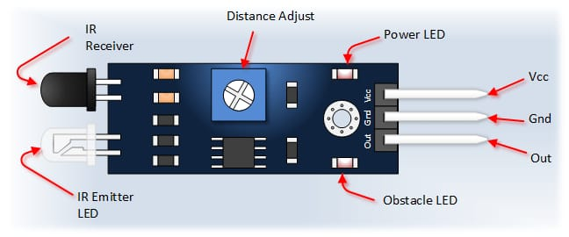The principle of an IR sensor working as an Object Detection Sensor can be explained using the following figure. An IR sensor consists of an IR LED and an IR Photodiode; together they are called as Photo – Coupler or Opto – Coupler.

Fig 2.4 IR Sensor

|  |  |
| --- | --- |
| **Pin Name** | **Description** |
| VCC | Power Supply Input |
| GND | Power Supply Ground |
| OUT | Active High Output |

Table 2.4 Pin description of IR Sensor

**2.4.1 WORKING OF IR SENSOR**

When the IR transmitter emits radiation, it reaches the object and some of the radiation reflects back to the IR receiver. Based on the intensity of the reception by the IR receiver, the output of the sensor is defined.

[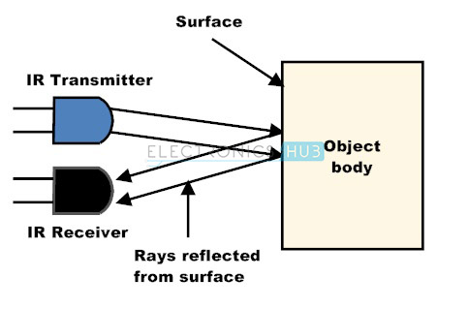](https://www.electronicshub.org/wp-content/uploads/2015/01/4.-Working-principle-of-IR-sensor.jpg)Fig.2.4.1 Working Principle

**2.5 Breadboard**

A breadboard is a construction base for prototyping of electronics. Originally it was literally a bread board, a polished piece of wood used for slicing bread. Because the solderless breadboard does not require soldering, it is reusable. This makes it easy to use for creating temporary prototypes and experimenting with circuit design. For this reason, solderless breadboards are also extremely popular with students and in technological education. Older breadboard types did not have this property. A stripboard (Vero board) and similar prototyping printed circuit boards, which are used to build semi-permanent soldered prototypes or one-offs, cannot easily be reused. A variety of electronic systems may be prototyped by using breadboards, from small analog and digital circuits to complete central processing units (CPUs).

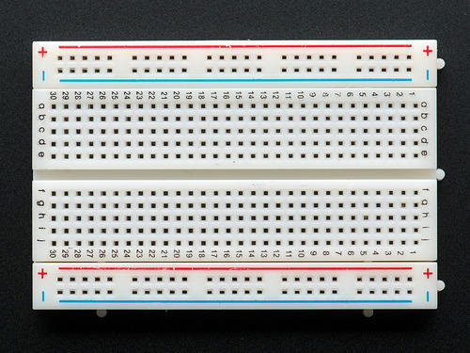

Fig.2.5 Breadboard

**2.6 Aims and Objectives**

**Aim**

Aim of this project is to develop a Smart Dustbin that will operate automatically with Anti-Theft mechanism.

**Objectives**

* To design and build a prototype for an automatic open dustbin that can automatically open the lid when it detects the people who want to throw out their trash. It also can detect the level of trash that inside the bin.
* To study arduino and IoT.
* To achieve knowledge of various sensors such as IR sensor, Ultrasonic sensor.

**CHAPTER 3**

**PROPOSED APPROACH**

Nowadays population is increasing rapidly, which results in lack of public awareness and people invest less money in programs related to the waste management. This has been creating a huge health issues all over the world. Proper management of waste materials is important to maintain healthy and hygienic environment to live. As per the research of CPHEEO (Central Public Health and Environmental Engineering Organization) the total amount of waste generated in India is approximately 1.3 pounds per person every single day. This figure is comparatively less compared to 4.6 pounds of waste generated per person everyday in the United State (U.S.). But the U.S. population was approximately 307 million in July 2009, whereas India’s population was 1.2 billion. These statistics shows that India is generating almost 27 million more tons of waste than the U.S. every year. Government of India have been struggling for many years to find a way to manage the country’s increasing amount of garbage. To manage this garbage, there are some methods that has already been developed. The first method was developed using LCD and weight sensor. They have used weight sensor for detecting the weight of garbage in the dustbin, however weight sensor doesn’t give any information about the distance in the dustbin. So, a latest system they have replaced weight sensor with IR sensor to sense the distance between garbage in dustbin. The IR sensor radiates light. IR sensor consists of transmitter and receiver. Now, in this system it replaces the IR sensor with ultrasonic sensor. The detailed workflow of system is further discussed in report.

**3.1 Automatic opening mechanism**

To implement the automatic opening of dustbin it requires ultrasonic sensor, servo motor and power supply. The ultrasonic sensor has four pins. The Vcc and ground pin of the sensor are connected to the Vcc and ground of Arduino. The Trigger and Echo pins are used as 5 and 6 respectively. Whenever any thing comes near to that sensor, a signal is received by arduino through ultrasonic sensor then arduino sends the signal to the servo motor in response of the input signal, servo motor starts functioning and hence it opens the dustbin.

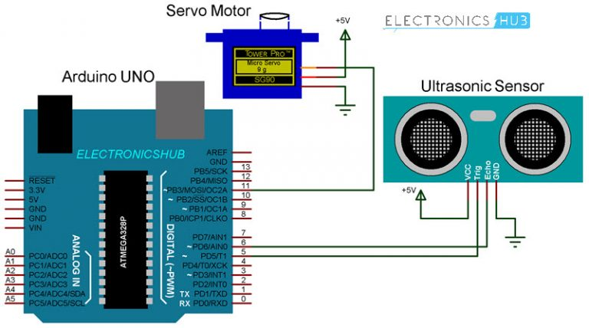

Fig.3.1 Pin connection of servo motor and ultrasonic sensor with arduino

**3.2 Antitheft Mechanism**

To implement anti-theft mechanism it uses buzzer, IR sensor and arduino. The arduino is code in such a way that it’s digital pin send high output to the buzzers positive pin when it cannot detect any object in front of it.

The IR sensor has three pins Vcc, Output and Ground pin. The Vcc and Ground pins are connected to the Vcc and ground of arduino respectively. The output pin is connected to the positive of buzzer. The arduino is programmed in such a way that when it detects any motion around it fires the buzzer.

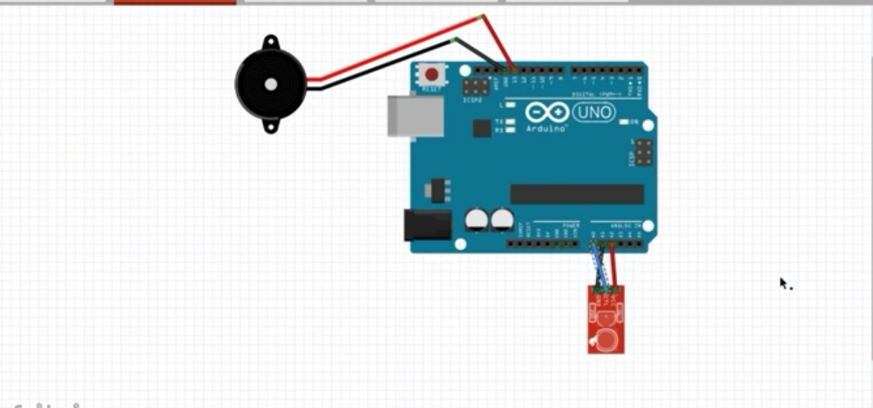

Fig.3.2: Antitheft Mechanism

**3.3 Level Indicator**

Garbage Level Indicator using IR sensor and arduino is an amazing and very useful project. The objective of this project is to notify the user the amount of garbage that is present in the dustbin. In ‘smart garbage management system’, the level of garbage in the dustbins is detected with the help of Sensor systems, and communicated to the authorized control room through LEDs. When the dustbin is empty it signals green and when it gets full signals as red. After it signals red, dustbin will be locked automatically and it means we have to truncate the garbage at proper place. The circuit diagram for this is shown below

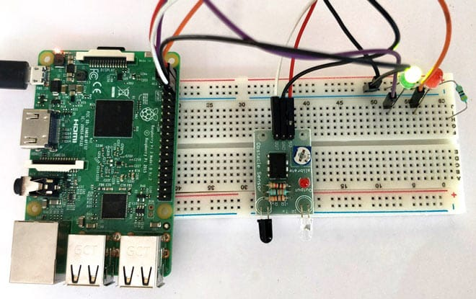

Fig.3.3 Level Indicator

**CHAPTER 4**

**Implementation and System architecture**

The IOT Garbage Monitoring system is a very innovative system which will help to keep the cities clean. This system monitors the garbage bins and informs about the level of garbage collected in the garbage bins via LEDs. For this the system uses IR sensors placed over the bins to detect the garbage level and compare it with the garbage bins depth. The system makes use of arduino family microcontroller, Ultrasonic sensor and a buzzer. The LEDs are used to display the status of the level of garbage collected in the bins.

TURN ON RED LED TURN ON BUZZER

YES

CHECK WHETHER PERSON IS NEAR TO DUSTBIN?

CHECK WHETHER Dustbin is full?

TURN ON MOTOR

GREEN LED ON

YES

NO

NO

NO

Fig 4 Flow chart of smart dustbin

**4.1 Steps for installation IDE**

1. Go to  <https://www.arduino.cc/en/Main/Software>
2. Install based on your operating system.
3. Once installed, Connect the Arduino board to the PC using USB port
4. Open the shortcut icon in the desktop/start menu.  
   Note: If you open the arduino IDE, without connecting the arduino board then as shown in the below figure the port will not be enabled.

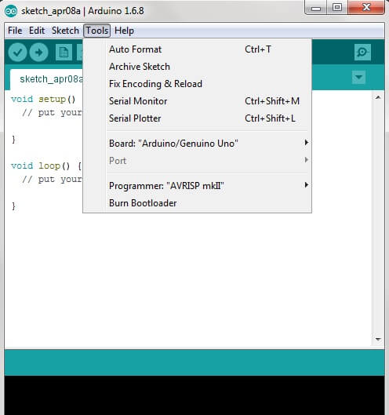

1. So first connect the arduino board and then open the IDE, now as shown in the below figure, the port will be activated.

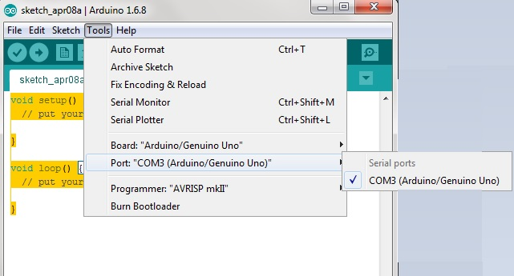

1. Now try some basic example projects comes along with the software.

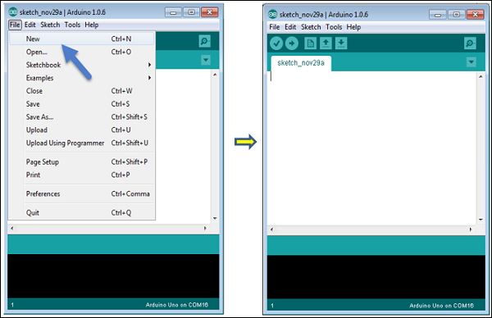

**A** − Used to check if there is any compilation error.

**B** − Used to upload a program to the arduino board.

**C** − Shortcut used to create a new sketch.

**D** − Used to directly open one of the example sketch.

**E** − Used to save your sketch.

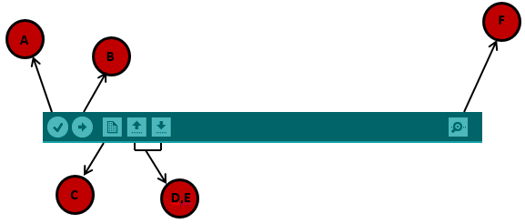**F** − Serial monitor used to receive serial data from the board and send the serial data to the board.

**4.2 Arduino Programming**

The source code for the IDE is released under the  [Lesser General Public License](https://en.wikipedia.org/wiki/GNU_General_Public_License) (LGPL), version 2. The Arduino IDE supports the languages [C](https://en.wikipedia.org/wiki/C_(programming_language)) and [C++](https://en.wikipedia.org/wiki/C%2B%2B) using special rules of code structuring. The Arduino IDE supplies a [software library](https://en.wikipedia.org/wiki/Software_library) from the [wiring](https://en.wikipedia.org/wiki/Wiring_(development_platform)) project, which provides many common input and output procedures. User-written code only requires two basic functions, for starting the sketch and the main program loop, that are compiled and linked with a program stub main() into an executable [cyclic executive](https://en.wikipedia.org/wiki/Cyclic_executive) program with the [GNU toolchain](https://en.wikipedia.org/wiki/GNU_toolchain). The arduino language is merely a set of C/C++ functions that can be called from your code.

**4.2.1 Functions used**

1. pinMode(): Configure the specified pin to as either input pin or output pin.

Syntax: pinMode(pin,mode)

1. digitalRead(): Reads the value from a specified digital pin either high or low.

Syntax: digitalRead(pin)

1. digitalWrite(): Write a high or low value to the digital pin.

Syntax: digitalWrite(pin,value)

1. delay(): Pause the program for the amount of time specified as parameter.

**4.3 UML diagrams**

**4.3.1 Use case diagram**

Smart dustbin system

User

Municipal Corporation

Fig.4.3.1 Use case diagram

**4.3.2 Activity diagram**

Output on IDE

Data processing

Output data to arduino

Collect data through ultrasonic sensor

Power supply

Fig. 4.3.2 Activity Diagram

**4.4 Source code**

**4.4.1 Interfacing of arduino with servo motor and ultrasonic sensor**

#include <Servo.h> //servo library

Servo servo;

int trigPin = 5;

int echoPin = 6;

int servoPin = 7;

//int led= 10;

long duration, dist, average;

long aver[3]; //array for average

void setup() {

Serial.begin(9600);

servo.attach(servoPin);

pinMode(trigPin, OUTPUT);

pinMode(echoPin, INPUT);

servo.write(0); //close cap on power on

delay(100);

servo.detach();

}

void measure() {

digitalWrite(trigPin, LOW);

delayMicroseconds(5);

digitalWrite(trigPin, HIGH);

delayMicroseconds(15);

digitalWrite(trigPin, LOW);

pinMode(echoPin, INPUT);

duration = pulseIn(echoPin, HIGH);

dist = (duration/2) / 29.1; //obtain distance

}

void loop() {

for (int i=0;i<=2;i++) { //average distance

measure();

aver[i]=dist;

delay(10); //delay between measurements

}

dist=(aver[0]+aver[1]+aver[2])/3;

if ( dist<15) {

//Change distance as per your need

servo.attach(servoPin);

delay(1);

servo.write(75);

delay(2000);

servo.write(150);

delay(1000);

servo.detach();

}

Serial.print(dist);

}

**4.4.2 Interfacing of arduino with IR and buzzer**

#define ir 8

#define buz 9

void setup() {

Serial.begin(9600);

pinMode(buz,OUTPUT);

pinMode(ir,INPUT);

}

void loop() {

if(digitalRead(ir)==1)

{

digitalWrite(buz,0);

delay(1000);

}

else

{

digitalWrite(buz,1);

}

}

**4.4.3 Interfacing of arduino with IR sensor and LEDs**

#define irr 8

#define rled1 9

#define gled2 10

void setup()

{

Serial.begin(9600);

pinMode(rled1,OUTPUT);

pinMode(gled2,OUTPUT);

pinMode(ir,INPUT);

}

void loop()

{

if(digitalRead(irr)==1)

{

digitalWrite(rled1,1);

digitalWrite(gled2,0);

}

else

{

digitalWrite(gled2,1);

digitalWrite(rled1,0);

}

}

**CHAPTER 5**

**RESULTS AND DISCUSSION**

The dustbin is able to open the lid with the help of servo motor and ultrasonic sensor whenever it detects motion. The IR sensor is giving the details about the waste present in the dustbin. The status of the waste is shown with the help of LEDs.

**5.1 Test result for opening mechanism**

The dustbin is able to open the lid with the help of servo motor and ultrasonic sensor whenever it detects motion.

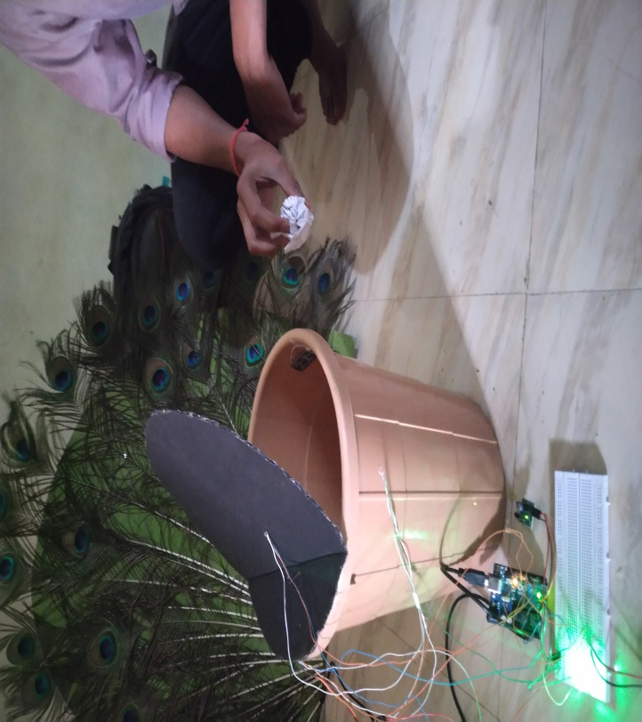

Fig.5.1 Result of opening mechanism

**5.2 Test result for antitheft mechanism**

Whenever the dustbin is moves from its position its fires the buzzeralong with red LED.

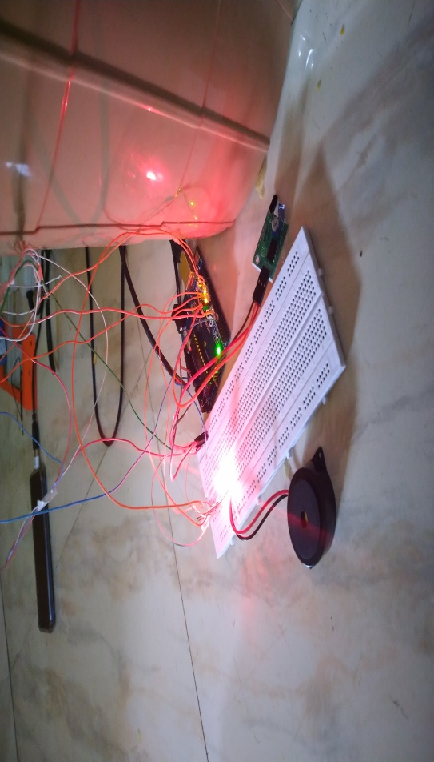

Fig. 5.2 Result of anti-theft mechanism

**5.3 Test result for level indicator**

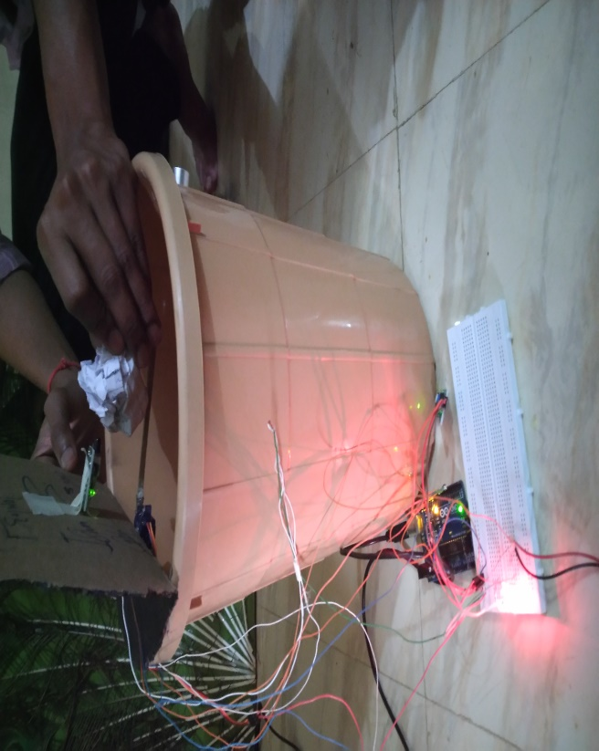The IR sensor is giving the details about the waste present in the dustbin. The status of the waste is shown with the help of LEDs.

Fig.5.3 Result of level detection

**CHAPTER 6**

**CONCLUSION**

Smart dustbins are the now the needs of Smart buildings. Smart waste monitoring and management is the keen idea of smart city planners. Smart dustbins is a new idea of implementation which makes a normal dustbin smart using sensors for garbage level detection and sending message to the user updating the status of the bin. As soon as the dustbin is full it moves in the predefined path to reach the larger container with the help of motors and wheels. The garbage is dumped to the container manually and the dustbin moves back in the same direction back to its initial place.

**6.1 Limitation of study**

* It is related to the usage of the IR sensor. Trash is non-uniformly distributed inside the container. Simple distance measurement leads to false fill level measurement. Although several software procedures were proposed to increase the accuracy of this sensor, unfortunately, results remain poor.
* Connections must be correct and tight-bounded to get accurate results.

**6.2 Future scope of work**

There is a great scope for the modifications of the Smart Dustbin in future. The system can be improved by adding new functionalities. Dumping of the waste was manual in smart dustbin this can be automated by fixing a robot arm or a tipper. The path tracking can be GPS enabled and the dustbins can be monitored through a GUI. The Smart dustbins can be well widely used in the smart buildings of smart cities.

**References**

1. <https://www.electronicshub.org/ir-sensor/>[Accessed on:14th February 2019 at 4:30 pm]
2. <http://www.electronicwings.com/sensors-modules/ultrasonic-module-hc-sr04>/[Accessed on:13th February 2019 at 11:30 am]
3. <https://www.arduino.cc/reference/en/>[Accessed on:13th February 2019 at 4:10 pm]
4. Parth Dwivedi, Suresh Sankarnarayanan and Vishwas Choudhary (2017). “IoT Based Smart Garbage Management System”, International Journal of Advanced Trends in Computer Science and Engineering, ISSN 2271-3091.
5. <https://www.youtube.com/watch?v=9yrP1CZN3Ds>[Accessed on:28th January 2019 at 5:00 pm]
6. <https://www.researchgate.net/publication/316700582_SMART_DUSTBIN_FOR_ECONOMIC_GROWTH>[Accessed on:28th January 2019 at 4:40 pm]