A PROJECT REPORT

on

“AI-Enabled FinTech B2B Invoice Management Application”

Submitted to

KIIT Deemed to be University

In Partial Fulfilment of the Requirement for the Award of

BACHELOR’S DEGREE
IN

COMPUTER SCIENCE AND ENGINEERING

BY

VISHAL SINGH

1905704

UNDER THE GUIDANCE OF

MENTOR NAME
DHUVI KALYANRAM,VARUN
(HOUSE-DAREDEVIL)


SCHOOL OF COMPUTER ENGINEERING

KALINGA INSTITUTE OF INDUSTRIAL TECHNOLOGY

BHUBANESWAR, ODISHA - 751024

May 2020

A PROJECT REPORT

on

“AI-Enabled FinTech B2B Invoice Management Application”

Submitted to

KIIT Deemed to be University

In Partial Fulfilment of the Requirement for the Award of

BACHELOR’S DEGREE IN
COMPUTER SCIENCE AND ENGINEERING

BY

VISHAL SINGH 1905704

UNDER THE GUIDANCE OF

MENTOR NAME
DHUVI KALYANRAM,VARUN
(HOUSE-DAREDEVIL)

SCHOOL OF COMPUTER ENGINEERING

KALINGA INSTITUTE OF INDUSTRIAL TECHNOLOGY

BHUBANESWAE, ODISHA -751024
May 2022

KIIT Deemed to be University

School of Computer Engineering
Bhubaneswar, ODISHA 751024

CERTIFICATE

This is certify that the project entitled

“AI-Enabled FinTech B2B Invoice Management Application”

submitted by

VISHAL SINGH

1905704

is a record of bonafide work carried out by them, in the partial fulfilment of the requirement for the award of Degree of Bachelor of Engineering (Computer Sci-ence & Engineering OR Information Technology) at KIIT Deemed to be university, Bhubaneswar. This work is done during year 2022-2023, under our guidance.

Date: 14/04/2022

DHUVI KALYANRAM,VARUN
Project Mentor

Acknowledgements

We are profoundly grateful to DHUVI KALYANRAM and VARUN of HighRadius Corporation for his expert guidance and continuous encouragement throughout to see that this project rights its target since its commencement to its completion. Also thankful to all other moderators who guided us in Project and enhanced our skills.

VISHAL SINGH
B.Tech(CSE)
1905704

ABSTRACT

Seller business interacts with various businesses and sells goods to all of them at various times. Hence, the seller business needs to keep track of the total amount it owes from all the buyers. This involves keeping track of all invoices from all the buyers. Each invoice will have various important fields like a payment due date, invoice date, invoice amount, baseline date etc.
The buyer business needs to clear its amount due before the due date. However, in real-world scenarios, the invoices are not always cleared ie. paid in full amount by the due date. The date on which a customer clears the payment for an invoice is called the payment date.
Account receivables Department:
In the ideal world, the buyer business should pay back within the stipulated time (ie the Payment Term). However, in the real world, the buyer business seldom pays within their established time frame, and this is where the Account Receivables Department comes into the picture.
Every business consists of a dedicated Account receivables Department to collect and track payment of invoices.
It consists of an Account receivables team that is responsible for:
- Collecting payments from customers for their past due to invoices.
- Sending reminders and follow-ups to the customers for payments to be made.
- Looking after the entire process of getting the cash inflow.
- Help the company get paid for the services and products supplied.

Keywords: B2B,Invoice,Payment Date Prediction,Accounts Receivable,Analytics

Contents

1 | Introduction |  |  | 1
2 | Basic Concepts |  |  | 2
 | 2.1 | Sub Section Name........................... |  | 2
3 | Problem Statement / Requirement Specifications |  |  | 3
 | 3.1 | Project Planning........................... |  | 3
 | 3.2 | Project Analysis........................... |  | 3
 | 3.3 | System Design ………………….. |  | 3
 |  | 3.3.1 | Design Constraints …… | 3
 |  | 3.3.2 | System Architecture / Block Diagram … | 3
4 | Implementation |  |  | 4
 | 4.1 | Methodology / Proposal ........................... |  | 4
 | 4.2 | Testing / Verification Plan ……………. |  | 4
 | 4.3 | Result Analysis / Screenshots …………. |  | 4
 | 4.4 | Quality Assurance …………………….. |  | 4
5 | Standard Adopted |  |  | 5
 | 5.1 | Design Standards . . . . . . . . . . . . . . . |  | 5
 | 5.2 | Coding Standards . . . . . . . . . . . . . . |  | 5
 | 5.3 | Testing Standards . . . . . . . . . . . . . . . |  | 5
6 | Conclusion and Future Scope |  |  | 6
 | 6.1 | Conclusion ……………………….. |  | 6
 | 6.2 | Future Scope ………………………. |  | 6
References |  |  |  | 7
Individual Contribution |  |  |  | 8
Plagiarism Report |  |  |  | 9

List of Figures

1.1 | SYSTEM ARCHITECTURE | 2
1.2 | PREDICTION | 9
1.3 | SEARCH
1.4 | ANALYTICS VIEW
1.5 | ADVANCE SEARCH

B2B INVOICE MANAGMENT APP

Chapter 1

Introduction

The B2B world operates differently from the B2C or C2C world. Businesses work with other businesses on credit. When a buyer business orders goods from the seller business, the seller business issues an invoice for the same. This invoice for the goods contains various information like the details of the goods purchased and when it should be paid. This is known in accounting terminology as “Accounts Receivable” and thus we need an application for keeping record of invoices and predict when the invoices are going to pe paid.

School of Computer Engineering, KIIT, BBSR 1

B2B INVOICE MANAGMENT APP

Chapter 2

Basic Concepts

Machine Learning : Pandas,Numpy,Matplotlib,Scikit-learn
Frontend : HTML,CSS,JavaScript,React.js
Backend : Java,Servlets,JDBC,JSP,Flask,MySQL
Tools : Eclipse IDE,TomCat Server,Postman API Testing Tools,SQL Yog,Jupyter Notebook
2.1 Machine Learning -
Pandas,Numpy,Matplotlib,Scikit-learn are the basic library used for data processing and making plots for analysis and furthur making prediction of payment Date

2.2 Frontend -
In frontend mainly React.js (a javascript library) is Used for Creating UI for our Invoice Managment application.

2.3 Backend -
In Backend JavaServlets are used for CRUD operation in Database.

2.4 Tools -
Eclipse IDE is used for maintaning backend Java Part ,and we have two servers Tomcat and Flask for handling API request from FrontEnd.

School of Computer Engineering, KIIT, BBSR 2

B2B INVOICE MANAGMENT APP

Chapter 3

Problem Statement / Requirement Specifications

To Build a web application to help the people working in the Accounts Receivable departments in their day-to-day activities. we need to build a web application where the users in the Account Receivable department can keep record of invoice and get pridiction of Payment Date using Machine Learning.

REQUIREMENTS OF APPLICATION-
Specifically, below are the major aspects of the application that needs to be developed. The details for each of the below are provided in the functional overview section.
Data Loading in DB:
- You will be provided with an invoices dataset which you need to parse, process, and load in the provided database schemas.
UI Representation of the data:
- Build a responsive UI that can display the invoice data loaded from the database.
- The UI should support searching and pagination
- The UI should support editing of some editable fields, adding a new row to the grid, deleting rows from the grid and advance search.
AI Support in the application:
- Add support for predicting the payment date for one or more invoice(s).
- UI should have a button to trigger the prediction of the payment date.
The payment date needs to be persisted across sessions in the UI.

3.1 Project Planning

First ML model is designed from given Dataset that Predicts Payment Date and then Front end UI is developed. Here are the list of Feactures that web application has:
- View the invoice data from various buyers.
- See various fields/attributes of the invoice(s) from a particular buyer.
- Perform Data Pre-processing on the invoice data.
- Get account-level analytics to easily visualize and interpret data- EDA and Feature Engineering.

- Get a prediction of when the invoice is going to get paid.
- Get a responsive Receivables Dashboard.
- Visualize Data in the form of grids.
- Visualize Data in the form of graphs.
- Perform Searching operations on the invoices.
- Add & Edit data in the editable fields of the grid.
- Delete data of selected rows in predefined templates.

3.2 Project Analysis

After the requirements are collected or the problem statements is conceptualized, this needs to be analyzed for finding any short of ambiguity, mistake, etc.

3.3 System Design

3.3.1 Design Constraints

In designing our ML model Jupyter Notebook , For backend Java part Eclipse IDE is used and For Creating UI React Setup is needed.

3.3.2 System Architecture OR Block Diagram
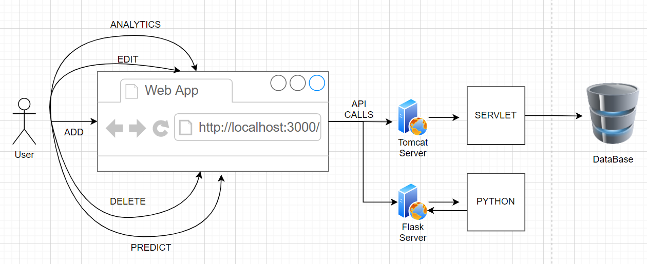.

Figure 1.1: SYSTEM ARCHITECTURE

School of Computer Engineering, KIIT, BBSR 3

B2B INVOICE MAMANGMENT APP

Chapter 4

Implementation

In this section, present the implementation done by you during the project development.

4.1 Methodology OR Proposal
In Machine Learning Part we started with cleaning of given data and performed spilitting of data,EDA,Feature Engineering ,Feature Selection,Modelling and finally predicted the payment date using that Model .
In React UI Datagrid is used for showing data and react-chart-js2 for analytics view.
In Backend Servlets are used to Perform CRUD on databases connected by JDBC.

4.2 Testing OR Verification Plan
After project work is compete, it must have some verification criterion so that we can decide whether the project satisfactorily completed or not. This is called Testing or verification. For example, in software development, some test case must be included and used to verify the outcome of the project.

Test | Test Case Title | Test Condition | System Behavior | Expected Result
ID
T01 | Predict Payment Date | On Selection of atleast one row it should activated | Aging Bucket populated with Predicted Value | Aging Bucket should be populated with Predicted Value
T02 | Add a Invoice in Data | Button should be in disabled state until a row is selected | A row added in invoices table with given data | A row should be added in invoices table with given data
T03 | Edit Data | Button should be activated on single row selection | Data edited with given value | Data should edited with given value
T04 | Delete Data | Button activated on selecting alteast one row | Is_deleted column set to 1 i.e; row deleted from invoice table | Selected Rows[s] should be deleted from Table
T05 | Search Data | Search by Customer number | Shows only row matching with customer ID | Should Show only row matching with customer ID
T06 | Advance Search | Search data based on given values | Shows only rows matching with Given data | Should Show only rows matching with Given data
T07 | Analytics View | Show Bar chart  For all Businesses with Total No. Customers and total amount open | Showing Bar chart for Given Data | Should display Bar chart/Pie Chart for Given Data

4.3 Result Analysis OR Screenshots

Prediction:
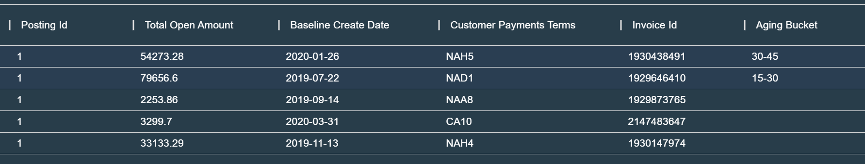
Figure 1.2: PREDICTION

Search by customer Id:
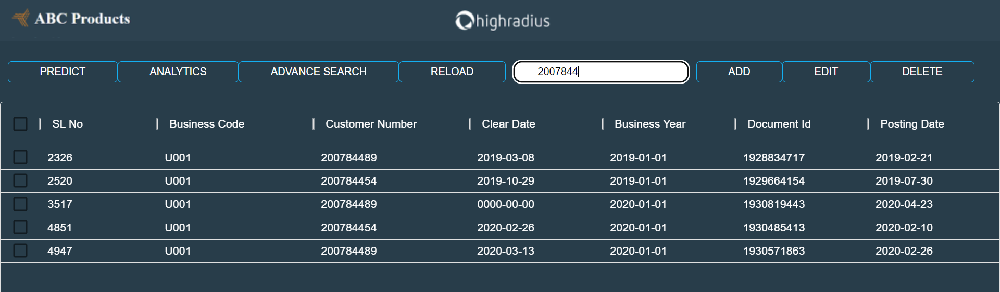
Figure 1.3: SEARCH

B2B INVOICE MANAGMENT APP

Analytics:
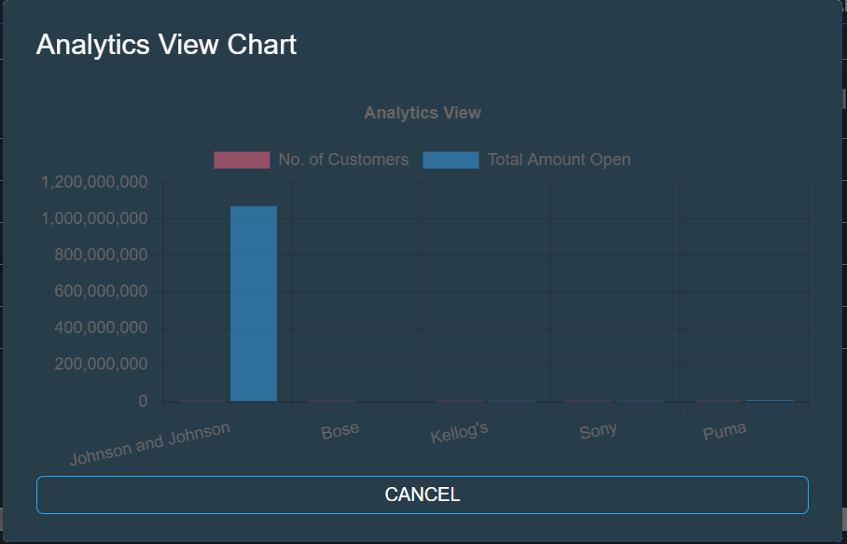
Figure 1.4: ANALYTICS VIEW

Advance Search:
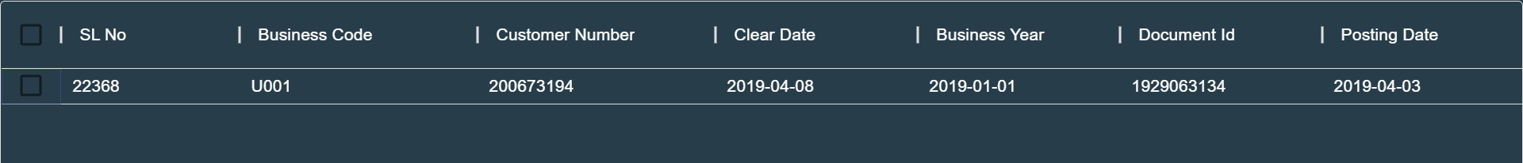
Figure 1.5: ADVANCE SEARCH

School of Computer Engineering, KIIT, BBSR 4

B2B INVOICE MANAGMENT APP

Chapter 5

Standards Adopted

5.1 Design Standards
In all the engineering streams, there are predefined design standards are present such as IEEE, ISO etc. List all the recommended practices for project design. In software the UML diagrams or database design standards also can be followed.

5.2 Coding Standards
Coding standards are collections of coding rules, guidelines, and best practices. Few of the coding standards are:
- Write as few lines as possible.
- Use appropriate naming conventions.
- Segment blocks of code in the same section into paragraphs.
- Use indentation to marks the beginning and end of control structures. Clearly specify the code between them.
- Don’t use lengthy functions. Ideally, a single function should carry out a single task.
…...

5.3 Testing Standards
There are some ISO and IEEE standards for quality assurance and testing of the product. Mention the standards followed for testing and verification of your project work.

School of Computer Engineering, KIIT, BBSR 5

B2B INVOICE MANAGMENT APP

Chapter 6

Conclusion & Future Scope

6.1 Conclusion

As we Know every companies have to keep track of its invoices and Every business consists of a dedicated Account receivables Department to collect and track payment of invoices and payments due to customers. Our web application can predict payment prediction date for the perticular customer with accuracy of Model approx 80 Percent and we can also send reminders and follow-ups to the customers for payments to be made and also use analytics data to make some business decisions.

6.2 Future Scope

This Web application scope will go on high as the number of cutomers in a business go high ,beacuse it won’t be easy to manage payments of such number of customer without this application and furthur enhancment can be done in application to send reminders and follow-ups to the customers for payments to be made.

School of Computer Engineering, KIIT, BBSR 6

References

- https://machinelearningmastery.com/train-test-split-for-evaluating-machine-learning-algorithms/#:~:text=Split%20for%20Regression-,Train%2DTest%20Split%20Evaluation,dividing%20it%20into%20two%20subsets.

- https://docs.oracle.com/javaee/7/api/javax/servlet/http/HttpServlet.html

- https://reactjs.org/tutorial/tutorial.html

- https://mui.com/x/react-data-grid/

[5]https://mui.com/material-ui/react-dialog/

TURNITIN PLAGIARISM REPORT

School of Computer Engineering, KIIT, BBSR 9

