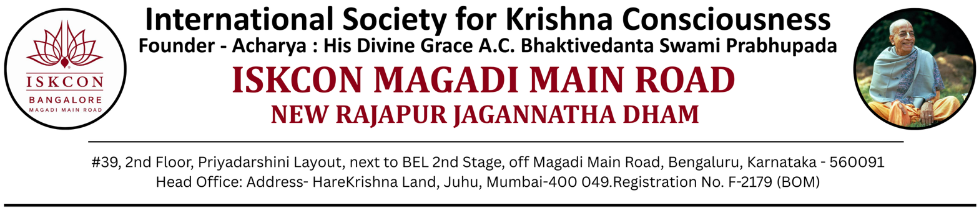
NANDOTSAV – 2026
Aug 17, 2026
To,
The Principal,
{School Name}
Bengaluru

SUBJECT: NANDOTSAV 2026 – Intimation regarding Inter-School Winners from your School

Dear Sir / Madam, Hare Krishna! Greetings from ISKCON Magadi Main Road, Bengaluru.

We are pleased to inform you that all rounds of NANDOTSAV 2026, including the finals, have been
successfully completed. We sincerely thank you, your staff, parents, and students for their enthusiastic
participation.

Before sharing the winners’ list, we would like to acknowledge the sincere efforts of all participating students. In the Bhagavad-gītā (12.20), Lord Krishna says: “ye tu dharmāmṛtam idaṁ
yathoktaṁ paryupāsate śraddadhānā mat-paramā bhaktās te ’tīva me priyāḥ” — indicating that “Those who walk this path of devoted service with faith, keeping the Lord as their highest aim, become especially dear to Him”. In this spirit, every participant of NANDOTSAV is truly a winner, having connected with the Lord through their heartfelt effort, creativity, and willingness to glorify Him.

We are happy to share the list of Inter-School Prize Winners from your school. The awards will be presented during the Prize Distribution Ceremony on:

- August 23, 2026
- Arati: 6:30 PM | Ceremony: 7:00 PM onwards
- ISKCON – New Rajapur Jagannatha Dham, Magadi Main Road
2nd Floor, #39 Priyadarshini Layout, Next to BEL 2nd Stage, Near CII Institute of Quality, Bengaluru –560091

The school-level Rolling Trophies for the top 3 schools will also be awarded on the same day.

We kindly request you to inform the respective winners so that they may attend the ceremony and collect their medals in person. All students are requested to come in school uniform. We also request the presence of your school representatives (teachers or coordinators) to accompany and support the participating students.

We are delighted to extend a cordial invitation to you and your staff to grace the event. For any clarifications, please contact us at 7349180286.

Looking forward to your continued association.

With regards,

Organizing Team – NANDOTSAV 2026

