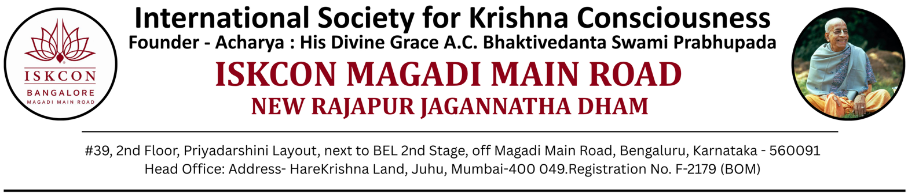
NANDOTSAV – 2026
Aug 17, 2026
To,
The Principal,
{School Name}
Bengaluru

SUBJECT: NANDOTSAV 2026 – Intimation regarding Inter-School Winners from your School

Dear Sir / Madam, Hare Krishna! Greetings from ISKCON Magadi Main Road, Bengaluru.

We are pleased to inform you that all rounds of NANDOTSAV 2026, including the finals, have been successfully completed. We sincerely thank you, your staff, parents, and students for their enthusiastic
participation.

To honour and recognise achievements at the school level, we are providing medals and certificates for the Intra-School winners (those who won at your school’s internal rounds). We request your school to kindly arrange to award these medals and certificates directly to the respective students at an appropriate school function.

We would like to acknowledge the sincere efforts of all participating students. In the Bhagavad-gītā (12.20), Lord Krishna says: “ye tu dharmāmṛtam idaṁ yathoktaṁ paryupāsate śraddadhānā mat-paramā bhaktās te ’tīva me priyāḥ” — indicating that “Those who walk this path of devoted service with faith, keeping the Lord as their highest aim, become especially dear to Him”. In this spirit, every participant of NANDOTSAV is truly a winner, having connected with the Lord through their heartfelt effort, creativity, and willingness to glorify Him.

Kindly note that none of the students from your school have found a place in the Inter-School winners list. Yet, their sincere participation itself is a noble offering, for in life the effort made with a pure heart carries deeper value than the final result.

We warmly encourage your school to consider increasing the number of participating students in future editions of NANDOTSAV. Greater participation not only raises the chances of inter-school recognition but also deepens students’ engagement with devotional values and creative expression.

For any clarifications regarding the medals and certificates or for assistance with next year’s participation, please contact us at 7349180286.

Looking forward to your continued association

With regards, Hare Krishna!

Organizing Team – NANDOTSAV 2026

