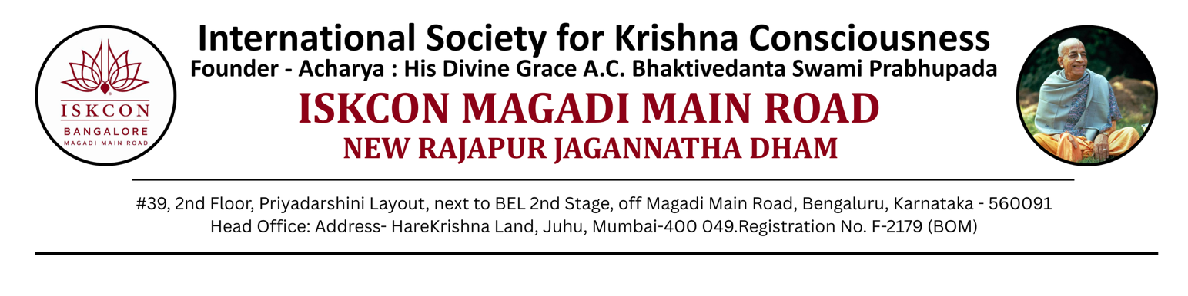
NANDOTSAV – 2026

To, The Principal
___________________
Bengaluru
SUBJECT: NANDOTSAV 2026 – Handing Over of Certificates and Medals for Students
Hare Krishna! Greetings from ISKCON New Rajapur Jagannatha Dhama (NRJD).
We once again extend our sincere thanks to you and your esteemed management for your participation in NANDOTSAV 2026.
We are pleased to inform you that the medals and certificates for the students from your school who were unable to attend the Prize Distribution Ceremony held on August 23, 2026 are being handed over along with.
Sl.No | Category | Medal Count | Certificate Count
1. | Inter-School
2. | Intra-School
We kindly request your school to arrange the distribution of these medals and certificates directly to the respective students during an appropriate school function.
For any clarifications regarding the medals and certificates, or for assistance with participation in next year’s NANDOTSAV, please feel free to contact us at 7349180286.
We look forward to your continued association.
With regards, Hare Krishna!

Organizing Team – NANDOTSAV 2026 School Coordinator Name:
School Coordinator Phone Number:

Signature:

