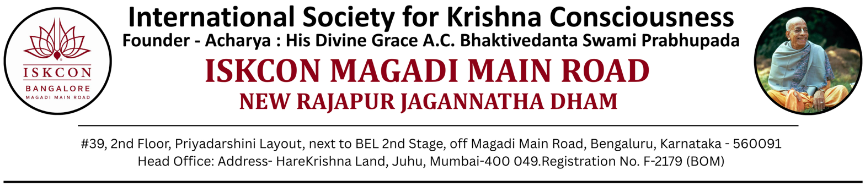
NANDOTSAV – 2026
Aug 24, 2026
The Principal,
{School Name}

Bangalore

Subject – NANDOTSAV 2025 – Winners Rolling Trophy

Respected Madam / Sir,

Hare Krishna!! Greetings from ISKCON New Rajapur Jagannatha Dham (NRJD).

Our congratulations to your school as represented by students, teachers and the management on being the
selected as the overall winner of the NANDOTSAV 2025 – Winners Rolling Trophy.

Accordingly, we are happy to award the NANDOTSAV 2025 – Winners Rolling Trophy along with this letter.
Kindly acknowledge receipt of the trophy by signing a copy of this letter.

We also wish to advise you that this is a ‘Rolling trophy’ and the same needs to be returned to us
(Organizing Committee – ISKCON NRJD) in June 2026.

We again take this opportunity to thank you, your staff and all the students for their participation in the
NANDOTSAV 2025 events and helping to make it a grand success.

Looking forward to having a continued spiritual association.

Thanking You
Yours sincerely

Organizing Team – NANDOTSAV 2026

