**Test Case ID: 12345  
Test Case Step Name: dfhgdfhdfh  
  
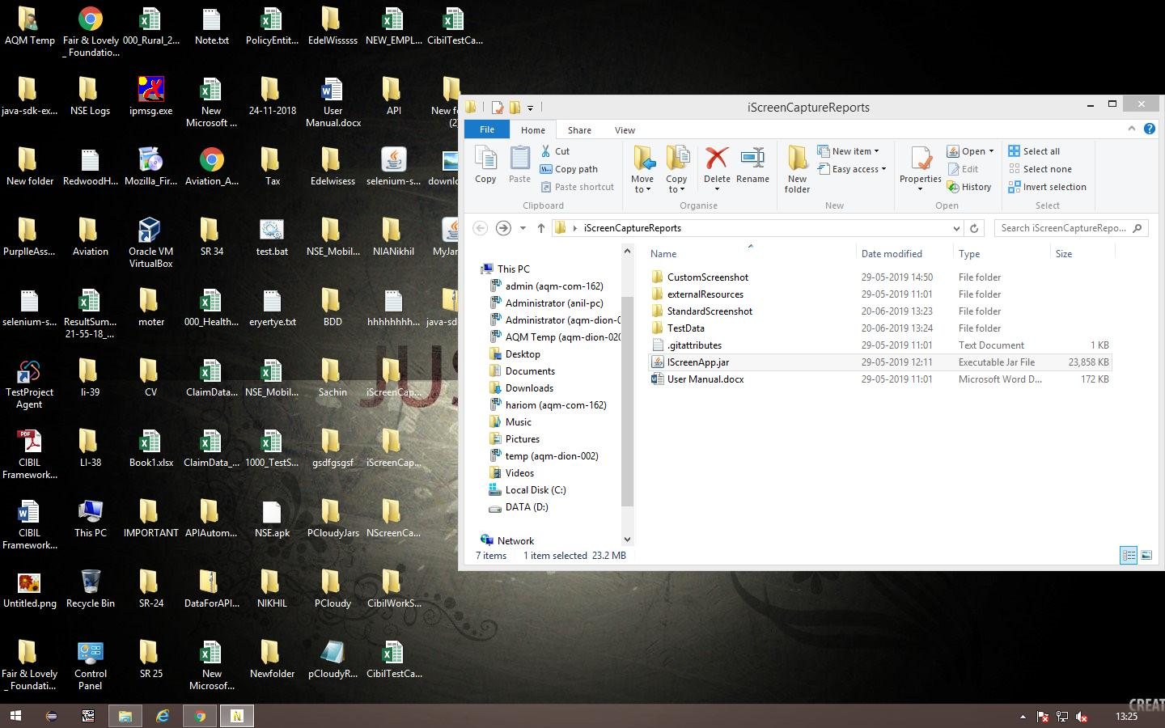**

**Test Case ID: 12345  
Test Case Step Name: dhdfhdfhd  
  
**

**Test Case ID: 12345  
Test Case Step Name: dfhdfhdfhdfh  
  
**