**Test Case ID: 1  
Test Case Step Name: Set User Name As Nikhilmymail101@Gmail.com  
  
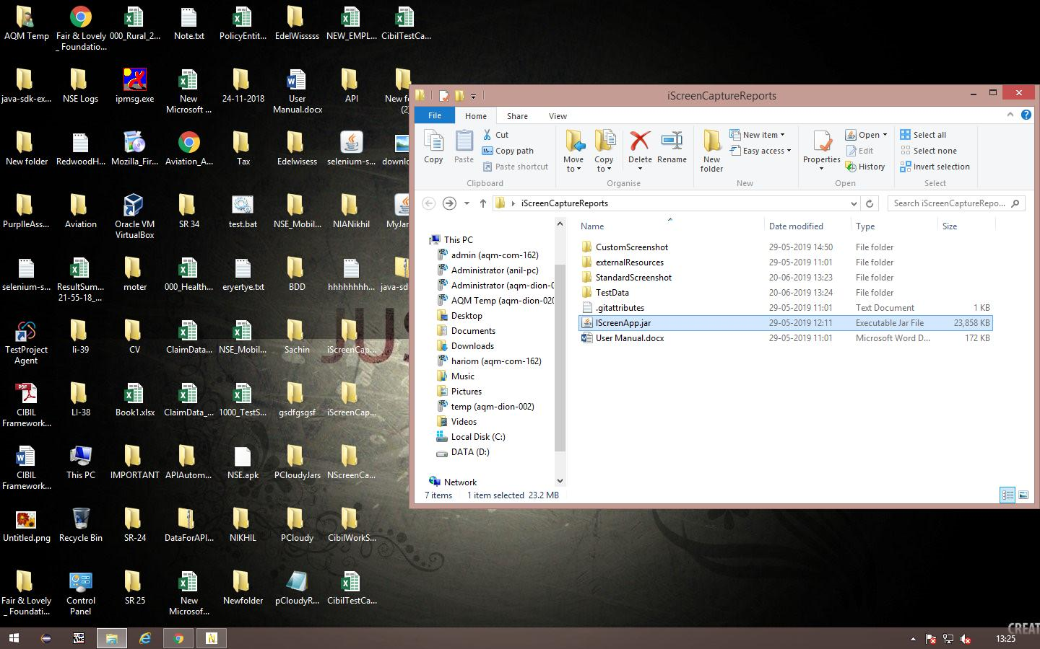**

**Test Case ID: 1  
Test Case Step Name: Set Password as abcd@123  
  
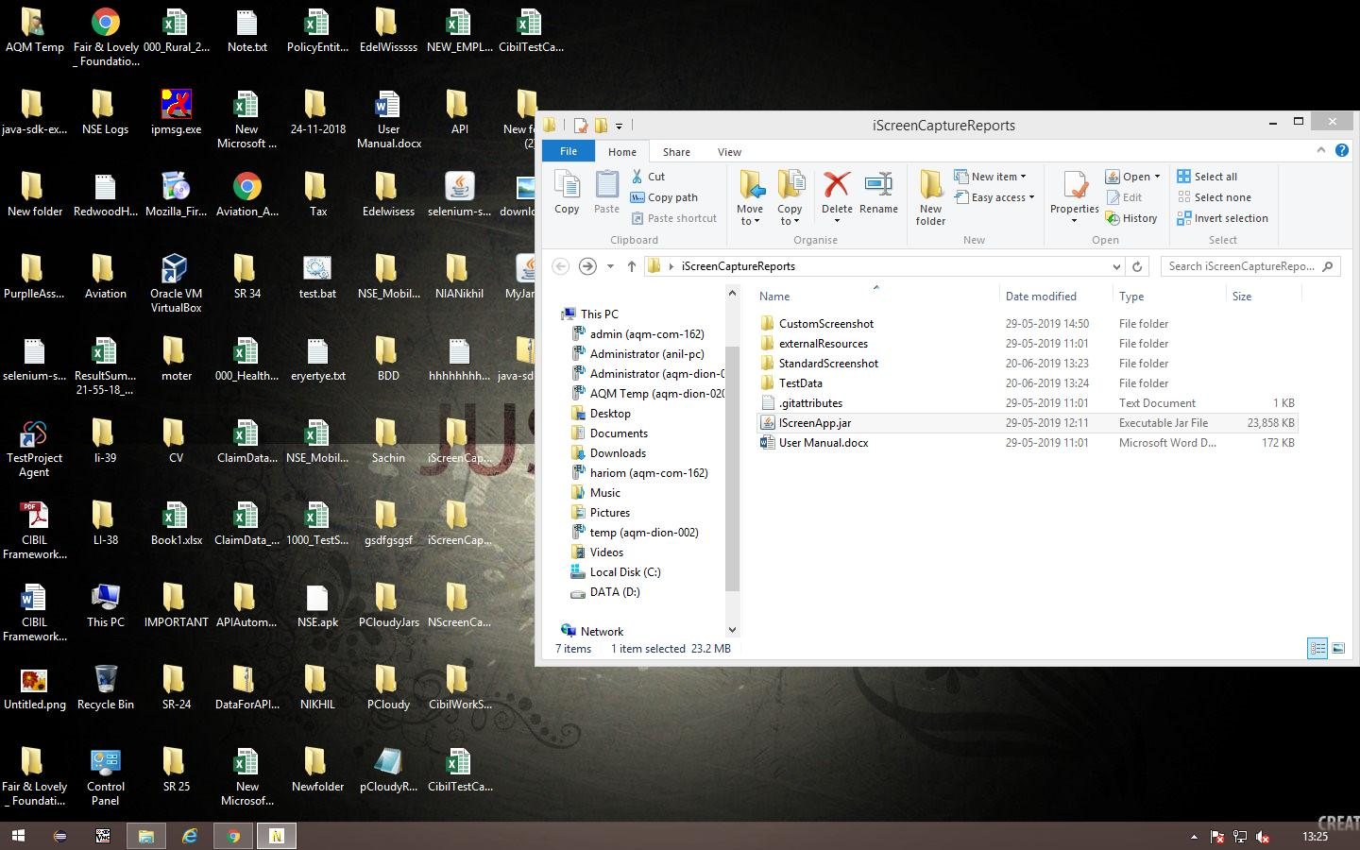**

**Test Case ID: 1  
Test Case Step Name: Verify Login Page  
  
**

**Test Case ID: 1  
Test Case Step Name: Click on Ok Button  
  
**