Name: Rahul V S | Reg. No: 3122235001104
Exp. No: 2 | Date: 15-07-2026

Implementation of Lexical Analyzer using LEX Tool
Aim:
To implement a Lexical Analyzer using the LEX (flex) tool that scans a C source program, classifies every token (keywords, identifiers, constants, operators, special characters, comments, function calls), and stores identifier attributes (name, type, no. of bytes, value) in a symbol table.
Tools Used:
- LEX / Flex (fast lexical analyzer generator)
- GCC Compiler
- Linux terminal
Code:
scanner.l
%{
#include <stdio.h>
#include <string.h>
#include <stdlib.h>

/* ---------- symbol table ---------- */
typedef struct {
char name[32];
char type[12];
int bytes;
char value[32];
} SymEntry;

SymEntry table[100];
int symCount = 0;

char activeType[12] = ""; /* type currently being declared on this line */
int lastIdIndex = -1; /* index of most recently declared identifier */
int awaitingEquals = 0; /* just saw an identifier that could get "= value" */
int awaitingValue = 0; /* just saw "=" after that identifier */

int sizeOfType(char *t) {
if (!strcmp(t, "char")) return 1;
if (!strcmp(t, "float")) return 4;
if (!strcmp(t, "double")) return 8;
return 2;
}

void recordSymbol(char *name) {
awaitingEquals = 0;
if (activeType[0] == '\0') { lastIdIndex = -1; return; }
strcpy(table[symCount].name, name);
strcpy(table[symCount].type, activeType);
table[symCount].bytes = sizeOfType(activeType);
strcpy(table[symCount].value, "-");
lastIdIndex = symCount;
awaitingEquals = 1;
symCount++;
}

void captureValue(char *val) {
if (awaitingValue && lastIdIndex >= 0) {
strcpy(table[lastIdIndex].value, val);
}
awaitingValue = 0;
lastIdIndex = -1;
}

void printSymbolTable(void) {
printf("\nContent of Symbol Table\n");
printf("%-15s %-8s %-12s %-10s\n", "Identifier", "Type", "No of bytes", "Value");
for (int k = 0; k < symCount; k++)
printf("%-15s %-8s %-12d %-10s\n",
table[k].name, table[k].type, table[k].bytes, table[k].value);
}
%}

%x COMMENT

DIGIT [0-9]
LETTER [a-zA-Z_]
HEX [0-9a-fA-F]

%%

"//".* { /* single line comment: ignore */ }

"/*" { BEGIN(COMMENT); }
<COMMENT>"*/" { BEGIN(INITIAL); }
<COMMENT>\n { /* stay in comment */ }
<COMMENT>. { /* consume comment body */ }
<COMMENT><<EOF>> {
printf("Error: unterminated comment\n");
yyterminate();
}

"auto"|"break"|"case"|"const"|"continue"|"default"|"do"|"else"|"enum"|"extern"|"for"|"goto"|"if"|"register"|"return"|"sizeof"|"static"|"struct"|"switch"|"typedef"|"union"|"unsigned"|"void"|"volatile"|"while"|"signed" {
printf("%s - keyword\n", yytext);
activeType[0] = '\0';
}

"int"|"char"|"float"|"double"|"long"|"short" {
printf("%s - keyword\n", yytext);
strcpy(activeType, yytext);
}

"printf"[ \t]*"("[^)]*")" { printf("%s - function call\n", yytext); }
"scanf"[ \t]*"("[^)]*")" { printf("%s - function call\n", yytext); }
"getch"[ \t]*"("[^)]*")" { printf("%s - function call\n", yytext); }
"clrscr"[ \t]*"("[^)]*")" { printf("%s - function call\n", yytext); }
"main"[ \t]*"("[^)]*")" { printf("%s - function call\n", yytext); }

{LETTER}({LETTER}|{DIGIT})* {
printf("%s - identifier\n", yytext);
recordSymbol(yytext);
}

"0"[xX]{HEX}+ { printf("%s - hexadecimal constant\n", yytext); captureValue(yytext); }

{DIGIT}+"."{DIGIT}+ { printf("%s - double constant\n", yytext); captureValue(yytext); }

{DIGIT}+ { printf("%s - integer constant\n", yytext); captureValue(yytext); }

\"([^"\n])*\" { printf("%s - string constant\n", yytext); captureValue(yytext); }

\'([^'\\]|\\.)\' { printf("%s - character constant\n", yytext); captureValue(yytext); }

"+="|"-="|"*="|"/="|"%=" { printf("%s - arithmetic assignment operator\n", yytext); awaitingEquals = 0; awaitingValue = 0; }
"++"|"--" { printf("%s - unary operator\n", yytext); }
"&&" { printf("&& - logical operator\n"); }
"||" { printf("|| - logical operator\n"); }
"==" { printf("== - relational operator\n"); }
"!=" { printf("!= - relational operator\n"); }
"<=" { printf("<= - relational operator\n"); }
">=" { printf(">= - relational operator\n"); }
"<<" { printf("<< - bitwise operator\n"); }
">>" { printf(">> - bitwise operator\n"); }

[+\-*/%] { printf("%c - arithmetic operator\n", yytext[0]); }
[<>] { printf("%c - relational operator\n", yytext[0]); }
"=" {
printf("= - assignment operator\n");
if (awaitingEquals) { awaitingValue = 1; awaitingEquals = 0; }
}
"!" { printf("! - logical operator\n"); }
[&|^] { printf("%c - bitwise operator\n", yytext[0]); }

[;,.\[\](){}] {
printf("%c - special character\n", yytext[0]);
if (yytext[0] == ';') activeType[0] = '\0';
}

[ \t\n]+ { /* skip whitespace */ }

. { /* skip anything unrecognized */ }

%%

int yywrap(void) { return 1; }

int main(void) {
yylex();
printSymbolTable();
return 0;
}

sample.c:
{
int a=10,b=20;
if(a>b)
printf("a is greater");
else
printf("b is greater");
}
Output:
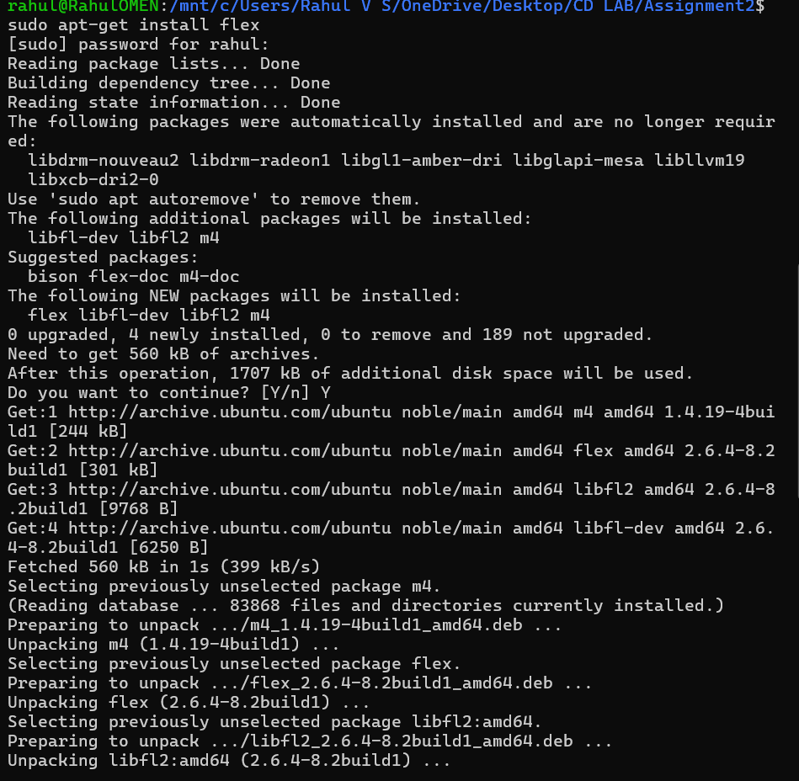
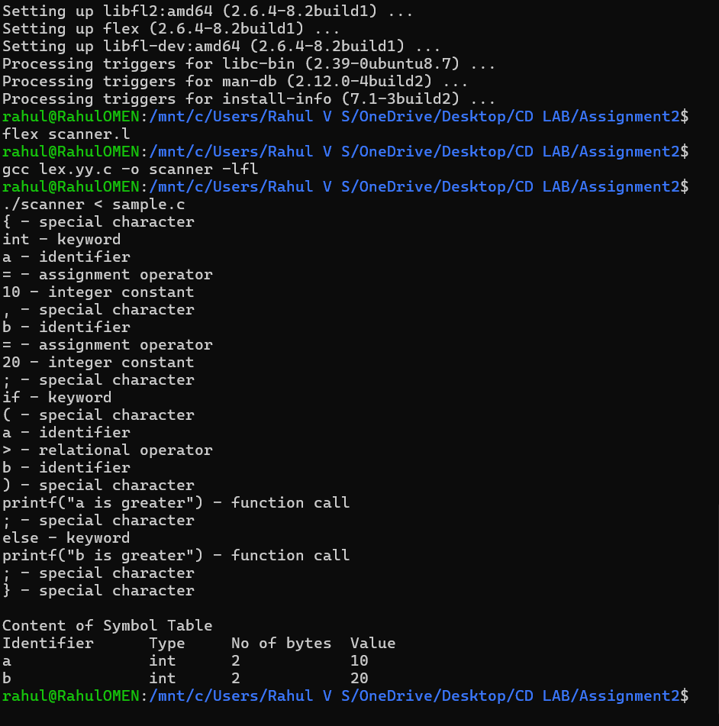

Additional Question Answers
Q1. How does your scanner handle multi-line comments that are not terminated correctly? How does it report errors in such cases?
The scanner uses a Flex exclusive start condition called COMMENT. When it reads /*, it switches into this state with BEGIN(COMMENT), and every character is silently consumed until it finds the closing */, which switches back to INITIAL. If the file ends while the scanner is still inside the COMMENT state — i.e., no */ was ever found — the special <COMMENT><<EOF>> rule fires, which prints Error: unterminated comment and stops scanning via yyterminate(). This was verified directly: feeding a file with /* this comment never ends and no closing tag produced exactly that error message after correctly processing the valid tokens before it.
Q2. Construct symbol table for storing the identifier information
The symbol table is implemented as an array of SymEntry structs, each holding name, type, bytes (computed from the type: char=1, float=4, double=8, else 2), and value. A global "active type" tracks the most recent type keyword seen (e.g. int); when the next identifier appears, it's recorded under that type. If an = immediately follows, the next constant token (integer/hex/double/char/string) is captured as that identifier's value. The table is printed once, after the whole file has been scanned, in this format:
Identifier Type No of bytes Value
a int 2 10
b int 2 20

9. Learning Outcomes
- Learned to write lexical specifications using regular expressions in Flex.
- Understood Flex's longest-match rule and how ordering/specificity of patterns affects tokenization (had to fix a bug where if(a>b) was wrongly caught by a generic function-call pattern before restricting it to named functions).
- Implemented exclusive start conditions (%x) to correctly handle multi-line comments and detect unterminated ones via <<EOF>>.
- Built a symbol table that tracks not just declarations but also assigned values, using small state flags to link identifiers to their following = and constant.

