Exp. No: 4 | Date: 31-07-2026
Name: Rahul V S | Reg. No: 3122235001104

Implementation of Desk Calculator using Yacc Tool
Aim
To write a Lex program to recognize the tokens required by a Yacc parser, and to implement a desk calculator using Yacc that evaluates arithmetic expressions involving the operators +, -, *, /, ^, ( and ), while preserving the correct precedence and associativity of each operator.

Tools Used
LEX / Flex (lexical analyzer generator)
YACC / Bison (parser generator)
GCC Compiler
Linux Terminal

Code (ex.l)
%{
#include "y.tab.h"
%}

%%
[0-9]+(\.[0-9]+)? { yylval.dval = atof(yytext); return NUMBER; }
[ \t] ;
\n return '\n';
[+\-*/^()] return yytext[0];
. ;
%%

int yywrap(void) {
return 1;
}

Code (ex.y)
%{
#include <stdio.h>
#include <stdlib.h>
#include <math.h>

int yylex(void);
void yyerror(char *s);
%}

%union {
double dval;
}

%token <dval> NUMBER
%type <dval> expr

%left '+' '-'
%left '*' '/'
%right '^'

%start program

%%

program : program line
|
;

line : expr '\n' { printf("Result = %g\n", $1); }
| '\n'
| error '\n' { yyerrok; }
;

expr : expr '+' expr { $$ = $1 + $3; }
| expr '-' expr { $$ = $1 - $3; }
| expr '*' expr { $$ = $1 * $3; }
| expr '/' expr { $$ = $1 / $3; }
| expr '^' expr { $$ = pow($1, $3); }
| '(' expr ')' { $$ = $2; }
| NUMBER { $$ = $1; }
;

%%

void yyerror(char *s) {
printf("%s\n", s);
}

int main(void) {
printf("Enter expression:\n");
yyparse();
return 0;
}

Sample Inputs (Test Cases)
3+9
3+9*6
(3+4)*7
(3-4)+(7*6)
5/7+2
4^2^1
(2^3)^2

Commands Used
lex ex.l
yacc -d ex.y
cc lex.yy.c y.tab.c -lfl -lm -o calc
./calc

Output:
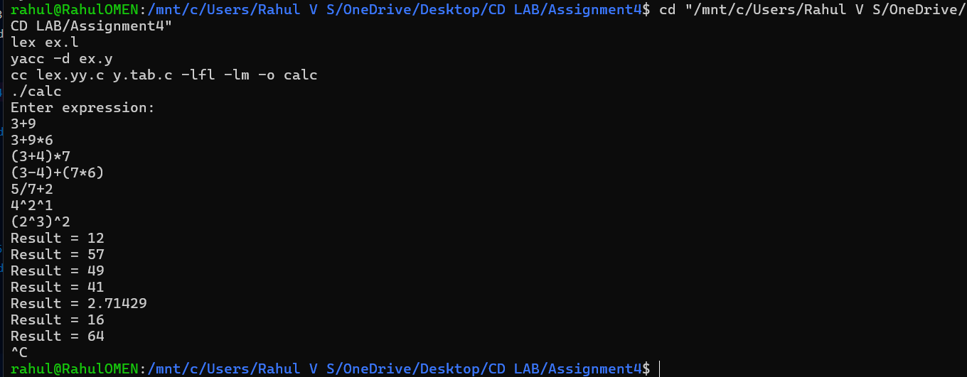

Learning Outcomes
Understood how Yacc resolves ambiguity in an arithmetic grammar using precedence and associativity declarations (%left, %right).
Learned that the start symbol must be a repeating (left-recursive) production such as program : program line | ; so the parser keeps accepting new lines instead of halting after the first one.
Learned how Lex and Yacc communicate through tokens and a %union-typed yylval/YYSTYPE, and why the type must match consistently between the generated lexer and parser headers.
Used Yacc's built-in error token and yyerrok to recover from a bad line and keep the calculator session running.

