Exp. No: 3 | Date: 24-07-2026
Name: Rahul V S | Reg. No: 3122 23 5001 104

Implementation of Recursive Decent Parser
Aim
To implement a recursive descent parser for the given grammar with left recursion eliminated.

Grammar:
E → T E'
E' → + T E' | ε
T → F T'
T' → * F T' | ε
F → ( E ) | id

Tools Used
- GCC Compiler
- Linux Terminal

Code (rdp.c)
#include <stdio.h>
#include <stdlib.h>
#include <string.h>

const char *input;
int i = 0;
int error = 0;

void E();
void E_prime();
void T();
void T_prime();
void F();

void match(char expected) {
if (input[i] == expected) {
i++;
} else {
error = 1;
}
}

void match_id() {
if (input[i] == 'i' && input[i + 1] == 'd') {
i += 2;
} else {
error = 1;
}
}

void E() {
T();
E_prime();
}

void E_prime() {
if (input[i] == '+') {
match('+');
T();
E_prime();
}
}

void T() {
F();
T_prime();
}

void T_prime() {
if (input[i] == '*') {
match('*');
F();
T_prime();
}
}

void F() {
if (input[i] == '(') {
match('(');
E();
match(')');
} else if (input[i] == 'i' && input[i + 1] == 'd') {
match_id();
} else {
error = 1;
}
}

void parse_string(const char *str) {
input = str;
i = 0;
error = 0;
printf("Parsing string: \"%s\"\n", input);

E();
if (error == 0 && input[i] == '\0') {
printf("Result: SUCCESS (String successfully parsed!)\n\n");
} else {
printf("Result: REJECTED (Syntax Error detected!)\n\n");
}
}

int main() {
parse_string("id+id*id");
parse_string("(id+id*id");
parse_string("id-id");
return 0;
}

Output:

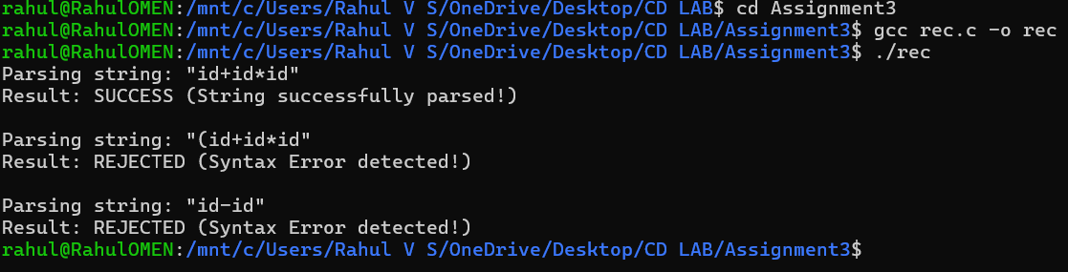

Learning Outcomes
- Learnt to implement grammar rules as recursive functions to simulate top-down parsing logic in C.
- Learnt to implement operator precedence handling, token matching, and detecting syntax errors during program execution.

