Name: Rahul V S | Reg. No: 3122235001104
Exp. No: 6 | Date: 14-08-2026

Generation of Intermediate Code using Lex and Yacc Tools
Aim:
To develop an intermediate code generator using Lex and Yacc that produces three address code for assignment statements and boolean expressions by writing suitable syntax directed translation rules.
Tools Used:
- LEX / Flex (lexical analyzer generator)
- YACC / Bison (parser generator)
- GCC Compiler
- Linux terminal (Ubuntu on WSL)
Code:
tac.l
%{
#include <stdio.h>
#include <string.h>
#include <ctype.h>
#include "y.tab.h"

char stmt_text[256]; /* source text of the statement just read */
static char srcline[256]; /* characters of the statement being read */

#define YY_USER_ACTION strncat(srcline, yytext, sizeof(srcline) - strlen(srcline) - 1);

/* Move srcline into stmt_text (without the terminator) and start afresh */
static void end_statement(void)
{
char *s = srcline;
int n;
while (isspace((unsigned char)*s)) s++;
strcpy(stmt_text, s);
n = strlen(stmt_text);
while (n > 0 && (isspace((unsigned char)stmt_text[n-1]) || stmt_text[n-1] == ';'))
stmt_text[--n] = '\0';
srcline[0] = '\0';
}

static int pending(void)
{
char *s;
for (s = srcline; *s; s++)
if (!isspace((unsigned char)*s)) return 1;
return 0;
}
%}

%option yylineno

DIGIT [0-9]
LETTER [a-zA-Z_]

%%

"or"|"||" { return OR; }
"and"|"&&" { return AND; }
"not"|"!" { return NOT; }

{LETTER}({LETTER}|{DIGIT})* { yylval.str = strdup(yytext); return ID; }
{DIGIT}+(\.{DIGIT}+)? { yylval.str = strdup(yytext); return NUM; }

":="|"=" { return ASSIGN; }
"<="|">="|"=="|"!="|"<"|">" { yylval.str = strdup(yytext); return RELOP; }
[+\-*/%()] { return yytext[0]; }

[\n;] { end_statement(); return EOL; }
[ \t\r]+ ;
. { return yytext[0]; }

<<EOF>> { if (pending()) { end_statement(); return EOL; }
return 0; }

%%

int yywrap(void)
{
return 1;
}

tac.y
%{
#include <stdio.h>
#include <stdlib.h>
#include <string.h>
#include <stdarg.h>

int yylex(void);
void yyerror(const char *s);

extern int yylineno;
extern char stmt_text[];

#define BASE 100 /* number given to the first instruction */
#define MAXCODE 100

static char code[MAXCODE][80]; /* three address code of the current statement */
static int ncode = 0; /* instructions generated so far */
static int ntemp = 0; /* temporaries used so far */
static int hasBool = 0; /* statement contains a boolean expression */

static char *newtemp(void)
{
char buf[16];
sprintf(buf, "t%d", ++ntemp);
return strdup(buf);
}

static void emit(const char *fmt, ...)
{
va_list ap;
va_start(ap, fmt);
vsnprintf(code[ncode++], sizeof(code[0]), fmt, ap);
va_end(ap);
}

static void reset(void)
{
ncode = ntemp = hasBool = 0;
}

/* Print the code of one statement: numbered from 100 only if it has booleans */
static void flush_statement(void)
{
int k;
printf("%s\n", stmt_text);
for (k = 0; k < (int)strlen(stmt_text); k++) putchar('-');
putchar('\n');
for (k = 0; k < ncode; k++) {
if (hasBool) printf("%d: %s\n", BASE + k, code[k]);
else printf("%s\n", code[k]);
}
putchar('\n');
reset();
}

/* result = x op y for arithmetic operators */
static char *arith(char *x, char op, char *y)
{
char *t = newtemp();
emit("%s = %s %c %s", t, x, op, y);
return t;
}

/* result = x relop y : four instructions giving the value 0 or 1 */
static char *relational(char *x, char *op, char *y)
{
char *t = newtemp();
int a = BASE + ncode; /* number of the 'if' instruction */
hasBool = 1;
emit("if %s %s %s goto %d", x, op, y, a + 3);
emit("%s := 0", t);
emit("goto %d", a + 4);
emit("%s := 1", t);
return t;
}

/* result = x and y / x or y */
static char *logical(char *x, const char *op, char *y)
{
char *t = newtemp();
hasBool = 1;
emit("%s := %s %s %s", t, x, op, y);
return t;
}
%}

%union { char *str; }

%token <str> ID NUM RELOP
%token ASSIGN OR AND NOT EOL

%type <str> expr

%left OR
%left AND
%right NOT
%nonassoc RELOP
%left '+' '-'
%left '*' '/' '%'
%right UMINUS

%%

program : program stmt
|
;

stmt : ID ASSIGN expr EOL { emit("%s = %s", $1, $3); flush_statement(); }
| EOL
| error EOL { reset(); yyerrok; }
;

expr : expr OR expr { $$ = logical($1, "or", $3); }
| expr AND expr { $$ = logical($1, "and", $3); }
| NOT expr { $$ = newtemp(); hasBool = 1;
emit("%s := not %s", $$, $2); }
| expr RELOP expr { $$ = relational($1, $2, $3); }
| expr '+' expr { $$ = arith($1, '+', $3); }
| expr '-' expr { $$ = arith($1, '-', $3); }
| expr '*' expr { $$ = arith($1, '*', $3); }
| expr '/' expr { $$ = arith($1, '/', $3); }
| expr '%' expr { $$ = arith($1, '%', $3); }
| '-' expr %prec UMINUS { $$ = newtemp(); emit("%s = -%s", $$, $2); }
| '(' expr ')' { $$ = $2; }
| ID { $$ = $1; }
| NUM { $$ = $1; }
;

%%

void yyerror(const char *s)
{
printf("Syntax error at line %d\n\n", yylineno);
}

int main(void)
{
yyparse();
return 0;
}

Input (input.txt)
a := b * -c + b* -c
x:= a<b or c<d and e<f

Commands Used
lex tac.l
yacc -d tac.y
cc lex.yy.c y.tab.c -lfl -o tac
./tac < input.txt

Output:
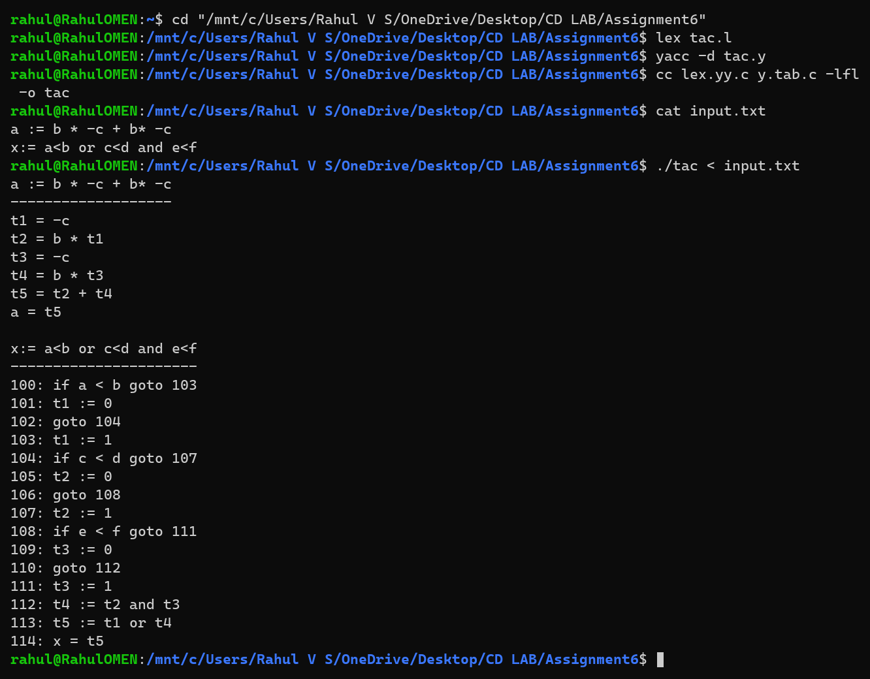
Three address code for the given input
Temporaries t1, t2, ... start again for every statement. Statements that contain a boolean expression are numbered from 100, and a relational expression a<b is translated into four instructions: if a<b goto (n+3), t := 0, goto (n+4), t := 1. The operator priority, from lowest to highest, is or, and, not, relational, arithmetic, so in a<b or c<d and e<f the and is evaluated before the or.
Additional Test Cases:
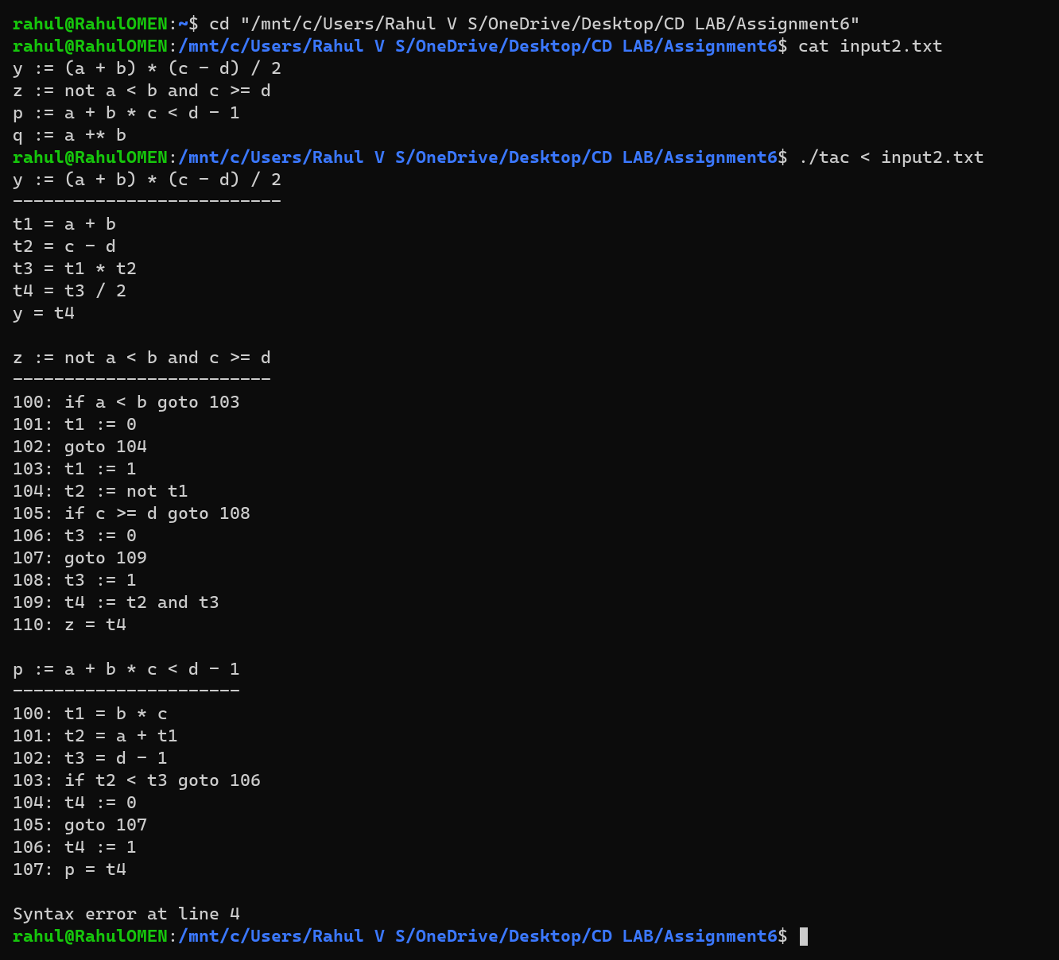
Additional test cases (the last statement has a syntax error)
Learning Outcomes:
- Learned how syntax directed translation attaches semantic actions to grammar rules so that three address code is generated while the input is being parsed.
- Understood how attributes ($$, $1, $3) carry the name of the temporary that holds the value of every sub-expression and how new temporaries are created.
- Learned to translate relational expressions into conditional jumps with instruction numbers and to combine them with and / or / not.
- Used precedence declarations to give unary minus, arithmetic, relational and logical operators the correct priority, and the yacc error token to recover from a bad line.

