Name: Rahul V S | Reg. No: 3122235001104
Exp. No: 8 | Date: 28-08-2026

Implementation of Code Generation
Aim:
To implement a code generator that converts a sequence of three address code statements containing assignments, arithmetic operators, relational operators, conditional constructs and iterative constructs into 8086 style assembly code.
Tools Used:
- C programming language
- GCC Compiler
- Linux terminal (Ubuntu on WSL)
Code:
codegen.c
/*
* Code generator : Three Address Code -> 8086 style assembly code
*
* Supports : assignment, arithmetic operators (+ - * / %), unary minus,
* relational operators (< <= > >= == !=), conditional statements
* (if a relop b goto L) and iterative constructs (labels + goto).
*
* Method : 1. read the TAC and turn it into machine level instructions
* (constants that must sit in a register get their own MOV)
* 2. live variable analysis (backward data flow, repeated until it
* stops changing - this is what makes loops work)
* 3. two names may share a register only if they are never live at
* the same time; a name that finds no free register is spilled
* 4. print the assembly code
*
* Input : x = y x = y op z x = -y if a relop b goto L
* goto L L: (a label may also precede a statement)
* Usage : ./codegen < input.tac or ./codegen input.tac
*/
#include <stdio.h>
#include <stdlib.h>
#include <string.h>
#include <ctype.h>
#include <stdarg.h>

#ifndef NREG
#define NREG 8 /* registers R0..R7 */
#endif
#define NALLOC (NREG - 2) /* R0..R5 are allocated, R6 and R7 are */
/* scratch registers used for spilled names */
#define NAME 32
#define MAXLAB 4
#define MAXSRC 200
#define MAXNODE 500
#define MAXVAR 300

/* ---------------------------------------------------------------- input TAC */

enum { S_COPY, S_BIN, S_NEG, S_IF, S_GOTO, S_NOP };

typedef struct {
int kind;
char dest[NAME], a[NAME], b[NAME]; /* x = a op b */
char op[3]; /* arithmetic operator, or relational */
char target[NAME]; /* jump target */
char lab[MAXLAB][NAME]; /* labels attached to this statement */
int nlab;
} Src;

static Src src[MAXSRC];
static int nsrc = 0;
static char pend[MAXLAB][NAME]; /* labels waiting for their statement */
static int npend = 0;

static void die(const char *msg, int lineno, const char *text)
{
printf("Error (line %d): %s : %s\n", lineno, msg, text);
exit(1);
}

static char *skip(char *p)
{
while (isspace((unsigned char)*p)) p++;
return p;
}

/* read an identifier or a number (a '-' directly before digits is part of it) */
static char *word(char *p, char *out, int minus)
{
int k = 0;
p = skip(p);
if (minus && *p == '-' && isdigit((unsigned char)p[1])) out[k++] = *p++;
if (isdigit((unsigned char)*p))
while (isdigit((unsigned char)*p) && k < NAME - 1) out[k++] = *p++;
else if (isalpha((unsigned char)*p) || *p == '_')
while ((isalnum((unsigned char)*p) || *p == '_') && k < NAME - 1) out[k++] = *p++;
out[k] = '\0';
return k ? p : NULL;
}

static int isnum(const char *s)
{
return isdigit((unsigned char)s[0]) || (s[0] == '-' && isdigit((unsigned char)s[1]));
}

static int keyword(char *p, const char *kw)
{
size_t n = strlen(kw);
return !strncmp(p, kw, n) && !isalnum((unsigned char)p[n]) && p[n] != '_';
}

static void parse_line(char *p, int lineno)
{
Src *s = &src[nsrc];
char *q, w[NAME];
const char *whole = p;

memset(s, 0, sizeof *s);
for (;;) { /* leading labels */
q = word(p, w, 0);
if (q && !isdigit((unsigned char)w[0]) && *skip(q) == ':' && !keyword(w, "if")) {
if (npend >= MAXLAB) die("too many labels", lineno, whole);
strcpy(pend[npend++], w);
p = skip(q) + 1;
} else break;
}
p = skip(p);
if (!*p) return; /* label only line */

if (keyword(p, "goto")) {
s->kind = S_GOTO;
if (!(q = word(p + 4, s->target, 0)) || *skip(q)) die("bad goto", lineno, whole);
} else if (keyword(p, "if")) {
s->kind = S_IF;
if (!(p = word(p + 2, s->a, 1))) die("bad if", lineno, whole);
p = skip(p);
if (!strncmp(p, "<=", 2) || !strncmp(p, ">=", 2) ||
!strncmp(p, "==", 2) || !strncmp(p, "!=", 2)) {
strncpy(s->op, p, 2); p += 2;
} else if (*p == '<' || *p == '>') {
s->op[0] = *p++;
} else die("relational operator expected", lineno, whole);
if (!(p = word(p, s->b, 1))) die("bad if", lineno, whole);
p = skip(p);
if (!keyword(p, "goto")) die("goto expected", lineno, whole);
if (!(q = word(p + 4, s->target, 0)) || *skip(q)) die("bad goto", lineno, whole);
} else {
if (!(p = word(p, s->dest, 0)) || isnum(s->dest)) die("bad statement", lineno, whole);
p = skip(p);
if (*p != '=' || p[1] == '=') die("'=' expected", lineno, whole);
p = skip(p + 1);
if (*p == '-' && !isdigit((unsigned char)p[1])) { /* x = -y */
s->kind = S_NEG;
if (!(p = word(p + 1, s->a, 0))) die("bad operand", lineno, whole);
} else {
if (!(p = word(p, s->a, 1))) die("bad operand", lineno, whole);
p = skip(p);
if (!*p) s->kind = S_COPY;
else if (strchr("+-*/%", *p)) {
s->kind = S_BIN;
s->op[0] = *p++;
if (!(p = word(p, s->b, 1))) die("bad operand", lineno, whole);
} else die("operator expected", lineno, whole);
}
if (*skip(p)) die("unexpected text", lineno, whole);
}
memcpy(s->lab, pend, sizeof pend);
s->nlab = npend;
npend = 0;
nsrc++;
}

/* ---------------------------------------------------------- machine level code */

enum { N_MOVI, N_COPY, N_BIN, N_NEG, N_CMPJ, N_JMP, N_NOP };

typedef struct {
int kind;
int d, a, b; /* variable numbers, -1 if unused */
long long imm; /* N_MOVI : constant loaded */
char op[3]; /* arithmetic or relational operator */
char tlabel[NAME]; /* N_CMPJ / N_JMP : target label */
int target; /* ... and the node that carries it */
char lab[MAXLAB][NAME]; /* labels on this node */
int nlab;
} Node;

static Node node[MAXNODE];
static int nn = 0;

static char names[MAXVAR][NAME]; /* variable table */
static int isconst[MAXVAR]; /* 1 : register holding a constant */
static long long cval[MAXVAR];
static int nvar = 0;

static int var(const char *name)
{
int v;
for (v = 0; v < nvar; v++)
if (!isconst[v] && !strcmp(names[v], name)) return v;
if (nvar >= MAXVAR) { printf("Error: too many variables\n"); exit(1); }
strcpy(names[nvar], name);
isconst[nvar] = 0;
return nvar++;
}

static int newconst(long long value)
{
if (nvar >= MAXVAR) { printf("Error: too many variables\n"); exit(1); }
sprintf(names[nvar], "#%lld", value);
isconst[nvar] = 1;
cval[nvar] = value;
return nvar++;
}

static Node *add(int kind, int d, int a, int b)
{
Node *n;
if (nn >= MAXNODE) { printf("Error: program too long\n"); exit(1); }
n = &node[nn++];
memset(n, 0, sizeof *n);
n->kind = kind; n->d = d; n->a = a; n->b = b;
return n;
}

/* Operand of a statement as a variable number; a constant is first loaded into
a register of its own (this MOV is emitted before the statement itself). */
static int operand(const char *s)
{
int v;
if (!isnum(s)) return var(s);
v = newconst(atoll(s));
add(N_MOVI, v, -1, -1)->imm = cval[v];
return v;
}

static void attach(int at, const Src *s)
{
memcpy(node[at].lab, s->lab, sizeof s->lab);
node[at].nlab = s->nlab;
}

/* May the constants of the conditional jump 'i' be loaded before its label?
Yes if every jump to that label comes from below (a loop back edge), because
then the label is only reached again after the constant was loaded. */
static int hoistable(int i)
{
int j, k;
if (src[i].kind != S_IF || src[i].nlab == 0) return 0;
for (j = 0; j < i; j++) {
if (src[j].kind != S_IF && src[j].kind != S_GOTO) continue;
for (k = 0; k < src[i].nlab; k++)
if (!strcmp(src[j].target, src[i].lab[k])) return 0;
}
return 1;
}

static void build(int hoist)
{
int i, first, a, b, d, at;
nn = 0; nvar = 0;
for (i = 0; i < nsrc; i++) {
Src *s = &src[i];
first = nn;
switch (s->kind) {
case S_COPY:
d = var(s->dest);
if (isnum(s->a)) add(N_MOVI, d, -1, -1)->imm = atoll(s->a);
else add(N_COPY, d, var(s->a), -1);
at = first;
break;
case S_NEG:
d = var(s->dest);
if (isnum(s->a)) add(N_MOVI, d, -1, -1)->imm = -atoll(s->a);
else add(N_NEG, d, var(s->a), -1);
at = first;
break;
case S_BIN:
a = operand(s->a); b = operand(s->b); d = var(s->dest);
strcpy(add(N_BIN, d, a, b)->op, s->op);
at = first;
break;
case S_IF:
a = operand(s->a); b = operand(s->b);
strcpy(add(N_CMPJ, -1, a, b)->op, s->op);
strcpy(node[nn - 1].tlabel, s->target);
at = (hoist && hoistable(i)) ? nn - 1 : first;
break;
case S_GOTO:
strcpy(add(N_JMP, -1, -1, -1)->tlabel, s->target);
at = first;
break;
default:
add(N_NOP, -1, -1, -1);
at = first;
}
attach(at, s);
}
/* resolve the jump targets */
for (i = 0; i < nn; i++) {
int k, m, found = 0;
if (node[i].kind != N_CMPJ && node[i].kind != N_JMP) continue;
for (k = 0; k < nn && !found; k++)
for (m = 0; m < node[k].nlab; m++)
if (!strcmp(node[k].lab[m], node[i].tlabel)) {
node[i].target = k; found = 1; break;
}
if (!found) { printf("Error: label %s is not defined\n", node[i].tlabel); exit(1); }
}
}

/* -------------------------------------------------------- live variable analysis */

static char in[MAXNODE][MAXVAR], out[MAXNODE][MAXVAR]; /* live before / after a node */
static char exitLive[MAXVAR];

static int is_temp(const char *s) /* t1, t2 ... */
{
int k;
if (s[0] != 't' || !s[1]) return 0;
for (k = 1; s[k]; k++) if (!isdigit((unsigned char)s[k])) return 0;
return 1;
}

static void liveness(void)
{
int changed = 1, k, v;
memset(in, 0, sizeof in); memset(out, 0, sizeof out); memset(exitLive, 0, sizeof exitLive);
for (v = 0; v < nvar; v++) /* results of the program stay alive */
if (!isconst[v] && !is_temp(names[v])) exitLive[v] = 1;

while (changed) {
changed = 0;
for (k = nn - 1; k >= 0; k--) {
Node *n = &node[k];
char o[MAXVAR], i2[MAXVAR];
memset(o, 0, sizeof o);
if (n->kind != N_JMP) { /* fall through to the next node */
if (k + 1 < nn) for (v = 0; v < nvar; v++) o[v] |= in[k + 1][v];
else for (v = 0; v < nvar; v++) o[v] |= exitLive[v];
}
if (n->kind == N_CMPJ || n->kind == N_JMP) /* jump to the target */
for (v = 0; v < nvar; v++) o[v] |= in[n->target][v];
memcpy(i2, o, sizeof i2);
if (n->d >= 0) i2[n->d] = 0; /* in = use + (out - def) */
if (n->a >= 0) i2[n->a] = 1;
if (n->b >= 0) i2[n->b] = 1;
if (memcmp(o, out[k], sizeof o) || memcmp(i2, in[k], sizeof i2)) {
memcpy(out[k], o, sizeof o);
memcpy(in[k], i2, sizeof i2);
changed = 1;
}
}
}
}

/* ---------------------------------------------------------- register allocation */

static char interf[MAXVAR][MAXVAR];
static int reg[MAXVAR]; /* register number, -1 = not allocated */
static int spilled[MAXVAR]; /* 1 = lives in memory */

static void interfere(int x, int y)
{
if (x != y) interf[x][y] = interf[y][x] = 1;
}

static void allocate(void)
{
int order[MAXVAR], seen[MAXVAR], cnt = 0, k, v, w, r, c;
memset(interf, 0, sizeof interf); memset(seen, 0, sizeof seen);
for (v = 0; v < nvar; v++) { reg[v] = -1; spilled[v] = 0; }

/* a name that is defined interferes with everything alive right after it
(except the source of a copy, which holds the same value) */
for (k = 0; k < nn; k++) {
Node *n = &node[k];
if (n->d < 0) continue;
for (w = 0; w < nvar; w++)
if (out[k][w] && !(n->kind == N_COPY && w == n->a)) interfere(n->d, w);
}
/* d = a - b : the result register must not be the register of b, otherwise
b would be overwritten before it is used (+ and * can simply be swapped) */
for (k = 0; k < nn; k++)
if (node[k].kind == N_BIN && node[k].op[0] != '+' && node[k].op[0] != '*')
interfere(node[k].d, node[k].b);
/* names that are alive on entry (used before being assigned) all coexist */
for (v = 0; v < nvar; v++)
for (w = v + 1; w < nvar; w++)
if (in[0][v] && in[0][w]) interfere(v, w);

/* colour the names in the order in which they first appear */
for (k = 0; k < nn; k++) {
int list[3] = { node[k].a, node[k].b, node[k].d };
for (c = 0; c < 3; c++)
if (list[c] >= 0 && !seen[list[c]]) { seen[list[c]] = 1; order[cnt++] = list[c]; }
}
for (k = 0; k < cnt; k++) {
int used[NALLOC + 1], pick = -1;
v = order[k];
memset(used, 0, sizeof used);
for (w = 0; w < nvar; w++)
if (interf[v][w] && reg[w] >= 0) used[reg[w]] = 1;
/* x = y, x = -y, x = y op z : x likes to reuse the register of y */
for (c = 0; c < nn && pick < 0; c++) {
int p = -1;
if (node[c].kind != N_COPY && node[c].kind != N_NEG && node[c].kind != N_BIN)
continue;
if (node[c].d == v) p = node[c].a; else if (node[c].a == v) p = node[c].d;
if (p >= 0 && reg[p] >= 0 && !used[reg[p]]) pick = reg[p];
}
for (r = 0; r < NALLOC && pick < 0; r++)
if (!used[r]) pick = r;
if (pick >= 0) reg[v] = pick; else spilled[v] = 1;
}
}

/* -------------------------------------------------------------- code emission */

#define S1 (NREG - 2) /* scratch registers */
#define S2 (NREG - 1)

static char pendlab[MAXLAB][NAME];
static int npendlab = 0;

static void emit(const char *fmt, ...)
{
va_list ap;
int k;
for (k = 0; k < npendlab - 1; k++) printf("%s:\n", pendlab[k]);
if (npendlab) printf("%s: ", pendlab[npendlab - 1]);
npendlab = 0;
va_start(ap, fmt);
vprintf(fmt, ap);
va_end(ap);
printf("\n");
}

static const char *opnd(int v) /* how an operand is written */
{
static char buf[4][NAME + 4];
static int turn = 0;
char *b = buf[turn++ & 3];
if (spilled[v]) {
if (isconst[v]) sprintf(b, "#%lld", cval[v]);
else sprintf(b, "[%s]", names[v]);
} else sprintf(b, "R%d", reg[v]);
return b;
}

static const char *mnemonic(const char *op)
{
switch (op[0]) {
case '+': return "ADD";
case '-': return "SUB";
case '*': return "MUL";
case '/': return "DIV";
default : return "MOD";
}
}

static const char *jump(const char *rel)
{
if (!strcmp(rel, "<")) return "JL";
if (!strcmp(rel, "<=")) return "JLE";
if (!strcmp(rel, ">")) return "JG";
if (!strcmp(rel, ">=")) return "JGE";
if (!strcmp(rel, "==")) return "JE";
return "JNE";
}

static void generate(void)
{
int k, m;
for (k = 0; k < nn; k++) {
Node *n = &node[k];
npendlab = 0;
for (m = 0; m < n->nlab; m++) strcpy(pendlab[npendlab++], n->lab[m]);

switch (n->kind) {
case N_MOVI:
if (isconst[n->d] && spilled[n->d]) break; /* used as an immediate */
if (spilled[n->d]) emit("MOV %s, #%lld", opnd(n->d), n->imm);
else emit("MOV R%d, #%lld", reg[n->d], n->imm);
break;
case N_COPY:
if (!spilled[n->d] && !spilled[n->a] && reg[n->d] == reg[n->a]) break;
if (spilled[n->d] && spilled[n->a]) {
emit("MOV R%d, %s", S1, opnd(n->a));
emit("MOV %s, R%d", opnd(n->d), S1);
} else emit("MOV %s, %s", opnd(n->d), opnd(n->a));
break;
case N_NEG: {
int r = spilled[n->d] ? S1 : reg[n->d];
if (spilled[n->a] || reg[n->a] != r) emit("MOV R%d, %s", r, opnd(n->a));
emit("NEG R%d", r);
if (spilled[n->d]) emit("MOV %s, R%d", opnd(n->d), r);
break;
}
case N_BIN: {
int r = spilled[n->d] ? S1 : reg[n->d];
int a_here = !spilled[n->a] && reg[n->a] == r;
int b_here = !spilled[n->b] && reg[n->b] == r;
int comm = (n->op[0] == '+' || n->op[0] == '*');
if (b_here && !a_here && comm) { /* r already holds b */
emit("%s R%d, %s", mnemonic(n->op), r, opnd(n->a));
} else if (b_here && !a_here) { /* x = y - x : r holds b */
emit("MOV R%d, %s", S1, opnd(n->a));
emit("%s R%d, R%d", mnemonic(n->op), S1, r);
emit("MOV R%d, R%d", r, S1);
} else {
if (!a_here) emit("MOV R%d, %s", r, opnd(n->a));
emit("%s R%d, %s", mnemonic(n->op), r, opnd(n->b));
}
if (spilled[n->d]) emit("MOV %s, R%d", opnd(n->d), r);
break;
}
case N_CMPJ:
if (spilled[n->a]) { /* CMP needs a register first */
emit("MOV R%d, %s", S1, opnd(n->a));
emit("CMP R%d, %s", S1, opnd(n->b));
} else emit("CMP %s, %s", opnd(n->a), opnd(n->b));
emit("%s %s", jump(n->op), n->tlabel);
break;
case N_JMP:
emit("JMP %s", n->tlabel);
break;
default:
break;
}
for (m = 0; m < npendlab; m++) /* labels of nodes that produced no code */
printf("%s:\n", pendlab[m]);
npendlab = 0;
}
}

/* ------------------------------------------------------------------------ main */

static void print_tac(void)
{
int i, m;
for (i = 0; i < nsrc; i++) {
Src *s = &src[i];
for (m = 0; m < s->nlab; m++)
printf(s->kind == S_NOP && m == s->nlab - 1 ? "%s:" : "%s: ", s->lab[m]);
switch (s->kind) {
case S_COPY: printf("%s = %s", s->dest, s->a); break;
case S_NEG: printf("%s = -%s", s->dest, s->a); break;
case S_BIN: printf("%s = %s %s %s", s->dest, s->a, s->op, s->b); break;
case S_IF: printf("if %s %s %s goto %s", s->a, s->op, s->b, s->target); break;
case S_GOTO: printf("goto %s", s->target); break;
default: break;
}
printf("\n");
}
}

int main(int argc, char *argv[])
{
FILE *fp = (argc > 1) ? fopen(argv[1], "r") : stdin;
char text[256];
int lineno = 0, v, hoist, k, any;

if (!fp) { perror(argv[1]); return 1; }
while (fgets(text, sizeof text, fp)) {
char *s = text, *c;
lineno++;
if ((c = strstr(s, "//")) != NULL) *c = '\0';
if ((c = strchr(s, '#')) != NULL) *c = '\0';
s[strcspn(s, "\r\n")] = '\0';
s = skip(s);
if (!*s) continue;
if (nsrc >= MAXSRC - 1) die("program too long", lineno, s);
parse_line(s, lineno);
}
if (npend) { /* labels at the very end */
memset(&src[nsrc], 0, sizeof(Src));
src[nsrc].kind = S_NOP;
memcpy(src[nsrc].lab, pend, sizeof pend);
src[nsrc].nlab = npend;
nsrc++;
}

/* load loop constants before the loop if that is safe, otherwise inside */
for (hoist = 1; ; hoist = 0) {
build(hoist);
liveness();
for (v = 0, any = 0; v < nvar; v++) if (isconst[v] && in[0][v]) any = 1;
if (!hoist || !any) break;
}
allocate();

printf("Three Address Code\n");
print_tac();
printf("\nAssembly Code\n");
generate();

printf("\nRegister Allocation\n");
for (v = 0; v < nvar; v++) {
if (isconst[v]) continue;
printf(" %-6s -> ", names[v]);
if (spilled[v]) printf("memory [%s]\n", names[v]);
else printf("R%d\n", reg[v]);
}
for (v = 0; v < nvar; v++) {
if (!isconst[v]) continue;
for (k = 0, any = 0; k < nn; k++) if (node[k].kind == N_MOVI && node[k].d == v) any = 1;
if (any && !spilled[v]) printf(" %-6s -> R%d\n", names[v], reg[v]);
}
for (v = 0; v < nvar; v++)
if (!isconst[v] && in[0][v])
printf("Note: %s is used before it is assigned (treated as an input)\n", names[v]);
return 0;
}

Input (input.txt) - three address code of x=0; for(i=1;i<=10;i++) x=x+1
x=0
i=1
L3: if i<=10 goto L1
goto L2
L1: t1=x+i
x=t1
t2=i+1
i=t2
goto L3
L2:

Commands Used
gcc codegen.c -o codegen
./codegen < input.txt

Output:
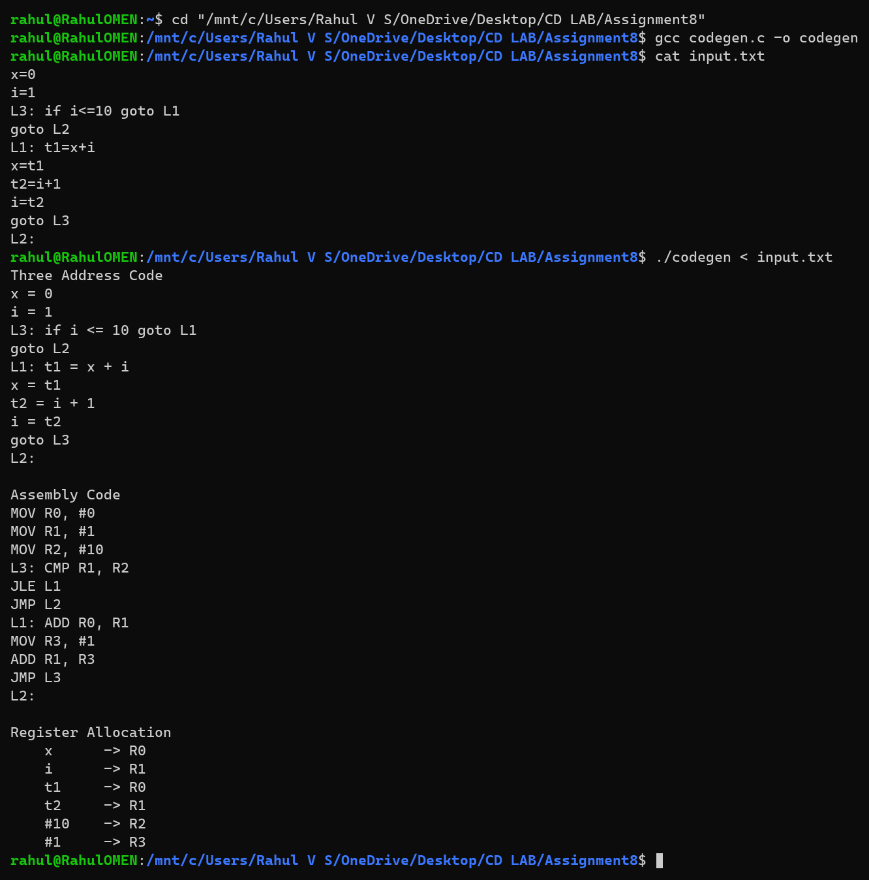
Assembly code generated for the given three address code
x = t1 and i = t2 need no instruction because t1 and t2 are placed in the registers of x and i, which are not needed any more. The constant 10 does not change inside the loop, so it is loaded into R2 once, before the label L3.
Additional Test Cases:
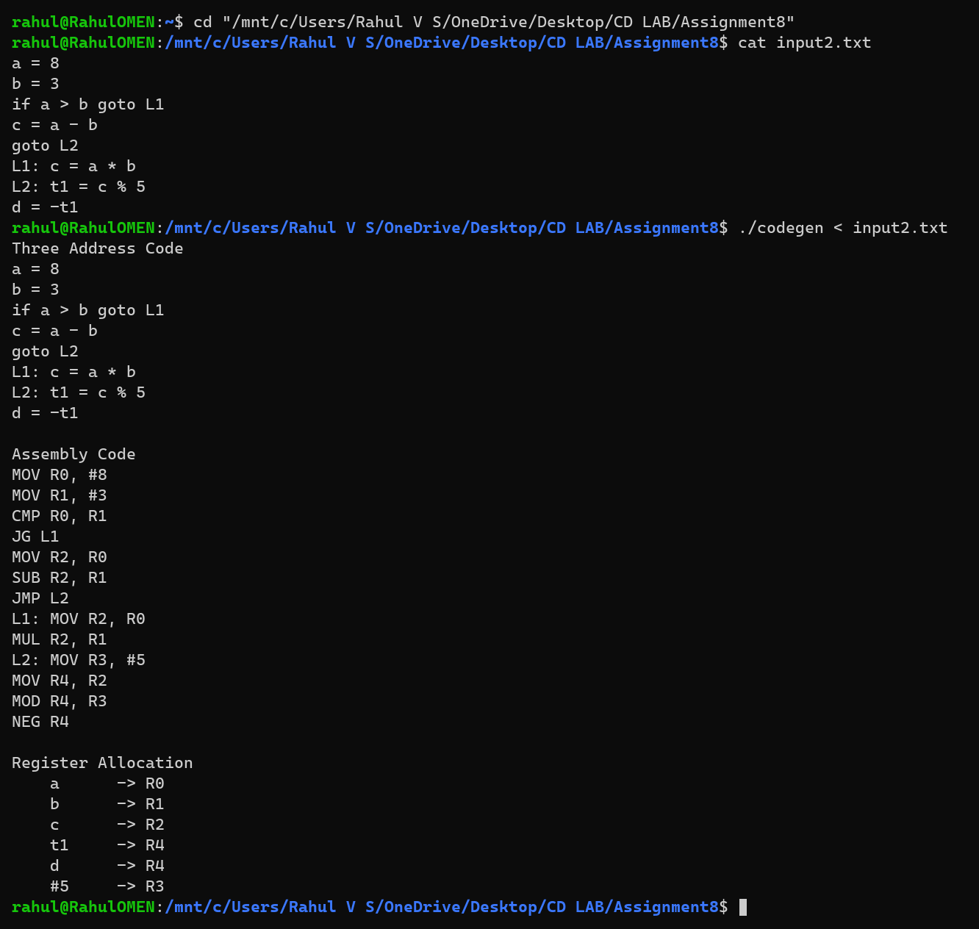
Additional test case: conditional statement with arithmetic operators
Learning Outcomes:
- Learned how three address code is translated into target instructions (MOV, ADD, SUB, MUL, DIV, CMP and the conditional jumps JL, JLE, JG, JGE, JE, JNE).
- Understood live variable analysis on a program with loops: it is a backward data flow problem that is repeated until nothing changes.
- Learned register allocation: two names may share a register only if they are never live at the same time; a name that finds no free register is kept in memory.
- Learned to translate relational operators and iterative constructs into a compare followed by a conditional jump, and to load loop-invariant constants before the loop only when that is safe.

