CleverTap

short line

## **Technical Account Manager Questionnaire**

**Name**: Ashish Jain

--------------------------------------------------------------------------------------------------------------------------------

**Tech Section:**

1. Integrate Android/Web on this Account: <https://eu1.dashboard.clevertap.com/KK4-R6K-565Z/my-board.html>

DONE

1. Add a button

DONE

1. On Click of the above button push Product Viewed Event, with properties: Product ID = 1 & Product Image = <https://d35fo82fjcw0y8.cloudfront.net/2018/07/26020307/customer-success-clevertap.jpg> & Product Name = CleverTap

DONE. I tested this using Alert function [ alert('test'); ] in the HTML file.

1. Push an Email Id ot the profile on click of the above button - Email = dk+<YOUR EMAIL ID>@clevertap.com - Example: [dk+anirduh@clevertap.com](mailto:dk+anirduh@clevertap.com)

Right now the below code is just lying in the HTML without any reference because on button click I am triggering properties listed in the 3rd point.

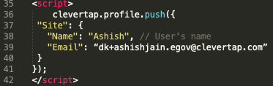

1. Integrate Firebase/Web Push Service using these credentials [For android you have to add channel ID “1”]:
   1. Sender ID - 675579704559
2. Write a script in any language to successfully upload the attached CSV as User Profiles

I would need your help in the 5th and 6th point. For the 5th point, I am using web application and not a mobile app. For web application the page should be HTTPS or on localhost. Thus, I haven’t configured either of them.

Dev Docs:<https://developer.clevertap.com/docs>

HTML File is uploaded here → <http://www.ashishja.in/clevertap/>

--------------------------------------------------------------------------------------------------------------------------------

**Product Section:**

1. Add your own Email Creds on the CleverTap Dashboard with NickName as your Name

DONE

1. Create an Email Campaign which goes out to all Users who have viewed the product today where Product ID = 1

DONE

1. Create a Journey which sends a Push notification to the User as soon as he/she launches the App

I am using this link (<https://docs.clevertap.com/docs/journeys>) to solve this. The push notifications will be to any user who visits → <http://www.ashishja.in/clevertap/> . Not sure in that push notification what has to be shown. The CleverTap portal asks about the Title, Message, Deep Link etc. Also to explore more about this feature, access restriction is there. Attached screenshot below:

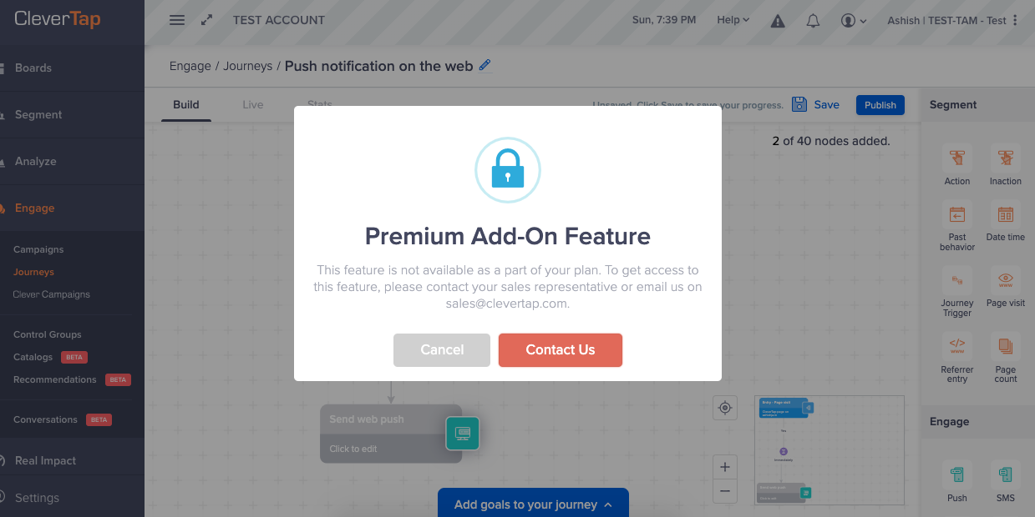

1. Create a funnel from App Launched to Product Viewed and bookmark it
2. Create a segment of Users which were uploaded

Segment of users cannot be formed because of the account type. Can we upload the list of users on the portal for this assignment?

**User Docs**: <https://docs.clevertap.com/docs>

short dash