

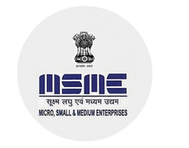






CERTIFICATE OF INTERNSHIP COMPLETION
This certificate is proudly presented to

{{name}}
This is to certify that thestudent bearing TechieHelp Student
ID : {{student_id}}
from {{college_name}}
has successfully completed the internship in {{domain}}
under the mentorship of TechieHelp–India’s Leading AI Software Development Company for Future
Innovators. The internship tenure was from {{start_date}} to
{{end_date}}

HR MANAGER

