DESIGN AND IMPLEMENTATION OF

INVENTORY MANAGEMENT SYSTEM
(CASE STUDY OF NSUK PRINTING PRESS)

BY

SHURAIHU USMAN
0219047003150

A RESEARCH PROJECT SUBMITTED TO THE DEPARTMENT OF COMPUTER SCIENCE, FACULTY OF NATURAL AND APPLIED SCIENCES, NASARAWA STATE UNIVERSITY KEFFI. IN PARTIAL FULFILMENT OF THE REQUIREMENTS FOR THE AWARD OF BACHELOR OF SCIENCE (B.SC.) DEGREE IN COMPUTER SCIENCE.

MAY, 2024

DECLARATION
I, Shuraihu Usman with the matriculation number 0219047003150 declare that this research work has been conducted by me under the able supervision of Mr. Abubakar Suleiman of the Department of Computer Science, Faculty of Natural and Applied Sciences, Nasarawa State University, Keffi.
________________________ _______________________
Shuraihu Usman Date
0219047003150

CERTIFICATION
This project titled Design and Implementation of Inventory Management System (case study of Nsuk Printing Press) has been read and approved as having met the regulation governing the award of a degree in Computer Science in the Faculty of Natural and Applied Sciences, Nasarawa State University, Keffi.

______________________ ____________________
Mr. Abubakar Suleiman Date
Project Supervisor

_______________________ ____________________
Dr. Binyamin A. Ajayi Date
Head of Department

_______________________ ____________________
Prof. Ishaq Oyebisi Oyefolahan Date
External Examiner
DEDICATION
This project is dedicated to my family, friends, and mentors, whose unwavering support and encouragement have been my guiding light throughout this journey. Their belief in my potential has inspired me to strive for excellence and persevere through challenges.
To our professors and academic advisors, I extend my heartfelt gratitude for their wisdom, guidance, and patience. Their commitment to our education and personal growth has been instrumental in shaping my academic journey.
Thank you for being our pillars of strength and our sources of inspiration.

ACKNOWLEDGEMENTS
I am deeply grateful to Almighty Allah for sustaining me throughout my studies at Nasarawa State University, Keffi. My heartfelt thanks go to my family, Malam Usman Abdulaziz and Hajiya Maryam Usman, for their endless encouragement, patience, and understanding, which have been a constant source of motivation.
I am profoundly grateful to my academic advisor, Mr. Abubakar Suleiman, for his invaluable guidance, insightful feedback, and continuous support. His expertise and dedication have been crucial in shaping the direction and quality of this work. Additionally, I extend my sincere thanks to my professors and instructors at Nasarawa State University, whose teachings and mentorship have provided a strong foundation for this project.
Special thanks to my friends and peers, whose camaraderie and moral support have made this journey more enjoyable and fulfilling. Their encouragement and shared experiences have been a great source of strength throughout this endeavor.

TABLE OF CONTENTS
Title Page- - - - - - - - - - i
Declaration - - - - - - - - - - ii
Certification - - - - - - - - - - iii
Dedication - - - - - - - - - - iv
Acknowledgements - - - - - - - - v
Table of contents - - - - - - - - vi
List of figures - - - - - - - - - x
List of plates - - - - - - - - - xi
Abstract - - - - - - - - - xii

CHAPTER ONE INTRODUCTION
1.1 Background of the Study - - - - - - 2
1.2 Justification for the Study- - - - - - 2
1.3 Statement of the Problem - - - - - - 4
1.4 Aim and Objectives - - - - - - - 4
1.5 Method of Achieving the Objectives - - - - - 5
1.6 Significance of the study - - - - - - 5
1.7 Scope of the Study - - - - - - - 5
1.8 Limitation of the Study - - - - - - 6

CHAPTER TWO
2.0 Literature Review - - - - - - - 7
2.1 Conceptual Frame Work - - - - - - 7

CHAPTER THREE
3.0 Research Methodology - - - - -- - - 13
3.1 Description of the Existing System - - - - - 13
3.2 Software development life cycle - - - - - - 14
3.2.1 The Need for a software Life cycle Model - - - - - 14
3.2.2 A Few Importance and Commonly used life cycle model - - 15
3.3 Waterfall Model - - - - - - 15
3.3.1 Requirement Gathering and analysis - - - - 16
3.3.2 Design - - - - - - - - 18
3.3.3 Implementation - - - - - - 18
3.3.4 Maintenance - - - - - - - - 18
3.3.5 Process Analysis - - - - - - - 19
3.4 Analysis of Current System - - - - - 21
3.5 Problem of the current system - - - - 22
3.6 Justification of the New system - - - - - 23
3.7 System Design - - - - - - 24
3.7.1 Flow Chart - - - - - - - 24
3.7.2 Use case - - - - - - - 26
3.7.3 Activity Diagram - - - - - - 26
3.7.4 UML Class diagram - - - - - - 28
3.7.5 Input design - - - - - - - 28
3.7.6 Output design - - - - - - - 28
3.7.7 Choice of Programming Language - - - - 29
3.7.8 Database design - - - - - 29
3.7.9 Files design - - - - - - 34
3.8 Requirement Specification - - - - 34
3.8.1 Software Requirement - - - - 34
3.8.2 Hardware Requirement - - - - 35

CHAPTER FOUR - Implementation, Testing and Design
4.0 Introduction - - - - - - - 36
4.1 Implementation - - - - - - 36
4.2 Result - - - - - - - - 37
4.3 Findings - - - - - - - 40

CHAPTER FIVE
5.0 Summary, Conclusion and Recommendations - - - 42
5.1 Summary - - - - - - - - 42
5.2 Conclusion - - - - - - - - 42
5.3 Recommendations - - - - - - - 43
5.4 References - - - - - - - - 44
5.5 Appendix - - - - - - - 46

Lists of Tables
Tables pages
4.0 Administration Login table - - 21
4.1 Drug Information Table ---- - - 22

List of Figures
Figures Pages
4.2 Administrator and Staff Login Page 23
4.3 Drug registration 24
4.4 Staff Registration 24
4.5 Customers 24
4.6 Shelfs 25
4.7 Drugs Populated the Data Base 26

ABSTRACT

This research project examined the “Design and Implementation of Pharmacy Management Information System” which shows how some records and data can be handled and stored within the system. The study encompassed an aim which is mainly to design and implement information system. The coverage of the research is limited to the activities of the pharmaceutical store which include the use of computer based management system for improving efficiency pharmaceutical unit. The research has literature review. The methodology for the research included description of the existing system, software development life cycle, interview , observation, record consultation, the use of admin login choice, current system analysis, analysis system analysis and justification of the new system. The fourth chapter of the research covered system design and implementation, input design of the new system, output design and specification, justification of programming language used, system requirement, hardware requirement, software requirement and system maintenance. It was concluded in the study that software will take care of the basic requirements of the management system because it capable of providing effective storage of information related activities. It was also recommended that there should also be basic computer knowledge for the users of the software.

CHAPTER ONE - INTRODUCTION
1.1 Background of the Study
Pharmacy management system is a management system that is designed to improve accuracy and to enhance safety and efficiency in the pharmaceutical store. It is a computer based system which helps the Pharmacist to improve inventory management, cost, medical safety etc. ((((Quiett (2012)
The system allows the user to enter a manufacturing and expiry date for a particular product or drug during transaction. The system will also give report showing the list of products expired after a specified date before the product eventually expires. It also involves entry of new batches of drugs and drug moved out of the pharmacy for a certain period, e.g. every month, the pharmacist may want to regenerate report of drugs in and out of the pharmacy, getting information about the drugs e.g. expiry date, date purchased, number of drug type left, and location of a drug in the pharmacy.
At present, manual system is being utilized in the pharmacy. It requires the pharmacist to manually monitor each drug that is available in the pharmacy. This usually leads to inefficient and delay as the workload of the pharmacist increases.
Integrated documentation and knowledge based computerized services in information system is a tremendous means to help health professionals in their daily practice and to improve its quality. Effort is continuously being made in designing and developing economically and reliable database system to satisfy the medical database information system.
The project is about the design and development of a Pharmaceutical database system for medical management of The Nasarawa State University Pharmacy Unit and shows how records and data can be handled and stored within the system.
The system will store the records of drug, drug inventory and dispensation as well as other relevant clinical information within the medicals’ pharmacy unit. The system will be used by the staff doctor, Pharmacist, consultants, and other relevant authorities as the demand may be within the clinic. It will process data speedily and accurately, provide information when and where required.
The Pharmacy database system will be used to store data, produce reports and handle management enquires. In clinics that are made up of doctors, nurses, patient and other personnel staff, an Information system is required to keep track of the day to day transaction of the Pharmacy unit of the clinic and to improve the communication skills. Also this system will help in monitoring major complication example check for known drug interaction, improve evidence based practice.
1.2 Justification for the Study
The purpose of this project is to reduce the manual work for managing the medicine, stocks. it tracks all the details inventory pharmacy sells.
Managing a very large pharmacy with records on papers will be difficult to keep track of inventories with regards to the drugs in the store
It is expected that with the introduction of the new system, a lot of positive changes will be noticed. The numerous problem associated with the manual system will be minimized, if not totally put to an end. The pharmacist who previously had difficulties in carrying out their work will now have to appreciate it. The work load on the pharmacist will be reduced as the system will assist in keeping drug record. This means that the system needs to be updated by the professional (pharmacist) in order to keep the efficiency of the system alive.

1.3 Statement of the Problem
It is observed that, the Pharmacy management of The Nasarawa State University has kept paper record in filing cabinets. Managing a very large pharmacy with records on papers will be difficult to keep track of inventories with regards to the drugs in the store, expiry date, quantity of drugs available based on the categories and their functions.
The pharmacist has to order drugs to replace the already sold stock. In addition, ordering of drugs is being carried out manually. Significant amount of time is allocated for writing the order as the pharmacist needs to go through the stock balance and make rough estimate of the amount to order based on Figures.
Drugs are not supposed to be used after they have expired. This project work will prompt the pharmacist about drugs that are close to expiry, preventing those drugs from being sold and also providing solution to the earlier stated problems.
1.4 Aim and Objectives
The aim of this project is to design and implementation of a pharmacy management information system
The pharmacist has to order drugs to replace the already sold stock. In addition, ordering of drugs is being carried out manually. Significant amount of time is allocated for writing the order as the pharmacist needs to go through the stock balance and make rough estimate of the amount to order based on Figures.
Drugs are not supposed to be used after they have expired. This project work will prompt the pharmacist about drugs that are close to expiry, preventing those drugs database management system.
1.5 Method of Achieving the Objectives
This Pharmacy Management System is a Web Application which will be developed following the Structured System Analysis and Design Method of software development. The System Development Life Cycle adopted was waterfall model and the data collection method was convergent parallel mixed methods designs which are: Interview, Observation and Record consultation method.
The tools that will be adopted for this development include PHP for back-end programming, Mysql database for database creation, HTML will be used to define the System content and CSS for the layout while JavaScript will be used for the front-end such as form validation.
1.6 Significant of the Study
The benefits derivable from this work include the following:
It will help to meet exact needs of the pharmacist
It will ensure an accurate record keeping of drug
It will help to reduce the workload of the pharmacist
It will help to reduce error in entry the number of drugs in the database

1.7 Scope of the Study
The scope of this project is limited to the activities of the Pharmaceutical store which include the use of a computer based management system for improving the efficiency of The Nasarawa State University Clinic in the department of pharmacy. The application of query is getting the desired reports on drug inventory in the pharmaceutical unit.
The system will not be able to handle drug prescription, drug to drug interaction. The system will not be able to handle contraindication and polypharmacy in a prescription; this implies that these services will be manually completed by the pharmacist.
1.8 Limitation of the Study
A good number of factors made the study difficult. Notably is the time factor due to the time limit and the convenience of the expertise, this project only focus on database of the Nasarawa State University Clinic department of pharmacy.

CHAPTER TWO – LITERATURE REVIEW
2.1 Literature Review
A pharmacist is a medical professional who dispenses drugs to patients according to a prescription ordered by a physician or other clinician. Pharmacists have an in-depth knowledge of the chemistry of various drugs and how they react in humans, and also how drugs interact with each other ((Charles, (2011).
(((Andriano, (2018) states that Database Management System for Pharmacy can be used to locate and find the medicines that exist in the pharmacy. If a customer needs a cough elixir, the pharmacist can locate the cough elixir by using database in the pharmacist’s computer. After the pharmacist fined the list of the cough elixir, he or she must find the type of cough elixir that suitable with the medicine recipe from the doctor. The pharmacist of the pharmacy can easily find the medicine that the costumer need. Therefore, it will save more time and the costumer doesn’t have to wait longer. So that the pharmacist don’t have to waste more energy and the costumer will be happy because of the quick service. If the pharmacists have new drug shipments, the pharmacist can easily input the data of the drug shipments in the database and the list of the medicines will be added in no time. So, the database will be up to date and if the drug stocks are emptied, the pharmacist will be noticed quickly and the pharmacist can restock it before costumers realize the emptiness. Database can also use for the data of the pharmacists who work in the pharmacy, so the owner of the pharmacy knows the people who work for him or her, how much the salary for each employee, and how long he or she had been working there.
Another function of database in pharmacy is to help the pharmacist calculate the balance of their pharmacy’s finance. If they connect the cashier machine with the database, every sales data they have made. So, they will not have to insert the sales data manually. (((Andriano (2018), and they can also insert the outcome to the database and then they can calculate the balances easily, accurately, and efficiently.
In a research article by((((( Eades, Ferguson, & O’Carroll (2011), they investigated the roles of pharmacists, in which, one of the five core roles of pharmacists is promotion of healthy lifestyles. Changing role was introduced in the new pharmacy contract which gave guidelines on the services to pharmacists must accurately measure and package medicine, ensuring its dosage and safety to be administered properly to a patient. While the pharmacist does not typically select or prescribe the medication, the pharmacist educates the patient on how to take the medication and what reactions or problems to be avoided. As medication experts, pharmacists are concerned with safeguarding the public's health in matters relating to medication distribution and use and disease state management.
(((Gebauer (2008) article presents a framework for repositioning pharmacies as healthcare service providers in the healthcare service supply chain. This article has given management implications for pharmacies as providing healthcare services has to be deliberate on the part of pharmacies because it requires both a clear motivation and specific strategic goals. The management policies outlined here are not meant to be exhaustive but rather to highlight potential directions that can result in a management contribution towards advancing decision-making in the healthcare service sector. Because repositioning pharmacies as healthcare service providers represents a specific illustration on increasing the service orientation in typical retail companies, the findings can be transferred into the general retailer context. Pharmacists play a vital role in improving patient care through the medicine and information they provide. ((((Kornfield, Donohue, Berndt, & Alexander (2013).
In a research article by(((((((( Fang, Yang, Feng, Ni, & Zhang (2011) in Xi’an, Shaanxi Province, China, explored the community pharmacist’s perception towards the concept of pharmaceutical care, which was developed by originally by Helper and Strand in the year 1990. Apart from pharmacists understanding of pharmaceutical care, perceived frequency of activities related to pharmaceutical care were studied.
((((((((((El Hajj, Salem, & Mansoor (2011) explored the public’s attitudes towards the community Pharmacists role in Qatar and determined the public’s views of satisfaction with community pharmacy services which are recently given in Qatar. ((((((((((El Hajj et al.. (2011)research conducted on patients on their opinion about pharmacies noted that, patients were of the opinion that pharmacists in the community should give not only give medications, but also directions for use and advise them about the treatments of minor ailments. Pharmacy location was the top factor that affected patient’s choice of any pharmacy.
(((Naik Panvelkar, Saini, & Armour (2009) examined and conducted an in-depth analysis of literature available which helped them to know and study patient satisfaction measurement with pharmacy services given by pharmacists in community pharmacies, in which they observed that patient satisfaction with three different levels of pharmacy services which are general services, intervention services and cognitive services. This research brings out important aspect of patient satisfaction is measured within the community pharmacy context to certain degree, further need for alternative approaches to measure satisfaction based on expectations and preference of patients towards pharmacies and comparing these to the services given by pharmacy.
(((Gupta & Gupta (2016) In their journal they stated that the Supply of medicines in any health system is a top priority. Supply chain management is nothing but managing the flow of goods, facilities and data from their suppliers to customers. The seven principles of supply chain management has been laid out for success in supply chain management. Pharmaceutical companies are the major drug suppliers which are associated with many risks which will disrupt the supply of medicine in many ways. Therefore risk identification and managing the risks is highly recommended.

CHAPTER THREE – RESEARCH METHODOLOGY
3.1 Research Methodology
This chapter deals with the careful analysis of the old system with the view of understanding of the old system and the problem associated with it, then produce a better method with the use of database management system to eradicate the major problems associated with the system.
The terms system analysis is a problem solving technique in which that decomposes a system into it component pieces for the purpose of studying how well those component parts work and interact to accomplish their purpose. Steiner,(2006).
The analysis is divided into two areas. Analysis of the current system and then the problems inherent in the existing system, the existing system typically involves the pharmacist to manually monitor each drug that is available in the pharmacy. This usually leads to inefficient, delay and the workload of the pharmacist increases.
Description of the Existing System
We need to carefully highlight the problems of the existing system so as to avoid recurrence. This analysis serves as a pointer on how to embark on building the proposed system that will help the Pharmacist provide optimal drug inventory management by monitoring the drug movement and state in the pharmacy. The problems of the current system should be outlined. Below are some of the problems associated with the existing system;
Significant amount of time is allocated for writing the order as the pharmacist needs to go through the stock balance and make rough estimate for the amount to order based on Figures.
The state of drugs in stock is manually checked.
Mistake of selling expired drugs to customers.
Too much workload on employees
Filing cabinet in the pharmacy with paper record.
3.2 SOFTWARE DEVELOPMENT LIFE CYCLE
LIFE CYCLE MODEL
A software life cycle model (also called process model) is a descriptive and diagrammatic
representation of the software life cycle. A life cycle model represents all the activities required
to make a software product transit through its life cycle phases. It also captures the order in
which these activities are to be undertaken. In other words, a life cycle model maps the different
activities performed on a software product from its inception to retirement. Different life cycle
models may map the basic development activities to phases in different ways.
3.2.1 THE NEED FOR A SOFTWARE LIFE CYCLE MODEL
The development team must identify a suitable life cycle model for the particular project and
then adhere to it. Without using of a particular life cycle model the development of a software
product would not be in a systematic and disciplined manner. When a software product is being
developed by a team there must be a clear understanding among team members about when and
what to do. Otherwise it would lead to chaos and project failure. This problem can be illustrated
by using an example. Suppose a software development problem is divided into several parts and
the parts are assigned to the team members. From then on, suppose the team members are
Allowed the freedom to develop the parts assigned to them in whatever way they like. It is
Possible that one member might start writing the code for his part, another might decide to
Prepare the test documents first, and some other engineer might begin with the design phase of
The parts assigned to him. This would be one of the perfect recipes for project failure. Software
Life Cycle Model defines entry and exit criteria for every phase. A phase can start only if its
Phase-entry criteria have been satisfied. So without software life cycle model the entry and exit
Criteria for a phase cannot be recognized. Without software life cycle models it becomes difficult
. 3.2.2 A few important and commonly used life cycle models are as follows:
Classical Waterfall Model
Iterative Waterfall Model
Prototyping Model
Evolutionary Model
Spiral Model
1. CLASSICAL WATERFALL MODEL
The classical waterfall model is intuitively the most obvious way to develop software. Though
the classical waterfall model is elegant and intuitively obvious, it is not a practical model in the
sense that it cannot be used in actual software development projects. Thus, this model can be
considered to be a theoretical way of developing software. But all other life cycle models are
essentially derived from the classical waterfall model. So, in order to be able to appreciate other
life cycle models it is necessary to learn the classical waterfall model. Classical waterfall model
divides the life cycle into the following phases as shown in fig.2.1:
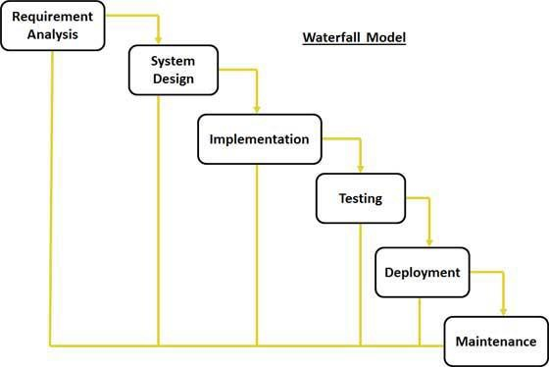
Fig 2.1: Waterfall Model
Feasibility study - The main aim of feasibility study is to determine whether it would be
financially and technically feasible to develop the product.
At first project managers or team leaders try to have a rough understanding of what is
required to be done by visiting the client side. They study different input data to the
system and output data to be produced by the system. They study what kind of processing
is needed to be done on these data and they look at the various constraints on the
behavior of the system.
After they have an overall understanding of the problem they investigate the different
solutions that are possible. Then they examine each of the solutions in terms of what kind
of resources required, what would be the cost of development and what would be the
development time for each solution.
Based on this analysis they pick the best solution and determine whether the solution is
feasible financially and technically. They check whether the customer budget would meet
the cost of the product and whether they have sufficient technical expertise in the area of
development.
Requirements analysis and specification: - The aim of the requirements analysis and
specification phase is to understand the exact requirements of the customer and to document
them properly. This phase consists of two distinct activities, namely
Requirements gathering and analysis
Requirements specification
The goal of the requirements gathering activity is to collect all relevant information from the
customer regarding the product to be developed. This is done to clearly understand the customer
requirements so that incompleteness and inconsistencies are removed.
The requirements analysis activity is begun by collecting all relevant data regarding the product
to be developed from the users of the product and from the customer through interviews and
discussions.
Design: - The goal of the design phase is to transform the requirements specified in the SRS
document into a structure that is suitable for implementation in some programming language. In
technical terms, during the design phase the software architecture is derived from the SRS
document. Two distinctly different approaches are available: the traditional design approach and
the object-oriented design approach.
Traditional design approach -Traditional design consists of two different activities; first
a structured analysis of the requirements specification is carried out where the detailed
structure of the problem is examined. This is followed by a structured design activity.
During structured design, the results of structured analysis are transformed into the
software design.
Object-oriented design approach -In this technique, various objects that occur in the
problem domain and the solution domain are first identified, and the different
relationships that exist among these objects are identified. The object structure is further
refined to obtain the detailed design.
Coding and unit testing:-The purpose of the coding phase (sometimes called the
implementation phase) of software development is to translate the software design into source
code. Each component of the design is implemented as a program module. The end-product of
this phase is a set of program modules that have been individually tested. During this phase, each
module is unit tested to determine the correct working of all the individual modules. It involves
testing each module in isolation as this is the most efficient way to debug the errors identified at
this stage.
Maintenance: -Maintenance of a typical software product requires much more than the effort
necessary to develop the product itself. Many studies carried out in the past confirm this and
indicate that the relative effort of development of a typical software product to its maintenance
effort is roughly in the 40:60 ratios.
3.3 Method of Data Collection
In this project work, a convergent parallel mixed methods design was adopted which are: Interview method, Observation method and Record consultation
3.3.1 Interview Method
The primary collection which is also known as interview method are the original collection of material or study unit from which information is to be collected on first hand basis through interview, measurement and questionnaire completion. But here the researcher only interviews the Doctors, Director of the pharmacy (Chief Pharmacist)and various staff in the department in Nasarawa State University Clinic Center Keffi, reviewing and sharing their experience about the problem of the existing system. Through this, useful information is collected, analyzed and recorded.
3.3.2 Observation Method
The methodology used in this study to obtain required data and information include group observation. Group observation here has to do with critical observation of records that are relevant to the proposed system.While the interview method involve face to face interaction with interview. During the interview, the interviewee asks the question who in turn provides answer to such questions. The above methods were used to obtain relevant data and information for this project.

3.3.3 Record Consultation
The verbal interactions of 4 initial consultation interviews were analyzed using Bergan's (1977) Consultation Analysis Record procedures. The consultants were the Matron’s, Doctors, Doctor’s assistance and the pharmacist while the consulates were field-based educational and Psychological professionals. The professional problems serving as the focus for each consultation session were both real and current.
3.4 Process Analysis
When the program is start up it displays the select form which the users (Admin or Staff) select their login choice.
The Admin logged in using the admin login button and entered his/her details (user name and password) to gain access to the following features: Add drug, Add Staff, View Drugs, Update Drugs, View Staff, and View Sales.
The Staff logged in using the Staff login button and entered his/her details (user name and password) to gain access to Sell Drugs. The structure chart is shown in the figure below:

Figure 1.0: Flowchart showing the process analysis

3.5 Analysis of Current System
The current system is being designed to satisfy and assure better management of the pharmaceutical unit in The Nasarawa State University Clinic Keffi. This project will be an offline automation of drugs management in the pharmacy, which will take over the manual process of record keeping of drugs in the pharmacy. The study is significant because of the centralization of the database. The method of drugs record by “handwriting” is termed not efficient. As a result of this deficiency, we were motivated to design a database management system for drugs, in order to contribute to the development of the school’s medical system thereby bridging the gap in the area of drugs prescription.
3.6 Analysis of Existing System
The purpose of designing a new system is to replace an existing system which is the manual process. The benefit from analyzing the existing system is because this analysis will give a better idea of what problems you are facing. This analysis will be useful for keeping drug record. A proper analysis will ensure that it meet the desire need of the new system.
ProblemsOf the Existing System
After a broad and in-depth analysis of the existing system, a number of short comings were discovered. The short comings make it impossible for the system to achieve its best in performing its operation. The problems are:
The old system is expensive to manage due to frequent reproduction of printed papers being used.
Information is to prone to loss due to certain factors like water, misplacement, fire, theft etc.
The existing system put a lot of stress on pharmacist especially when there are lot of drug to be recorded
Error occurs due to workload on the pharmacist.
3.8 Justification of the New System
It is expected that with the introduction of the new system, a lot of positive changes will be noticed. The numerous problem associated with the manual system will be minimized, if not totally put to an end. The pharmacist who previously had difficulties in carrying out their work will now have to appreciate it. The work load on the pharmacist will be reduced as the system will assist in keeping drug record. This means that the system needs to be updated by the professional (pharmacist) in order to keep the efficiency of the system alive.

CHAPTER FOUR
4.0 System Design and Implementation
System design and implementation is the realization of a technical specification or algorithm as a program, software component, or other computer system through computer programming and deployment. It is also the practice of creating or modifying a system to create a new process or replace an existing process. Specific programming language is used to arrive at the solution described by the specifications from analysis and design phase of the system; the system implementation incorporates all other development phase to produce a functional system. The design of the new system will result in preparation of system specification, while system implementation involves the coordination and controlling of all involved in putting the new system into operation by following details set out in the specification.
4.1 Output Specification and Design
This is a shared collection of data that are related or files that are to meet the immediate need of authorized users. These data may be in form of text, numeric, date or encoded images.
Table 4.0 ADMINISTRATOR LOGIN TABLE:
Field Name | Field Type | Field Length | Description
Admin_Username | Varchar | (15) | Admin Username
Password | Varchar | (15) | Admin password
Table 1 above serves as a repository for administrator details that will be able to have access to the entire details on the application. It is a table that stores the administrator login details.
Table 4.1 DRUG INFORMATION TABLE
Field Name | Field Type | Field Length | Description
Drug_Name | Varchar | (15) | Drug Name
Drug_ID | Varchar | (7) | Drug Number in stock
Manufacturer | Varchar | (15) | Manufacturer
Batch_No | Varchar | ( 5) | Batch Number
Production_Date | Date/Time | ( ) | Production Date
Expiry_Date | Date/Time | ( ) | Expiry Date
Dosage | Text | ( ) | Dosage
Reg_Date | Date/Time | ( ) | Registration Date
Quantity | Int | ( ) | Quantity
Cost_Price | Int | ( ) | Cost Price
Interest_Rate | Int | ( ) | Interest Rate
Expected_Sale | Int | ( ) | Expected Sale

Drug information table: This table is named DRUG it depicts the information of the drugs in the pharmacy.

OUTPUT DESIGN OF THE NEW SYSTEM
4.2 Input Specification and Design
Input specification is simply the data or values that are needed by the Admin or Staff, The input to the system is divided into Admin and Staff Login were the operator of the software can gain access in other to use the system, the Administrators Login Page were the Expertise login to update the database in case of new drugs are available and The Drug Update Form which the Expertise uses to Update drugs into the Database.
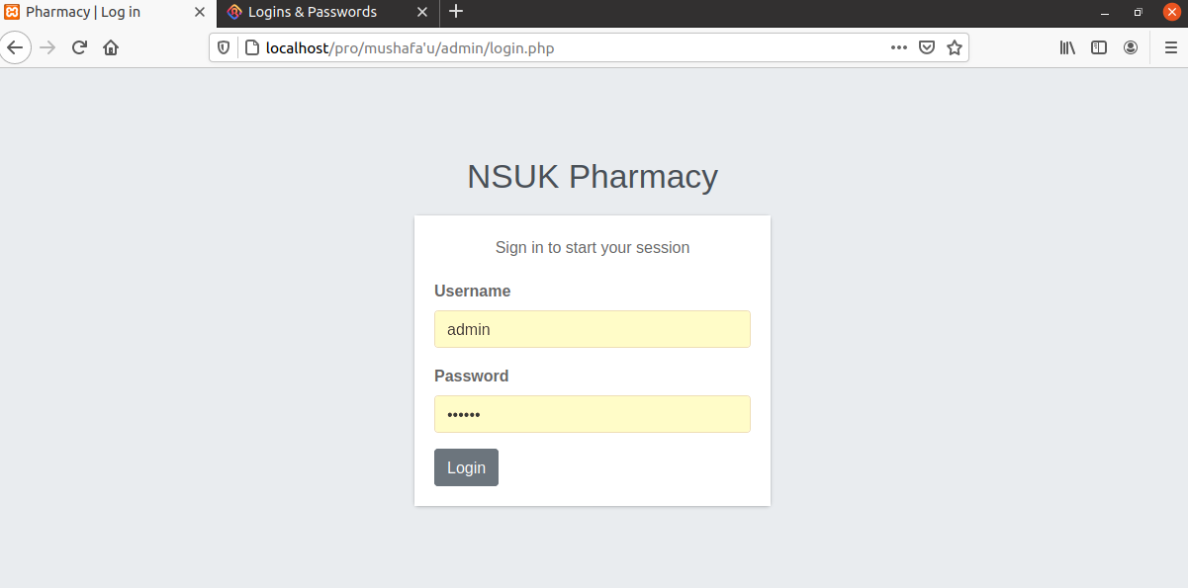
Figure 4.2: Administrator and Staff login page
4.3 Input Design
INPUT DESIGN OF THE NEW SYSTEM
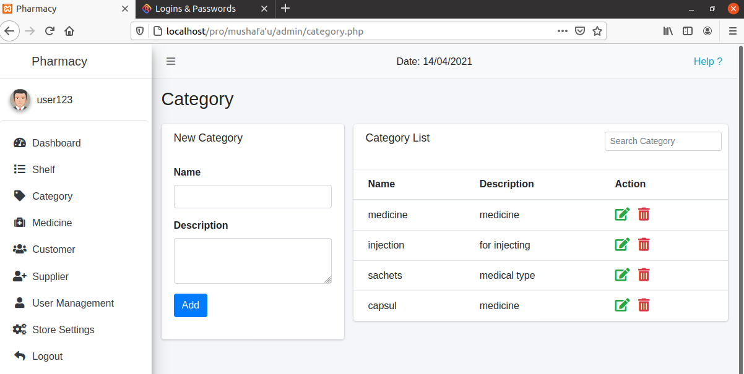
Figure 4.3: Drug registration

Figure 4.4: Staff registration
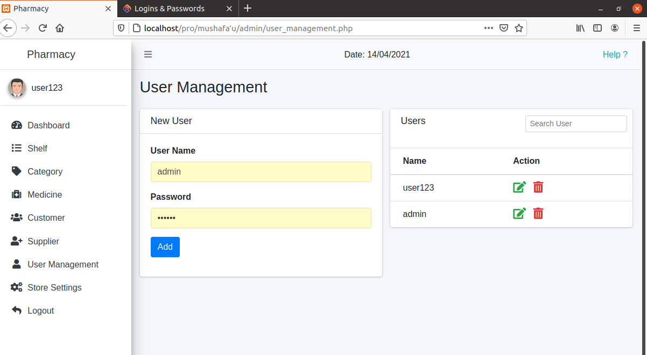
Figure 4.5: Customers
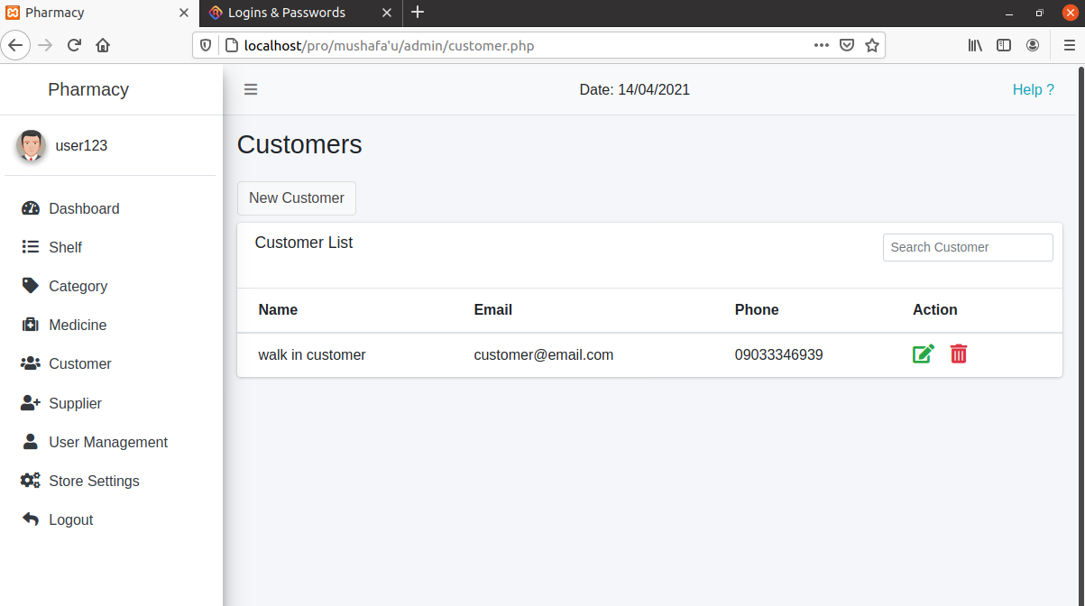

Figure 4.6: Shelfs
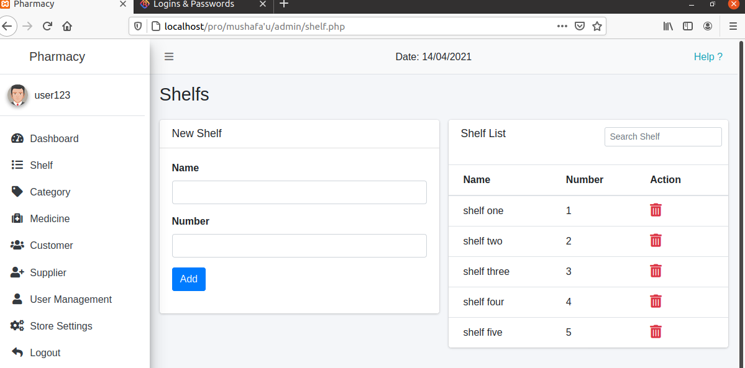

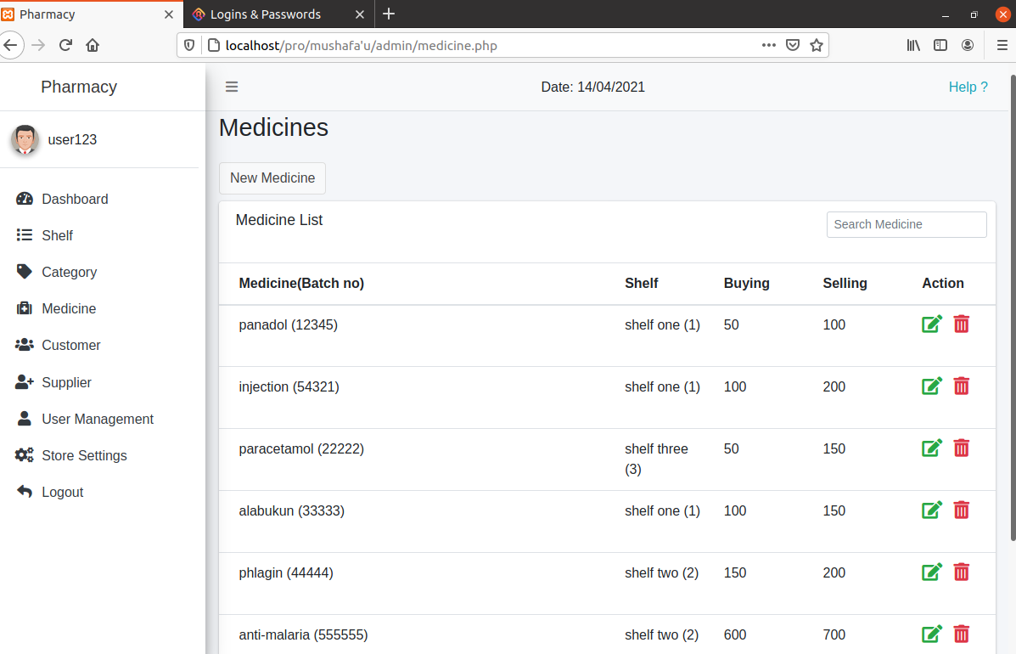
Figure 4.7: Drug populated into the database.
4.4 Justification of Programming language Used
The development tools are defined as the basic required devices that are used during the design of the computer based processing and publishing system to enable the programmer design effective and efficient software. The programming language adopted for implementation of this project work utilized PHP for back-end programming, Mysql database for database creation, HTML will be used to define the System content and CSS for the layout while JavaScript will be used for the front-end such as form validation.
Hypertext processor (PHP) Web Development Services is one of the most popular used languages to create website because.
It is an open source which makes it really cost-effective to work on.
The error detection in PHP is easier as the language as the language is highly efficient.
It is among the fastest languages available and it process the data very fast
Its high usability, it is training and acquiring is risk free.
Mysql its one of the best database system for most web-based application because of its speed, reliability and cost.
Hypertext Markup Language (HTML) it use for encoding Web pages.
Cascading Style Sheets (CSS) it is the coding language that give website its look and layout. Along with HTML, is fundamental to web design, without it website would still be plain on white backgrounds
4.5 System Requirement
This embodies the hardware and the software that must be set up for the smooth operation of the system.
4.5.1 Hardware Requirement
For the purpose of development and testing of the computer based testing application, computer with the following configuration are used:
Processor: Intel(R) Celeron(R) CPU 900 @2.20GHz
Installed Memory(RAM): 4.00GB
Hard Disk: 320GB
But, for real use and for efficiency where the system will be controlling drug information and drugs management in the database facility, faster and more rugged computer system of at least 8GB RAM and 500GB-1000 Terabit Hard disk will be required in order to ensure optimum performance.
4.5.2 Software Requirement
During the development and testing of the computer Based Testing application, the following software was installed and make used of:
Microsoft Windows operating system (Windows 8.0)
Visual Studio code (VSCode)
Xampp
4.6 System Maintenance
Since documentation is very important in the development of any software or any system, it is
very important to maintain the document. If the system is appropriately maintained as going to be stated below, it will go a long way in serving the pharmacy unit The Federal Polytechnic Medical center Bida. Below are some of the system maintenance measures:
After installing the software, workable or updated anti-virus software such as Avast 2018 should be installed on the computer to protect the system and software from all forms of viruses, malwares and spywares that may cause the software to malfunction.
After working on the application, the user should quit or logout to avoid any external or unauthorized personality from getting access to it.
The system should not be opened to an illiterate person i.e someone who does not have any basic knowledge of computing drug record, to avoid loss of data.
Training of staffers in computer operation.

CHAPTER FIVE
5.0 SUMMARY, CONCLUSION AND RECOMMENDATIONS
5.1 Summary
Pharmacy management system is designed to improve the accuracy, enhance safety and efficient pharmaceutical store. It is a computer based system which helps the Pharmacist to improve inventory management, cost, medical safety etc.
Pharmacy management system was developed to ensure the security of information and reliability of Pharmacy records when accessing and providing services to the customers. The information gathered during the data collection was properly analyzed and the results provided the basis for the new system. The system was tested and found to be functional and the outputs produced by this system were encouraging. The application will hence reduce the loss of information unlike the existing system and also information will be processed fast.
5.2 Conclusion
Effective implementation of this software will take care of the basic requirements of the pharmacy management system because it is capable of providing easy and effective storage of information related to activities happening in the stipulated area. With these, the objectives of the system design will be achieved.
5.3 Recommendations
Designing this application (Pharmacy database management system) is not an easy task. It all started from the requirement gathering and passes through so many other stages before completion. Based on the benefits of this system and tremendous value it will add to customer-user satisfaction, the below recommendation will be considered;
It is recommended that the new system should be used with the necessary specifications of the system requirements and provision for an uninterrupted power supply should be made available throughout the hours of operation of the pharmacy to avoid power outage.
There should also be basic computer knowledge for the users of the software.
It is recommended that the software be improved especially in areas of accounting as it will be of great impact to the development of retail pharmacy. In order to allow for future expansion, the system has been designed in such a way that will allow possible modification as it may deem necessary by the pharmacy management, whenever the idea arises.

REFERENCES
Andriano E Wibowo. (2018). The Importance of Database Management System for A Pharmacy, 1–2. Retrieved from https://blog.ub.ac.id/andriano777/2010/11/18/database-system-pharmacy/
Charles E. Rosenberg, M. J. V. (2011). The Therapeutic Revolution: Essays in the social history of American Medicine, 2, 174.
Eades, C. E., Ferguson, J. S., & O’Carroll, R. E. (2011). Public health in community pharmacy: A systematic review of pharmacist and consumer views. BMC Public Health. https://doi.org/10.1186/1471-2458-11-582
El Hajj, M. S., Salem, S., & Mansoor, H. (2011). Public’s attitudes towards community pharmacy in Qatar: A pilot study. Patient Preference and Adherence, 5, 405–422. https://doi.org/10.2147/PPA.S22117
Fang, Y., Yang, S., Feng, B., Ni, Y., & Zhang, K. (2011). Pharmacists’ perception of pharmaceutical care in community pharmacy: A questionnaire survey in Northwest China. Health and Social Care in the Community, 19(2), 189–197. https://doi.org/10.1111/j.1365-2524.2010.00959.x
Gebauer, H. (2008). Robust management policies for positioning pharmacies as healthcare service providers. European Management Journal, 26(3), 175–187. https://doi.org/10.1016/j.emj.2008.01.003
Gupta, S., & Gupta, N. V. (2016). Pharmaceutical supply chain management. International Journal of Pharmaceutical Sciences Review and Research.
Kornfield, R., Donohue, J., Berndt, E. R., & Alexander, G. C. (2013). Promotion of Prescription Drugs to Consumers and Providers, 2001-2010. PLoS ONE. https://doi.org/10.1371/journal.pone.0055504
Millerso, D. (2014). Definition of Pharmacist.
Munga MA. (2010). Polypharmacy and combination therapy in the management of hypertens.
Myers, T. (2006). Mosby’s dictionary of medicine, nursing and health professions.
Naik Panvelkar, P., Saini, B., & Armour, C. (2009). Measurement of patient satisfaction with community pharmacy services: A review. Pharmacy World and Science. https://doi.org/10.1007/s11096-009-9311-2
Quiett, L. (2012). Clerical and Data Management for the Pharmacy Technician.
Tannenbaum C, S. N. (2014). Unkderstanding and Preventing Drug-drug and drug-gene interaction.
Watkins, E. S. (2009). From History of Pharmacy to the Pharmaceutical History.
Webster, M. (2016). Definition of Sytem.

APPENDIX
1.Adddrug
Dim CONN As New ADODB.Connection
Dim RECC As New ADODB.Recordset
Dim LQuanAs Integer
Dim ctrl As Control

Private Sub cmdClear_Click()
For Each ctrl In Me
If TypeOf ctrl IsTextBox Then
ctrl.Text = ""
End If
Next
End Sub

Private Sub cmdExit_Click()
Dim x As Variant
x = MsgBox("Are Sure You Want To Return To The Main Form?", vbYesNo + vbCritical, App.Title)
If x = vbYes Then
Unload Me
frmAdminPage.Show
End If
End Sub

Private Sub cmdPrint_Click()
Dim x As Variant
x = MsgBox("Are Sure You Want To Print The Current Form?", vbYesNo + vbCritical, App.Title)
If x = vbYes Then
frmAddDrug.PrintForm
MsgBox "Form has been sent to printer successfully", vbInformation, App.Title
End If
End Sub

Private Sub cmdSave_Click()
For Each ctrl In Me
If TypeOf ctrl IsTextBox Then
If ctrl.Text = "" Then
MsgBox "All Fields Are Reqiured!",vbCritical, App.Title
Exit Sub
End If
End If
Next
If IsNumeric(txtquantity.Text) = False Then
MsgBox "please enter a numeric value", vbOKOnly
txtquantity.Text = ""
txtquantity.SetFocus
Exit Sub
End If
If IsNumeric(Me.txtDname.Text) = True Then
MsgBox "Your text should be a aphabet!",vbCritical, App.Title
txtDname.Text = ""
txtDname.SetFocus
Exit Sub
End If
If IsNumeric(Me.txtmanufacturer.Text) = True Then
MsgBox "Your text should be a aphabet!",vbCritical, App.Title
txtmanufacturer.Text = ""
txtmanufacturer.SetFocus
Exit Sub
End If
If IsNumeric(Me.txtRnumber.Text) = False Then
MsgBox "please enter a numeric value", vbOKOnly
txtRnumber.Text = ""
txtRnumber.SetFocus
Exit Sub
End If
If RECC.State<> 0 Then
RECC.Close
CONN.Close
End If
CONN.Open "Provider = Microsoft.jet.OLEDB.4.0; Data Source =" &App.Path& "\Database2.mdb"
RECC.CursorLocation = adUseClient
RECC.Open "Select * From Drugs Where DrugName ='" &txtDname& "'", CONN, adOpenDynamic, adLockOptimistic
If Not RECC.EOF Then
With RECC
.Fields(0).Value = Me.txtDname.Text
.Fields(1).Value = LQuan + Val(Me.txtquantity.Text)
.Fields(2).Value = Me.txtmanufacturer.Text
.Fields(3).Value = Me.txtCost.Text
.Fields(4).Value = Me.txtPdate.Value
.Fields(5).Value = Me.txtEDate.Value
.Fields(6).Value = Me.txtPrice.Text
.Fields(7).Value = Me.txtRnumber.Text
.Fields(8).Value = Me.txtLoc.Text
.Update
End With
MsgBox "Drug Updated Successfuly", vbInformation, App.Title
Else
With RECC
.AddNew
.Fields(0).Value = Me.txtDname.Text
.Fields(1).Value = LQuan + Val(Me.txtquantity.Text)
.Fields(2).Value = Me.txtmanufacturer.Text
.Fields(3).Value = Me.txtCost.Text
.Fields(4).Value = Me.txtPdate.Value
.Fields(5).Value = Me.txtEDate.Value
.Fields(6).Value = Me.txtPrice.Text
.Fields(7).Value = Me.txtRnumber.Text
.Fields(8).Value = Me.txtLoc.Text
.Update
End With
MsgBox "Drug Added Successfuly", vbInformation, App.Title
End If
If RECC.State<> 0 Then
RECC.Close
CONN.Close
End If
End Sub
Private Sub cmdSearch_Click()
Dim sQl As String
sQl = txtSearch.Text
If RECC.State<> 0 Then
RECC.Close
CONN.Close
End If
CONN.Open "Provider = Microsoft.jet.OLEDB.4.0; Data Source =" &App.Path& "\Database2.mdb"
RECC.CursorLocation = adUseClient
RECC.Open "Select * From Drugs Where DrugName ='" &sQl& "'", CONN, adOpenDynamic, adLockOptimistic
If Not RECC.EOF Then
Set Me.txtQleft.DataSource = RECC
Me.txtQleft.DataField = "Quantity"
LQuan = RECC.Fields("Quantity")
If RECC.State<> 0 Then
RECC.Close
CONN.Close
End If
Else
If RECC.State<> 0 Then
RECC.Close
CONN.Close
MsgBoxsQl&" Was Not Found In The Drug Database", vbInformation, App.Title
Form_Load
End If
End If
End Sub

Private Sub Form_Load()
If RECC.State = 0 Then
CONN.Open "Provider = Microsoft.jet.OLEDB.4.0; Data Source =" &App.Path& "\Database2.mdb"
RECC.CursorLocation = adUseClient
RECC.Open "Select * From Drugs", CONN, adOpenDynamic, adLockOptimistic
End If

End Sub

Private Sub Form_Unload(Cancel As Integer)
If RECC.State<> 0 Then
RECC.Close
CONN.Close
End If
End Sub

Private Sub Timer1_Timer()
Ptitle.Left = Ptitle.Left + 50
If Ptitle.Left>= 4920 Then
Ptitle.Left = -3360
End If
End Sub

Private Sub txtPrice_Change()
txtCost.Text = Val(txtPrice.Text) * Val(txtquantity.Text)
End Sub

2.selldrug
Dim CONN As New ADODB.Connection
Dim RECC As New ADODB.Recordset
Dim ctrl As Control

Private Sub cmdClear_Click()
For Each ctrl In Me
If TypeOf ctrl IsTextBox Then
ctrl.Text = ""
End If
Next
End Sub

Private Sub cmdExit_Click()
Dim x As Variant
x = MsgBox("Are you sure you wants to return to the main menu?", vbYesNo, App.Title)
If x = vbYes Then
Unload Me
Form2.Show
End If
End Sub
Private Sub cmdSave_Click()
'Dim dNam As String
Dim LQuanAs Integer
Dim CQuanAs Integer
For Each ctrl In Me
If TypeOf ctrl IsTextBox Then
If ctrl.Name = "txtSearch" Then GoTo hell:
If ctrl.Name = "txtQleft" Then GoTo hell:
If ctrl.Text = "" Then
MsgBox "All Fields Are Reqiured!",vbCritical, App.Title
Exit Sub
End If
End If
hell:
Next
If IsNumeric(txtquantity.Text) = False Then
MsgBox "please enter a numeric value", vbOKOnly
txtquantity.Text = ""
txtquantity.SetFocus
Exit Sub
End If

If RECC.State<> 0 Then
RECC.Close
CONN.Close
End If
CONN.Open "Provider = Microsoft.jet.OLEDB.4.0; Data Source =" &App.Path& "\Database2.mdb"
RECC.CursorLocation = adUseClient
RECC.Open "Select * From Drugs Where DrugName ='" &txtSearch& "'", CONN, adOpenDynamic, adLockOptimistic
'RECC.Open "Select * From Sell Where DrugName ='" &txtSearch& "'", CONN, adOpenDynamic, adLockOptimistic
With RECC
'.AddNew
'.Fields(0).Value = Me.txtSearch.Text
.Fields(1).Value = Me.txtQleft.Text
'.Fields(9).Value = Me.txtQuantity.Text
'.Fields(10).Value = Me.txttotal.Text
' .Fields(11).Value = Me.txtDdate.Value
'.Fields(2).Value = Me.txtCost.Text
' .Fields(3).Value = Me.txtQuantity.Text
' .Fields(4).Value = Me.txttotal.Text
' .Fields(5).Value = Me.txtDdate.Value
' .Fields(6).Value = Me.txtRnumber.Text

.Update
End With

If RECC.State<> 0 Then
RECC.Close
CONN.Close
End If
CONN.Open "Provider = Microsoft.jet.OLEDB.4.0; Data Source =" &App.Path& "\Database2.mdb"
RECC.CursorLocation = adUseClient
RECC.Open "Select * From Sell Where DrugName ='" &txtSearch& "'", CONN, adOpenDynamic, adLockOptimistic
With RECC
.AddNew
.Fields(0).Value = Me.txtSearch.Text
.Fields(1).Value = Me.txtCost.Text
.Fields(2).Value = Me.txtquantity.Text
.Fields(3).Value = Me.txttotal.Text
.Fields(4).Value = Me.txtDdate.Value
.Fields(5).Value = Me.txtRnumber.Text
.Update
End With
'If Not RECC.EOF Then
'LQuan = RECC.Fields("Quantity")
' If (Val(LQuan) < Val(Me.txtQuantity)) Then
' MsgBox "You don't have up to that amount in the data base", vbCritical, App.Title
' RECC.Close
'CONN.Close
'Exit Sub
'Else
'CQuan = Val(LQuan) - Val(txtQuantity)
' With RECC
'.Fields(10).Value = CQuan
'.Fields(11).Value = Me.txttotal.Text
'.Fields(12).Value = txtDdate.Value
'End With
MsgBox "Drug Distributed Sucessfully", vbInformation, App.Title
' IfRECC.State<> 0 Then
' RECC.Close
' CONN.Close

'End If
'End If
'Else
'MsgBox "Drug Does not exist", vbCritical, App.Title
' IfRECC.State<> 0 Then
' RECC.Close
' CONN.Close
' End If
' Exit Sub
' End If
If RECC.State<> 0 Then
RECC.Close
CONN.Close
End If
End Sub

Private Sub cmdSearch_Click()
Dim sQl As String
sQl = txtSearch.Text
If RECC.State<> 0 Then
RECC.Close
CONN.Close
End If
CONN.Open "Provider = Microsoft.jet.OLEDB.4.0; Data Source =" &App.Path& "\Database2.mdb"
RECC.CursorLocation = adUseClient
RECC.Open "Select * From Drugs Where DrugName ='" &sQl& "'", CONN, adOpenDynamic, adLockOptimistic
If Not RECC.EOF Then
Set Me.txtQleft.DataSource = RECC
Me.txtQleft.DataField = "Quantity"
Set Me.txtCost.DataSource = RECC
Me.txtCost.DataField = "Price"
LQuan = RECC.Fields("Quantity")
Set Me.txtRnumber.DataSource = RECC
Me.txtRnumber.DataField = "ReceiptNumber"
If RECC.State<> 0 Then
RECC.Close
CONN.Close
End If
Else
If RECC.State<> 0 Then
RECC.Close
CONN.Close
MsgBoxsQl&" Was Not Found In The Drug Database", vbInformation, App.Title
Form_Load
End If
End If
End Sub
Private Sub Form_Load()
'Connect
End Sub
'End Sub
Private Sub Form_Unload(Cancel As Integer)
If RECC.State<> 0 Then
RECC.Close
CONN.Close
End If
End Sub

Private Sub Timer1_Timer()
Ptitle.Left = Ptitle.Left + 50
If Ptitle.Left>= 4800 Then
Ptitle.Left = -3120
End If
End Sub

Private Sub txtQuantity_Change()
txttotal.Text = Val(txtquantity.Text) * Val(txtCost.Text)
txtQleft.Text = Val(txtQleft.Text) - Val(txtquantity.Text)
End Sub
3.Adminlogin
Private Sub cmdExit_Click()
Dim x As Variant
x = MsgBox("Are you sure you want to exit?", vbYesNo + vbQuestion)
If x = vbYes Then
End
End If
End Sub

Private Sub cmdLogin_Click()
If txtName.Text = "admin" And txtPassword.Text = "admin" Then
Unload Me
frmAdminPage.Show
Else
MsgBox "Please enter the correct user name and password", vbCritical, "Error"
End If
End Sub
4.Addstaff
Dim CONN As New ADODB.Connection
Dim RECC As New ADODB.Recordset
Dim ctrl As Control

Private Sub cmdaddnew_Click()
For Each ctrl In Me
If TypeOf ctrl IsTextBox Then
ctrl.Text = ""
End If
Next
RECC.AddNew
End Sub

Private Sub cmdExit_Click()
Dim x As Variant
x = MsgBox("Are you sure you wants to return to the main menu?", vbYesNo, App.Title)
If x = vbYes Then
Unload Me
frmAdminPage.Show
End If
End Sub

Private Sub cmdSave_Click()

With RECC
.Fields(0).Value = Me.txtId.Text
.Fields(1).Value = Me.txtName.Text
.Fields(2).Value = Me.DTPicker1.Value
.Fields(3).Value = Me.txtSex.Text
.Fields(4).Value = Me.txtstatus.Text
.Fields(5).Value = Me.txtAddress.Text
.Fields(6).Value = Me.txtnationality.Text
.Fields(7).Value = Me.txtstate.Text
.Fields(8).Value = Me.txtDate.Value
.Fields(9).Value = Me.txtphone.Text
.Fields(10).Value = Me.txtemail.Text
.Fields(11).Value = Me.txtuser.Text
.Fields(12).Value = Me.txtpass.Text
.Fields(13).Value = Me.Text2.Text
.Update
End With
MsgBox "Staff Record Saved Successfully", vbInformation, App.Title
End Sub

Private Sub Form_Load()
Dim i As Integer
CONN.Open "Provider = Microsoft.jet.OLEDB.4.0; Data Source =" &App.Path& "\Database2.mdb"
RECC.CursorLocation = adUseClient
RECC.Open "Select * From staff", CONN, adOpenDynamic, adLockOptimistic

With txtSex
.AddItem "Male"
.AddItem "Female"
End With
End Sub

Private Sub Form_Unload(Cancel As Integer)
If RECC.State<> 0 Then
'recc.Close
CONN.Close
End If
End Sub

Private Sub jcbutton1_Click()
CommonDialog1.Filter = "Image(*.jpg)|*jpg;*"
CommonDialog1.ShowOpen
Text2.Text = CommonDialog1.FileName
Image2.Picture = LoadPicture(Text2.Text)
End Sub

Private Sub Timer1_Timer()
Ptitle.Left = Ptitle.Left + 50
If Ptitle.Left>= 4800 Then
Ptitle.Left = -3120
End If
End Sub

