WEEK 06
MODEL EVALUATION,
COMPARISON & BUSINESS RECOMMENDATIONS
Beauty & Wellness – Data Science Internship
Final Technical Report

Report detail | Information
Internship task | Week 06 – Model Evaluation and Business Recommendations
Domain | Beauty & Wellness / Customer Review Sentiment Analysis
Dataset | Cleaned Amazon Beauty Reviews sample
Dataset size | 10,192 reviews; 12 columns in the cleaned dataset
Model evaluation split | 80% training (8,153) / 20% testing (2,039)
Feature representation | TF-IDF, maximum 5,000 features
Models compared | Logistic Regression, Multinomial Naive Bayes, Decision Tree, Balanced Naive Bayes
Submission | Technical report with evaluation charts and recommendations

Prepared as the Week 06 internship deliverable.

Executive Summary
This report evaluates four machine-learning classifiers for three-class sentiment classification of beauty and wellness product reviews. The classes are Positive, Neutral and Negative. The cleaned dataset contains 10,192 reviews and is strongly imbalanced: positive reviews form 82.13% of the data, while neutral and negative reviews form 10.79% and 7.07%, respectively. Text was represented using TF-IDF with up to 5,000 features. The models were assessed on a stratified 80:20 train-test split containing 8,153 training examples and 2,039 test examples.
Logistic Regression achieved the strongest overall test performance: 77.49% accuracy, 79.66% weighted F1-score, 57.31% macro F1-score and 0.8540 macro one-vs-rest ROC-AUC. It is therefore selected as the recommended model among the evaluated candidates. However, its performance on the minority Neutral and Negative classes is substantially lower than on Positive reviews. The model should be used as a decision-support tool, with uncertain or negative cases reviewed by a human.

1. Introduction
Online customer reviews are an important source of feedback for beauty and wellness businesses. Reviews can reveal customer satisfaction, product concerns, recurring complaints and opportunities for improvement. Reading a large volume of reviews manually is time-consuming. Sentiment analysis can help organize this feedback by predicting whether a review expresses a positive, neutral or negative sentiment.
The purpose of this Week 06 task is to evaluate the developed sentiment-classification models, compare their performance using multiple metrics, identify the most suitable model, interpret its limitations and translate the results into practical business recommendations.

2. Objectives
- Evaluate the trained sentiment-classification models on held-out test data.
- Compare models using accuracy, precision, recall, F1-score and ROC-AUC.
- Review class-wise performance rather than relying only on overall accuracy.
- Visualize model performance and sentiment-class distribution.
- Select a recommended model and explain the selection.
- Provide realistic business recommendations, limitations and future improvements.

3. Dataset Description
The project uses a cleaned sample of Amazon Beauty Reviews. The cleaned dataset contains 10,192 rows and 12 columns. Review text is the principal input for sentiment classification. Ratings are mapped to sentiment labels as follows:
Rating | Sentiment label | Meaning
1–2 | Negative | Dissatisfied or unfavourable review
3 | Neutral | Mixed, moderate or neither clearly positive nor negative
4–5 | Positive | Satisfied or favourable review

The class distribution is shown below.
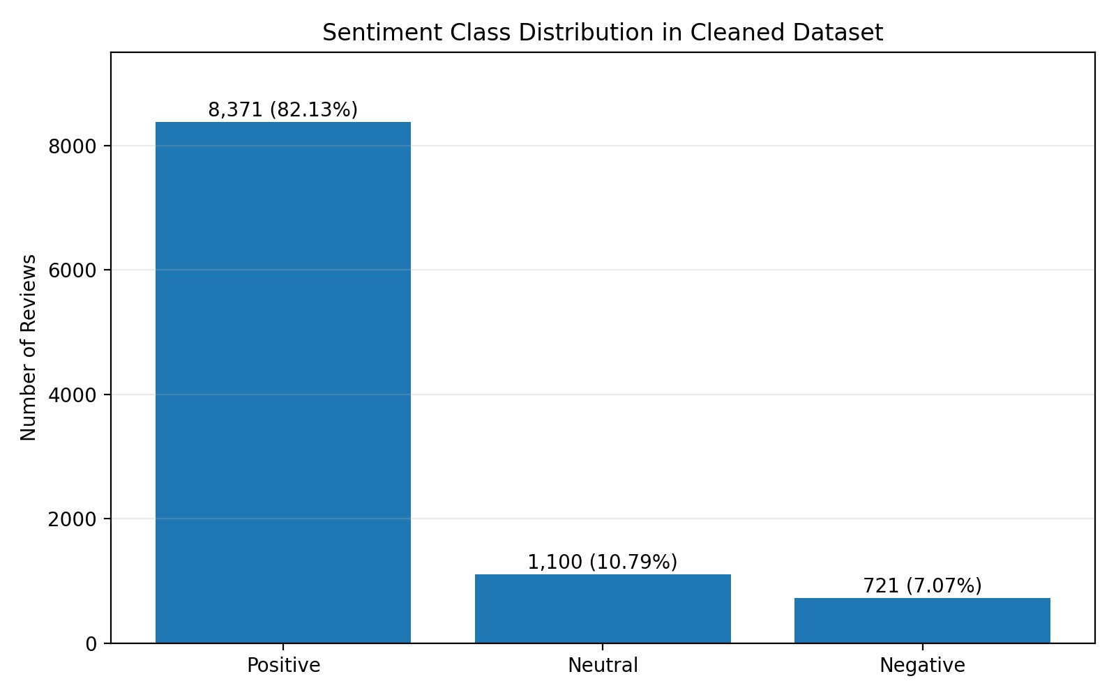
Figure 1. Distribution of sentiment labels in the cleaned dataset.
Sentiment | Number of reviews | Percentage
Positive | 8,371 | 82.13%
Neutral | 1,100 | 10.79%
Negative | 721 | 7.07%
Total | 10,192 | 100.00%

The dataset is imbalanced because positive reviews substantially outnumber neutral and negative reviews. This is important when interpreting accuracy: a model can obtain a reasonable overall score while still missing a meaningful share of minority-class reviews.

4. Data Preparation and Experimental Setup

4.1 Text representation
Review text was converted into numerical features using Term Frequency–Inverse Document Frequency (TF-IDF). TF-IDF gives greater importance to terms that are informative within a document while reducing the influence of terms that occur very frequently across documents. The feature limit was set to 5,000.

4.2 Train-test split
Subset | Number of reviews | Share
Training set | 8,153 | 80%
Testing set | 2,039 | 20%
Total | 10,192 | 100%

A stratified 80:20 split was used so that the sentiment proportions were approximately preserved in both subsets. The test subset was used for final model comparison.

4.3 Models evaluated
Model | Description
Logistic Regression | A linear classifier that estimates class probabilities from weighted text features.
Multinomial Naive Bayes | A probabilistic classifier commonly used for word-count or TF-IDF text features.
Decision Tree | A tree-based classifier that learns feature-based decision rules.
Balanced Naive Bayes | The second Naive Bayes model included in the evaluation run; its observed predictions were identical to Multinomial Naive Bayes.

4.4 Evaluation metrics
Metric | What it measures | Why it matters
Accuracy | Fraction of all predictions that are correct. | Useful overall measure, but can be misleading with imbalanced classes.
Precision | Of the reviews predicted as a class, how many truly belong to it? | Helps understand false alarms for each sentiment.
Recall | Of the actual reviews in a class, how many were found? | Important for identifying negative feedback that should not be missed.
F1-score | Harmonic mean of precision and recall. | Balances precision and recall.
Weighted F1 | F1 averaged using each class's support. | Reflects overall performance while giving more weight to larger classes.
Macro F1 | Unweighted average of the F1-scores across classes. | Gives minority classes equal importance.
ROC-AUC | Measures class-separation ability across thresholds; macro one-vs-rest used here. | Provides a threshold-independent view of discrimination.

5. Model Evaluation Results
The following table summarizes the held-out test-set results from the completed Week 06 evaluation.
Model | Accuracy | Weighted F1 | Macro F1 | Macro ROC-AUC
Logistic Regression | 77.49% | 79.66% | 57.31% | 0.8540
Multinomial NB | 73.17% | 76.91% | 56.24% | 0.8476
Decision Tree | 70.03% | 72.68% | 45.11% | 0.6447
Balanced NB | 73.17% | 76.91% | 56.24% | 0.8476

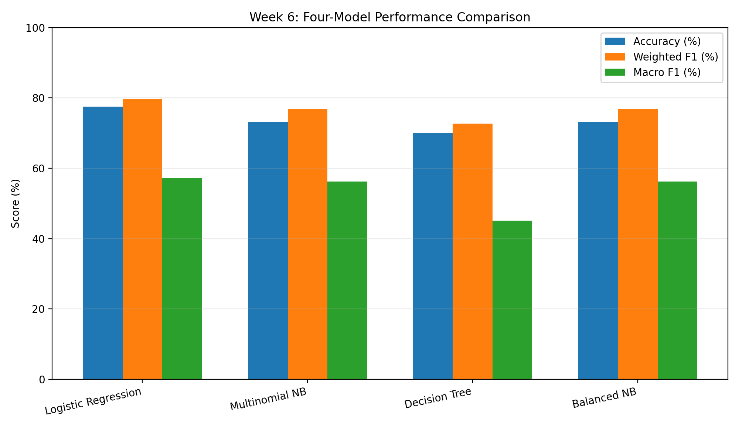
Figure 2. Comparison of accuracy, weighted F1 and macro F1 across the four models.
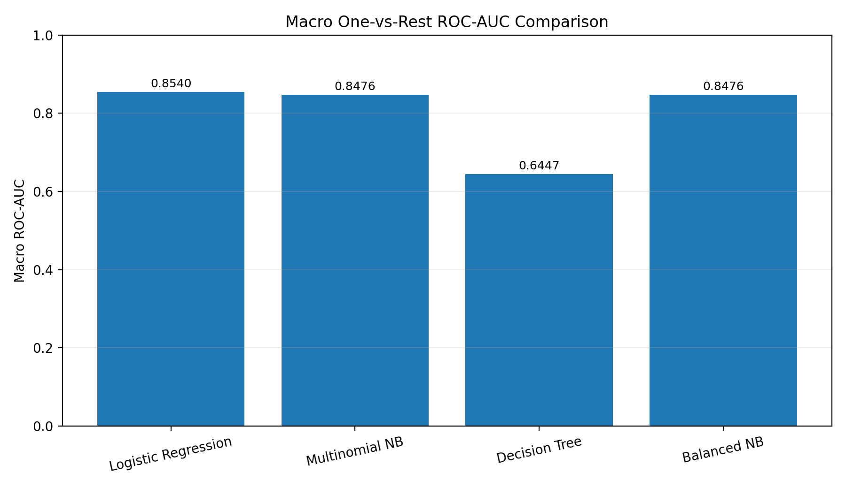
Figure 3. Macro one-vs-rest ROC-AUC comparison.

6. Class-wise Performance
Class-wise results help reveal how well the models handle each sentiment. The following values are rounded to two decimal places from the classification reports generated in Colab.

Model | Class | Precision | Recall | F1-score | Support
Logistic Regression | Negative | 0.42 | 0.55 | 0.47 | 144
Logistic Regression | Neutral | 0.30 | 0.48 | 0.37 | 220
Logistic Regression | Positive | 0.93 | 0.83 | 0.88 | 1,675
Multinomial NB | Negative | 0.38 | 0.61 | 0.47 | 144
Multinomial NB | Neutral | 0.27 | 0.58 | 0.37 | 220
Multinomial NB | Positive | 0.95 | 0.76 | 0.85 | 1,675
Decision Tree | Negative | 0.24 | 0.52 | 0.33 | 144
Decision Tree | Neutral | 0.18 | 0.21 | 0.19 | 220
Decision Tree | Positive | 0.89 | 0.78 | 0.83 | 1,675
Balanced NB | Negative | 0.38 | 0.61 | 0.47 | 144
Balanced NB | Neutral | 0.27 | 0.58 | 0.37 | 220
Balanced NB | Positive | 0.95 | 0.76 | 0.85 | 1,675

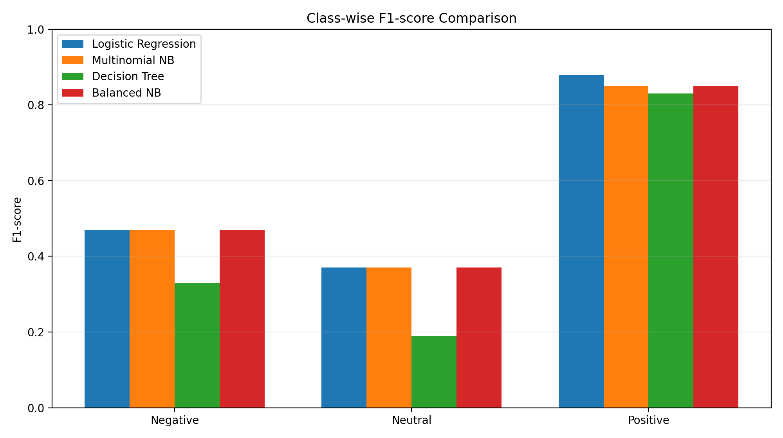
Figure 4. Class-wise F1-score comparison. Values are rounded.
Logistic Regression performs best on the Positive class and achieves the strongest overall summary metrics. However, the F1-scores for Neutral and Negative reviews are much lower. This indicates that the model has difficulty separating less common or ambiguous sentiment classes. Multinomial Naive Bayes has somewhat higher recall for the minority classes in this test run, but lower positive-class F1 and lower overall scores.

7. Confusion Matrix Interpretation
Confusion matrices were generated in the Colab notebook for all four models. They show the number of correct and incorrect predictions for each actual-versus-predicted sentiment pair. Figure 5 presents the original confusion matrices for Logistic Regression, Multinomial Naive Bayes, Decision Tree and Balanced Naive Bayes. In each matrix, rows are the actual sentiment, columns are the predicted sentiment, and the diagonal cells are correct predictions.
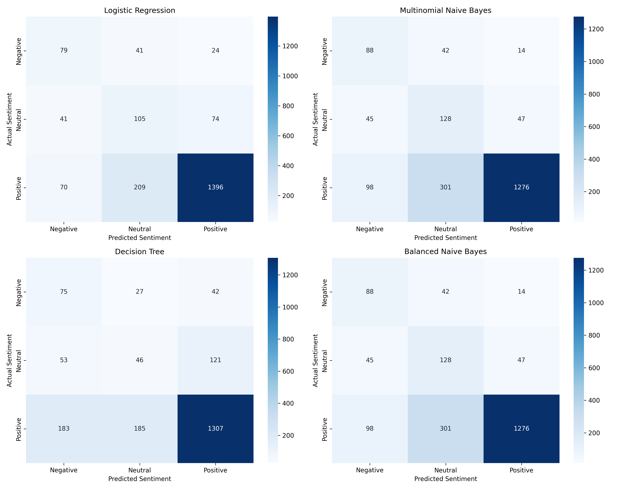
Figure 5: Confusion Matrices of All Four Evaluated Models

Interpretation
Across all four models, the largest cell is Positive reviews correctly predicted as Positive, reflecting the dominance of the Positive class in the test set (1,675 of 2,039 reviews). Logistic Regression classifies 1,396 of these correctly, compared with 1,276 for both Naive Bayes models and 1,307 for the Decision Tree. Its diagonal total (79 + 105 + 1,396 = 1,580 of 2,039) is consistent with the reported 77.49% accuracy.
The main weakness shared by the models is confusion between Positive and Neutral reviews. Logistic Regression correctly identifies 105 of 220 Neutral reviews, and 209 Positive reviews are predicted as Neutral. The Naive Bayes models identify more Neutral reviews correctly (128 of 220) and more Negative reviews correctly (88 of 144, versus 79 for Logistic Regression), but misclassify 301 Positive reviews as Neutral and 98 as Negative. This is consistent with their higher minority-class recall and lower Positive-class recall reported in Section 6.
The Decision Tree is weakest on the Neutral class, correctly identifying only 46 of 220 Neutral reviews, with 121 predicted as Positive. It also predicts 183 Positive reviews as Negative, more than any other model. The Multinomial Naive Bayes and Balanced Naive Bayes matrices are identical cell for cell, which confirms that the Balanced Naive Bayes configuration did not change the predictions in this run.

8. Model Selection and Discussion
Logistic Regression is selected as the recommended model for this experiment. It achieved the highest accuracy (77.49%), weighted F1 (79.66%), macro F1 (57.31%) and macro ROC-AUC (0.8540) among the four evaluated models. Its results are relatively balanced compared with the Decision Tree, which had the lowest macro F1 and ROC-AUC.
The Balanced NB and Multinomial NB outputs were identical in this run: their predictions and reported metrics matched. Therefore, this experiment does not demonstrate an improvement from the 'Balanced NB' configuration. The implementation should be checked before making any claim that class balancing improved Naive Bayes performance.
The selection is not a claim that Logistic Regression is perfect. The Neutral class has an F1-score of 0.37 and the Negative class an F1-score of 0.47. A business deployment should therefore include human review, particularly for negative reviews, uncertain predictions and issues that may require customer support.

9. Business Recommendations
- Create a negative-review alert queue: route low-sentiment reviews to a support or quality team for timely review.
- Group recurring complaints: examine repeated mentions of packaging, fragrance, texture, product quality, delivery and customer experience.
- Use positive feedback to understand strengths: identify product attributes customers appreciate and use these insights in product descriptions and marketing, after human verification.
- Review neutral feedback separately: neutral reviews may contain mixed experiences or suggestions that can guide product and service improvements.
- Track sentiment over time: monitor weekly or monthly changes by product, category and issue type rather than relying on a single overall score.
- Keep a human in the loop: sentiment predictions should prioritize and organize feedback, not automatically determine product safety, efficacy, refunds or customer outcomes.
- Monitor model quality: periodically label a fresh sample of reviews and recalculate class-wise precision, recall, F1 and ROC-AUC.

10. Limitations
- Class imbalance: positive reviews account for 82.13% of the dataset, which makes minority-class learning more difficult.
- Language ambiguity: sarcasm, spelling mistakes, slang, mixed opinions and context can lead to incorrect predictions.
- Rating-derived labels: mapping star ratings to sentiment is a practical proxy and may not always match the emotion expressed in the written review.
- Sample limitation: results are based on the available cleaned review sample and may not generalize to every beauty or wellness product or platform.
- Single held-out split: performance can vary with a different train-test split or new incoming data.
- Balanced NB duplication: the Balanced NB predictions were identical to Multinomial NB in this run, so the intended balancing effect was not demonstrated.
- Human validation: automated predictions should not replace review by a domain expert or customer-support team.

11. Future Improvements
- Collect and label more neutral and negative reviews to reduce class imbalance.
- Test class-weighted Logistic Regression and carefully validated resampling methods.
- Tune model hyperparameters using stratified cross-validation without using the final test set for tuning.
- Explore n-grams, improved text cleaning and domain-specific vocabulary.
- Compare TF-IDF models with transformer-based sentiment models if compute and time permit.
- Add confidence thresholds so low-confidence predictions are sent for human review.
- Evaluate the model on newer reviews to measure performance drift.

12. Conclusion
The Week 06 evaluation compared Logistic Regression, Multinomial Naive Bayes, Decision Tree and a second Naive Bayes configuration on a three-class beauty-review sentiment task. Logistic Regression achieved the strongest overall performance, with 77.49% accuracy, 79.66% weighted F1, 57.31% macro F1 and 0.8540 macro ROC-AUC. The results also highlight a substantial gap between performance on positive reviews and the minority neutral and negative classes. Logistic Regression is the recommended candidate for a supervised pilot, provided that human review and ongoing monitoring are retained. The evaluation demonstrates how model metrics can be translated into actionable customer-feedback insights.

13. Reproducibility and Submission Checklist
- ☐ Week 06 Colab notebook (.ipynb) downloaded and saved.
- ☐ Model comparison CSV saved.
- ☐ ROC-AUC results CSV saved.
- ☐ Per-model prediction CSV files saved.
- ☐ All generated graph images saved in the Graphs folder.
- ☐ This report saved in the Week-06 folder.
- ☐ Notebook, report, CSV files and Graphs folder uploaded to the internship GitHub repository.
- ☐ README.md added with a short description of the task, files and key findings.

Appendix A. Key Results at a Glance
Item | Result
Cleaned dataset | 10,192 reviews
Train/test split | 8,153 / 2,039
TF-IDF feature limit | 5,000
Best overall model | Logistic Regression
Best accuracy | 77.49%
Best weighted F1 | 79.66%
Best macro F1 | 57.31%
Best macro ROC-AUC | 0.8540
Main concern | Lower performance on Neutral and Negative classes

Appendix B. Notes on Figures
Figures in this report are generated from the recorded Week 06 evaluation metrics and class counts. The class-wise F1 chart uses rounded F1 values from the classification reports. No synthetic confusion-matrix counts have been added. The confusion-matrix figure in Section 7 is the original image exported from the Colab notebook.

