CREATE IAM ROLE NAMED “VMIMPORT”
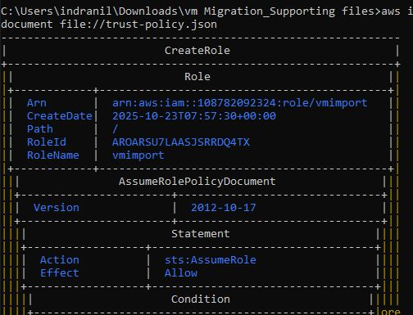

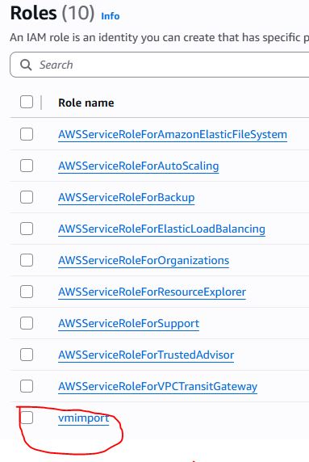
CREATE ROLE POLICY

IMPORT IMAGE TO CREATE CUSTOME AMI AND SNAPSHOT
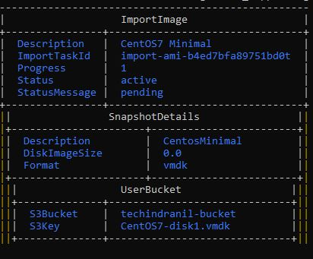
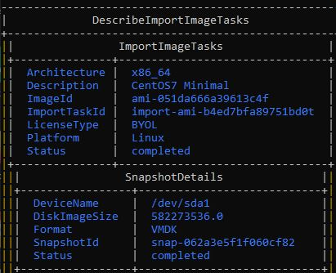

SNAPSHOT CREATED FROM VMDK FILE
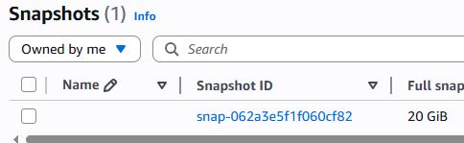

AMI CREATED FROM VMDK FILE
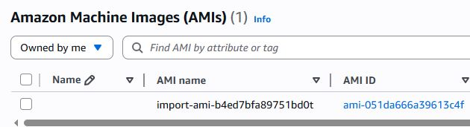

SSH TO EC2 INSTANCE WHICH RUN BY CUSTOME AMI

