Logs

Log levels: INFO,ERROR,DEBUG,WARN

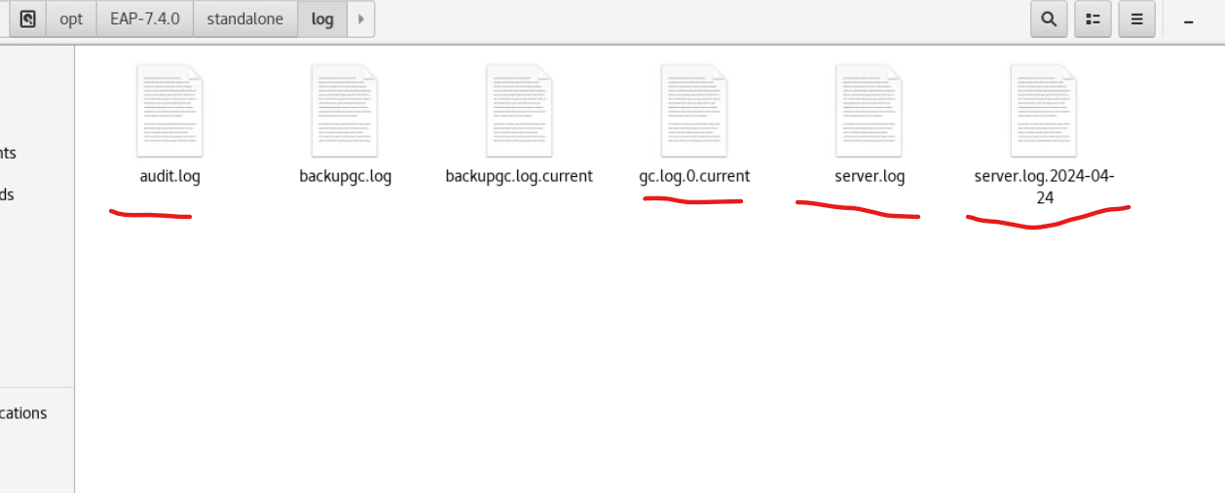

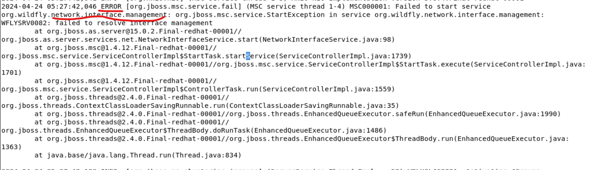

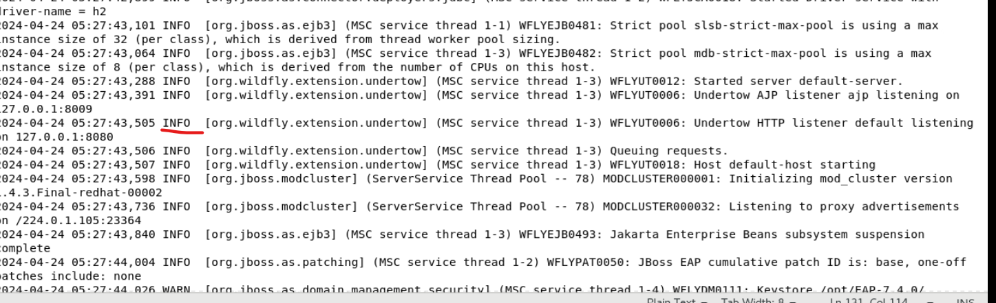

Wrong configuration



