**Label**

A label is a key value pair attached to any resource in Kubernetes. That can be a **Pod**, a node, service, and basically any other resource

Labels are key-value pairs which are attached to pods, replication controller and services.

Labels used as identifying attributes for objects such as pods and replication controller.

it can be added to an object at creation time and can be added or modified at the run time.

Labels are the mechanism you use to organize Kubernetes objects. A label is a key-value pair with certain restrictions concerning length and allowed values but without any pre-defined meaning.

To create a pod with labels.

**Syntax:**kubectl run <pod name> --image=<container image name> --port=<container port> --labels="<value1>,<value2>" --generator=run-pod/v1

**Example:**kubectl run mypodtest1 --image=nginx --port=80 --labels="app=web,env=prod" --generator=run-pod/v1

kubectl run podalabeltest --image=nginx --port=80 --labels="app=web,env=dev" --generator=run-pod/v1

pod/podalabeltest created

--generator=run-pod/v1🡪Specify --generator to pin to a specific behavior forever when you use generator-based commands such as kubectl run or kubectl expose

**Generators**

You can generate the following resources in kubectlrunusing--generator flag:

* Pod - use run-pod/v1.
* Replication controller - use run/v1.
* Deployment - use extensions/v1beta1 and for an endpoint - use deployment/v1beta1 (default).
* Deployment - use apps/v1beta1 and for an endpoint - use deployment/apps.v1beta1 (recommended).
* Job - use job/v1.
* CronJob - use batch/v1beta1and for an endpoint - use cronjob/v1beta1(default).
* CronJob - usebatch/v2alpha1 and for an endpoint - use cronjob/v2alpha1 (deprecated).

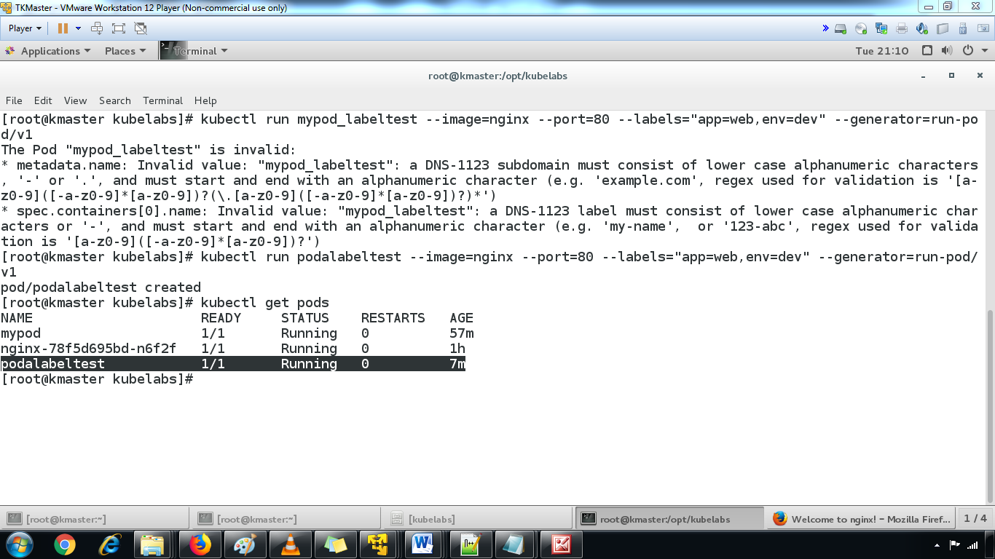

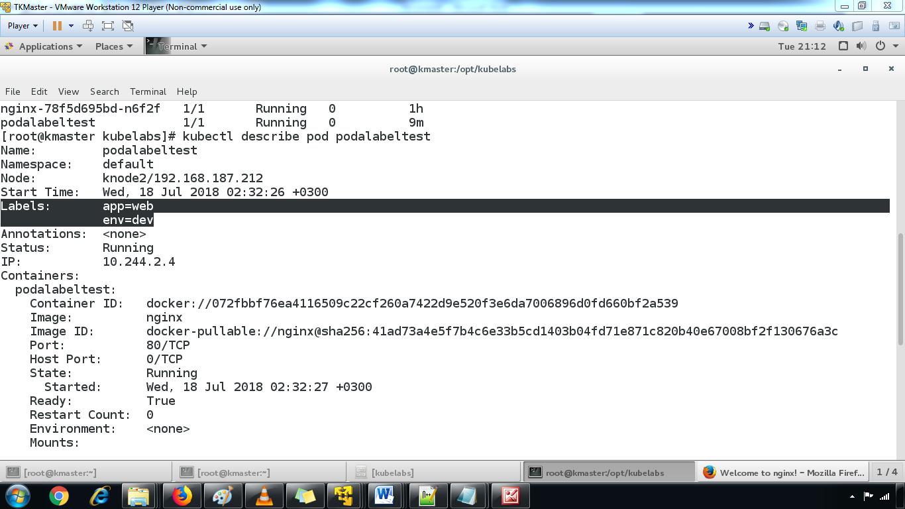

#### ****2.**creating pod with labels using yml**

#### **kubectl apply -f podlabelsample.yml**

#### **kubectl get pods -o wide**

3.list the all pod labels

kubectl get pods --show-labels

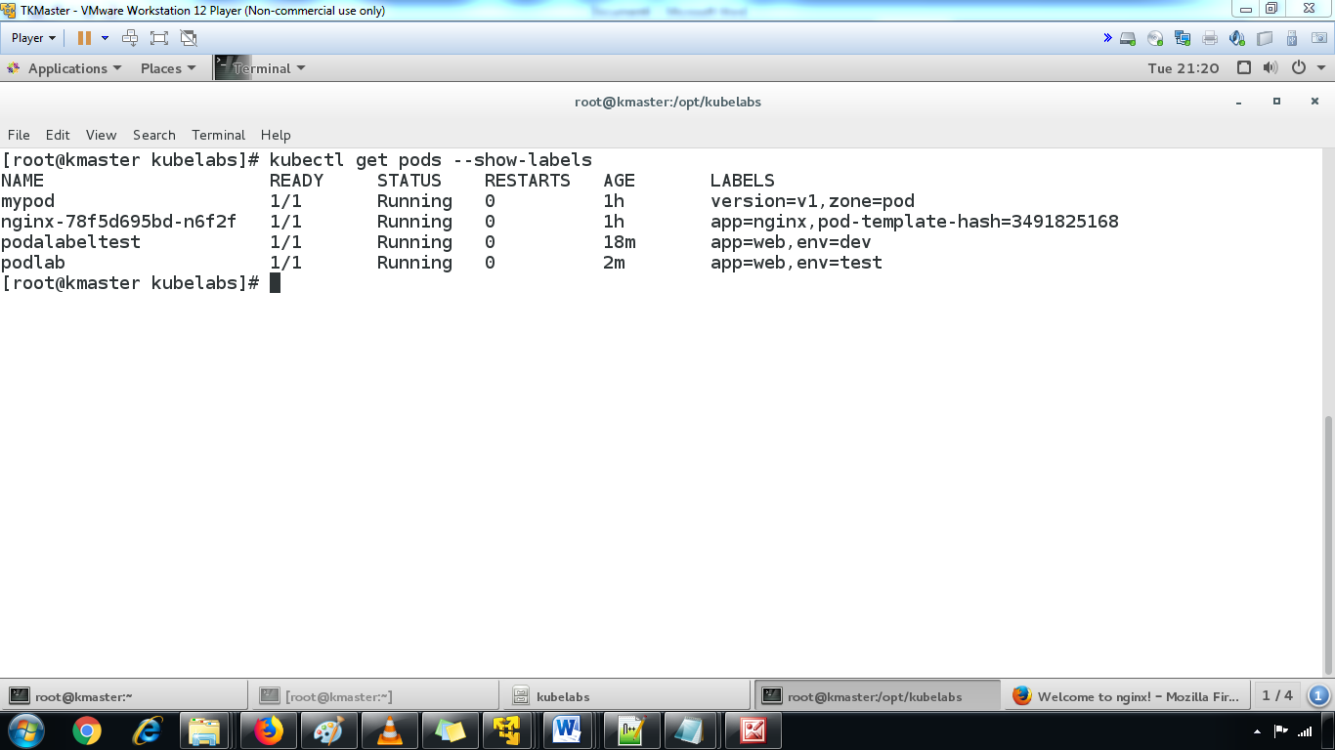

4. use the label selector to filter the required pods

