KENNITECH

Small Office VLAN
Network Report
Implementation, security configuration and verification

Project detail | Information
Project | Project 01: Small Office VLAN Network
Environment | Cisco Packet Tracer 9.x on macOS
Implementation date | 7 November 2026
Network devices | Cisco 2911 router, Cisco 2960-24TT switch, six PCs
Departments | Sales, IT and HR
Addressing | IPv4, three /24 departmental subnets
Prepared for | KenniTech networking project portfolio

Project outcome
A segmented small-office network was built using three VLANs, router-on-a-stick inter-VLAN routing, DHCP address assignment and named extended IPv4 access control lists. The final endpoint tests shown in the supplied evidence match the required department access policy.

1. Executive summary
The network separates Sales, IT and HR into VLANs 10, 20 and 30. A Cisco 2960 switch provides Layer 2 connectivity. A Cisco 2911 router provides the default gateway for each VLAN through 802.1Q subinterfaces on a router-on-a-stick link. DHCP is configured on the router, and extended ACLs restrict traffic initiated by Sales and HR while permitting selected return traffic.
Evidence supplied on 7 November 2026 shows the topology, active VLANs, trunk status, router subinterfaces, DHCP leases, ACL entries, ACL interface attachment and final ping tests. The router and switch configurations were copied to startup configuration and Packet Tracer returned [OK].

2. Scenario, objectives and security policy
The scenario is a small office with three departments. Each department has two PCs and its own IPv4 subnet. The objective is to provide inter-VLAN connectivity where permitted while preventing unauthorised access between departments.
Source department | Destination | Required policy
Sales | IT | Block Sales-initiated access
Sales | HR | Block Sales-initiated access
IT | Sales and HR | Allow IT-initiated access
HR | IT | Block HR-initiated access
HR | Sales | Allow HR-initiated access

The implementation uses inbound extended ACLs on the Sales and HR router subinterfaces. No inbound ACL is attached to the IT subinterface in the evidence. Return-traffic entries are placed before deny entries so that selected replies to IT-initiated sessions can pass.

3. Topology and equipment
The logical topology contains one Cisco 2911 router connected to one Cisco 2960-24TT switch. Six end devices connect to switch access ports, with two PCs per department. The router-to-switch uplink carries VLANs 10, 20 and 30 using IEEE 802.1Q tagging.
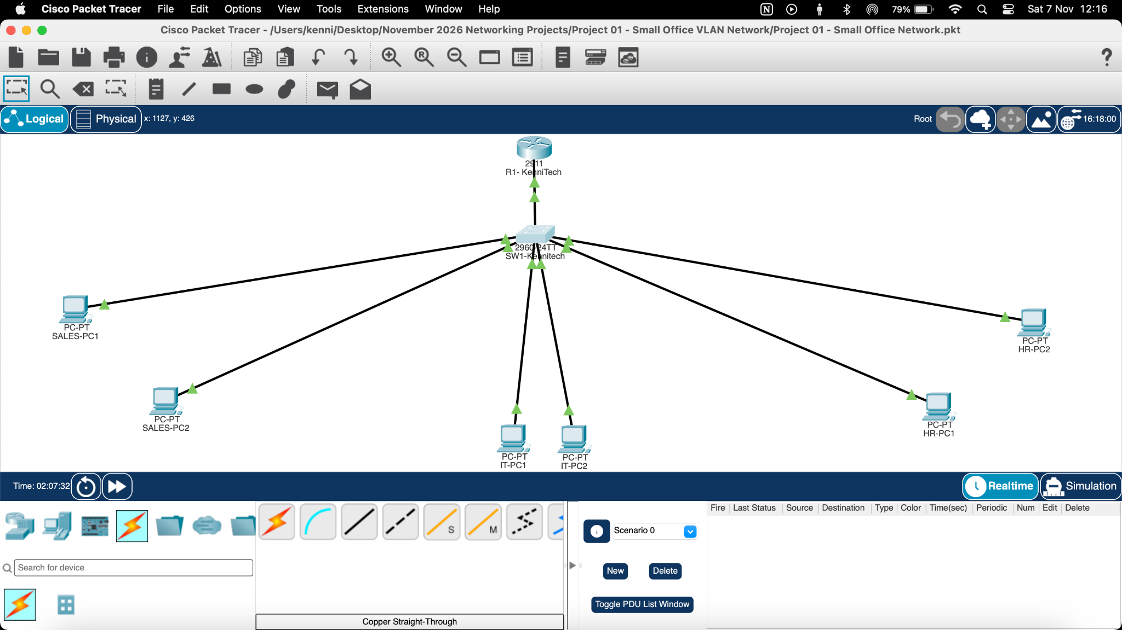
Figure 1. Packet Tracer logical topology showing R1, SW1 and six departmental PCs.
Device | Model / role | Purpose
R1-KenniTech | Cisco 2911 router | Inter-VLAN routing, DHCP and extended ACL enforcement
SW1-KenniTech | Cisco 2960-24TT switch | VLAN segmentation, access switching and 802.1Q trunk
Sales-PC1 and Sales-PC2 | PC endpoints | Sales department clients, VLAN 10
IT-PC1 and IT-PC2 | PC endpoints | IT department clients, VLAN 20
HR-PC1 and HR-PC2 | PC endpoints | HR department clients, VLAN 30

4. VLAN and IPv4 addressing plan
Department | VLAN | Network / mask | Default gateway | DHCP leases evidenced
Sales | 10 | 192.168.10.0/24  255.255.255.0 | 192.168.10.1 | 192.168.10.11, .12
IT | 20 | 192.168.20.0/24  255.255.255.0 | 192.168.20.1 | 192.168.20.11, .12
HR | 30 | 192.168.30.0/24  255.255.255.0 | 192.168.30.1 | 192.168.30.11, .12

The router DHCP configuration excludes addresses .1 through .10 in each subnet. The gateway addresses therefore remain outside the observed DHCP client range. The DHCP binding output shows two automatic leases in each departmental subnet.
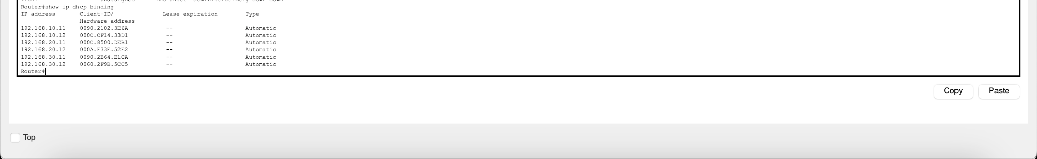
Figure 2. Switch VLAN membership output: Sales on Fa0/1-Fa0/2, IT on Fa0/3-Fa0/4 and HR on Fa0/5-Fa0/6.
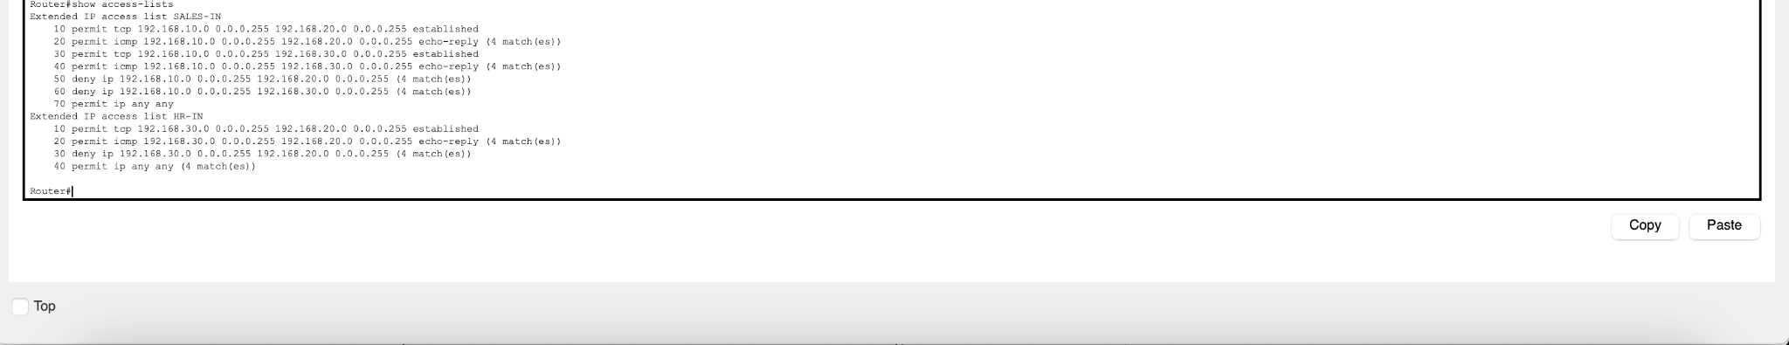
Figure 3. Switch trunk verification showing GigabitEthernet0/1 trunking with VLANs 10, 20 and 30 active.

5. Switch configuration and verification
The switch port allocation shown by show vlan brief is:
VLAN | Name | Access ports
10 | SALES | FastEthernet0/1 and FastEthernet0/2
20 | IT | FastEthernet0/3 and FastEthernet0/4
30 | HR | FastEthernet0/5 and FastEthernet0/6

GigabitEthernet0/1 is shown as an 802.1Q trunk. The trunk output lists VLANs 1, 10, 20 and 30 as active in the management domain and in the spanning-tree forwarding state. VLAN 1 is the native/default VLAN; the departmental VLANs are carried across the uplink.
show vlan brief
show interfaces trunk
copy running-config startup-config
The switch save operation completed and Packet Tracer displayed [OK].

6. Router configuration and verification
The router uses subinterfaces on GigabitEthernet0/0. Each subinterface has 802.1Q encapsulation for its VLAN and an IPv4 gateway address for that subnet.
Router subinterface | VLAN tag | Gateway address | Observed state
GigabitEthernet0/0.10 | 10 | 192.168.10.1/24 | up / up
GigabitEthernet0/0.20 | 20 | 192.168.20.1/24 | up / up
GigabitEthernet0/0.30 | 30 | 192.168.30.1/24 | up / up

The router's show ip interface brief output reports all three subinterfaces as up/up. The DHCP binding output contains the six client leases listed in Section 4.
show ip interface brief
show ip dhcp binding
show running-config
copy running-config startup-config
The router save operation completed and Packet Tracer displayed [OK].

7. Extended ACL design and placement
Two named extended ACLs are used. SALES-IN is applied inbound to GigabitEthernet0/0.10. HR-IN is applied inbound to GigabitEthernet0/0.30. This placement filters packets as they enter the router from the relevant department.

7.1 SALES-IN
Sequence | Rule | Purpose
10 | permit tcp Sales to IT established | Permit established TCP return traffic from IT-initiated sessions
20 | permit icmp Sales to IT echo-reply | Permit ping replies to IT-originated requests
30 | permit tcp Sales to HR established | Permit established TCP return traffic from HR-initiated sessions
40 | permit icmp Sales to HR echo-reply | Permit ping replies to HR-originated requests
50 | deny ip Sales to IT | Block other Sales-originated IP traffic to IT
60 | deny ip Sales to HR | Block other Sales-originated IP traffic to HR
70 | permit ip any any | Permit traffic not matched by earlier restrictions

7.2 HR-IN
Sequence | Rule | Purpose
10 | permit tcp HR to IT established | Permit established TCP return traffic for IT-initiated sessions
20 | permit icmp HR to IT echo-reply | Permit ping replies to IT-originated requests
30 | deny ip HR to IT | Block other HR-originated IP traffic to IT
40 | permit ip any any | Permit traffic not matched by earlier restrictions, including HR to Sales

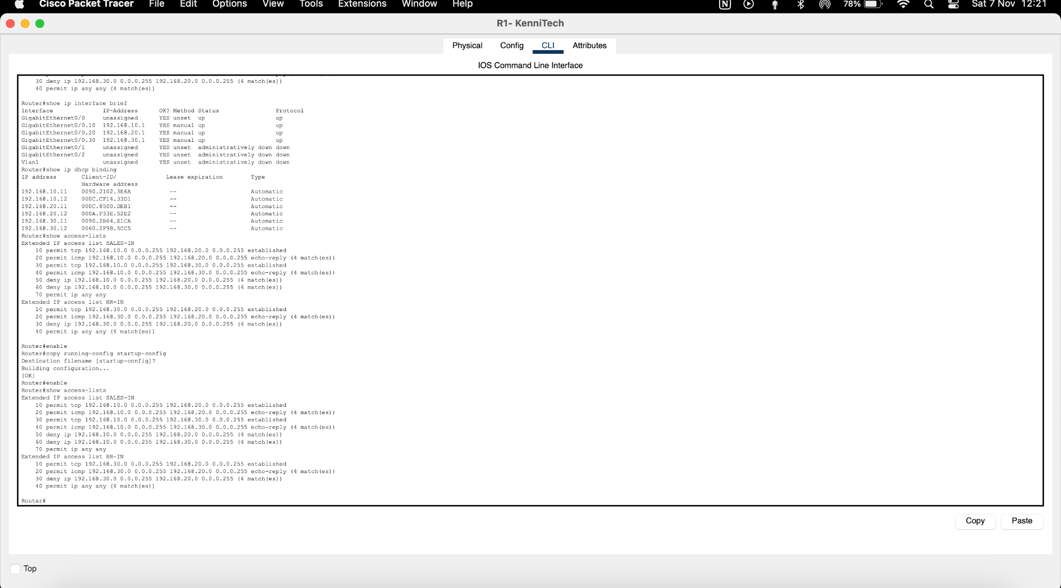
Figure 4. Router ACL verification output showing SALES-IN and HR-IN entries and match counters.
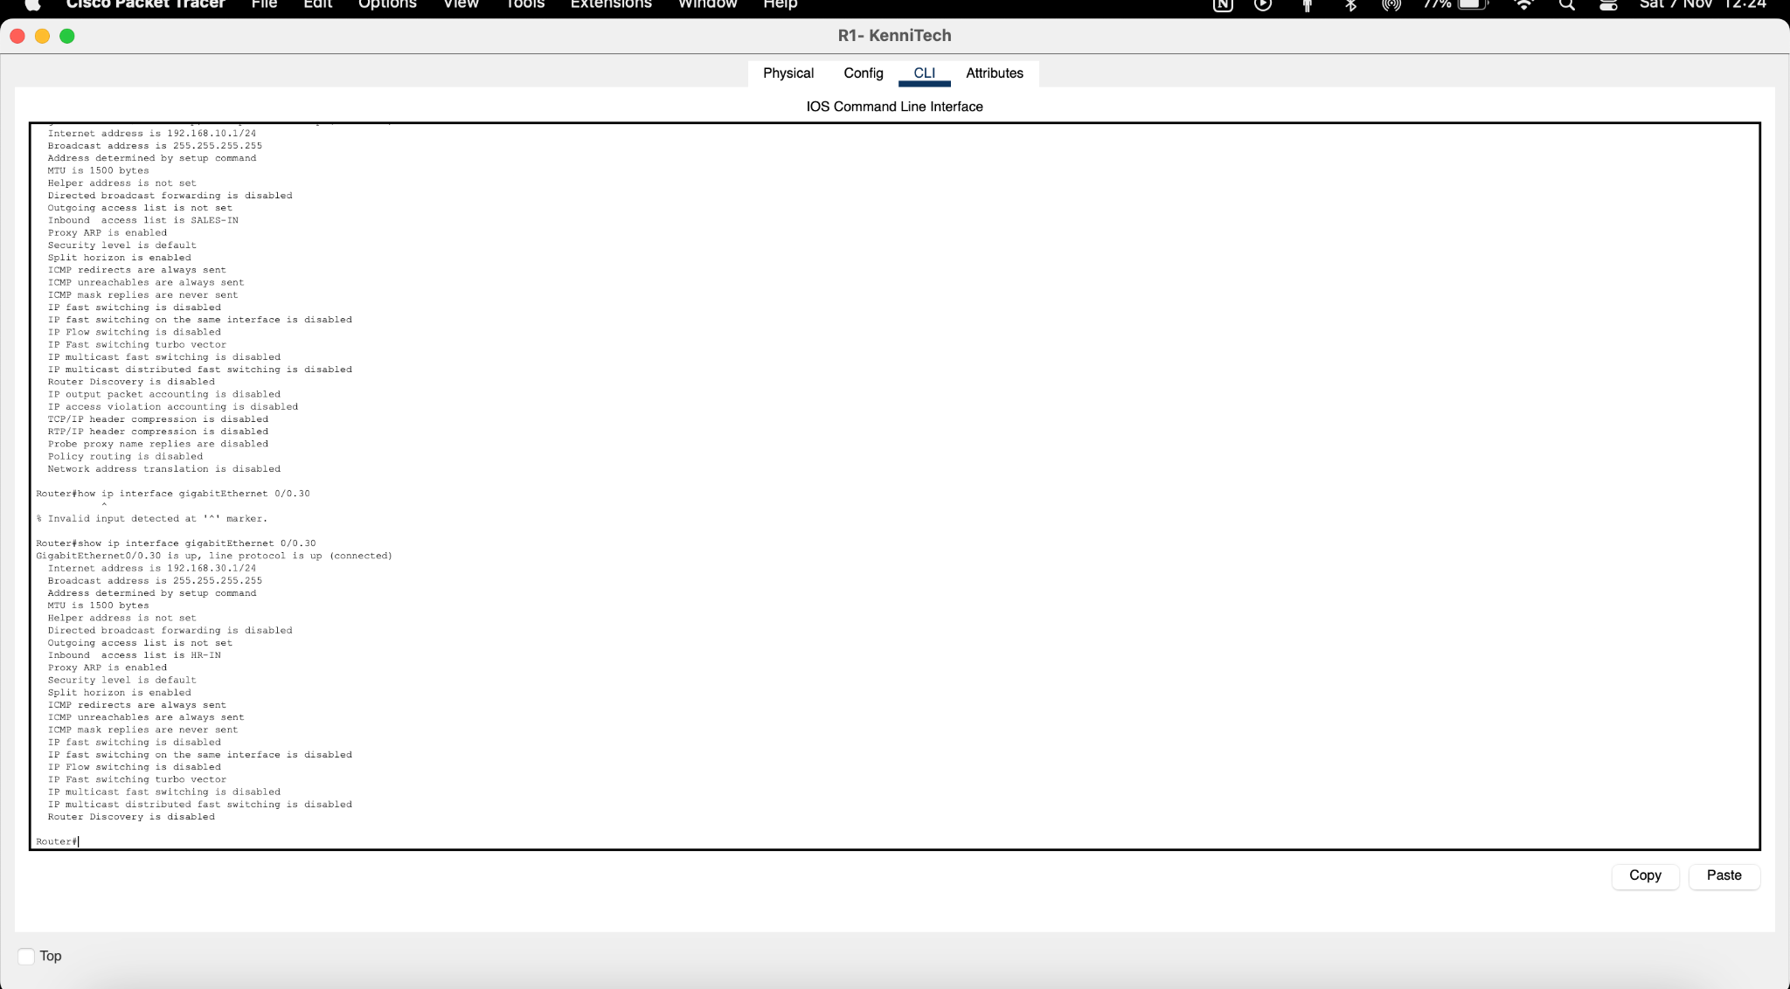
Figure 5. Router interface verification showing SALES-IN inbound on VLAN 10 and HR-IN inbound on VLAN 30.

8. Connectivity testing and results
The final command-prompt screenshots were checked against the required access policy. The Sales tests show 100% packet loss when attempting to reach the IT and HR endpoints. The IT tests show successful replies from both Sales and HR. The HR tests show successful replies from Sales and 100% packet loss when attempting to reach IT.
Test source | Destination | Expected | Observed in final evidence
Sales-PC1 (192.168.10.x) | IT-PC1 (192.168.20.11) | Blocked | Blocked: destination host unreachable
Sales-PC1 (192.168.10.x) | HR-PC1 (192.168.30.11) | Blocked | Blocked: destination host unreachable
IT-PC1 (192.168.20.x) | Sales-PC1 (192.168.10.11) | Allowed | Successful: 4 replies, 0% loss
IT-PC1 (192.168.20.x) | HR-PC1 (192.168.30.11) | Allowed | Successful: 4 replies, 0% loss
HR-PC1 (192.168.30.x) | IT-PC1 (192.168.20.11) | Blocked | Blocked: destination host unreachable
HR-PC1 (192.168.30.x) | Sales-PC1 (192.168.10.11) | Allowed | Successful: 4 replies, 0% loss

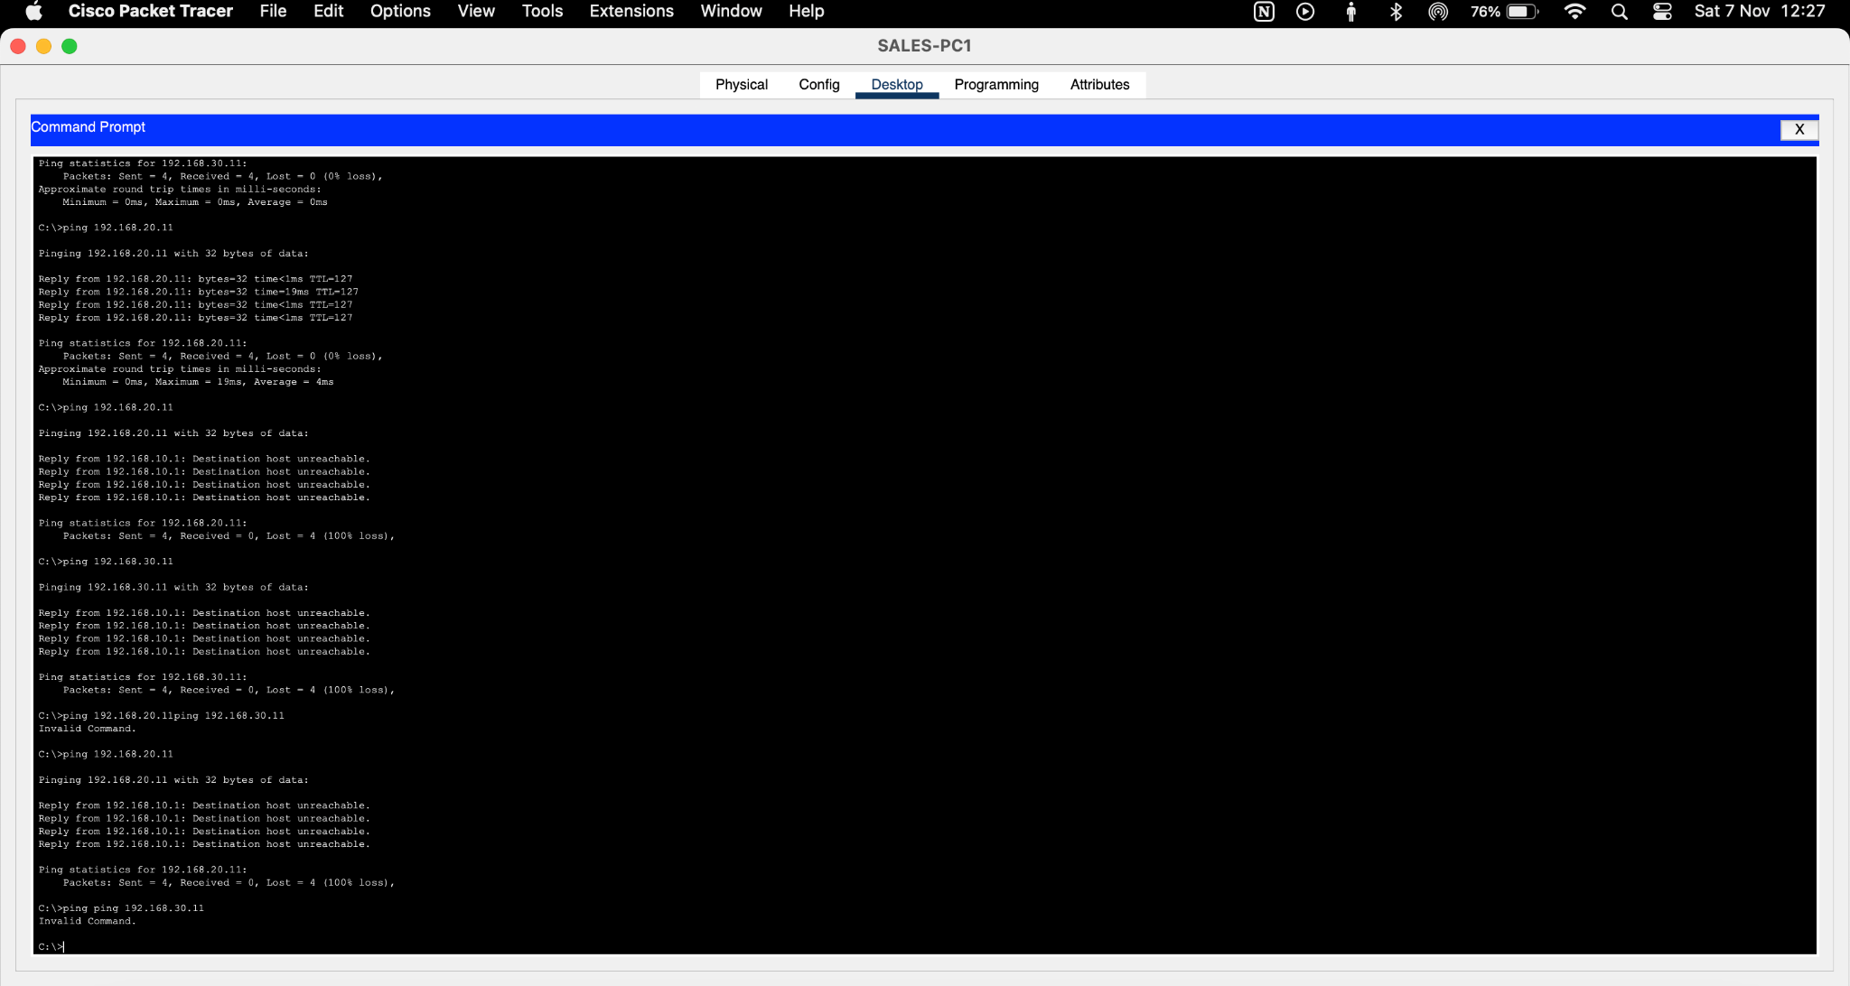
Figure 6. Sales-PC1 final ping tests. Attempts to reach IT and HR are blocked.
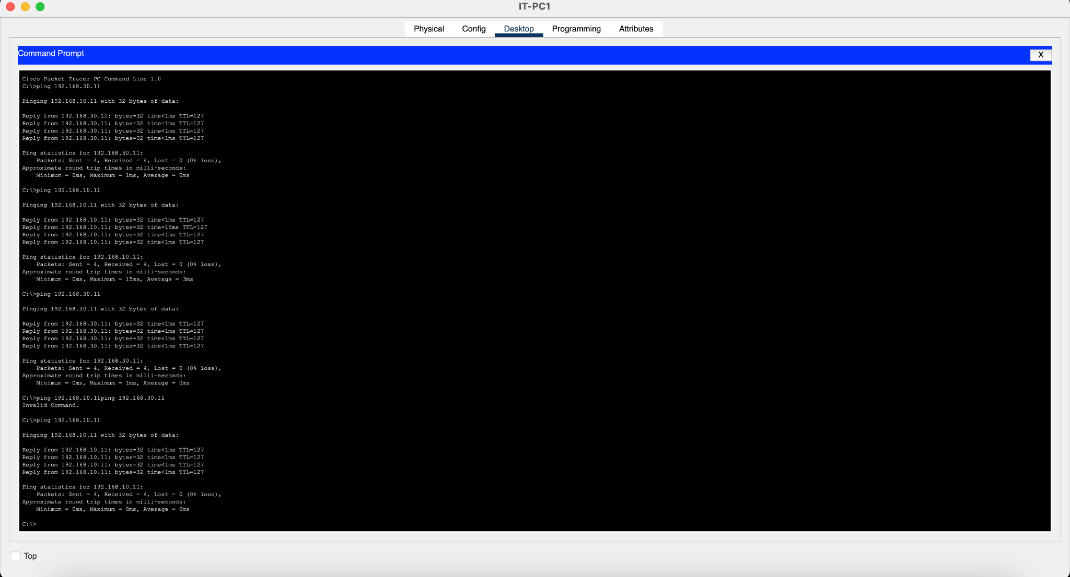
Figure 7. IT-PC1 ping tests. Connections to HR and Sales succeed.
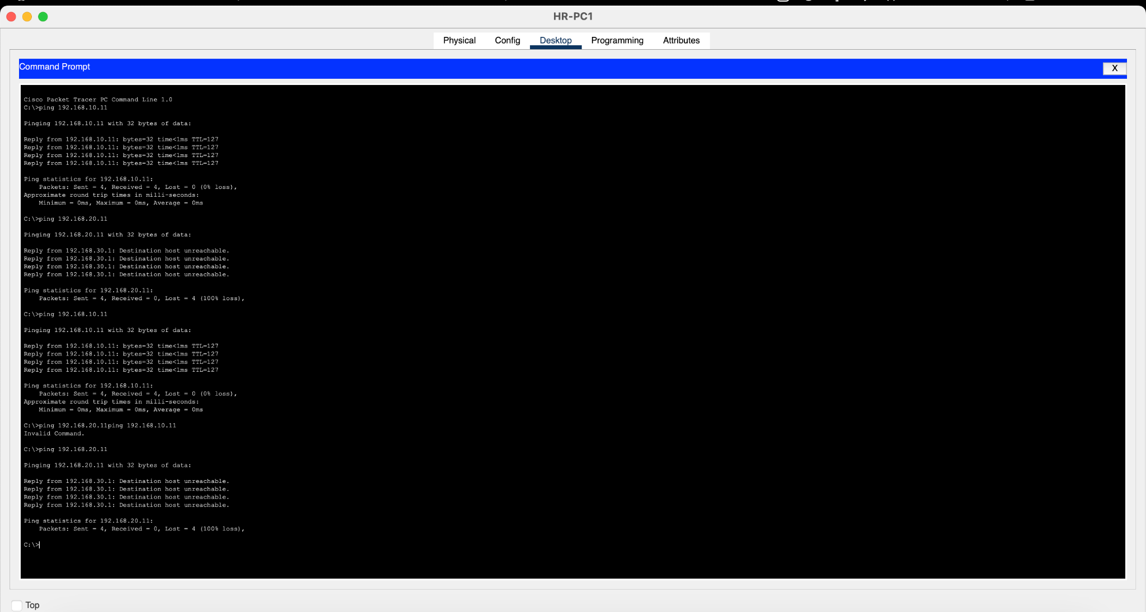
Figure 8. HR-PC1 ping tests. Access to IT is blocked and access to Sales succeeds.

9. Interpretation, limitations and recommended additional validation
The six final ICMP tests match the specified departmental policy. The ACL counters also show that the configured permit and deny entries have been matched. This is good evidence that the rules are active and that the intended ping paths are filtered.
The current tests validate ICMP reachability, not every application protocol. The established keyword in a Cisco extended ACL is a TCP flag check, not a full stateful firewall inspection. The ICMP echo-reply entries permit replies to ping requests. Other return protocols, including UDP-based application traffic, have not been validated by these screenshots. Before claiming that every IT-initiated application session works, test the actual TCP or UDP service required by the scenario.
A first ping can time out while ARP resolves a destination's MAC address. For evidence, use the repeated test output and packet statistics, rather than treating a single initial timeout as proof of an ACL block. In the final supplied tests, the blocked paths repeatedly report destination host unreachable, while allowed paths show four replies and zero packet loss.

10. Configuration backup and project files
- Router: copy running-config startup-config completed and returned [OK].
- Switch: copy running-config startup-config completed and returned [OK].
- Packet Tracer project title bar showed the file in the November 2026 Networking Projects folder.
- Recommended filename: Project 01 - Small Office Network.pkt.
- Keep the topology, switch, router, ACL and endpoint test screenshots together in a Project 01 Evidence folder.
Recommended final persistence check: close and reopen the Packet Tracer project, then repeat show vlan brief, show interfaces trunk, show ip interface brief, show ip dhcp binding and show access-lists. Confirm that the saved configuration and connectivity behaviour remain intact.

11. Conclusion
Project 01 successfully implements a small office network with three departmental VLANs, router-on-a-stick inter-VLAN routing, DHCP and extended ACL-based access restrictions. The final endpoint evidence demonstrates that Sales cannot reach IT or HR, IT can reach Sales and HR, and HR cannot reach IT but can reach Sales. Both network device configurations were saved to startup configuration. The project meets the stated ICMP connectivity and access-control objectives, with additional application-layer testing recommended for full protocol coverage.

Appendix A. Useful verification commands
! On the switch
show vlan brief
show interfaces trunk
show running-config
! On the router
show ip interface brief
show ip dhcp binding
show access-lists
show ip interface gigabitEthernet 0/0.10
show ip interface gigabitEthernet 0/0.30
show running-config
! Save configurations
copy running-config startup-config

Appendix B. Evidence index
Figure | Evidence item | File timestamp
1 | Logical network topology | 12:16:33
2 | VLAN membership | 12:12:20
3 | 802.1Q trunk status | 12:12:54
4 | Router ACL entries and counters | 12:21:41
5 | ACL attachment to Sales and HR subinterfaces | 12:24:03
6 | Sales blocked connectivity tests | 12:27:00
7 | IT successful connectivity tests | 12:27:44
8 | HR allowed and blocked connectivity tests | 12:28:33

