For enhancement three: Databases, I picked my CS 340 Grazioso Salvare Dashboard. This project is a Python dashboard that connects to a MongoDB database and lets the user view and filter animal shelter records. I created this project in my Client/Server Development course in April of last year.
I chose this artifact because it shows my ability to work with a database inside a real application. The project uses an AnimalShelter CRUD module to connect to the AAC database and the animals collection. The dashboard then uses that data to show a table, filters, a chart, and a map. The project had the main pieces working, but when I looked back at the code, I saw places where the database file could be safer and more complete.
I updated the project by improving on the CRUD module and making small changes to the dashboard. One of the first changes I made was improving how the database login information is handled. Before, the project used the username and password directly in the code. I updated this so it can also use environment variables or the original login credentials as a fallback.
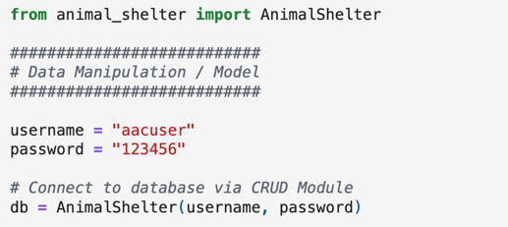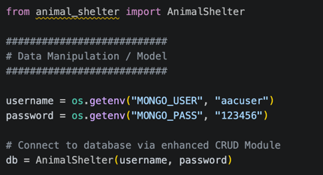

I also improved the read method by adding projection support. In the original code, the dashboard read the full MongoDB records and then removed the _id field afterwards. Now the dashboard can exclude _id directly when reading from MongoDB.
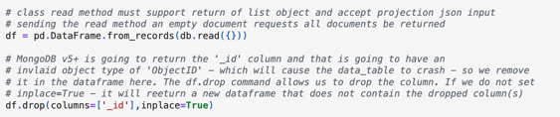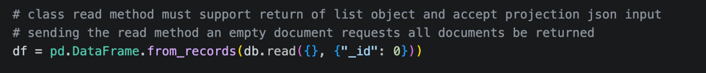
I also updated the create, read, update, and delete methods by adding better validation. The original code checked if values were not None. The updated code checks that the query or data is actually a dictionary before sending it to MongoDB. This makes the database code more reliable because it helps prevent invalid input from being passed into the database methods.
Another important enhancement was making the update and delete methods safer. In the original version, the methods could run as long as the query was not None. That was risky because an empty query could update or delete more records than intended. In the enhanced version, update and delete require a non-empty query dictionary.
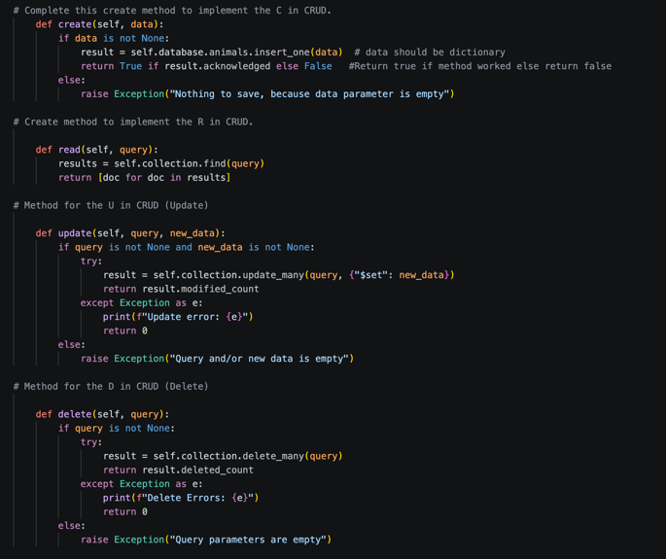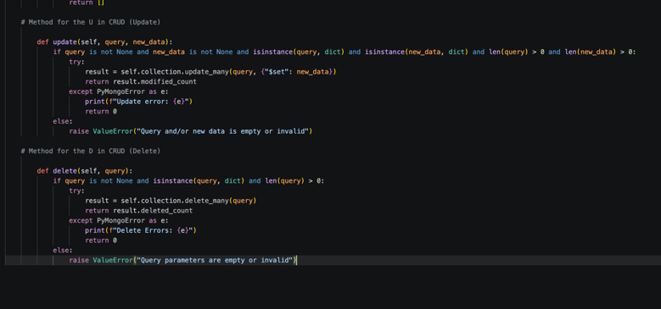
This helps protect the database from accidental changes. I also added PyMongo error handling so database errors can be handled more clearly instead of only using broad exception handling.
This enhancement supports the database and software engineering outcome because I improved a working MongoDB application using Python, PyMongo, Dash, and Jupyter. It also supports the security outcome because I improved credential handling, added input validation, added better error handling, and made update and delete operations safer.
While updating and enhancing this artifact, I learned that database work is not only about connecting to the database and showing records. The database layer also needs to be safe, reusable, and easy to maintain. The original project had a good base because the dashboard worked and the CRUD module connected to MongoDB. The goal was not to rebuild the whole thing. The goal was to make the existing database code stronger.
The hardest part was making improvements without changing too much of the original project. I kept the same basic structure and focused on the parts that mattered, like validation, safer credentials, projection support, and safer update and delete methods. Small changes like this in the database can make a project feel more professional and more secure.

