if you are an EC2 machine, whenever we are adding an additional volume, that particular volume is called as EBS volume. If we are using only a default one which we are getting, that one is called as root volume. And if you are adding an additional volume, that particular volume is called as EBS volume.

We create one Linux EC2 machine with multiple volumes. One is with root volume and one is with EBS volume.

While creating EC2 instance we can add EBS volume.
AWS EC2 enter all required details go to Configure Storage Add new Volume 5GB Launch Instane.
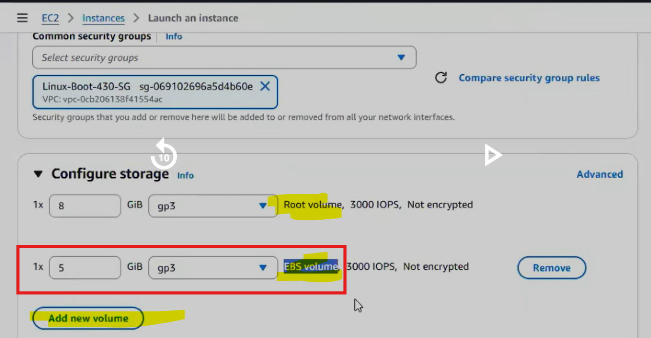

We can see there are 2 volumes we attached.
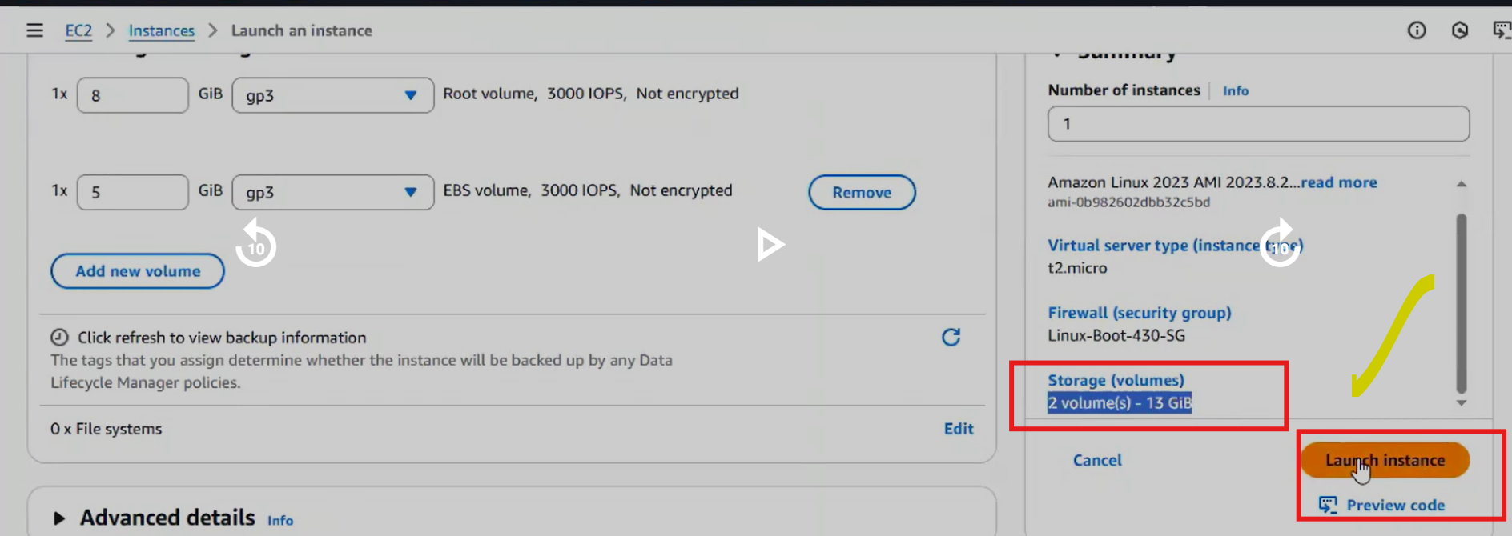

After launch:
Go to:
EC2 → Storage → Volumes.
You will see:
Volume 1 → 8GB → Root
Volume 2 → 5GB → Additional EBS

Both are attached to the instance.

What is an EBS Volume?
EBS (Elastic Block Store) is a network storage disk used with an Amazon EC2 instance.
Think of it like:
- Hard disk attached to a virtual machine

When you create an EC2 instance:
Volume Type | Description
Root Volume | Default disk containing OS
Additional Volume | Extra disk added manually (EBS volume)

Example:
Volume | Size | Purpose
Root volume | 8 GB | OS + system files
Additional EBS | 5 GB | Data storage

Both are technically EBS volumes, but the first one is specifically called root volume.

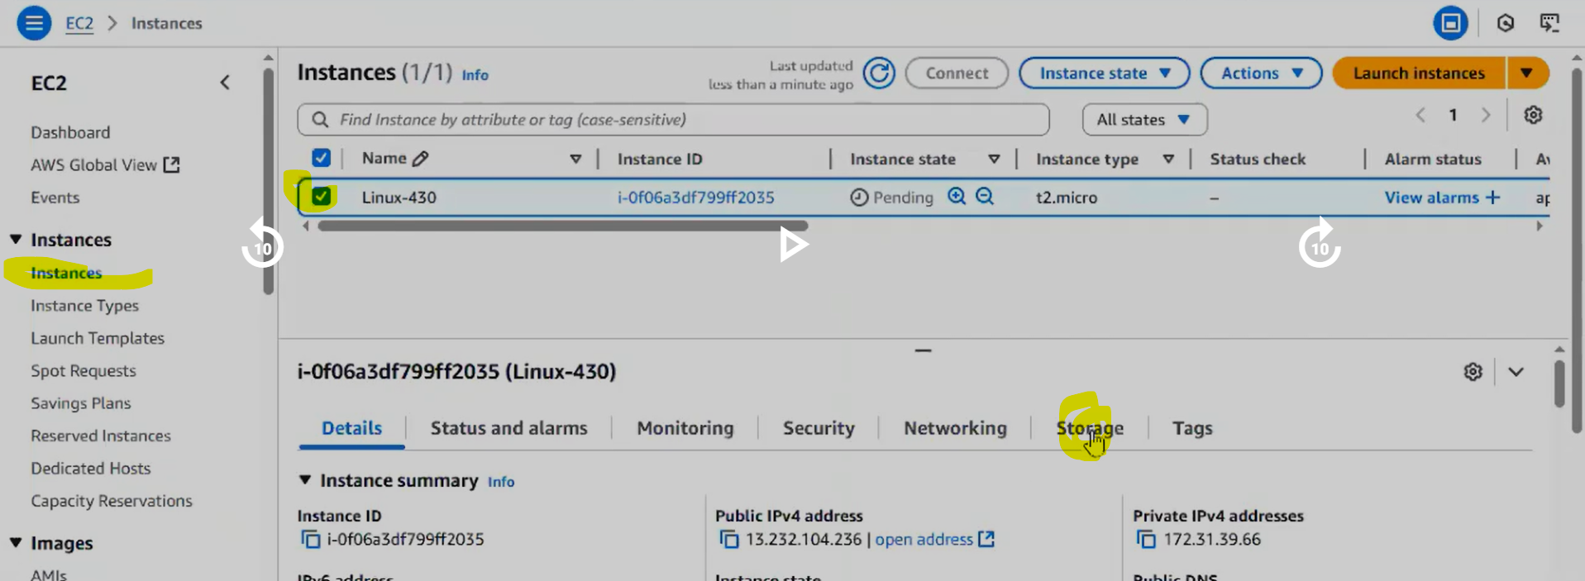

We can see EBS volumes in AWS EC2 Elastic Block store out volumes.
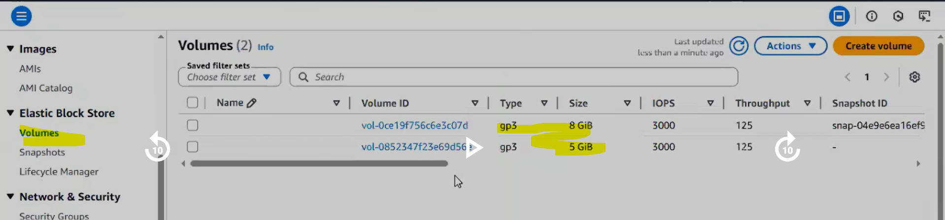

These both the volumes are attached to our EC2 machine.
Right now we can't store data, but we have to do some more steps. Then only we can store some data in that particular volume.
Once after crating the EBS volume can we store data in tat volume? NO.
Why We Cannot Store Data Immediately?
Even though the volume is attached, Linux cannot use it yet.
Because:
- It has no filesystem
- It is not mounted
So the OS does not know where to access it.
We have to mount the volume.
Connect to EC2 machine using gitbash.
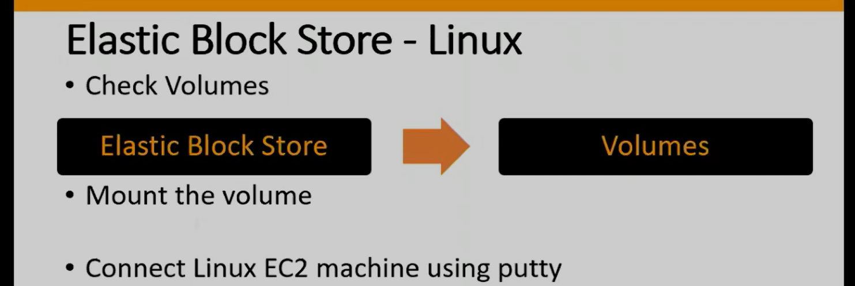

Check Mounted Volumes? With the below command we can see the only volumes which are mounted.
$ df -h
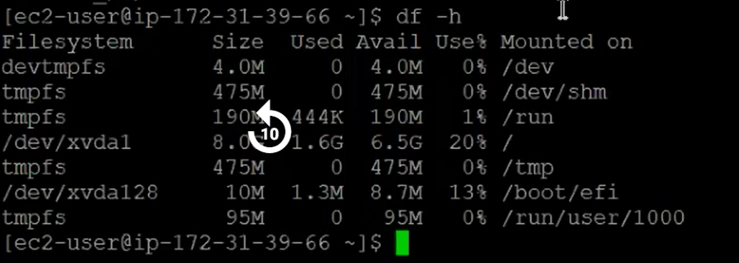

From above we can not see the EBS volume we extra added, we can see oly root volume. 8GB. Why because 5GB EBS volume not yet mounted.
Only root volume is visible.
Your 5GB volume will NOT appear.

To mount new volume first we need to know that volume name, then how to find that umounted volume name? we can use below command.

$ lsblk
Identify New Volume
Run: $ lsblk
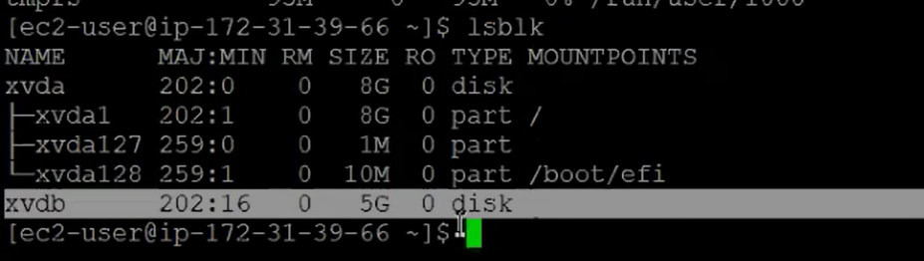
Above we can see newly created EBS volume. With the name xvdb wit 5GB. This may name differ every time we create EBS volume in EC2 machine.

Once after knowing the name we have to do some process.
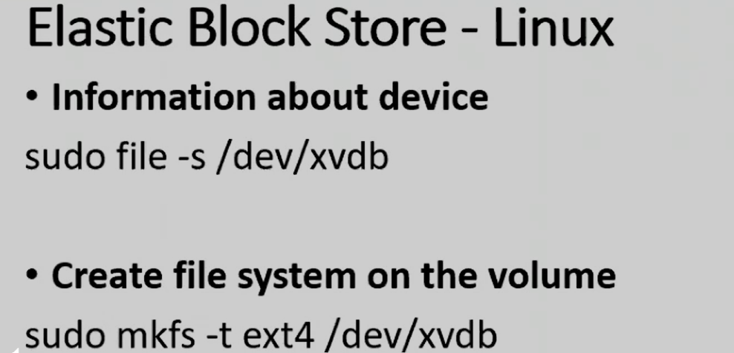

$ sudo file -s /dev/vxdb this step is optional.

Create Filesystem
Before using a disk, Linux needs a filesystem.
Example: ext4

$ sudo mkfs -t ext4 /dev/xvdb
Run this command on gitbash. One question why /dev? How it came here?

Meaning:
Part | Meaning
mkfs | Make filesystem
ext4 | Linux filesystem type
/dev/xvdb | Disk name
This is the first step I am going to do it, I am going to install file system. Now what are these file systems? File system is like a software we are going to install in our volume, based on that this particular volume is going to be compatible for Linux based operating system. And which file system we are installing, the name of the file system is called as ext4. And here is the name of the volume, the last xvdb.
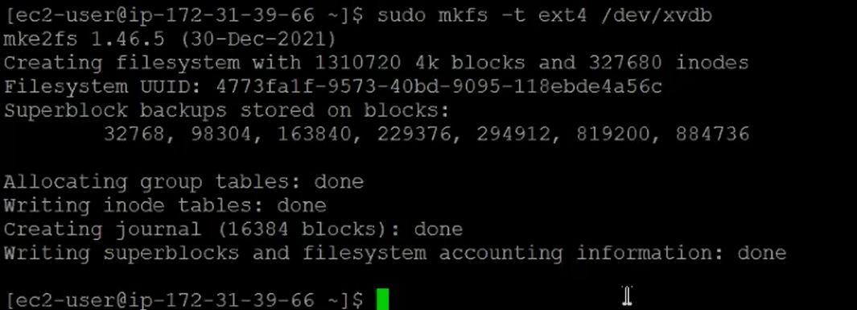

Next step creating a directory. Any name we can give it, anywhere we can create it.
$ mkdir test
Why we created this directlry? Volume we created that is we are going to link to this directory.
Create Directory (Mount Point)
Create a folder that will represent the disk.
This folder will act as the entry point to the disk.
It means if I am going to do any work under this directory, if I am going to create any file under this directory, it means that particular file is actually created in our volume. That particular file is going to create under our volume.

Now Mount the Volume:
$ sudo mount /dev/xvdb test
This means Attach disk → to directory.
/dev/xvdb → /test

Now to check mounted volumes we need to use $ df -h
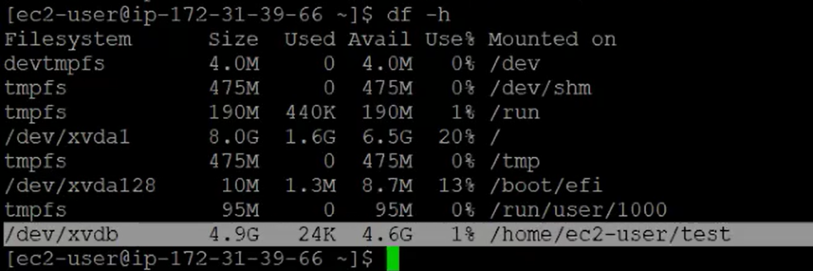
Now we can see our newly mounted EBS volume.
Above we can see volume path and directory path.

Now if I go to test directory and create some files, actually those created files will come under volume.
$ cd test
$ touch f1 f2 f3 f4
This file is stored in the EBS volume, not the root disk.
We are not consuming the space of ROOT volume we are using EBS volume space.
This is how we can create volume and mount that volume to EC2 machine.

$ df -hT check the disk space usage.

Why Use Separate EBS Volumes?
Advantages:
Benefit | Explanation
Data persistence | Data survives instance restart
Easy scaling | Increase volume size
Move between servers | Attach to another EC2
Backup | Snapshots

Now lets assume there is an requirement removing EBS volume from first ec2 machine to 2nd ec2 machine, is it possible? YES it is possible.
Moving Volume to Another EC2
Yes, this is possible.
Example requirement:
Move 5GB volume
EC2-A → EC2-B

First we need to remove from first ec2 machine, here removal means UNMOUNT. First we have mounted, now we are unmounting.
Unmount is 2 step process.
- Come out of test directory and run unmount command.
  - $ sudo unmount test
  - $ df -h
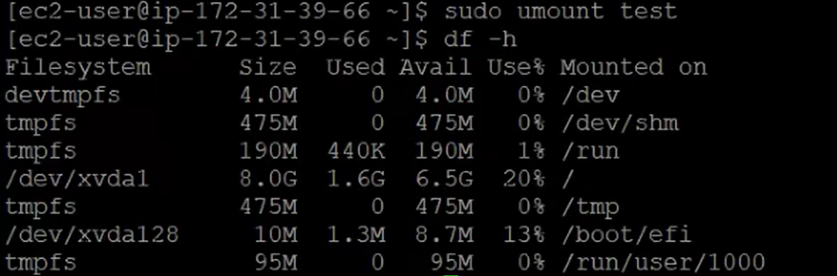
- Remove value from our ec2 machine.
AWS Elastic Block storage Volumes select our EBS volume with 5GB Action drop down detach volume.
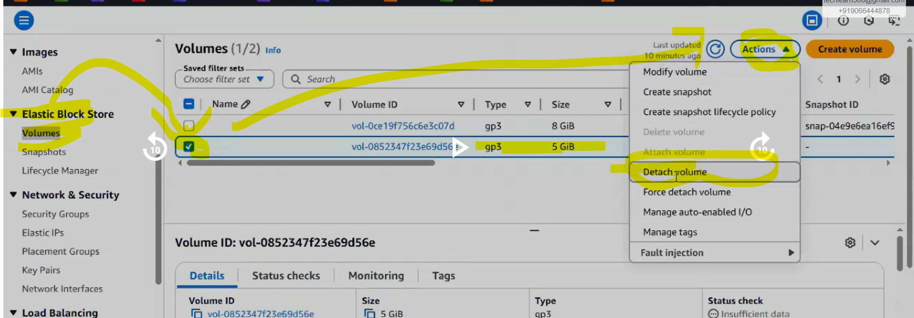
** After sometime it shows available then attach to another ec2 machine. But make sure that EC2 machine is also in same availability zone. It is Mandatory to have EBS volume and EC2 machine in same AZ.
If it is in different AZ it is not possible to attach to EC2 machine.

Now create new EC2 edit network settings there we need to add AZ which is similar to Volume AZ. launch EC2 instance.
Note: while creating new EC2 machine we can not attach old Volume, if we try to attach a new volume while creating Ec2 machine it is going to create new Volume. Still we don’t have option to attach existing volume to newly creating Ec2 machine.

So while creating new Ec2 instance we don’t need to attach any new EBS volume if you want to use existing volume.

❌ You cannot attach an existing EBS volume during EC2 creation.
You can only create new volumes during launch.
Existing volumes must be attached after instance creation.

Now after creating new Ec2 machine go to EBS volumes select OLD volume action drop down attach volume select our Ec2 machine newly created device name can be anyName randomly displayed below. attach volume
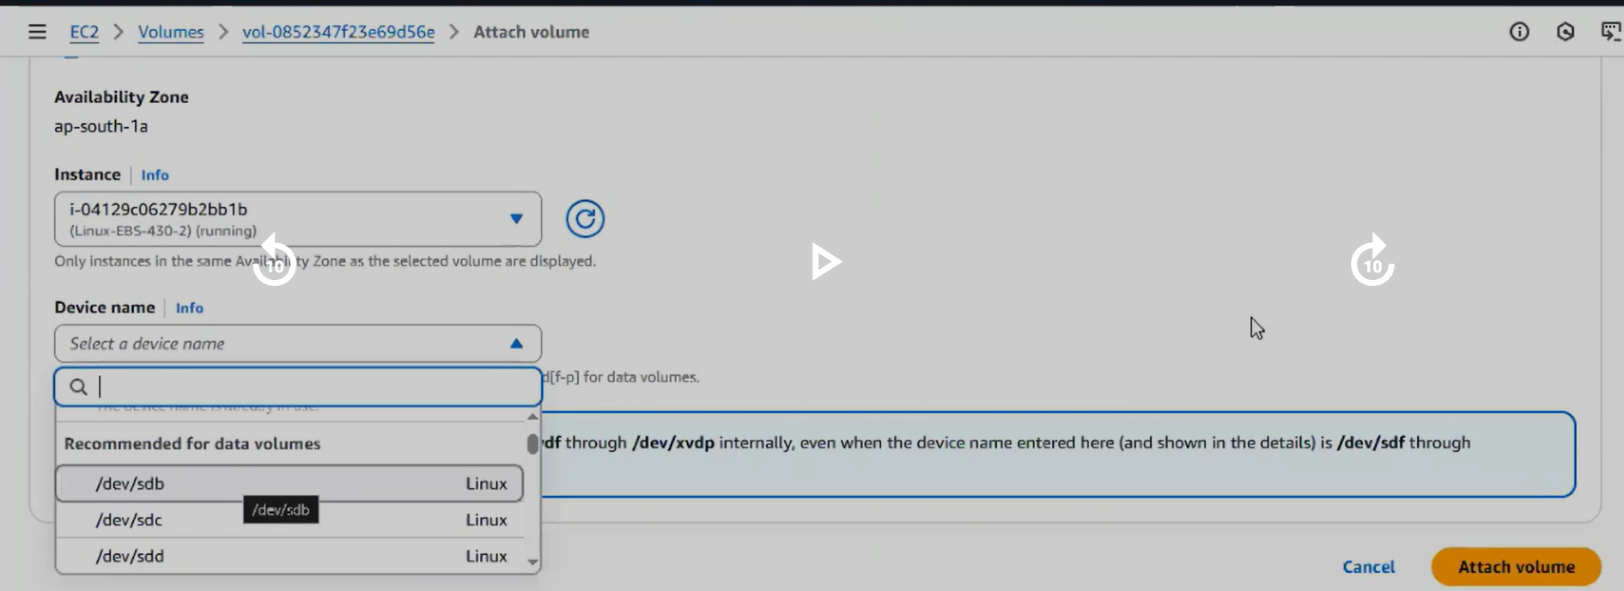
Now we are able to attach out volume to 2nd ec2 machine.

Now do we need to follow all steps before we did?
No, only 2 steps we need to follow. $ mkfs not required as already file system available we created earlier.
- Create directory.
- Link directory to volume.(mounting)

$ mkdir trainings
$ lsblk
$ sudo mount /dev/xvdb training
$ df -h

Since filesystem already exists, do NOT run mkfs again.
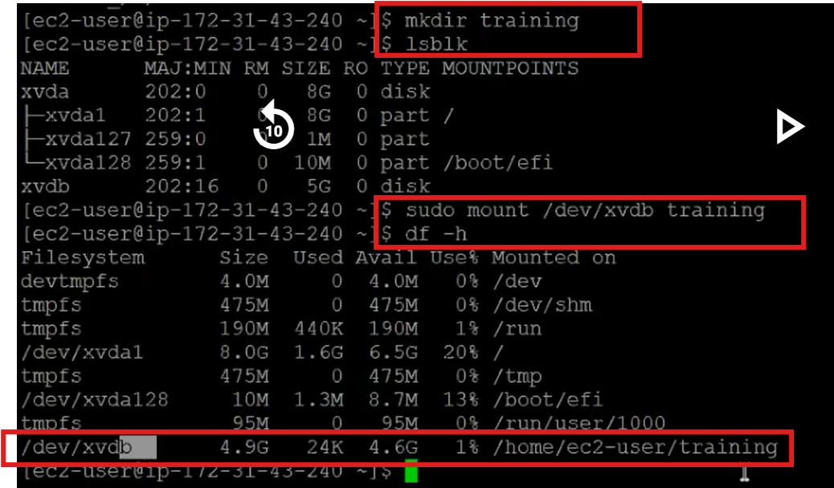
Now we can go inside training directory and add files.
Question: are we going to see previously created f1 f2 f3 files in the trainings directory? YES.
Go inside training directory and do $ ls, we can see all previously creates files there.
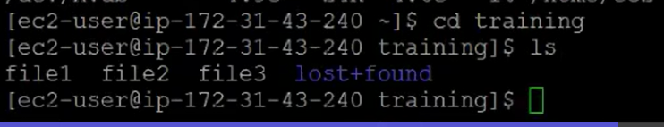

Why? Test directory is just a path for volume, file are not going to store there permanently. If you detach volume with old ec2 machine, then those files removed from test directory and available in volume which we detached.

If we attach that volume to new ec machine, there we can see those files.

Files always stored in EBS volume not in ec2 machine directory.

Think of EBS volume like a USB drive.
Laptop A → USB drive attached
Files created:
resume.doc
photo.jpg
notes.txt
Now unplug USB and connect to: Laptop B
You still see the same files.
Same concept in AWS.

Deleting EC2 vs Deleting EBS
When you terminate EC2:
Volume Type | What happens
Root Volume | Automatically deleted
Additional EBS | Not deleted automatically
So you must manually delete it: EC2 → Volumes → Delete Volume

Can one EBS attach to multiple EC2? Normally No.
Except special type:EBS Multi-Attach (only for io1/io2)

Maximum EBS Size Maximum volume size: 16 TB

Can EBS move between AZ?--> No.
But you can: Create Snapshot → Restore in another AZ

Full Workflow Summary
1 Create EC2 + extra EBS
2 lsblk
3 mkfs.ext4 /dev/xvdb
4 mkdir test
5 mount /dev/xvdb test
6 create files

7 umount /test
8 detach volume

9 create new EC2 (same AZ)
10 attach volume

11 mkdir training
12 mount /dev/xvdb training

Windows with EBS volumes:
Creating a Windows EC2 Instance
You launch a Windows server in Amazon EC2.
Example configuration:
Setting | Value
AMI | Windows Server
Instance type | t3.medium
Root volume | 30 GB
Security group | RDP (3389)
Additional volume | Not created initially
Sometimes in real projects, extra storage is required later (for logs, backups, or applications). In that case we create a new volume and attach it to the running instance.

Creating a New EBS Volume
Go to the console of Amazon Web Services.
Navigate:
EC2 → Elastic Block Store → Volumes
Create a volume.
Example:
Property | Value
Size | 5 GB
Volume type | gp3
Availability Zone | us-east-1a
⚠ Important rule:
The volume must be created in the same Availability Zone as the EC2 instance.
Example:
Resource | AZ
EC2 instance | us-east-1a
EBS volume | us-east-1a

Attach the Volume
Select the volume → Actions → Attach Volume
Choose:
Option | Example
Instance | Windows EC2
Device name | /dev/sdf
After attaching, AWS shows status:
In-use
Meaning the disk is attached to the instance.

Connect to Windows EC2: To connect windows EC2 we must generate a password.
Windows instances use RDP connection.
Steps:
- Go to EC2 → Instances
- Click Connect
- Choose RDP client
- Get Password
You must upload the .pem key pair used during instance creation.
AWS decrypts the password.
Then connect using:
Public IP + Username: Administrator + Decrypted password

We can change the password of windows ec2 machine not while creating the Ec2 machine. It is possible only after creating the ec2 machine.

Why the Disk Is Not Visible Yet in windows Ec2 machine?
Even though the EBS disk is attached, it will not appear in "This PC" immediately.
Reason:
The disk must be:
- Initialized
- Partitioned
- Assigned a drive letter
This is similar to Linux mounting.

Mounting the Volume in Windows
Open Server Manager.
Navigate:
Server Manager
→ File and Storage Services → Disks
You will see the new disk.
Example:
Disk | Status
Disk 0 | OS disk
Disk 1 | New EBS volume
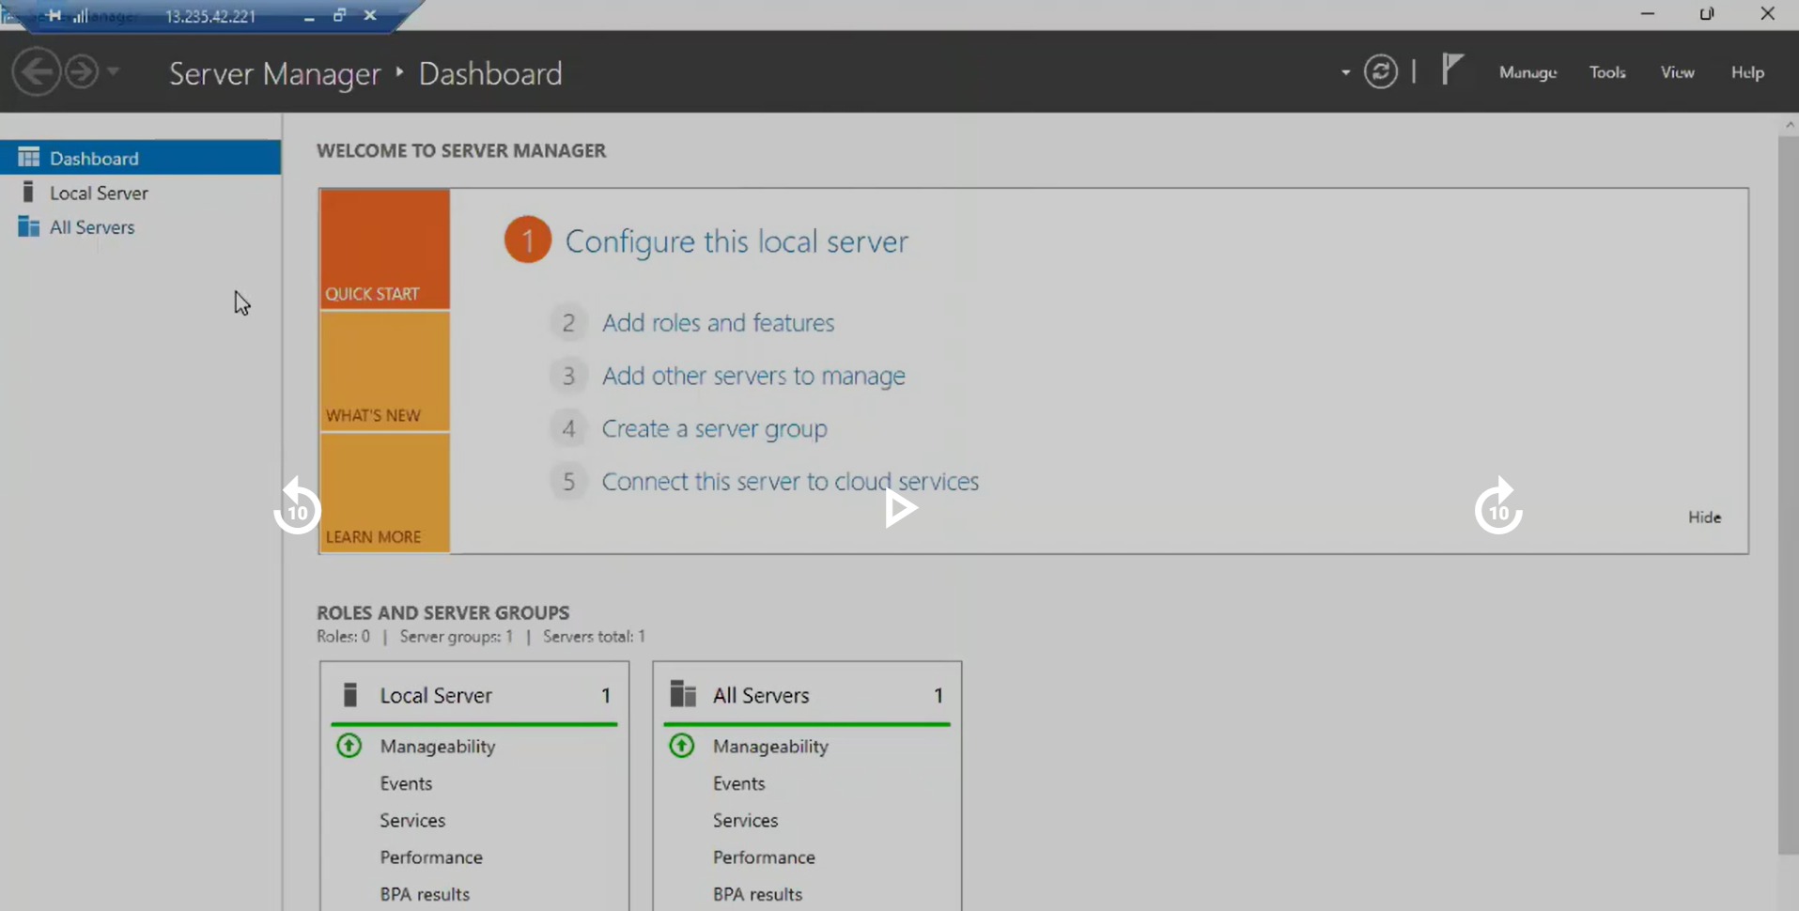
Wait until loading completely. It will take time to load completely.

Initialize the Disk
Right-click the new disk(5GB disk). Select: Initialize Disk
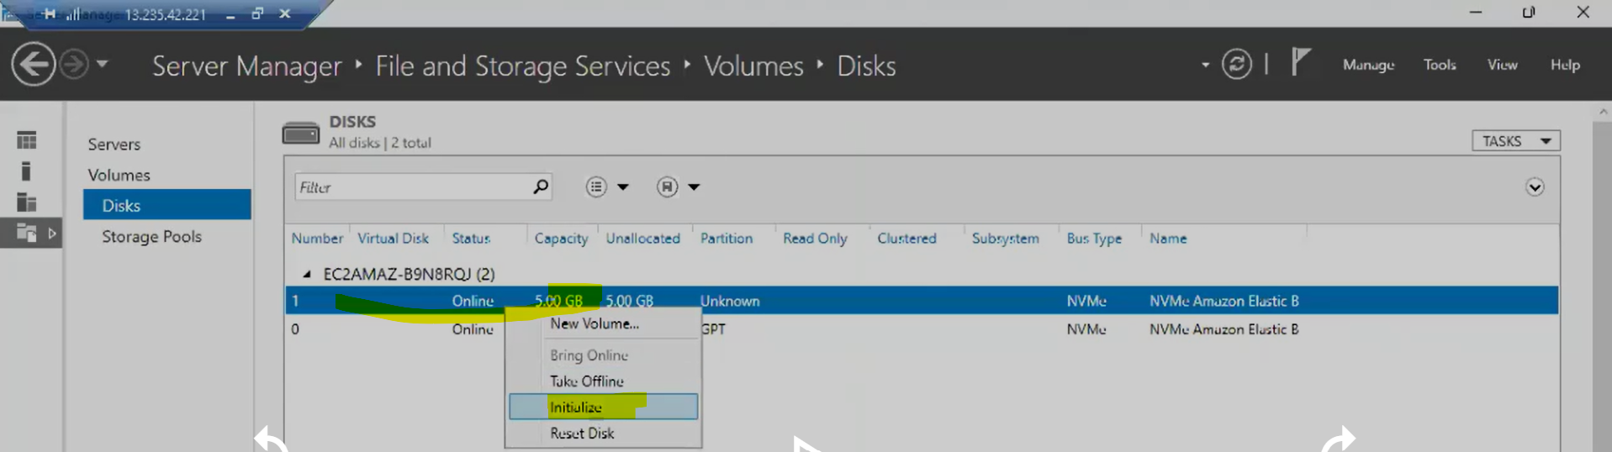

Choose partition type:
Type | When used
MBR | Small disks
GPT | Modern systems
Usually GPT is recommended.

Create a New Volume
Right-click the disk(5GB disk) again.
Select:
New Volume
Follow wizard: Next Next Assign Drive Letter Next Finish
Example:
Drive letter: D:
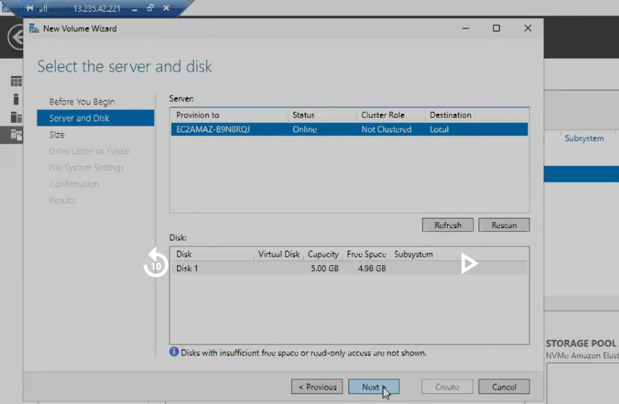

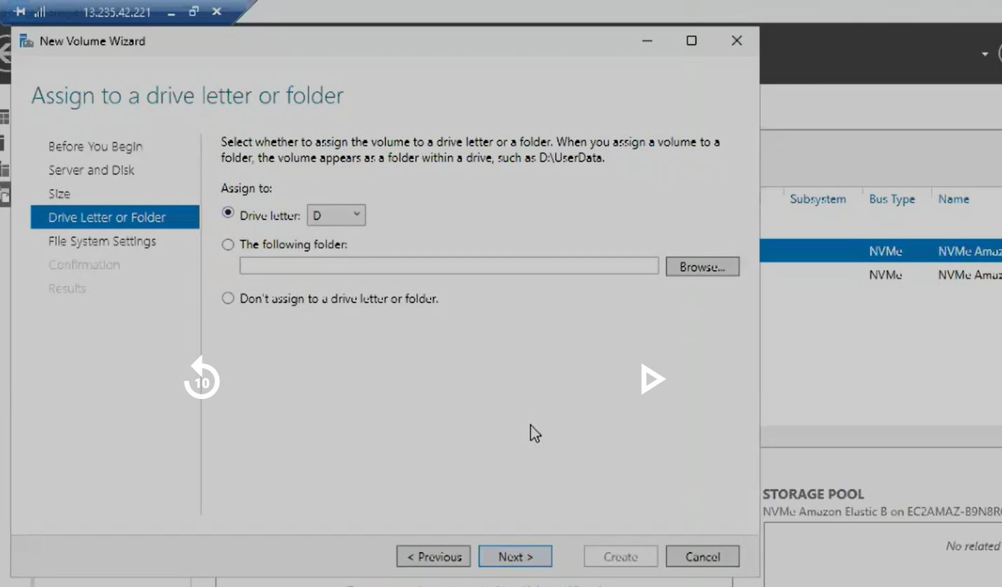

Now open windiws ec2 drives, we can see “D”D drive.
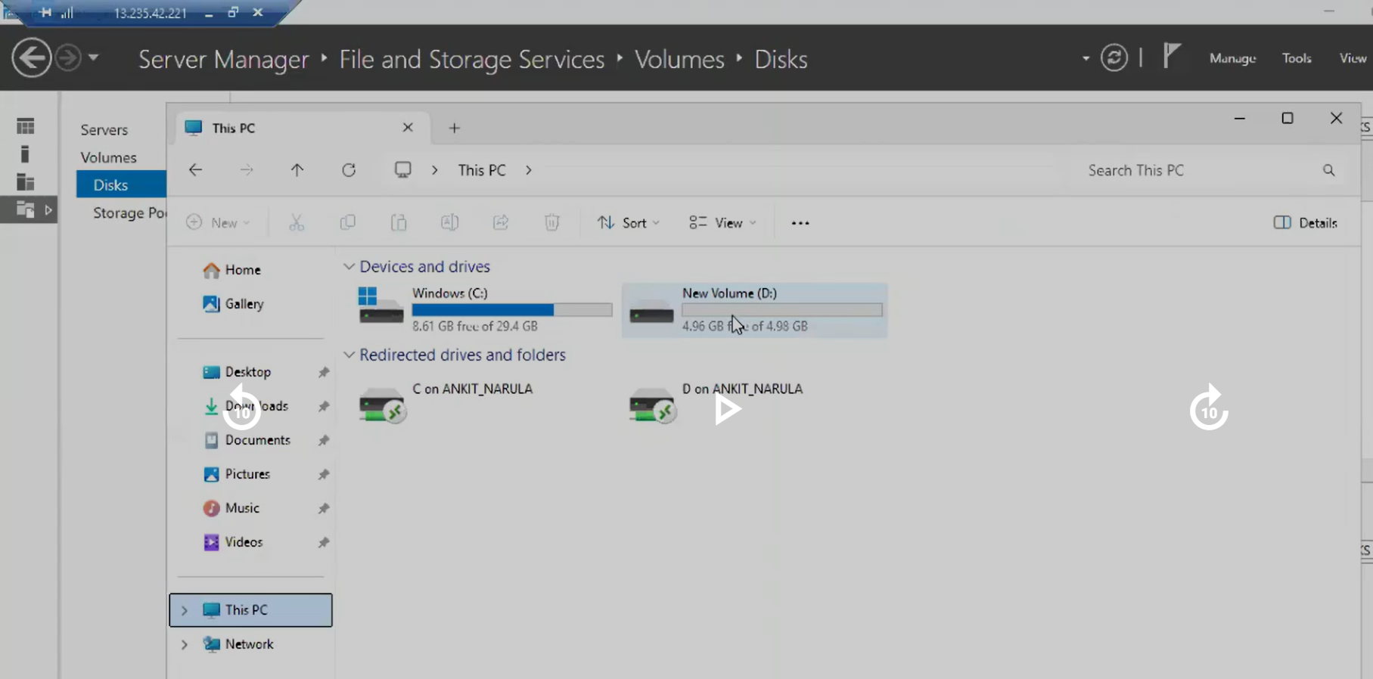

Open D drive and create any file in you want.

Verify the Volume
Open This PC.
Now you will see:
Local Disk (C:) → Root volume
New Volume (B:) → EBS volume
Now you can store files.
Example:
B:\backup
B:\logs
These files are stored in the EBS volume, not the root disk.

What Happens If You Move the Volume
If you detach this EBS volume and attach it to another EC2 instance:
All files remain intact.
Why?
Because data lives in the EBS disk, not in the EC2 instance.
This works exactly like a USB drive between computers.

Root Volume vs Additional EBS
When you terminate an EC2 instance:
Volume | Behavior
Root volume | Deleted automatically
Extra EBS | Remains (must delete manually)
You must delete unused volumes from:
EC2 → Volumes → Delete Volume
Otherwise AWS will still charge for storage.

Backup Scheduling (What Your Instructor Mentioned)
AWS provides automated backups through:
AWS Backup
With this service you can schedule:
Backup frequency | Example
Daily | Every night
Weekly | Sunday backup
Monthly | Long-term retention
This is commonly used for EBS snapshots.

Linux vs Windows Mount Comparison
Step | Linux | Windows
Identify disk | Lsblk | Disk Manager
Create filesystem | mkfs.ext4 | Initialize Disk
Mount | mount command | Assign drive letter
Access | /test directory | Drive like B:\
Concept is the same, only tools differ.

Workflow for Windows EC2 EBS volume:
1 Create Windows EC2
2 Create EBS volume (same AZ)
3 Attach volume
4 Connect via RDP
5 Server Manager → File and Storage Services
6 Initialize disk
7 Create volume
8 Assign drive letter
9 Use the disk
Can we set password to windows EC2 machine? YES it is possible.
Remove(Unmount) the EBS from windows ec2:
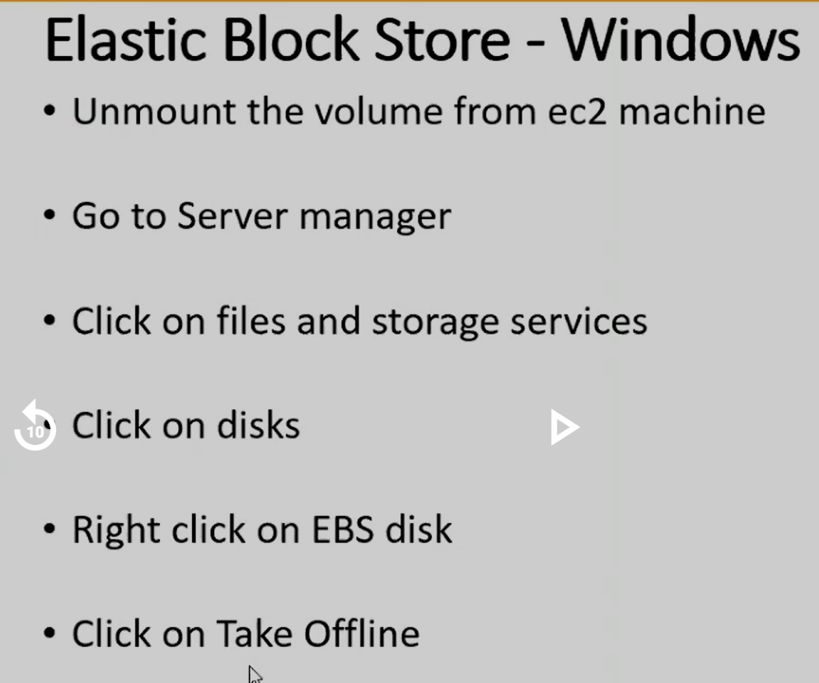

Server Manager files and storage services volumes disks volume Take Offline.
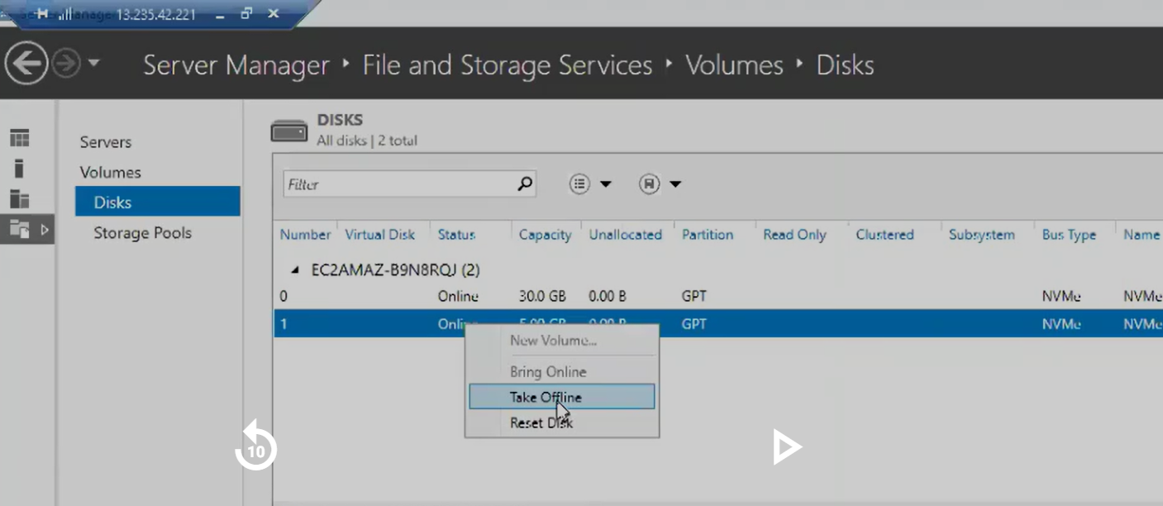

Remember, when we delete ec2 machines root volume will be deleted, but EBS volume we need to delete manually.

Now disconnect the volume in EC2 Elastic lock store volumes select our volume actions Detach volume.

In the same way if we have any other Ec2 machine, we can do same above step and attach the volume to that new EC2 machine.

When ever we create any new windows ec2 machine, we need to generate password o connect it.

What Happens If You Move the Volume
If you detach this EBS volume and attach it to another EC2 instance:
All files remain intact.
Why?
Because data lives in the EBS disk, not in the EC2 instance.
This works exactly like a USB drive between computers.

Root Volume vs Additional EBS
When you terminate an EC2 instance:
Volume | Behavior
Root volume | Deleted automatically
Extra EBS | Remains (must delete manually)
You must delete unused volumes from:
EC2 → Volumes → Delete Volume
Otherwise AWS will still charge for storage.

Backup Scheduling (What Your Instructor Mentioned)
AWS provides automated backups through:
AWS Backup
With this service you can schedule:
Backup frequency | Example
Daily | Every night
Weekly | Sunday backup
Monthly | Long-term retention
This is commonly used for EBS snapshots.

Workflow for Windows EC2 EBS volume:
1 Create Windows EC2
2 Create EBS volume (same AZ)
3 Attach volume
4 Connect via RDP
5 Server Manager → File and Storage Services
6 Initialize disk
7 Create volume
8 Assign drive letter
9 Use the disk

Question:
I have connected one Linux machine and I have attached a volume to that machine. Now I have unmounted that particular volume and now I want to attach that particular volume to Windows EC2 machine. So what do you think? Can we attach that volume to the Windows EC2 machine?

no, we can't attach the reason is file system. Because Linux file system is different, Windows file system is different. You can try to attach, but in console you can do that, but when you try to access that particular volume, it's not going to mount it there. So we can't attach that particular volume to another operating system. Linux one is compatible with Linux, you can attach to any Linux operating system.

When we attach volume we ill not got error, but while mounting we will get error.

Important Question From Your Instructor
Can a Linux EBS volume be attached to a Windows EC2?
Your instructor answered No, but the correct explanation is more nuanced.
Scenario | Result
Linux volume attached to Windows | Possible but not readable
Windows volume attached to Linux | Possible but not readable
Reason:
File system compatibility
Linux commonly uses:
ext4
xfs
Windows commonly uses:
NTFS
FAT32
Windows cannot read ext4 by default.
Linux cannot read NTFS easily without drivers.
So the volume can attach, but the OS cannot mount the filesystem.
That’s why it appears unusable.

Example
Linux machine created volume with:
ext4
Now attach it to Windows.
Windows Disk Manager will show:
Unknown File System
You would have to format the disk to use it.
But formatting erases all data.

Same Concept with Linux Machines
If you attach a Linux volume to another Linux EC2:
lsblk
mount /dev/xvdb /test
Files will appear because the filesystem is supported.

Availability Zone Rule (Very Important)
EBS volumes work only inside the same AZ.
Example:
us-east-1a
Resource | AZ
EC2 | us-east-1a
EBS | us-east-1a
If EC2 is in us-east-1b, attachment will fail.

Real-World Example
Think of EBS like a USB drive.
If you format USB as:
ext4
and plug into Windows laptop:
Windows will detect the disk but say:
Drive needs to be formatted
Same behavior.

Summary of Windows Workflow
1 Create Windows EC2
2 Create EBS volume
3 Attach volume
4 Open Server Manager
5 Initialize disk
6 Create new volume
7 Assign drive letter
8 Store files
9 Take disk offline
10 Detach volume
11 Attach to another EC2

How can we identify what is windows volume or linux volume? we cant identify just like that, while creating volume we need to give proper naming convention.

00:52 EFS
https://www.logiclabstech.com/s/courses/689f14e47a4733254fee75a0/take

