RDS with MYSQL:

RDS- Relational Database Service:

AWS search RDS Aurora and RDS
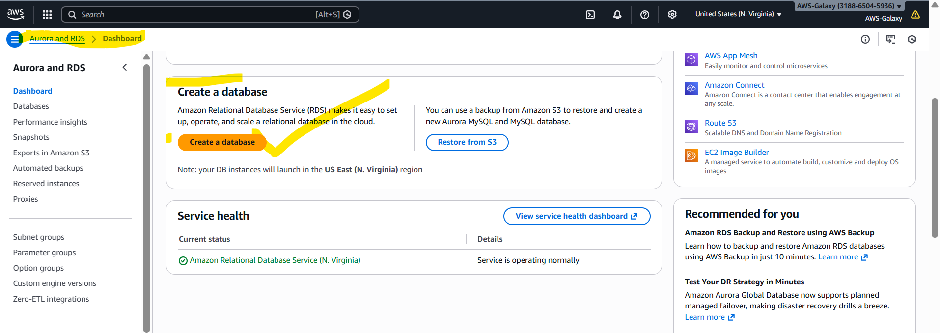
Click on Create a database:
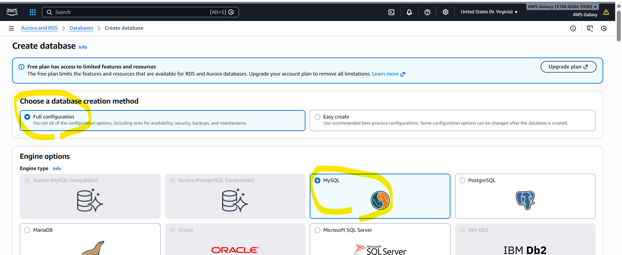

Maximum default values only we are going to use, only give password manually any values in file 8+ characters.
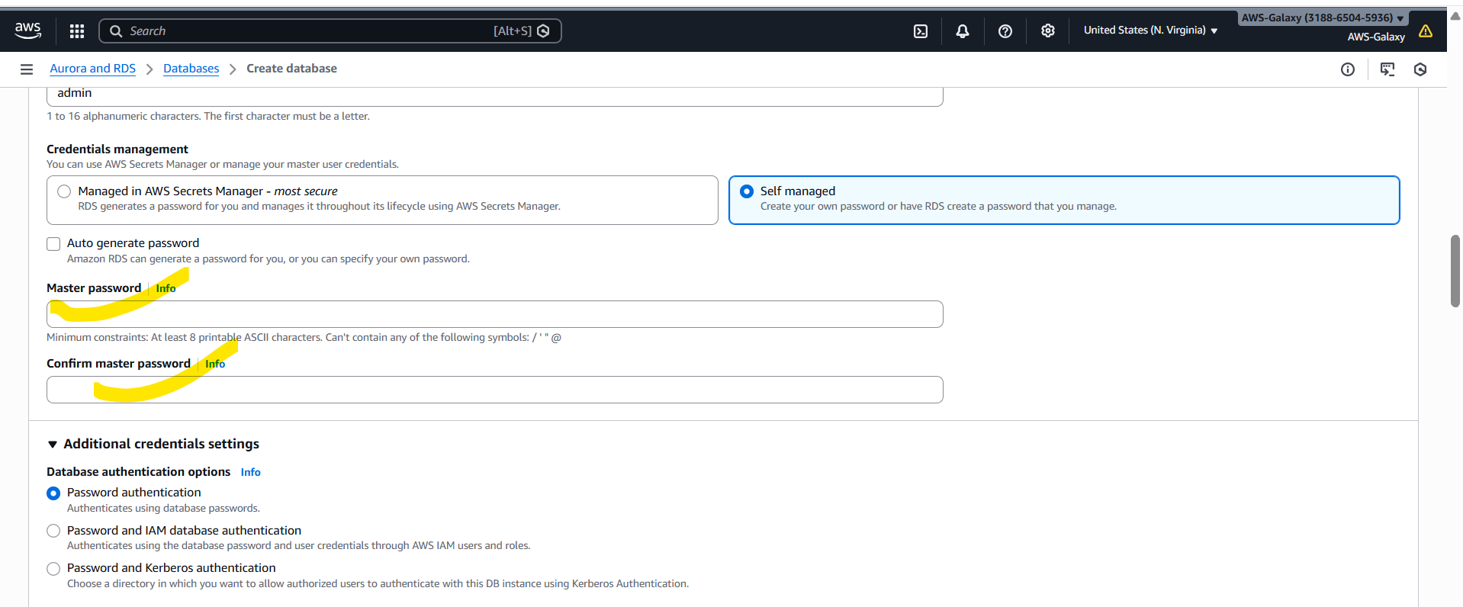

We need to give public access. Enable radio button for public access.
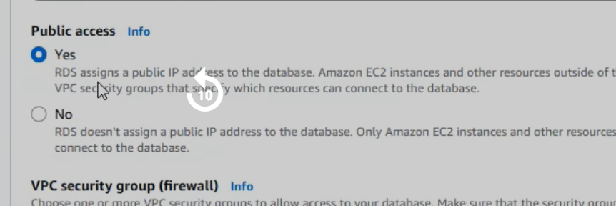

Now create Database. It will take some time, wait patiently. Database Status needs to come as “available”.

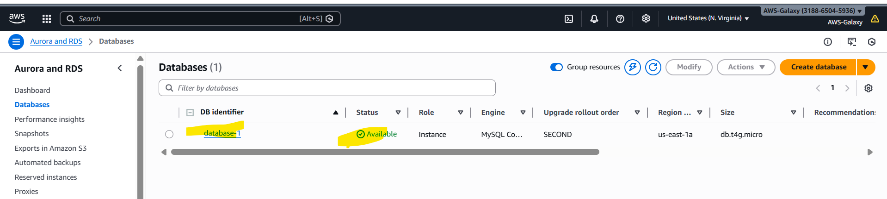

Next go to created database database1 Connectivity & security Security group rules click on default inbound rule go inside security group ID Edit inbound rules Add rule Below all screenshots are added please check.

Add below details in inbound rules:
Field | Value
Type | MySQL/Aurora
Protocol | TCP
Port | 3306
Source | My IP 0.0.0.0/0
Click on below Security group
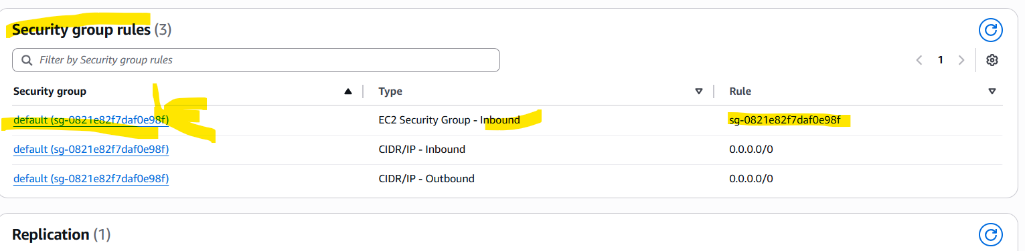

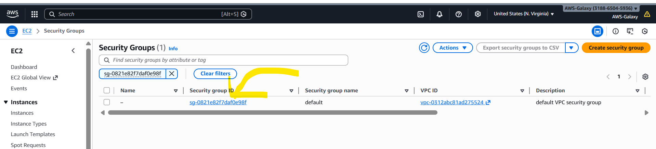

Edit inbound rules:
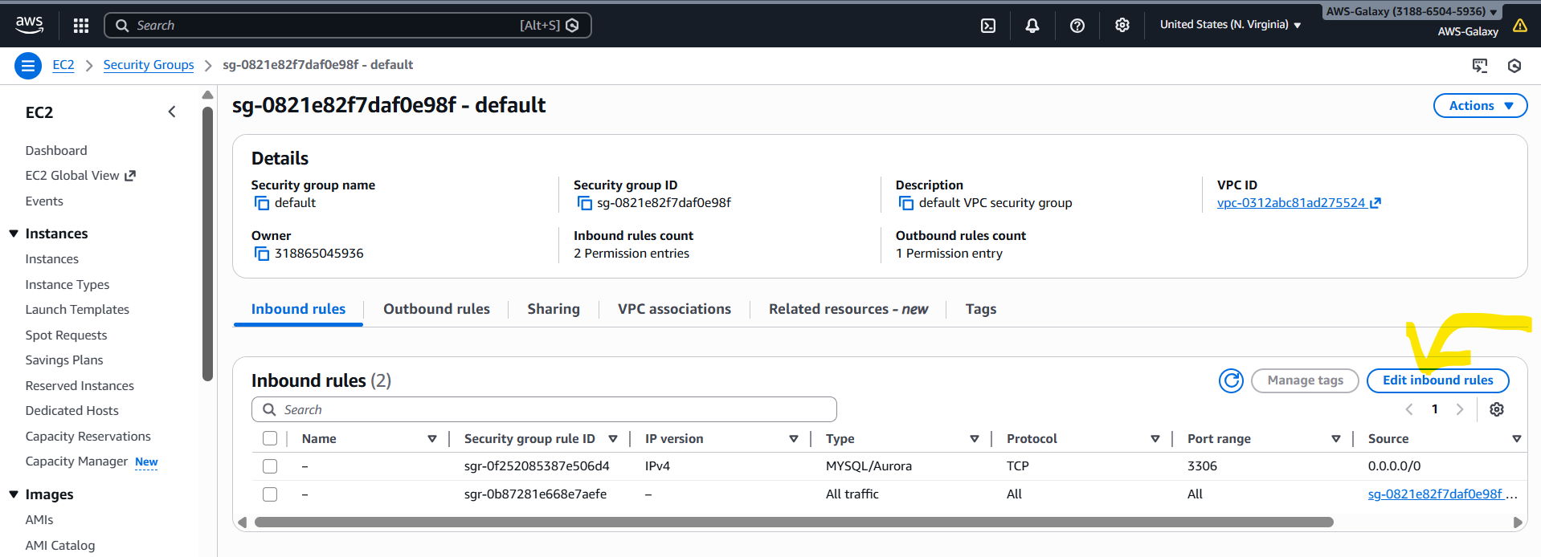

We will not be able to connect rds DB if we don’t add these in bound rules.
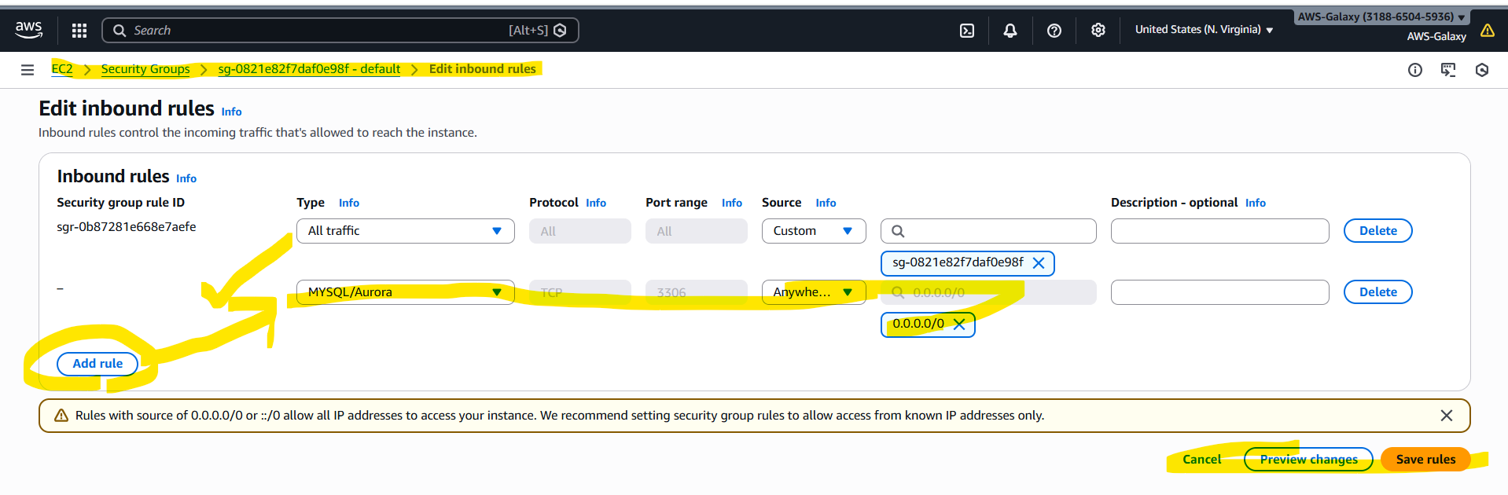
After adding inbound rules only we are able to connect to RDS MYSQL.

mySQl work bench:
Mysql workbench menu databases manage connections new
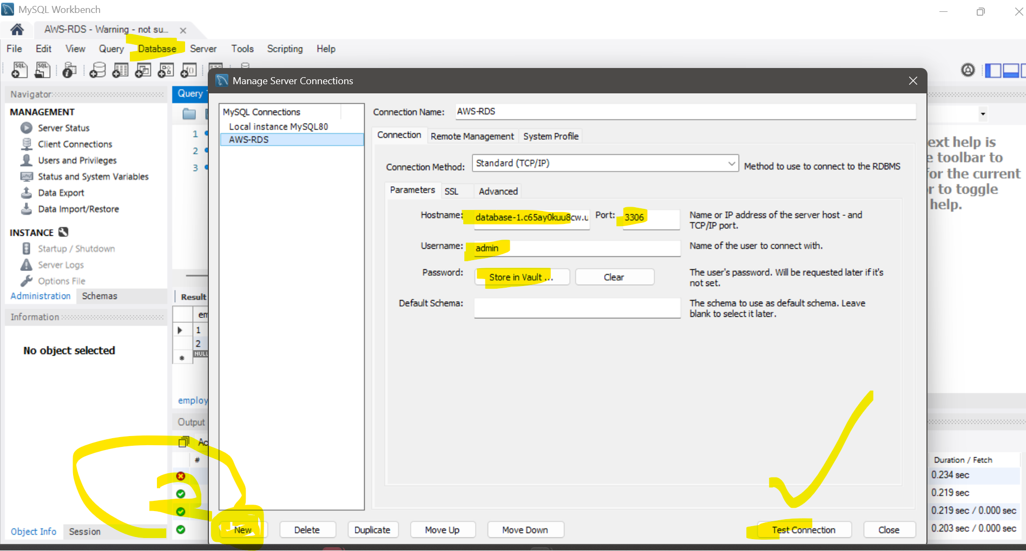

Once after connecting to mysql work bench use below commands and create testdb and then create table etc..
create database testdb;
use testdb;

MYSQL workbench:
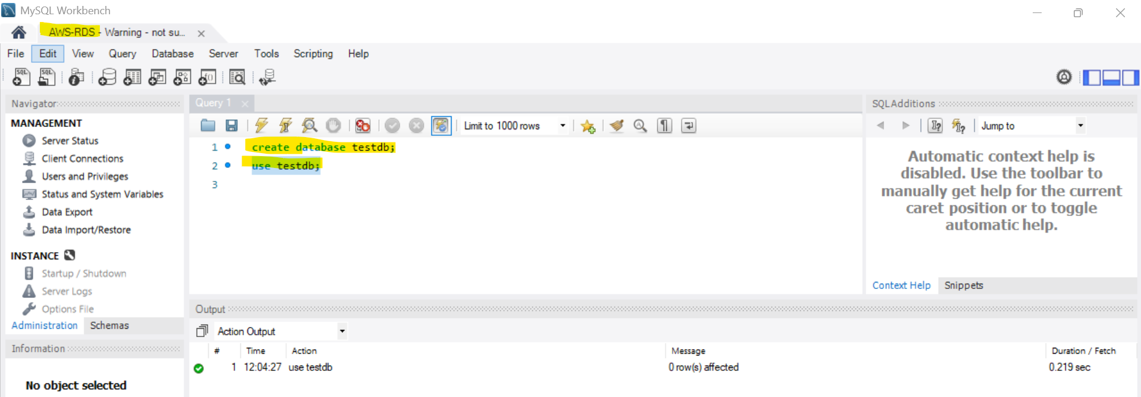

application-rds.yaml
spring:
datasource:
driver-class-name: com.mysql.jdbc.Driver
url: jdbc:mysql://database-1.c65ay0kuu8cw.us-east-1.rds.amazonaws.com:3306/testdb
username: admin
password: rootroot
jpa:
database: mysql
show-sql: true
database-platform: org.hibernate.dialect.MySQLDialect
hibernate:
ddl-auto: update
data:
jpa:
repositories:
enabled: true

For local applications we use | For AWS RDS MySql applications we use
url: jdbc:mysql://localhost:3306/testdb | url: jdbc:mysql://<AWS_DOMAIN>:3306/testdb

Spring boot dependencies:
build.gradle:
dependencies {
implementation 'org.springframework.boot:spring-boot-starter-data-jpa'
runtimeOnly 'com.mysql:mysql-connector-j'
testImplementation 'org.springframework.boot:spring-boot-starter-data-jpa-test'
}

Create java entiry class and repository classes and use repo class in service class.
EmployeeEntity.java | EmployeeRepository.java
import jakarta.persistence.*;  import java.util.Date;  @Entity  @Table(name = "employees")  public class EmployeeEntity {  @Id  @GeneratedValue(strategy = GenerationType.IDENTITY)  @Column(name = "emp_id")  private Integer empId;  @Column(name = "emp_name", nullable = false, length = 100)  private String empName;  @Temporal(TemporalType.DATE)  @Column(name = "emp_doj")  private Date empDOJ;  @Column(name = "emp_salary")  private Double empSalary;  @Column(name = "is_permanent_emp")  private Boolean isPermenentEmp;  // default CTR/ para cter…  // setters, getters. Tostring, equals…. | @Repository  public interface EmployeeRepository extends JpaRepository<EmployeeEntity, Integer> {  // All basic CRUD methods are available from JpaRepository:  // save, findById, findAll, deleteById, existsById, count, etc.  }

EmployeeServiceImpl.java
@Service
@Transactional
public class EmployeeServiceImpl {
private final EmployeeRepository repo;
public EmployeeServiceImpl(EmployeeRepository repo) {
this.repo = repo;
}
// Create
public EmployeeEntity createEmployee(com.skh.models.Employee e) {
EmployeeEntity emp = new EmployeeEntity(null, e.getEmpName(), e.getEmpDOJ(), e.getEmpSalary(), e.getIsPermenentEmp());
/**
* Above dont assign/set empId to the EmployeeEntity class, why because we are using @GeneratedValue(strategy = GenerationType.IDENTITY)
* in entity class.
*/
return repo.save(emp);
}
// Read all
public List<EmployeeEntity> getAllEmployees() {
return repo.findAll();
}
// Read by id
public Optional<EmployeeEntity> getEmployeeById(Integer id) {
return repo.findById(id);
}
// Update (full replace)
public EmployeeEntity updateEmployee(Integer id, EmployeeEntity updated) {
return repo.findById(id)
.map(existing -> {
existing.setEmpName(updated.getEmpName());
existing.setEmpDOJ(updated.getEmpDOJ());
existing.setEmpSalary(updated.getEmpSalary());
existing.setIsPermenentEmp(updated.getIsPermenentEmp());
return repo.save(existing);
})
.orElseGet(() -> {
// If not found, set id and create new (optional behavior)
updated.setEmpId(id);
return repo.save(updated);
});
}
// Delete
public void deleteEmployee(Integer id) {
repo.deleteById(id);
}
// Exists helper
public boolean exists(Integer id) {
return repo.existsById(id);
}
}

How to Get out Public IP address Git Bash & modern Windows.
In Git Bash / cmd prompt:
$ curl ifconfig.me

For RDS automatic backup is enables automatically.
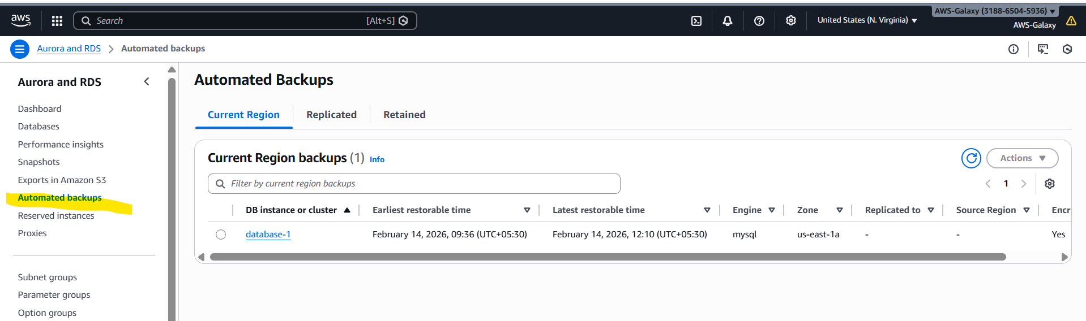

If we select our database we created and click on Action drop down we are will get so many options we need to learn all those options.
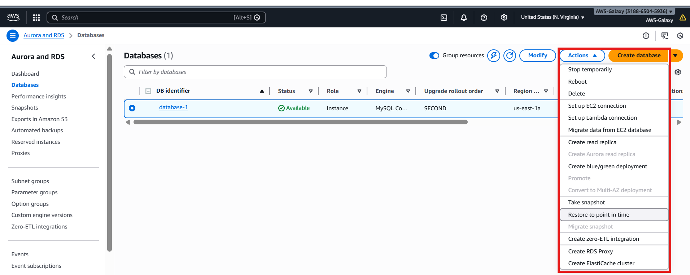

Restore point in time?

AWS Database – Advantages:
• Highly Scalable: We can scale your database as our application grows without any downtime!
• Fully Managed: Everything, from maintenance to hardware upgrades, is managed by AWS.
• Enterprise Class: We get the same world-class infrastructure used by Amazon’s giant ecommerce platform.
• Workforce Reduction: Since everything is managed by AWS, you don’t need a Database Maintenance team in your organization.

AWS Database – Types:
• Relational Database RDS (Relational DB Service(supports Eight DB engine types)), Amazon Redshift
• Key Value Database Amazon DynamoDB.
• In Memory Database Amazon ElastiCache, Amazon MemoryDB for Redis
• Document Database Amazon DocumentDB (with MongoDB compatibility)
• Wide Column Database Amazon Keyspaces
• Graph Database Amazon Neptune
• Time Series Database
• Ledger Database

AWS Database - Key Value:
• A key-value database is a type of non-relational database that uses a simple key-value method to store data. A key-value database stores data as a collection of key-value pairs in which a key serves as a unique identifier. It is NoSQL Database.
Use Cases: High-traffic web applications, ecommerce systems, gaming applications.
• Types of AWS Services in Key Values
• Amazon DynamoDB

AWS Database - In Memory
• An in-memory database keeps all its data in the random access memory (RAM) of a computer. Only the main memory is accessed when querying data. This allows for faster access of that data than a disk-based system. It is NoSQL Database.
• User Cases: Session management, gaming leaderboards, real time Bidding.
• Types of AWS Services in In Memory
• Amazon ElastiCache
• Amazon MemoryDB for Redis

AWS Database – Document:
• Document databases store data in JSON or JSON-like documents. You can query data using the same document-model format used in programming applications.
• User Cases: Content management, catalogs, user profiles
• Types of AWS Services in Document
• Amazon DocumentDB (with MongoDB compatibility)

AWS Database - Wide Column:
• In Wide Column data is stored and grouped into separately stored columns instead of rows. Queries for a particular value in a column are very fast, as the entire column can be loaded and searched quickly. Such databases organize information into columns that function similarly to tables in relational databases.
• Use Cases: High-scale industrial apps for equipment maintenance, fleet management, and route optimization
• Types of AWS Services in Wide Column
• Amazon Keyspaces

AWS Database – Graph:
• This database type represents relationships directly. You can query data with specific graph languages. It storing billions of relationships and querying the graph with milliseconds latency.
• Use Cases: Fraud detection, social networking, and recommendation engines
• Types of AWS Services in Graph
• Amazon Neptune

AWS Database - Time Series • Time-series databases store data in time-order and as append-only. We can query data over various time intervals. Time series data are simply measurements or events that are tracked, monitored, down sampled, and aggregated over time. • Use Cases: Application performance monitoring, trades in a market, sensor data, DevOps, network data & many other types of analytics data. • Types of AWS Services in Time Series •

Amazon Timestream AWS Database - Ledger • Ledger databases add a layer of digital signatures for each transaction so anyone can audit the list and see that it was constructed correctly. More importantly, no one has gone back to adjust a previous transaction to change history. • Use Cases: Banking Transactions, supply chain, Crypto currency, Insurance claims & HR and payroll • Types of AWS Services in Ledger • Amazon Quantum Ledger Database

AWS Database - Relational Database:
• Use Cases: Traditional applications, enterprise resource planning (ERP), customer relationship management (CRM), and ecommerce
• Types of AWS Services in Relational Database
• RDS (Relational Database Service)
• Amazon Redshift

AWS Database - Relational Database:
• Amazon RDS supports Eight DB engine types:
• Amazon Aurora (MYSQL Compatible)
• Amazon Aurora (PostgreSQL Compatible)
• Oracle
• Microsoft SQL Server
• MySQL
• PostgreSQL
• MariaDB
• IBM Db

Relational Database Service - RDS :
• Amazon RDS supports an array of database engines to store and organize data. It also helps with relational database management tasks, such as data migration, backup, recovery and patching.
• Advantage of RDS
• Automatic Backups
• Multi Availability Zone
• Read Replica RDS - Backup

• Backup refers to the copying of physical or databases to a secondary location for preservation in case of equipment failure.
• Types of Backups
• Automatic Backup
• Manual Backup RDS –Backup

• Automatic backup is a type of data backup model that requires little or no human intervention in backing up and storing data from a local network/system to a backup facility.
• Automating the backup process saves time and complexity required to manually back up a computer, network or IT environment.
• Automatic backup allow us to recover our database to any point in time within a retention period. The retention period can be between 1 and 35 days.
• Default Retention Period is 7 Days
• Automatic backups will take a full daily snapshot and will also store transaction logs throughout the day. When we do a recovery, AWS will first choose the most recent daily backup, and then apply transaction logs relevant to that day.
• After they are deleted, the automated backups can't be recovered. • Automatic backups are enabled by default RDS –Backup
• Automated backups rule:
• Our DB instance must be in the AVAILABLE state for automated backups to occur. Automated backups don't occur while your DB instance is in a state other than AVAILABLE, for example STORAGE_FULL.

• Manual Backup
• Manual Backup are also called as Snapshot.
• Database Snapshot are done manually. They are stored even after we delete the original RDS instance, unlike automatically backups.
• We can have up to 100 manual snapshots per Region.

RDS –Multi Availability Zone:
• Multi AZ allow us to have an exact copy of our production database in another AZ. AWS handles the replication for us. When our production database is written to, this write will automatically be synchronized to the stand by database.
• In the event of planned database maintenance, database instance failure or and Availability zone failure, Amazon RDS will automatically failover to the standby so that database operations can resume quickly without administrative intervention.
• Both Database Servers have same DNS endpoints
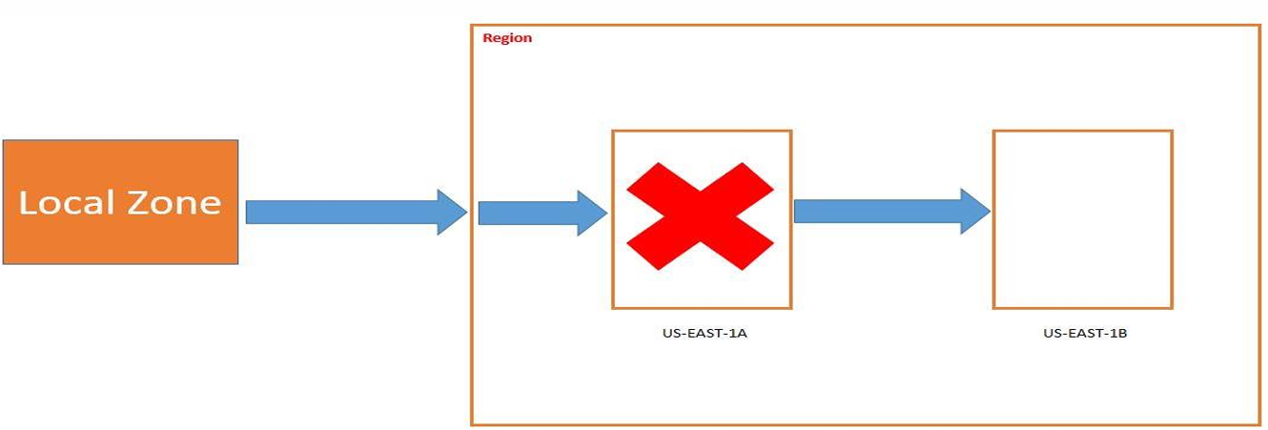

RDS –Read Replica:
• Read replica allows us to have a read only copy of our production database.
• Amazon RDS Read Replicas provide enhanced performance and durability for RDS database (DB) instances.
• They make it easy to elastically scale out beyond the capacity constraints of a single DB instance for read-heavy database workloads.
• We can have up to 5 read replica copies of any database.
• We can have read replicas of read replicas (But Latency will be there)
• When we create a read replica, RDS gives us a read-only endpoint which is a DNS that resolves only to our read replica.
• A read replica and the master may be in different availability zones, and even in different regions.

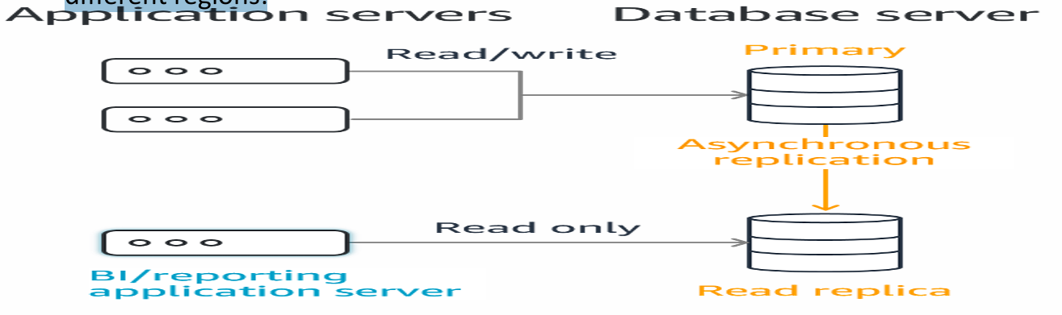

RDS –Create Read Replica:


RDS –Manual Snapshot:

Note: While practice don’t click on take snapshot otherwise we will start getting bill.

RDS –Restore Snapshot:




RDS –Enable Multi Availability Zone:
Select the instance Click on Modify Go to Availability & Durability Select create a standby instance

Amazon Aurora is a fully managed relational database service provided by Amazon Web Services (AWS).
• Compatible with MySQL and PostgreSQL
• Designed for high performance, high availability, and automatic scaling
• Built for the cloud from the ground up
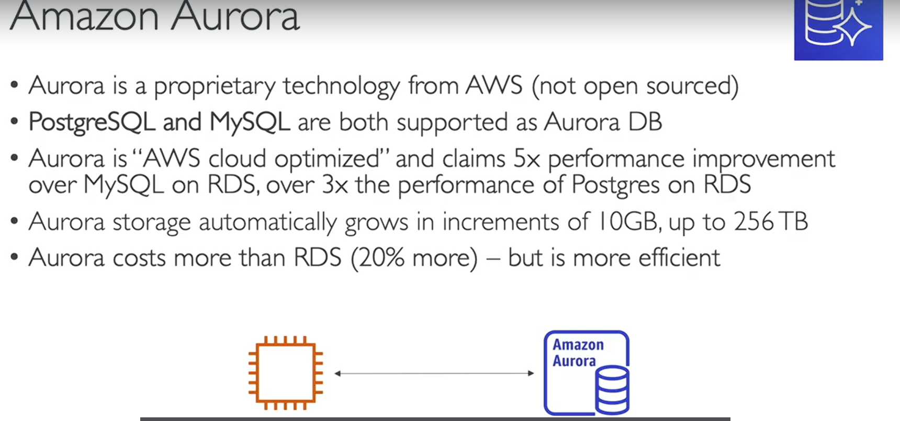

Think of Aurora as a cloud-optimized MySQL/PostgreSQL that gives better performance and reliability than standard MySQL/PostgreSQL running on EC2.

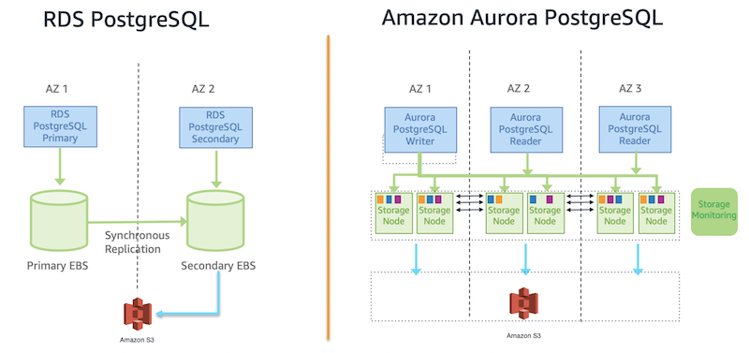
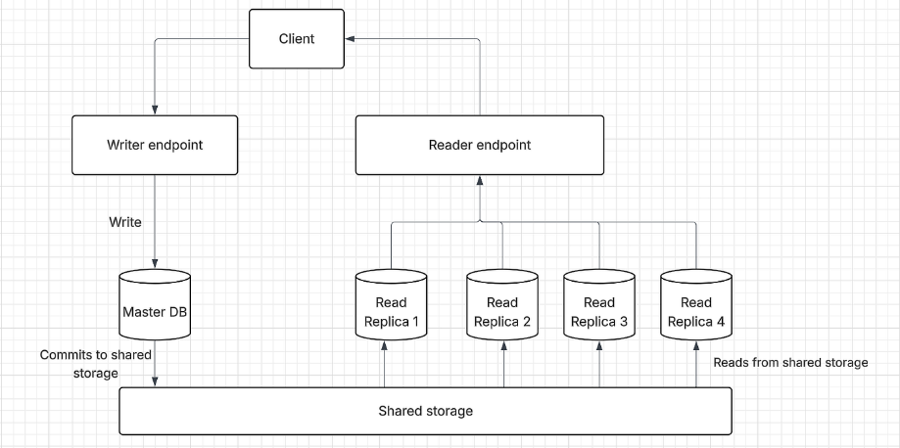

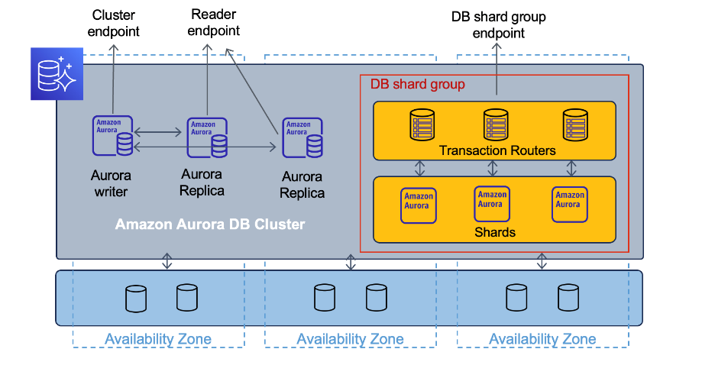
Aurora uses a DB Cluster architecture:
- Writer Instance (Primary)
  - Handles INSERT, UPDATE, DELETE
- Reader Instances (Replicas)
  - Handle SELECT queries
  - Used for read scaling

Aurora Variants
Aurora supports two engines:
1️⃣ Aurora MySQL
Compatible with:
- MySQL 5.7
- MySQL 8.0
2️⃣ Aurora PostgreSQL
Compatible with:
- PostgreSQL 11+
- PostgreSQL 12+
- etc.

🆚 Aurora vs RDS
Amazon RDS vs Aurora:
Feature | RDS MySQL | Aurora
Storage scaling | Manual | Automatic
Performance | Good | Very High
Replication | Standard | Storage-level
Availability | Multi-AZ | Built-in cluster

NOTE: Aurora is technically part of RDS but has a different architecture.
When Should You Use Aurora?
Use Aurora when:
✅ High traffic applications
✅ Need automatic scaling
✅ Need high availability
✅ Microservices architecture
✅ SaaS applications

